Chapter 1
Barriers in Communication

Components of Communication:

Verbal Messages:

Categories in Non-Verbal Messages:

Categories in Non-Verbal Messages:

Non-Verbal Messages:
1. Account for about 55% of what is perceived and understood by others.
2. Are conveyed through our facial expressions as well as our postures and gestures.

Para verbal Messages:
- Messages that we transmit through the tone, pitch, and pacing of our voices.
- It is how we say something, not what we say.
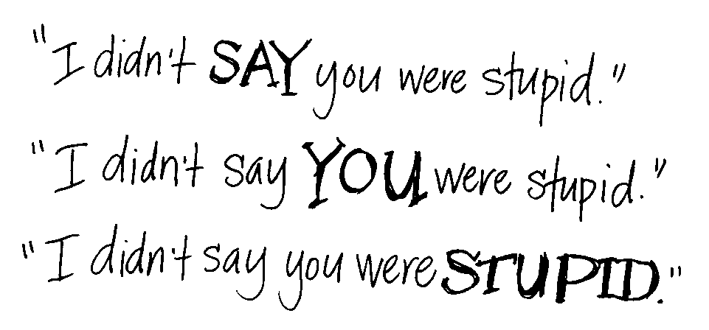
Verbal Messages:
Paraphrasing | a brief, concise statement reflecting the content of the speakers message
Reflecting Feeling | a statement, in a way that conveys understanding, of the feeling that the listener has heard
Summarizing | a statement of the main ideas and feelings to show understanding
Questioning | asking open questions to gain information, encourage the speaker to tell her story, and gain clarification

What is a Barrier?

How would you define a Communication Barrier?

Barriers to Business Communication:
- Language Barriers
- Physiological Barriers
- Psychological Barriers
- Cultural Barriers
- Bypassed Instructions
- Abstracting

Language Barriers:

Physiological Barriers:

Psychological Barriers:

Cultural Barriers:

Nonverbal Barriers:
- Flashing or rolling eyes
- Quick or slow movements
- Arms crossed, legs crossed
- Gestures made with irritation
- Poor personal care
- Doodling
- Staring at people or avoiding eye contact
- Excessive twitching with materials

Definition:
Verbal Communication:
Sending and receiving messages by using words, sounds, speaking and language.
Nonverbal Communication
Sending and receiving messages in a variety of ways without the use of verbal codes (words).
Category:
Verbal Communication
- Speaking (Oral)
- Written(via email)
- Sign
Nonverbal Communication
- Physical (facial expression, touch, smell, body motion)
- Aesthetic (dancing, painting)
- Sign (signal flag, horns, siren, alphabets)
- Symbolic (religious, status)
Function:
Verbal Communication
- Speaking to inform
- Speaking to inspire and motivate
- Telling or narrating story
- Asking questions
Nonverbal Communication
- Express emotions
- Express interpersonal attitude
- Accompany speech
- Self presentation of one’s personality
- Rituals/ Ceremonies
Other Differences:
Verbal Communication | Nonverbal Communication
- Verbal cues are digital | - Analogical
- Less universal | - More universal
- Less sensory directness | - Offer greater sensory  directness
- Less spontaneous | - More spontaneous

Similarities:
- Both involve receiver and sender
- Both reveal emotions, exchange ideas & thoughts
- Both have cues that are distinct
- Both can have multiple meanings
- Both can be used for deceptive/ manipulative purposes
- Both exhibit the property of productivity

Repetition | NV messages strengths verbal messages e.g. pointing to the object of discussion
Conflicting | Verbal and Nonverbal don’t support each other e.g. telling a lie
Complementing | Verbal messages elaborate the idea and Nonverbal messages supplement/ reinforce each other
Substituting | Nonverbal can be used instead of verbal e.g. saying “NO”
Regulating | e.g. touching i.e. you want to talk
Acceding/ Moderating | Moderates our tone e.g. shaking hands 03215276226

Summary:
- Verbal Communication
- Non verbal Communication
- Para verbal communication
- Barriers in Communication
- Verbal & Nonverbal Communication

Chapter 2

Introduction to Communication Skills

Outline:
- What is Communication?
- How do we communicate?
- What is a Skill?
- Language Skills
- Types of Communication
- Styles of Communication
- The Communication Cycle
- Communication in Workplace

What is Communication?
The dictionary defines communication as a process by which information is exchanged between individuals through a common system of symbols, signs or behaviors.
- Communication is the activity of conveying information
- Communication has been derived from the Latin word "communis", meaning to share
- Communication requires:
  - a sender
  - a message, and
  - an intended recipient

What is a Skill?
Skill is defined as a learned power of doing something competently. It is a developed aptitude or ability.

Language Skills:

Communication Frequency:

Communication is of 2 Types:
- Verbal Communication
  - Words
  - Voice Modulation
- Non-verbal Communication
  - Posture & Movement
  - Gestures
  - Facial Expressions

Styles of Communication:
  - Agressive communication
  - Submissive communication
  - Assertive communication

How do we communicate?
Written-Visual | Verbal-Non verbal
- Assignment  - CV  - Application  - Report | - Interview  - Presentation  - Meetings

A communication system normally goes through a cycle involving:
1 | The Sender | person who sends the message; the source
2 | The Receiver | The person who receives the message
3 | The message | Subject matter of communication. It may contain facts, ideas, feelings and thoughts
4 | The Channel | Verbal/ Nonverbal
5 | The Feed back | Receiver’s response or reaction or reply to the message, which is directly towards the sender

The Communication Cycle:
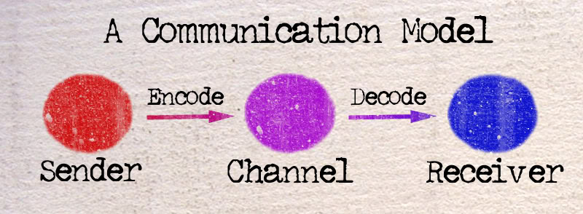

1. A message sent | Gesture Facial expression  Drawing Spoken/written
- Entry in sensory world  (all senses) | Sight Smell  Hearing Taste  Touch
- Stimuli  (Picks up message) | - Stimuli varies from person to person:  Person’s abilities  Cultural background  Drowsy/dizzy/day dreaming/ not alert  Outside noises  Facial expressions  Double/ dual meaning
- The Filtering Process  (brain) | Through contents  Experiences  Knowledge  Emotions  Cultural background
5. Message Response through: | Words  Gestures  Physical actions
6. The Cycle Repeated
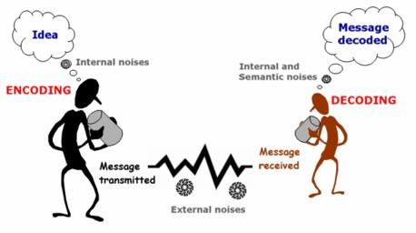
Communication in Workplace:
Dictionary definition: A place, such as an office or factory, where people are employed.

Why do we communicate?
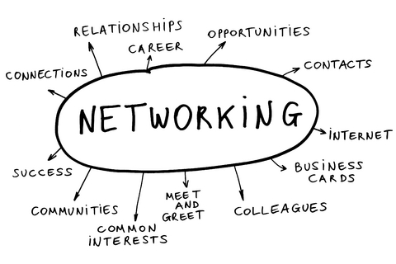
What is our workplace?
- Administration office
- Accounting office
- Human Resources Office
- Bookstore
- Maintenance office
- Engineering office
- General Services
- Clinic
- Registrar
- Security Guard office
- Student Services
- Discipline office
- Campus Ministry office
- Others

Communication:
- The exchange of thoughts, messages, or information, as by speech, signals, writing, or behavior.
- The art and technique of using words effectively to impart information or ideas.
- Acceptable communication differs from company to company, but many aspects are universal.

Tips to help us communicate effectively in the workplace:
- Listen
- When you listen to others attentively it makes them feel good. It also makes for a deeper and more positive connection with others.
- In turn, you form an understanding and they will listen to you when it’s your turn to speak.
- Poor listening happens often and results in misunderstandings and miscommunications.

- Have Intention
- Ask yourself what your intention is before starting a project, going to a meeting, or speaking to someone.
- You can also ask others what their intentions are in similar situations. Knowing your intention will help you be more conscious of what you’re doing or saying.
- Which means you’ll be able to be more effective and skillful.

- Speak Clearly
- Take a deep breath and remain positive when talking to people.
- Try to cut out the “ums,” “uh-hmms” and “ahhs;” these make it difficult for people to understand what you’re trying to communicate.
- Try to keep your voice steady and don’t talk too quickly or too quietly.
- Be confident in what you’re saying and others will feel your confidence too.

- Be Genuine
- Being genuine can include speaking honestly, expressing excitement or sadness when you feel like it, and being friendly.
- There is nothing wrong with saying, “no, I don’t really agree with that,” or “you know, I think you’ve changed my mind!” However, don’t be rude. “I was just being honest” is not a good excuse for being harsh.
- Being genuine builds your confidence.

- Be Receptive
- Be open to what others are saying or offering.
- Often, people restrict the flow of ideas or communication because they’re making too many assumptions or are being too quick to judge and criticize.

Communication Flow:
- Downward communication
- Upward communication
- Lateral communication
- The Grapevine

Downward Workplace Communication: Enabling:
- Let's focus first on downward communication in the workplace, and a couple of its important characteristics. Consider these common, downward forms of workplace communication:
- A manager explains a task to an employee
- A customer gives an order to a supplier
- Shareholders instruct management
- And, as information moves downward in the workplace, it grows increasingly detailed.

- All organizations of more than one person must use workplace communication in one way or another.
- One person must give another instruction before any activity can occur.
- At each stage in the downward flow of communication, people in the organization receive information to help them do their jobs. And, at each stage the information become less abstract, more specific, and more detailed.

Upward Communication: Compliance:
- A second major flow of communication is upward, from employee to supervisor, supervisor to department head, department head to vice president, and so on.

Lateral communication: Coordination:
- Now, think of the information that flows back and forth between you and your peers, whether you're a front-line worker, a manager, or a member of the board of directors. This is lateral communication.

Characteristics:
- First, no superior/subordinate relationship exists here; it's strictly a case of two people with roughly equal amounts of power and prestige. That makes this form of communication voluntary and discretionary.
- Yes, the boss may tell us to communicate with each other, but unless we both want to do it, we're not going to exchange much information of value.

The Grapevine: Filling the Gaps:
- It’s Tuesday morning, and John down the hall just emptied out his desk and left the building. Apparently for good.
- Everyone wants an answer to the same question: "Why?" If there's no official answer, and sometimes even if there is one, the people around him begin speculating about possible reasons.
- This is a communication channel that no one owns and no one controls. And while we might complain about gossips and busybodies, we all use it sooner or later.

It has a Function:
- Despite its many faults, though, the grapevine does have a place, a function, in all organizations. It fills in gaps left behind by conventional and official communication.

Communication Flow:
- Downward, or enabling, communication that moves instructions and other directive information down or through a hierarchy
- Upward, or compliance, communication that provides feedback to the people who originate downward communication
- lateral, or coordinating, communication that moves between peers to maintain or improve operational efficiency
- The grapevine, which fills in gaps in official communication and provides answers to unaddressed questions.

Why is effective communication essential in the workplace?
- Communication: we are constantly bombarded by it. It may be in the form of spoken or written words, pictures, gestures, symbols and (for an interesting few) telepathic messages from a variety of intriguing sources. But in the workplace, effective communication is essential to our progress and well being.

What is your communicating style?
- Good communication skills require a high level of self-awareness. Understanding your personal style of communicating will go a long way toward helping you to create good and lasting impressions on others

Three basic communication styles:
  - Aggressive
  - Passive
  - Assertive

- Elements of the Aggressive Style
  - Beliefs
    - "Everyone should be like me."
    - "I am never wrong."
    - "I've got rights, but you don't."
  - Communication Style
    - Close minded
    - Poor listener
    - Has difficulty seeing the other person's point of view
    - Interrupts
    - Monopolizing

- Elements of the Passive Style
  - Beliefs
    - "Don't express your true feelings."
    - "Don't make waves."
    - "Don't disagree."
    - "Others have more rights than I do."
  - Communication Style
    - Indirect
    - Always agrees
    - Doesn't speak up
    - Hesitant

- Elements of the Assertive Style
  - Beliefs
    - Believes self and others are valuable
    - Knowing that assertiveness doesn't mean you always win, but that you handled the situation as effectively as possible
    - "I have rights and so do others."
  - Communication Style
    - Effective, active listener
    - States limits, expectations
    - States observations, no labels or judgments
    - Expresses self directly, honestly, and as soon as possible about feelings and wants
    - Checks on others feelings
Recap- Important Details:
- Be calm and collected at all times
- Be loud enough to be easily heard
- Use words with accurate diction & correct pronunciation
- Speak slowly and make use of pauses to stress important ideas

References:
- citt.hccfl.edu/Manuals/PDev/comm_handout.ppt
- www.nopsscea.org/.../Communication%20in%20the%20Workplace

Chapter 3

Theories of Communication

Theories of Communication:

Definition of Theory:
- Theory is any attempt to explain or represent a phenomenon
- It helps to answer the “how” and “why” questions about communication

Characteristics of Theory:
- Theory is an abstraction
- Theory is a construction
- As Robert Cox said
“Theory is always for someone and for some purpose” (Cox, 1981: 128)
Goals of Theory:
- Explanation
- Understanding
- Prediction
- Social change

- The Two Step Flow Theory:
- The two step flow theory was first introduced by Paul Lazarsfeld, Bernard Berelson and Hazel Gaudet in the People’s Choice,
- A 1948 study focused on the process of decision-making during Presidential election campaign
- This theory argued that: Ideas often flow from the mass media to the opinion leaders and from them to the less active sections of the population

- The Concentric Circle Theory:
- Theory developed by Elmo Roper
- Elmo Roper: (1900-1971) was a pioneer in the fields of market research and public opinion
- The concentric–circle theory stated that ideas evolve gradually to:
  - The public at large moving in concentric circles from
      - great thinkers to
      - great followers to
      - great disseminators to
      - lesser disseminators to
      - the active audience to
      - the inert (inactive)

- The Diffusion of The Internet:
- The Internet as a communications tool has exceeded cultures, boundaries and geographies

- Convergence Theory:
- This digital convergence theory emphasized the new reality of convergence of new technologies
- This means that these technologies integrate all digital media types, including video, data, and voice in one medium (the MOBILE)

- Spiral of Silence Theory:
- Is an innovative theory of public opinion developed by Elisabeth-Noelle-Neumann
- She argued that people tend to remain silent when they feel that their views are in the minority
- The so-called silent majority fears becoming isolated

Why mapping communication Theories?
- Public relations professionals should have an idea about these theories,
- Because it represents the conceptual foundation which helps them understand the foundations of a successful public relation strategy

Goals of communication:
- In public relations, communication should undergo a process of planning, management and reflection
- In public relations every act of communication has a goal, an objective or a purpose

Four Typical Communication Goals:
- Informing:
The communication goal of public relations is to inform a particular public
- Persuading:
A regular goal of public relations communication is to persuade people to take actions
- Motivating:
Motivation of employees to “pull for the team” is a regular organizational communications goal
- Building mutual understanding:
Public relations communicators often seek to attain mutual understanding between opponents in a group, community or society at large

The Publics of Public Relations:
Public relations people must communicate with many different publics
- Each having its own special needs and requiring different types of communication
- The lines that divide these publics are thin, and
- The overlapping potential is significant
- Publics can be classified into several overlapping categories:
  - Internal and external:
Internal publics are inside the organization:
    - clerks
    - supervisors
    - managers
    - stockholders
    - and the board of directors
External publics are those not directly connected with the organization:
    - The press
    - Government
    - Educators
    - Customers
    - Suppliers
    - The community

The Functions of Public Relations:
- Writing: a fundamental public relations skill
- News releases
- Speeches
- Brochures
- Researching:
- Beliefs
- Values
- Attitudes
That influence behavior
- Marketing communication:
- other marketing-related functions, such as
    - Creating brochures
    - Sales literature
    - Promotions
- Community relations:
- positively putting forth the organization’s
  - Messages
  - Images
Within the community
- Consumer relations:
- interfacing with consumers through
  - Written
  - Verbal
Communications

References:
- http://www.powershow.com/view/20443-YjhjN/3_Theories_of_Communication_powerpoint_ppt_presentation
- Based on a research and Seitel’s The Practice of Public Relations by Dr. Mohammed Ibahrine

Chapter 4

Verbal Communication
&
Nonverbal Communication

Verbal Communication:
We may often think that, having good communication skills is all about the ability to speak well or all about “SPEAKING.”

We are right:
But only 50% right because Verbal Communication has another very important part “LISTENING”.

“Speaking” + “Listening” = “Verbal Communication.”

Kinds of LISTENING:
There are different kinds of listening…
- Appreciative Listening
- Empathetic Listening
- Comprehensive Listening
- Critical Listening
- Sympathetic Listening

Broadly, LISTENING may be classified into:
- Sympathetic LISTENING…
  - In sympathetic listening we care about the other person and show this concern in the way we pay close attention and express our sorrow for their ills and happiness at their joys.
  - In other words there is “sharing” of feelings.
  - Example for sympathetic listening…
    - On your way back from office, you slip and fall and hurt your back. When you reach home your family members “Feel” for you. They “share” your hurt feelings and maybe even shed a tear in sympathy.

- Empathetic LISTENING…
  - When we listen empathetically, we go beyond sympathy to seek a truer understanding of how others are feeling.
  - This requires excellent discrimination and close attention to emotional signals.
  - When we are being truly empathetic, we actually acknowledge what they are feeling.
  - In order to get others to expose these deep parts of themselves to us, we also need to demonstrate our empathy in our demeanor towards them, listening sensitively and in a way that encourages self-disclosure
  - Example for empathetic listening …
    - On your way back from office, you slip and fall and hurt your back. You visit your doctor. Your doctor does not share your feelings. He does not reject or trifle your feelings, but on the contrary, he acknowledges your feelings totally and treats you for your injuries. Here, there is no “sharing” of feelings, but acknowledgement of “feelings.”

For effective Verbal Communication Skills:
We need to develop our skills at Empathetic Listening.
How do we do it?
* First of all, we would need to acquaint ourselves with the parameters that constitute Empathetic Listening while evaluating someone’s speaking skills.

Parameters of evaluation:
- Speed….number of words per minute
- Clarity…if audible & free of distortion
- Pronunciation…utterance of speech
- Familiarity...acquaintance with words used
- Punctuation…use of various kinds of pauses
- Fluency…Able to express easily
- Expression…transforming of ideas into words
- Content… meaning or substance of speech

Speaking:
‘To speak’ and ‘to speak well’ are two things. A fool may talk, but a wise man speaks. ~Ben Johnson.

Speaking consists of two parts:
- “What to Speak”
- Content development:
  - The first step is Brainstorming
  - The next step is to choose a Presentation Format/ Storage System
  - The Final step is the Presentation itself
- “How to Speak”

“Speak clearly, if you speak at all; carve every word before you let it fall.” Oliver Wendell Holmes
- Guidelines
  - Speed - number of words per minute.
- While Most Indians speak at 170 to 180 wpm, their foreign counterparts speak at 110 to 120 wpm.
- Slowing down on rate of speech is the first step towards better speech.
  - Clarity - if audible & free of distortion.
- Speech should be loud enough to carry to all the listeners. Judge the acoustics of the room.
- Voice Clarity can be mastered with regular practice.
  - Punctuation - utterance of speech.
- Always remember that English is not "phonetic". That means that we do not always say a word the same way that we spell it.
- Use a Good Dictionary or work with your Trainer to correct pronunciation.
  - Punctuation - use of various kinds of pauses.
- Pause at Full Stops
- Pause at Commas
- Pause at Semi colons
- Pause at Question marks
  - Familiarity - acquaintance with words used.
- Learning new words…
- Using known words in new contexts…
- Understanding contexts and situations before reading again
  - Fluency - Able to express easily.
- Developing Fluency is a matter of having all the other parameters in place.
- Fluency indicates that a comfortable working ability with the language has been established.
  - Expression - Transforming of ideas into words and also the outward manifestation of a mood or a disposition by way of words.
- Expression of different feelings with words, word stress, tone, pitch and inflection.

Nonverbal Communication:
Is it possible to communicate without words?. Studies show that over half of your message is carried through nonverbal elements:
- Your appearance
- Your body language
- The tone and
- the pace of your voice

First Impression:
We know the importance of “first impression” But first impressions happen everytime we initiate the communication
Before someone processes our verbal messages,
- She has taken in our appearance
- Registered our enthusiasm and sincerety
- Noted our tone of voice and processed all into nonverbal message

Projecting a Powerful Image:
- How would you like to sound?
- How would you like to look?
- How did you look &sound ?
The name of the difference is the “image gap”. Projecting an image that is consistent with the person you want to be significantly improves your ability to develop trust & rapport

First Impression:
First impression includes:
- Dress & grooming
- Voice
- Handshake
- Eye contact
- Body posture
- Positive first impression make communications much easier and more comfortable.
- Negative first impressions can cut off a relationship before it gets started.
- Many people give up rather than trying to reverse the other people’s negative impression.
- Accent
- Monotone and weak voice
- Poor vocabulary
- Cold, limp handshake
- Lower quality, with inappropriate coloures, messy dressing style, dirty shoes
- Seldom eyecontact
- Poor posture, bad hygiene creates a barrier.

Projecting a Powerfull Image:
- The response you receive from the world around you is a measure of your success in interpersonal relations.
- From the beginning to the end of every transaction with another person, you are on the stage.
- Every word, gesture, expression an dimpression is being seen and evaluated
- Therefore be careful and respectful generally.

Language of Gestures:
- Body language and nonverbal communication are transmitted through the eyes, face, hands, arms, legs and posture (sitting and walking)
- Each individual, isolated gesture is like a word in sentence; it is difficult and isolated dangerous to interpret in and of itself.
- Therefore consider the gesture in the light of everyhing else that is going on around you.

Eyes:
- Windows of the soul, excellent indicators of feelings.
- Shifty eyes, beady eyes and look of steel demonstrate awareness.
- Honest person has a tendency to look you straight in the eye when speaking.
- At least listeners accept it like that.
- People avoid eye contact with other person when an uncomfortable question asked.
- Try to reduce tension and build trust rather than increase tension.
- The raising of one eyebrow shows disbelief and two shows surprise.
- People are classified as right lookers and leftlookers. Right lookers are more influenced by logic and precision, left lookers are found to be more emotional, subjective and suggestible.

The Face:
- The face is one of the most reliable indicators of a person’s attitudes, emotions & feelings
- By analysing facial expressions, interpersonal attitudes can be discerned and feedback obtained.
- Some people try to hide their true emotions. The term Poker Face describes them.
- Common facial gestures are:
- Frowns: unhappiness, anger
- Smiles: happiness
- Sneers: dislike, disgust
- Clenched jaws: tension, anger
- Pouting lips: sadness.

The Hands:
- Tightly clenched hands usually indicate that the person is experiencing undue pressure.
- It may be difficult to relate to this person because of his tension and disagreement.
- Superiority and authority are usually indicated when you are standing and joining your hands behind your back.
- Rubing gently behind or beside the ear with the index finger or rubbing the eye usually means the other person is uncertain about what you are saying.
- Leaning back with both hands supporting the head usually indicates a feeling of confidence or superiority.
- Cupping one or both hands over the mouth, especially when talking, may well indicate that the person is trying to hide something
- Putting your hand to your cheek or stroking your chin generally portrays thinking, interest or consideration.
- Fingers bent across the chin or below the mouth most often shows critical evaluation.

The Arms and Legs:
- Crossed arms tend to signal defensiveness. They seemingly act as a protective guard against an anticipated attack or a fixed position which the other person would rather not move.
- Conversely, arms open and extended toward you generally indicate openness and acceptance.
- Crossed legs tend to seem disagreement.
- People who tightly cross their legs seem to be saying that they disagree with what you are saying or doing. If the people have tightly crossed legs and tightly crossed arms, their inner attitude is usually one of extreme negativity toward what is going on around them. It may be difficult to get agreement.

References:
- www.slideshare.net/.../ppt-non-verbal-communication - United States
- xa.yimg.com/kq/groups/4749922/.../Verbal%20Communication.ppt
- www.cmpe.boun.edu.tr/.../Nonverbal%20Communication%20BU.ppt

Chapter 5 & 6

7 C’s of Communication

What is Business Writing?
Business writing is workplace writing, which is a form of technical writing. Business Writing is technical communication or technical writing

Workplace Writing:
Workplace writing is generally “persuasive” writing.
Example 1: A Resume to persuade a potential employer to offer an interview
Example 2: A Findings Report to persuade employees to follow certain policies or procedures in order to improve performance or correct errors or problems

Some Types of Workplace Writings:
Business Letters | Formal; An external communication
E-mail Transmissions | Informal; External correspondence written to business associates and internal correspondence to personal friends
Memoranda/ Memorandum | Informal style of business letter; Internal correspondence written to colleagues within a company
Reports | Financial, audit, or statistical report that identifies the specific problem and presents collected data, research, or recommendations for the change process
Contracts | Binding agreements or proposals between two or more parties that can become legal documents if they include an offer that is accepted
Manuals | A written set of instructions, procedures or policies
PowerPoint | A soft-ware generated, visual slide show, with animation options, that hosts a set of notes or bulleted points, an agenda, or other information that supports a discussion

General Business Tip:
Generally, it is an expected and common business practice to keep photocopies / hard (paper) copies of any communication you send to another person regarding any business matter.

How to Create Effective Technical or Workplace Writings:
- Focus on the purpose of your writing
- Focus on your readers (Audience)
- Satisfy document requirements (Documentation style; visuals; data)
- Get to the point (Concise, uncluttered sentences)
- Provide accurate information (Research)
- Express yourself clearly (Grammar; Proofreading)
- Format your pages carefully (be neat and leave white space)
- Manage your time efficiently (Meet deadlines)

Formatting a Business Memo:
What should you know about Business Memos? They
- are used within an organization
- usually are informal in style
- normally function as a non-sensitive communication
- are short and to-the-point
- have a business tone / no slang or jokes
- do not require a salutation (formal greeting)
- do not have a complimentary closing as does a business letter (END)
- have a format very different from a business letter
- may address one person or a group of individuals

Memo Sample:

Formatting a Business Report:
What is a “Business Report”?
- A business report is a technical report designed to persuade readers.
- A written business report communicates research findings, progress evaluations, proposal plans, or other information regarding a business practice, situation, or project

Why create Business Reports?
- In a global society, the ability to report findings and develop expansion plans and propose solutions to business-related problems Gives Company’s a strategic advantage in world markets.
- Business reports, formal or informal, are technical communications that support business by persuading business leaders, employees, clients and other business stakeholders.

Regardless of what you write, consider this Triangle:

Formal Business Report Format:
General Sections of a long Business Formal Report:
- Title Page
- List of Tables and Illustrations
- Letter of Transmittal
- Synopsis / Executive Summary / Abstract
- Table of Contents
- Introduction (required) (Header may start on this page)
- Methods of Research
- Findings / Analysis (Discussion)
- Conclusions
- Recommendations
- Appendix (Graphs and Tables)

7 Cs 0F Communication:

- Completeness:
Business message is complete when it contains all facts the reader or listener needs for the reaction you desire. As you strive for completeness, keep the following guidelines in mind;
- Provide all necessary information
- Answer all questions asked
- Give something extra when desirable
Answer all questions that are asked. Give something extra when desirable. Check for five Ws & one H (Who, What, When, Where, Why and How). Answering the five W’s helps make messages clear. Look for questions: some may even appear buried within a paragraph. Locate them and then answer precisely. Use your good judgment in offering additional material if the sender’s message was incomplete.
Exercise: You are the president of an industry association and have received the following inquiry from an out of town member:
“I think I would like to attend my first meeting of the association, even though I am not acquainted with your city. Will you please tell me where the next meeting is being held?”

How would you reply to this letter keeping in mind Completeness of the message?

- Conciseness
  - Eliminate wordy expressions.
  - Include only relevant statements
    - be focused
    - Shorten & avoid long explanations
    - avoid gushing politeness
  - Avoid unnecessary repetitions
    - use short forms the second time
    - use pronouns
Eliminate Wordy Expressions:
Use single words in place of phrases. Even Winston Churchill made extensive use of simple, one syllable words.

CONCISE:
- Due to the fact that
- Employed the use of
- Basic fundamentals
- Completely eliminate
- Alternative choices
- Actual experience
- Connected together
- Final result
- Prove conclusively
- In as few words as possible
- Due to the fact that
- Employed the use of
- Basic fundamentals Completely eliminate
- Alternative choices
- Actual experience
- Connected together
- Final result
- Prove conclusively
- In as few words as possible
- Because
- Used
- Fundamentals
- Eliminate
- Alternatives
- Experience
- Connected
- Result
- Prove
- Concisely
Include Only Relevant Material

Concise: We appreciate your confidence.

Exercise 1:
- Find single word substitutes for the phrases:
    - With regard to about
    - Despite the fact that although
    - At the present writing now
    - Is of opinion that thinks
    - In the first place first
    - At a rapid rate fast
Exercise 2:
Rewrite the following by omitting articles, trite (worn out) expressions, wordy sentences and repetitions:
“At this time I am writing to you to enclose the post paid appointment for the purpose of arranging a convenient time when we might get-together for a personal interview.
Will you ship us sometime, any time during the month of October, or even November if you are rushed, for November will suit us just as well, in fact a little bit better, 300 of the regular three and a half inch blue arm bands with white sewn letter in the middle.”

- Consideration
Consideration means preparing every message with the message receivers in mind; try to put yourself in their place.
- You are considerate
- you do not lose your temper
- you do not accuse and you do not charge them without facts
- the thoughtful consideration is also called “you-attitude”.
- Focus on YOU instead of I & WE
- Show reader benefit & interest
- Emphasize on positive & pleasant
- Apply integrity & ethics

Focus on “You” Instead of “I” or “We”
Using “you” does help project a you-attitude. But overuse can lead to a negative reaction.

Show Audience Benefit or Interest in the Receiver
Reader may react positively when benefits are shown them. Benefits must meet recipients:
  - needs
  - address their concerns, or
  - offer them rewards
Most important they must be perceived as benefits by the receivers.

Ex.- Write with a ‘you ‘ attitude , it shows consideration
- I want to send my congratulations for --(Congratulations to you….)
- We will ship soon the goods of your order---
- We pay eight percent interest on -----

Ex -Avoid negative – unpleasant words to show consideration
- It is impossible to open an account for you today.
- When you travel on company expense, you will not receive approval for first class fare.

Ex : Show reader benefit or interest
- Because we have not written to you in sometime, please help us bring our record by filling and returning the other half of the card.

- CONCRETENESS
Communicating concretely means being specific, definite, and vivid rather than vague and general. Often it means using donatives (direct, explicit, often dictionary based) rather than connotative words (ideas or notions suggested by or associated with a word or phrase)

Use Specific Facts and Figures
It is desirable to be precise and concrete in both written and oral business communication.
- Example

Put Action in Your Verbs
Verbs can activate other words and help make your sentences alive, more vigorous.
- Use active rather than passive verbs.
- Put action in your verbs rather than nouns
- Example
- Passive : The memo was sent by the manager
Active:
- Passive: The scientist discovered the formula.
Active:
Choose Vivid, Image-Building Words:
Business writing uses less figurative language than does the world of fiction.

Ex- Rewrite the following in concrete form as the sentences are too general and vague
- Our product has won several prizes.
- These brakes stop a car within a short distance.

Ex: Put action into the words by using active instead of passive voice
- Tests were made by us.
- A full report will be sent to you by the supervisor.
- Mr. Singh will give consideration to the report…

Ex : Use vivid image building words – adjectives and adverbs , and use less of abstract nouns
- The camera has a system that gives good pictures.

- CLARITY
Getting the meaning from your head to the head of your reader (accurately) is the purpose of clarity. Of course you know it is not simple. We all carry around our own unique interpretations, ideas, experiences associated with words.

Choose precise, concrete and familiar words
Unfamiliar: After our perusal of pertinent data, the conclusion is that a lucrative market exists for the subject property.
Familiar: The data we studies show that your property is profitable and in high demand.

Construct Effective Sentences and Paragraphs
At the core of clarity is the sentences. This grammatical statement, when clearly expressed, moves thoughts within a paragraph. Important characteristics to consider are:
  - Length
  - Unity
  - Coherence
  - Emphasis

Ex : Use simple words
- Subsequent later
- Accede agree
- Endeavour try
- Supersede replace
- Disclose show

- COURTESY
True courtesy involves being aware not only of the perspective of others, but also their feelings. Courtesy stems from a sincere you-attitude. The following are suggestions for generating a courteous tone;
- Be sincere , tactful, thoughtful and appreciative
- Omit expressions that hurt , irritate, or insult
- Grant apologies graciously

Be Sincerely Tactful, Thoughtful, and Appreciative
Though few people are intentionally abrupt or blunt, these negative traits are a common cause of discourtesy.

Use Expressions that Show Respect
No reader wants to receive message that offend.

Activity
- Bring courtesy in the following text:
Hey man, what’s this I hear about the good news? You sure pulled a fast one this past weekend-and then didn’t tell any of us about it.
Give my regards to the little lady. And wish her the best; she’ll need it.

More courteous
Warm congratulations on your wedding!
Well, you certainly took us by surprise. In fact, just a few of us even suspected you were taking off to get married. But even though we did not hear about it, we wish you the best.
Give our warm regards to your new partner.

Choose Nondiscriminatory Expressions
Another requirement for courtesy is the use of nondiscriminatory language that reflects equal treatment of people regardless of gender, race, ethnic origin, and physical features.

Sexist Terms: “Man” words
- Freshman - New student, Entering student
- Manpower - Workers, Employees
- Man-made - Constructed, Manufactured, Built
- Chairman - Chairperson, Chair

Singular pronouns
- Anyone who comes to the class late will get his grade reduced.
- Each manager has an assigned parking place. He should park his car……….
Names
- Treat each gender with respect.
Examples:
- Ted Aprill and Ruth
Ted and Ruth Aprill
- Mrs Aprill and Ted
Ms. Aprill and Mr. Aprill

Titles
- Mr.
- Miss
- Mrs.
- Ms

Ex : Show courtesy by avoiding tactless & blunt language
- Your letter is not clear at all:
- Obviously, if you would read your policy carefully you will be able to answer these questions yourself.

Ex : Use gender friendly substitutes
- The best man for the job
- Manpower
- Salesman
- Chairman

- CORRECTNESS
At the core of correctness is proper grammar, punctuation, and spelling. However a message may be perfect grammatically and mechanically but still insult or lose a customer.
- Use the right level of language
- Check accuracy of facts, figures and words
- Maintain acceptable writing mechanics
- Choose non discriminatory language
- Use parallel language

The right level of language, accuracy, and acceptable mechanics
- Select the right level of language for your communication either formal or informal.
- Realize that formal language is most often used in business communication.
- Check for correct figures, facts, and words.
- Apply the principles of accepted mechanics to your writing.

Use the Right Level of Language

Few tips for effective verbal messages
- Be direct
- Consider your audience
- Be clear
- Watch your non-verbal signals
- Pay attention to the receivers
- Repeat when needed
- Communicate bit by bit
- Use varying techniques
- Auditory/Visual/Kinesthetic

Summary:
- What is Business writing?
- Types?
- 7 Cs of Communication
  - Completeness
  - Conciseness
  - Consideration
  - Clarity
  - Concreteness
  - Courtesy
  - Correctness

Chapter 7

Similarities and Differences Between Verbal and Non Verbal Communication
and
Introduction to Business Communication

Similarities:
- Both involve receiver and sender
- Both reveal emotions, exchange ideas & thoughts
- Both have cues that are distinct
- Both can have multiple meanings
- Both can be used for deceptive/ manipulative purposes
- Both exhibit the property of productivity
Repetition | NV messages strengths verbal messages e.g. pointing to the object of discussion
Conflicting | Verbal and Nonverbal don’t support each other e.g. telling a lie
Complementing | Verbal messages elaborate the idea and Nonverbal messages supplement/ reinforce each other
Substituting | Nonverbal can be used instead of verbal e.g. saying “NO”
Regulating | e.g. touching i.e. you want to talk
Acceding/ Moderating | Moderates our tone e.g. shaking hands

Verbal & Nonverbal Communication:
- Verbal Communication
  - The encoding of messages into words, either written or spoken
- Nonverbal
  - The encoding of messages by means of facial expressions, body language, and styles of dress.

Communication and Management:
- Communication
  - The sharing of information between two or more individuals or groups to reach a common understanding.
- Importance of Good Communication
  - Increased efficiency in new technologies and skills
  - Improved quality of products and services
  - Increased responsiveness to customers
  - More innovation through communication

The Role of Perception in Communication:
- Perception
  - process through which people select, organize, and interpret sensory input to give meaning and order to the world around them
- Biases
  - systematic tendencies to use information about others in ways that can result in inaccurate perceptions
- Stereotypes
  - often inaccurate beliefs about the characteristics of particular groups of people
  - can interfere with the encoding and decoding of messages

The Dangers of Ineffective Communication:
When managers and other members of an organization are ineffective communicators, organizational performance suffers and any competitive advantage the organization might have is likely to be lost

Information Richness and Communication Medium:
Managers and their subordinates can become effective communicators by:
  - Selecting an appropriate medium for each message—there is no one “best” medium.
  - Considering information richness
    - A medium with high richness can carry much more information to aid understanding.

Question?
What is the amount of information that a communication medium can carry?
- Channel capacity
- Information richness
- Bandwidth
- Message capacity

Communication Medium
- Face-to-Face
  - Has highest information richness.
  - Can take advantage of verbal and nonverbal signals.
  - Provides for instant feedback.
  - Management by wandering around takes advantage of this with informal talks to workers.
  - Video conferences provide much of this richness and reduce travel costs and
meeting times.
- Spoken Communication Electronically Transmitted
  - Has the second highest information richness.
  - Telephone conversations are information rich with tone of voice, sender’s emphasis, and quick feedback, but provide no visual nonverbal cues.
- Personally Addressed Written Communication
  - Has a lower richness than the verbal forms of communication, but still is directed at a given person.
  - Personal addressing helps ensure receiver actually reads the message—personal letters and e-mail are common forms.
- Personally Addressed Written Communication
  - Does not provide instant feedback to the sender although sender may get feedback later.
  - Excellent media for complex messages requesting follow-up actions by receiver.

- E-Mail Dos and Don’ts
E-mail allows telecommuting employees to work from home and keep in contact. The use of e-mail is growing rapidly and e-mail etiquette is expected:
  - Typing messages in all CAPITALS is seen as “screaming” at the receiver.
  - Punctuate your messages for easy reading and don’t ramble on.
  - Pay attention to spelling and treat the message like a written letter.
- Impersonal Written Communication
  - Has the lowest information richness.
  - Good for messages to many receivers where little or feedback is expected (e.g., newsletters, reports)
- Many managers do not have time to read all the electronic work-related information available to them
- Problem with information overload is the potential for important information to be ignored or overlooked
- Can result in lost productivity

Barriers to Effective Communication:
  - Messages that are unclear, incomplete, difficult to understand
  - Messages sent over the an inappropriate medium
  - Messages with no provision for feedback
  - Messages that are received but ignored
  - Messages that are misunderstood
  - Messages delivered through automated systems that lack the human element

Communication Skills for Managers as Senders:
  - Send clear and complete messages.
  - Encode messages in symbols the receiver understands.
  - Select a medium appropriate for the message and, importantly, one that is monitored by the receiver.
  - Avoid filtering (holding back information) and distortion as the message passes through other workers.
  - Include a feedback mechanism is in the message.
  - Provide accurate information to avoid rumors.

Communication Skills for Managers as Senders:
- Jargon
  - specialized language that members of an occupation, group, or organization develop to facilitate communication among themselves
  - should never be used when communicating with people outside the occupation, group, or organization

Communication Skills For Managers as Receivers:
  - Pay attention to what is sent as a message.
  - Be a good listener: don’t interrupt.
  - Ask questions to clarify your understanding.
  - Be empathetic: try to understand what the sender feels.
  - Understand linguistic styles: different people speak differently.
  - Speed, tone, pausing all impact communication.

Summary:
- Similarities and Differences between Verbal and Nonverbal Communication
- Verbal & Nonverbal Communication
- Communication and Management
- The Role of Perception in Communication
- Information Richness and Communication Medium
- Communication Skills for Managers as Senders

Chapter 8

Listening Skills

Communication:

Communication Frequency:

Introduction
- There is a reason God gave us two ears but only one mouth. By listening actively we can:
  - better understand what is expected of us,
  - build rapport with our coworkers, family and friends,
  - resolve problems,
  - grasp underlying meanings.

Types of Listening:
- Discriminative listening
- Comprehension listening
- Critical listening
- Biased listening
- Evaluative listening
- Appreciative listening
- Sympathetic listening

The Importance of Good Listening Skills:
- Identification
- Body Language
- Respect
- Comprehension
- Response

Keys to Become a Better Listener:
Use your DISC drive
- Desire
- Interest
- Self discipline
- Concentration

Why You Need Good Listening Skills?
- better understand assignments and what is expected of you;
- build rapport with co-workers, bosses, and clients;
- show support;
- work better in a team-based environment;

Advantages of listening
- Protects you from troubles
- Lets you know what is going on
- Makes you competent
- Makes you look intelligent
- Increases your power
- Helps you understand
- Helps you negotiate
- Defuses anger
- Builds self esteem
- Makes love real

Difference between Listening & Hearing?
- Listening
The act of interpreting and evaluating what is being said
- Hearing
The physiological process by which sounds waves are received by the ear

Nonverbal Distraction:

Physical Barrier:
Two major physical constraints of effective listening are:
      - Noise environment
      - Learning Impairment i.e. hearing problems

Psychological Barrier:
- It consists of thoughts and feelings
    - Attitudinal problem
    - Preoccupation
    - Egocentrism
    - Fear of appearing ignorant
    - Faulty assumptions

Language Barrier:
- For effective listening language is important
- Better to use simple words and avoid unfamiliar words

How to Improve Listening?
- Resist distractions
- Avoid fake listening
- Be willing to use energy
- Prepare yourself
- Take notes
- Ask questions

Asking Questions:
- Sincere Questions
- Paraphrasing
  - Paraphrasing content
  - Paraphrasing intent
  - Paraphrasing feeling

Types of Workplace Listening:
- Listening to Supervisors
Hearing instructions, assignments, and explanations of work procedures
- Listening to Employees
Supervisors spend more time listening to employees than reading, writing or speaking
- Listening to Customers
Improves sales and profitability as well as increases repeat business

Bad Habits of Poor Listeners:
- Interrupting
- Jumping to conclusions
- Finishing others’ sentences for them
- Frequently (and often abruptly) changing the subject
- Inattentive body language
- Not responding to what others have said
- Failing to ask questions and give feedback

Activity:
- How you can overcome the listening barriers?

The Process of Listening:

Four sides of Messages:

Explanation
- Factual Information- explains the facts
- Self-revelation- express the sender himself and his feelings
- Relationship- expresses what the sender expects from receiver and what kind of relationship (contact) exists between the two parties
- Appeal- seeks to have an influence on the other

Explanation:
- FACTUAL INFORMATION- ‘Your presence is nice’ The fact that the son is there is good.
- SELF-REVELATION- ‘I am lonely’ the mother missed her son, she wanted to see him.
- RELATIONSHIP- ‘you don’t visit me often’The critical undertone implies the closeness and trust of the relationship between the mother and her son.
- APPEAL- ‘Visit me more often’ The mother uses the message to express her wish.

Four ‘EARS’ of Listener:
The correct decoding of the message by the receiver means that he has to have a particular ear of each of the messages.

Explanation for active listener
- FACTUAL INFORMATION- What is the factual content of the report?
- SELF-REVELATION- What is this telling me about the other person?
- RELATIONSHIP- What does the other person want me to know about myself and about the relationship?
- APPEAL- What does he want to achieve?

Listening Responses:
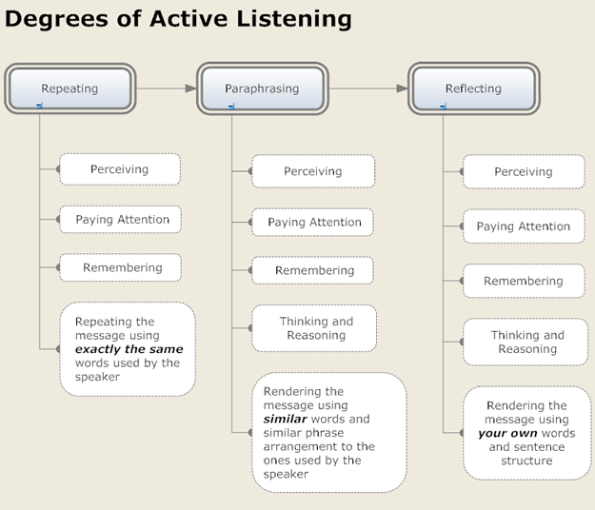

Following Directions (Listening to Instructions):
- Write your name at the upper right corner of your paper
- For the rest of these directions, start near the top of your paper. Then print the result of each new direction below the previous result.
- Print “IAMSMART”.
- Insert two “O”s after the third, the sixth, and the eighth letters, in the IAMSMART statement.
- Move the first letter so that it is between the third and fourth letters from the end.
- Insert “N” before the third letter from the end and after the first letter.
- Insert “D” before and after the first double “O”.
- Insert “C” after the third letter and at the end.
- Insert “G” before the first double “O” and after the third letter following the second double “O”.
- Insert “L” before the second double “O”.
- Remove the fourth letter.
- Change the ninth letter to “K” and move it so that it falls between the eighth and ninth letters from the end.
- Some letters appear more then once. Get rid of the third letter which does not appear more than once.
- Remove the last letter.
- Get rid of all the letters which are like the first letter (but leave the first letter).
- Get rid of the third letter and all letters which are like it.
- Write the first and last statements together.

Summary:
Key to success:
Become a more effective listener. Practice the active listening technique and make it one of your active communication skills

Recap:
- Listening VS hearing
- Listening Barriers
  - Physical Barriers
  - Psychological Barriers
  - Language Barriers
- How to overcome these barriers?
- The Process of Listening
- The Four Ears of Listeners

Activities:
- Activity 1
http://www.ets.org/toefl_junior/prepare/standard_sample_questions/listening_comprehension
- Activity 2
http://listenandwrite.com/
- Activity 3
Train 2
- Activity 3 (Quiz on Train 2)
1. Where does the man want to go?
A. Tokyo Subway Station
B. Tokyo Art Museum
C. Tokyo Tower
2. How much is the train fare?
A. 130 yen
B. 140 yen
C. 150 yen
3. Where should the man get on the train?
A. platform number 3
B. platform number 4
C. platform number 5
4. How often do the trains come?
A. about every five minutes
B. about every six minutes
C. about every seven minutes
5. Where should the man get off the train?
A. at Kamiyacho Station
B. at Kamigaya Station
C. at Kamiyama Station
- Activity 3 (Quiz on Train 2)
Answers:
1. Tokyo Tower
2. 130 yen
3. Platform number 4
4. about every six minutes
5. at Kamiyacho Station
- Activity 4
Steve Jobs Speech
- Activity 4 (Quiz on Speech)
- How many stories is Steve Jobs going to present?
  - 3
  - 4
  - 5
2. Did SteveJobs graduate from college?
  - He graduated from college.
  - He never graduated from college.
3. Where is he presenting?
  - At Yale
  - At Harvard
  - At Stanford
4. What is the first story about?
  - connecting the dots
  - love and loss
  - death
5. When did he drop out?
  - After the first 3months
  - After the first 6months
  - After the first 9months
6. Who his father and mother wanted their adopted baby to be?
  - A girl
  - A boy
  - They didn't care about it.
7. Why did he decide to drop out?
  - He wanted to go to another college.
  - He wanted to run a company by himself.
  - He didn't see the value in college.
8. What did he think about his decisions?
  - One of the best decisions
  - One of the worst decisions
  - Not a big deal.
9. After dropping out, what did he drop in (take) ?
  - Business class
  - Calligraphy class
  - Grammar class
10. What kind of typefaces did he learn in the calligraphy class?
  - Serif and semi serif
  - Serif and san serif
  - Seris and van serif
11. Which company copied the Mac?
  - IBM
  - Toshiba
  - Microsoft
12. Considering the whole content of the speech, what does the title of speech "connecting the dots" mean?
  - The outline of the project has revealed.
  - Something has been the turning point of one's life.
  - An array of events which looks like irrelevant each other becomes relevant in the end.
13. What was his biological mothers' hope when she decided to put him up for adoption?
  - Her son being adopted to parents who graduated from college.
  - Her son being adopted to parents who are very rich.
  - Her son being adopted to parents who are in the field of IT.
14. Why does Steve Jobs regard his decision, dropping out his college, as a best determination in his life considering his future career?
  - Because of that, he could enter better college.
  - Because of that, he could be employed good in company.
  - Because of that, he could make a computer which has good fonts.

References:
- www.lifeofexcellence.com
- www.listenandwrite.com
- http://www.ets.org/toefl_junior/prepare/standard_sample_questions/listening_comprehension

Chapter 9

Reading Skills

What is Reading?

Strategic VS Fluent Reading:
- Strategic Reading
      - an ability of the reader to use a wide variety of reading strategies to accomplish a purpose of reading
- Fluent Reading
      - An ability to read at an appropriate rate with adequate comprehension
      - Reading Process

Reading Process:

Interactive Approach:

You are expected to do much more reading at university than at school or college; it's not called ‘reading for a degree' for nothing.

Five Tips to Improve Reading:
  - Styles of reading
  - Active reading
  - A tip for speeding up your active reading
  - Previewing
Styles of Reading:
- Scanning: for a specific focus
  - looking up a name in the phone book
  - It's useful to scan parts of texts to see if they're going to be useful to you:
    - the introduction or preface of a book
    - the first or last paragraphs of chapters
    - the concluding chapter of a book
Examples of Scanning
  - The "What's on TV" section of your newspaper
  - A train / airplane schedule
  - A conference guide
- Skimming: for getting the gist of something
  - going through a newspaper or magazine: you read quickly to get the main points, and skip over the detail
  - to preview a passage before you read it in detail
  - to refresh your understanding of a passage after you've read it in detail
  - Use skimming when you're trying to decide if a book in the library or bookshop is right for you
Examples of Skimming
  - The Newspaper (quickly to get the general news of the day)
  - Magazines (quickly to discover which articles you would like to read in more detail)
  - Business and Travel Brochures (quickly to get informed)
  - Styles of Reading
- Detailed reading: for extracting information accurately
  - Where you read every word, and work to learn from the text
  - In this careful reading, you may find it helpful to skim first, to get a general idea, but then go back to read in detail
  - Use a dictionary to make sure you understand all the words used
- Active Reading
  - Underlining and highlighting
  - Note key words
  - Questions
  - Summaries

A Tip for Speeding Up Your Active Reading
- SQ3R Technique
    - Survey
    - Question
    - Read
    - Recall
    - Review

Previewing:
Previewing a text means gathering as much information about the text as you can before you actually read it. You can ask yourself the following questions:
  - What is my Purpose for Reading?
  - What can the Title Tell Me About the Text?
  - Who is the author?
  - How is the text structured?

Reading for Main Idea
- Reading Tips
  - As soon as you can define the topic, ask yourself “What general point does the author want to make about this topic?”
  - Most main ideas are stated or suggested early on in a reading; pay special attention to the first third of any passage, article, or chapter.
  - Pay attention to any idea that is repeated in different ways.
  - Once you feel sure you have found the main idea, test it.
  - The main idea of a passage can be expressed any number of ways. For example, you and your roommate might come up with the same main idea for a reading, but the language in which that idea is expressed would probably be different.
  - If you are taking a test that asks you to find the thesis or theme of a reading, don’t let the terms confuse you, you are still looking for the main idea.
Exercise 1
Directions:
Read the passage. Then note the letter of the statement that effectively sums up the main idea.
A number of recent books with titles like Raising Cain, Real Boys, and Lost Boys all focus on the same issue: Today’s teenaged boys are feeling more anxiety than ever before about their physical appearance. Bombarded by advertising featuring well-muscled, semi-clad young men, teenage boys are experiencing what teenage girls have been coping with for years. They are afraid that they cannot possibly live up to the media’s idealized image of their gender. Young boys below the average in height, weight, or both suffer the most. Often, they are brutally teased by their brawnier peers. Some react to the ridicule by heading for the gym and lifting weights. Yet even those who successfully “bulk up” don’t like feeling that they are considered worthless if they lose their hard-won muscle tone. Others, convinced that no amount of body building can help, often withdraw from social contact with their peers. This is their way of avoiding taunts about their size or shape. Still, they are understandably angry at being badly treated because of their body type. Although school psychologists generally recognize that boys today are having severe body image problems, they are at a loss about what to do to solve those problems.

- Exercise-1 (Main Idea)
- More than in previous generations, teenaged boys are getting into body building.
- Teenaged boys today are showing more anxiety about their physical appearance than did boys of previous generations.

Exercise 2
In 1997, the U.S. Consumer Products Safety Commission reported that skateboarding injuries were up by 33 percent. Mountain climbing injuries were also up by 20 percent. Similarly, snowboarding injuries showed an increase of thirty-one percent. By all accounts, many Americans are having a love affair with risky sports; as a result, they are injuring themselves in ever greater numbers. One reason for the growing participation in risky, or extreme, sports has been put forth by Dan Cady, a professor of popular culture at California State University. According to Cady, previous generations didn’t need to seek out risk. It was all around them in the form of disease epidemics, economic instability, and global wars. At one time, just managing to stay alive was risky, but that feeling has all but disappeared, at least for members of the privileged classes. To a degree Cady’s theory is confirmed in the words of adventure racer Joy Marr. Marr says that risk has been “minimized” in everyday life, forcing people to seek out challenges in order to prove themselves. (Source: Karl Taro Greenfield. “Life on the Edge.” Time. September 6, 1999, p.29).

- Exercise-2 (Main Idea)
- According to Professor Dan Cady if California State, many Americans yearn for the days when just staying alive was a difficult task.
- More and more Americans are taking up high-risk sports; as a result, injuries from these sports are increasing.

Strengthening your Reading Comprehension:
- Analyze the time and place in which you are reading
- Rephrase each paragraph in your own words
- Read aloud sentences or sections that are particularly difficult
- Reread difficult or complicated
- Slow down your reading
- Turn headings into questions
- Write a brief outline of major points
- Highlight key ideas
- Write notes in the margins
- Determine whether you lack background knowledge

Exercise-3
- BIG CITY NOISE

Summary:
- What is Reading?
- Strategic VS Fluent Reading
- Reading Process
  - Bottom-up Approach
  - Top-Down Approach
  - Interactive Reading
- Tips to Improve Reading Skills
- Types of Reading
- Practice

References:
- www.readtheory.org

Chapter 11

Reading Activities

What is reading comprehension?
Understanding a written text: Extracting the required information from it as efficiently as possible

What do we read?
- Novels
- Short stories
- Tales
- Essays
- Diaries
- Anecdotes
- Biographies
- Poems
- Limericks
- Nursery rhymes
- Letters
- Postcards
- Telegrams
- Notes
- Newspapers
- Magazines
- Etc

There are 2 main reasons for reading:
- Reading for pleasure
- Reading for information:
- To find out something
- To do something with the information you get

How do we read – the main ways of reading are:
- Skimming: quickly running one’s eyes over the text
- Scanning: quickly going through a text to find specific information
- Extensive reading: reading long texts
        - Reading for pleasure
- Intensive reading: reading short texts to extract information
        - Reading for detail

Skills involved when reading:
- Recognizing
- Understanding information
- Interpreting
- Transcoding information
- Scanning
- Skimming
- Identifying the main point

Developing reading skills – how to?
- Start with global understanding of the text and afterwards move towards detailed understanding:
      - Builds students’ confidence
      - Develops awareness of how texts are organized
      - Encourages to find out what is in the text
- Use authentic texts
- Do not separate reading comprehension from other skills such as writing, listening and speaking.
- Present reading is an active skill: guessing, predicting, checking, asking questions, - responding to what is read.
- Give flexible and varied exercises.
- Define the aim of the exercise given.
- Make a clear distinction between teaching and testing

What can we do in the classroom?
- Encourage silent reading to develop efficient reading strategies
  - Consider the text as a whole
  - Accompany pictures, diagrams,
  - Make guesses: what the text is about, who it is for, who wrote it, where it appeared…
  - Skim through the text to see if you were right
  - Ask questions referring to the content of the text
  - Reread the text – answer the questions asked
- The students should time themselves
  - Record their speed on a chart
- Encourage comparisons between different interpretations and discussion
  - Silent reading followed by an individual activity
  - Comparisons in pairs, groups
  - A general discussion involving the whole class

Reading comprehension exercise – types:
1. Sensitizing – develop strategies to cope with unfamiliar words and complex or obscure sentences.
- Inference – making use of syntactic, logical and cultural clues to discover unknown elements
- Understanding relations within the sentence – train to look first for the ‘core’ of the sentence: subject + verb
- Linking sentences and ideas – recognizing connectors and reference words
2. Improving reading speed
Give students passages to read and ask them to time themselves
3. From Skimming to Scanning
- Predicting – predicting or guessing what is to come next
- Previewing – specific reading technique using beyond the text information to find where the required information is likely to be
- Anticipation – causing an expectation of the text
- Skimming and scanning – from a general view of the whole text to a limited reading of the text

How the aim is conveyed?
- Function of the text – why was it written
- Organization of the text – the pattern of the text was chosen to alter the message
- Thematization -order of the elements in a sentence

Understanding meaning and content:
- Use various types of questions
- Devise exercises in which there is no simple, obvious answer
- Make the students active in the reading process
- Devise activities which are natural to the text: responding to a letter, reacting to an advertisement…

Assessing the text – the ability to evaluate the text:
- Being aware of the writer’s intention:
  - Tone
  - Language used
  - Discuss and judge the ideas presented
- Discriminating from facts and opinions

Now You Try…
With a partner, read the next story and draw a picture to represent each story part. Use just the pictures to retell the story.

“The Contest”

Reading from the picture?
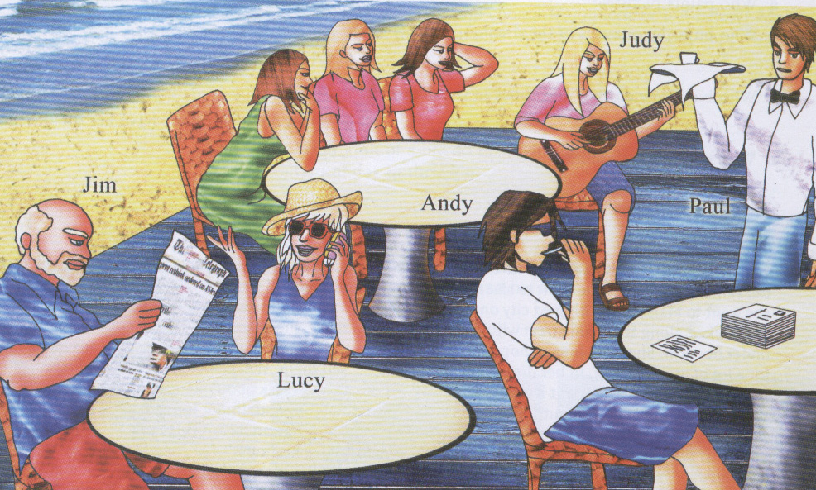

Questions?
- Who was reading the newspaper?
- Who was playing on the guitar?
- What was the waiter carrying in his hand?
- What was placed on right most table?
- Who was talking on the phone?

Activity 2
- Love Train

Activity 3
- Remains of a Marriage
- Reading Comprehension Quiz

Activity 4
- Dreams

Summary
- Reading is a constant process of guessing.
- What one brings to the text is often more important than what one finds in it.
- You must learn to use to understand unknown elements.

Chapter 12

Skimming, Scanning and Reading for the Main Idea

Recap:
- What we read?
- Why do we read; Two main reasons for reading
- Skills involved when reading:
- Recognizing
- Understanding information
- Interpreting
- Transcoding information
- Scanning
- Skimming
- Identifying the main point
- What can we do in the classroom to improve reading speed?
- Reading from the picture?
- Reading Exercises

The how to on skimming, scanning, and quick reading:
Skimming:
- Quickly identify main ideas of a text
- Skimming is 3 to 4 times faster regular reading
- Used when there is a lot of material and a short amount of time

How to Skim:
- Read the first and last paragraph
- Read headings, subheadings, titles, subtitles, and illustrations
- Read the first sentence of every paragraph
- Skimming works well with dates, names and places

Scanning:
- Used to search for key terms
- When you know what you are looking for you can through texts to find the information
- Good to use when determining whether a source will have the answers you are looking for

How to Scan:
- First look at how the author organizes his information
- Look for bold faces, italics, or different sized fonts
- The author may also put key information in the margins of pages

Skimming and scanning are especially valuable when there is only one item of information that you need to find from a Particular passage.
Skimming and scanning are very rapid reading methods in which you glance at a passage to find specific information. These reading methods make it easier for you to grasp large amounts of material, especially when you're previewing. They are also useful when you don't need to know every word.

Skimming refers to the process of reading only main ideas within a passage to get an overall impression of the content of a reading selection. An example of this is when we read the title of a newspaper to know what happens everyday.

How to skim:
- Read the title.
- Read the introduction or the first paragraph.
- Read the first sentence of every other paragraph.
- Notice any pictures, charts, or graphs. * Notice any italicized or boldface words or phrases.
- Read the summary or last paragraph.

Scanning is a reading technique to be used when you want to find specific information quickly. In scanning you have a question in your mind and you read a passage only to find the answer, ignoring unrelated information.

How to scan:
- State the specific information you are looking for.
- Try to anticipate how the answer will appear and what clues you might use to help you locate the answer. For example, if you were looking for a certain date, you would quickly read the paragraph looking only for numbers.
- Use headings and any other aids that will help you identify which sections might contain the information you are looking for.
- Selectively read and skip through sections of the passage.

Quick reading tips:
1. Prepare yourself
- Set the time length that you will read for
- Collect all your materials
- Find a comfortable place to read
- Relax and focus on what you need to accomplish
2. Overview
- Look at titles, subtitles, and headings to find what information is there
- Look at charts and pictures and relate them to subtitles
- Ask what you are going to get from the reading

3. Read during Daylight Hours
- Studies show people are most efficient readers during the day time
- A person will read a passage in half the time if they read in the daylight
- Read during breaks in you day to allot for relaxation during the night when you need rest

4. Avoid Distractions
- Keep a notebook near you to write down things that come to mind (other assignments, people to call, etc) so you can them later
- Read in place where there is nothing to distract you
- Turn off TV, music, facebook, and anything else that will break your concentration

5. Take a Break
- Studies show that reading becomes less efficient if you do not take a break to refresh your mind
- A 5 minute break is recommended for every hour of reading
- Do something well defined so it does not drag on and you do not become distracted

6. Read Often
- Reading often helps build your reading skills
- Reading at the same time everyday turns reading into a habit
- You paid for your textbooks so you might as well read them

Skim and Scan this special note in 30 seconds:
Special Note:
When you skim and scan, you need to cover everything, even titles, subtitles, side features, and visuals. That bit of information you need may not be tidily packaged in a paragraph, so you need to check the entire page--not just the main body of the text, there are also many visual clues that help you to find information. Heads and subheads break up the text and identify the content of each part. Where key terms are introduced and defined, they appear in boldface type. Graphs and charts have titles and/or captions that tell you what they are about. These clues will help you to find information but only if you use them.

SW: Skim and Scan the text:
A newly published report indicates that jogging could have adverse health effects, especially for those who do it alone. A team of researchers from Harvard University has suggested that going for a run on your own is not as healthy as previously believed and is nowhere near as beneficial as jogging as part of a group. They suggested it could actually be detrimental to one’s health. Experiments conducted on rats indicated that running alone raises stress levels and stifles brain cell regeneration. Professor Elizabeth Gould, who led the research, said: “These results suggest that, in the absence of social interaction, a normally beneficial experience can exert a potentially deleterious influence on the brain.”

The researchers monitored two groups of rats on exercise wheels. One group exercised alone, the other as part of a rodent jogging team. After two weeks, the scientists conducted tests to ascertain the rate of brain cell growth in all of the test animals. The results revealed that the communal joggers had double the amount of new brain cells as the solo runners. Professor Gould concluded that: “When experienced in a group setting, running stimulates neurogenesis (brain cell growth). However, when running occurs in social isolation, these positive effects are suppressed.” Joggers around the world should perhaps take the research with a pinch of salt and remember that jogging is healthier than the rat race.

Part 1: Skimming
- Answer the following questions using your own words but taking into account the information in the text
  - According to the text, is jogging alone beneficial for our health? Why?
  - Has this piece of research been tested on humans?
- Choose a, b or c in each question below. Only one choice is correct.
  - Some Harvard researchers claim that jogging alone
    - is not healthy.
    - is as healthy as it was thought.
    - is not as healthy as it was thought.
  - Jogging alone..
    - increases the production of brain cells.
    - increases the size of the brain. c. reduces the production of brain cells.

Part 2: Scanning
Are the following statements TRUE or FALSE? Identify the part of the text that supports Your answer.
- Jogging with rats stimulates the brain cell production: ________
Evidence:

- Jogging rats produce more brain cells if they do it in group: ________
Evidence:

Answer the following questions:
- What does Professor Gould says about the results of this experiment?
- What were her conclusions?

Let us test your reading speed!
Improving Listening Comprehension Online
http://www.execuread.com/reading-speed-and-comprehension-test-2.htm

Main Idea
- The main idea is the “big point” or the most important idea that the writer is communicating to the reader.
- Often the reader can find the main idea just by looking at the title.
- For example, a passage titled: “Why Students Should Have Less Homework” will include reasons for that idea.

What’s the Point?
Read this short paragraph:
Engineers create wealth for society. So, tennis is a game and the resources of the earth are rare. Have you gone mad? Thus the only solution is to educate the public on being socially responsible.
DID THIS MAKE SENSE?????
OF COURSE NOT!!!
- It did not have a MAIN IDEA!
- We would go crazy if texts were written like this all the time.
- It was difficult to understand because it was made of different ideas that did not link. There was no common thread.
- The good news is that normal passages have main ideas!
Main Idea:
- Main Idea - is like the heart of the text or a paragraph.
- It is the controlling idea.
- All the other supporting details in the text or within a paragraph should tell us more about the main idea.

Ask Yourself:

The Topic Sentence:
Many paragraphs have topic sentences that indicate the main idea. Find the topic sentence in the following paragraph:
Homeless people have many problems. In winter, it’s hard to stay warm and it gets too hot in summer. It’s also hard to keep things safe without a home. Worst is the lack of privacy.

Supporting Details:
Supporting details prove the value of the main idea. What are they here?
Homeless people have many problems. In winter, it’s hard to stay warm and it gets too hot in summer. It’s also hard to keep things safe without a home. Worst is the lack of privacy.

Stated and Implied Main Idea:
- Sometimes, a paragraph has a stated main idea usually in the topic sentence. This means the paragraph “says” what the main idea is.
- Sometimes, a paragraph doesn’t have a stated main idea, but has an “implied” main idea.
    - This means that you need to state the main idea in your own words because it doesn’t actually “say” it in the paragraph. Let’s take a look at two examples…

“The students had fun on their field trip. They Visited the Marine Museum. They were able to tour a tug boat and they bought souvenirs in the gift Shop. After the tours they ate a picnic lunch in the park and played with their friends.”
The underlined portion of the sentence is the main idea and is stated for the reader.

“The Native Americans used the trees to build their houses. They hunted and trapped animals in the forest for food. They found roots and berries that they could eat. Some plants found in the forest were used for medicine.”
In this paragraph, the main idea isn’t stated. However, by reading the paragraph, the reader can determine the main idea:
- Native Americans used resources in the forest to survive.

Too much information:
- All of the sentences in a paragraph should support the main idea of that paragraph.
- Information that does not support the main idea does not belong in the same paragraph.
- Take a look at the example on the next slide. Find the “extra” information that does not support the main idea…

“Maria offered to help her mother clean the house. She vacuumed the living room and dusted the furniture. She picked up the toys in the playroom. She ate a ham sandwich for lunch. Then, she mopped the kitchen floor.”
Which sentence does not support the main idea?

Find the sentence that does not support the main idea:
“Winter provides the opportunity for many outdoor activities. Many people enjoy ice skating on a pond. Swimming in the pond in summer can also be fun. Skiing can be a thrilling experience too. After a new snowfall, you can even build a snowman!”

“The rain forest is home to many creatures. Monkeys, toucans and macaws live in the rain forest. Butterflies and anteaters also live in the rain forest.”
What is the main idea?
A) Sloths and tapirs are other creatures that live in the rain forest.
B) The rain forest is home to many creatures.
C) Monkeys, toucans and macaws live in the rain forest.

“Soccer players learn many skills when playing soccer. Soccer players learn how to dribble and pass the ball. They also learn how to control the ball so they can eventually score. Most importantly, soccer players learn how to work together with their teammates.”
What is the main idea?
A) They also learn how to control the ball so they can eventually score.
B) Soccer players learn how to dribble.
C) Soccer players learn many skills when playing soccer.

Swimming is one thing that can be done at the beach. Snorkeling is another thing that can be enjoyed. Playing beach volleyball can be a lot of fun. It is also fun to look for shells. Some people simply like to sunbathe.”
What is the implied main idea?

Now write your own paragraph about a topic that interests you. Underline the main idea sentence. If you have extra time, add an illustration.

Summary:
- Skimming
- Scanning
- Tips for Quick Reading
- Reading for main idea
- Activities

References
- www.reslife.net/assets/docs/Speed_Skim_and_Reading.ppt
- www.worlduc.com/UploadFiles/.../scanning_and_skimming.ppt
- schools.nashua.edu/.../Main%20Idea%20and%20Supporting
- http://www.readingdynamicsrsa.com/speedtest.htm

Chapter 13

Writing Skills

Writing Skill:
- Writing skills are an important part of communication.
- This is a Productive Skill.
- Good writing skills allow you to communicate your message with clarity and ease to a far larger audience than through face-to-face or telephone conversations.

Before Writing you should know?
- Who is the audience?
- What format is required – essay or report or reflection on experience?
- Styles of writing–
  - writing in a logical and `objective’ way
  - writing from personal experience
- Academic conventions – referencing and plagiarism

Formal and Informal Writing:

Formal Writing Style:
- Complex
  - Longer sentences are likely to be more prevalent in formal writing.
  - You need to be as thorough as possible with your approach to each topic when you are using a formal style.
  - Each main point needs to be introduced, elaborated and concluded.
- Objective
  - State main points confidently and offer full support arguments.
  - A formal writing style shows a limited range of emotions and avoids emotive punctuation such as exclamation points (!), ellipsis (…) etc., unless they are being cited from another source.
- Full Words
  - No contractions should be used to simplify words (in other words use "It is" rather than "It's").
  - Abbreviations must be spelt out in full when first used, the only exceptions being when the acronym is better known than the full name (BBC, or NATO for example).
- Third Person
  - Formal writing is not a personal writing style.
  - The formal writer is disconnected from the topic and does not use the first person point of view (I or we) or second person (you).
- Process
  - Formal writing follows writing techniques.
  - It follows a writing process.
  - Material is organized on a set pattern.
Informal Writing Style:
- Colloquial
  - Informal writing is similar to a spoken conversation.
  - Informal writing may include slang, figures of speech, broken syntax and so on.
  - Informal writing takes a personal tone as if you were speaking directly to your audience (the reader). You can use the first or third person point of view (I and we), and you are likely to address the reader using second person (you and your).
- Simple
  - Short sentences are acceptable and sometimes essential to making a point in informal writing.
  - There may be incomplete sentences or ellipsis (…) to make points.
- Contractions and Abbreviations
  - Words are likely to be simplified using contractions
    - for example, I’m, doesn’t, couldn’t, it’s
    - Abbreviations (e.g. TV, photos) whenever possible.
- Empathy and Emotion
  - The author can show empathy towards the reader regarding the complexity of a thought and help them through that complexity.

Writing Effectively
Conciseness:
- Avoid redundant categories
  - Same idea repeated
- Unnecessary clause
- Unnecessary construction
- Awkward repetition
Revising for Conciseness:
- Example 1:
  - ORIGINAL: The reason buying a new house is so difficult because the process is so complex.
  - PROBLEM: Redundancy – “reason… is because”
  - REVISED: Buying a house is so difficult because the process is so complex.
- Example 2
  - ORIGINAL: A realtor who is experienced and well recommended is a must.
  - PROBLEM: Unnecessary clause.
  - REVISED: An experienced, well- recommended realtor is a must.
- Example 3
  - ORIGINAL: It is when you can find a fixed-interest advance loan with single-digit interest that you should lock it in, rather than settling for a variable rate loan.
  - PROBLEM: Unnecessary expletive construction.
  - REVISED: When you can find a advance loan with a single-digit fixed rate, you should lock it in, rather than settling for a variable rate loan.
- Example 4
  - ORIGINAL: Don’t forget that your down payment is only one part of your closing costs. Closing costs may also include having the home inspected, prepaying a year’s worth of taxes in advance, insuring the house and even having the property surveyed.
  - PROBLEM: Awkward repetition. Revise by combining sentences and reducing phrases to single words.
  - REVISED: Don’t forget that your down payment is only one part of your closing costs, which may also include having a home inspected, prepayment of taxes, home insurance and even a survey.

Revising for Coordination or Subordination:
Focus on identifying and correcting problems of:
  - Coordination
  - subordination
- Example 5
  - ORIGINAL: Joan was 35 and she had not lost her taste for learning and she wanted to finish her degree.
  - PROBLEM: Excessive coordination, unclear relationships among ideas.
  - REVISED: Although Joan was 35, she had not lost her taste for learning and wanted to finish her degree.
- Example 6
  - ORIGINAL: She had a few early successes, but she felt she could do it after all.
  - PROBLEM: Illogical coordination.
  - REVISED: When she had a few early successes, she felt she could do it after all.
- Example 7
  - ORIGINAL: Her family transformed itself into a support system. She wondered how single people could manage the workload by themselves.
  - PROBLEM: Unclear - Subordination would make the connection betweenideas clearer.
  - REVISED: As her family transformed itself into a support system, she wondered how single people could manage the workload by themselves.

Revising for Parallelism:
Focus on identifying and correcting problems of parallelism
- Example 8
  - ORIGINAL: My father’s boss, losing histemper, lashed out at my father and my father quit after running out of patience.
  - PROBLEM: Unclear - Use parallel construction to emphasize the contrast.
  - REVISED: My father’s boss, losing his temper, lashed out at my father and my father, losing his patience, quit.
- Example 9
  - ORIGINAL: He had lost his job, but his sense of identity was also gone.
  - PROBLEM: Improper conjunction – Need to use correlative conjunctions and parallel form.
  - REVISED: He had lost not only his job, but also his identity.

Writing Exercise:
Vincent Van Gogh’s First Steps
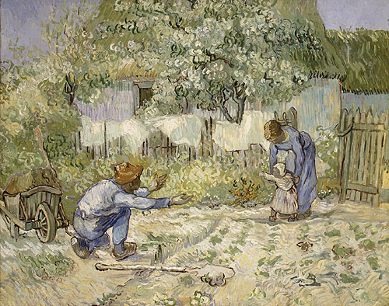

First Steps: Writing as Process Exercise:

Planning and Shaping

Drafting:
- Draft a paragraph that leads up to the climactic moment of this child’s first steps.
- Establish the setting, then focus on the adults, then the child, then the actual first step.
- Try to capture the parents’ excitement.
Revising:
- Include at least one of each of the following sentence types:
  - simple, compound, complex.
- Include a cluster of at least three longer sentences (20+ words) followed by a very short sentence (<8 words).
- Include at least two sentences describing visual parallels or contrasts using parallel structures.
- Include a sentence in which the subject and verb are held for last - the sentence in which the first step occurs.
Editing:
- Reread your paragraph, checking for correctness of sentence structure, grammar, spelling, and punctuation.
- Make any necessary changes.
Discussion:
- Compare the two paragraphs you have written.
- Which one does a better job of capturing the excitement of the moment?
- Why?
Summary:
- Writing Styles
  - Formal writing
  - Informal Writing
- Writing Efficiently
  - Conciseness
  - Coordination and Subordination
  - Parallelism
- Writing Exercise
References:
- http://www.skillsyouneed.co.uk/writing_skills.html
- Pearson Prentice Hall 2003

Chapter 14

The Writing Process

During our review of the writing process:
Make sure to keep your work organized in your writing folder.

Topic Highlights:
- The three Writing Stages
  - Pre-writing
  - Writing
  - Re-writing
- Exercise

Three Stages of the Writing Process:

- Pre-writing - Planning
- Writing - Drafting, Editing, Revising
- Re-writing - Finishing

Prewriting:

- The first stage of the writing process is a time of discovery – you unearth ideas.
- Prewriting can condense swirling mists of thoughts into words on paper.
- You uncover raw material to shape and polish later.
- There is no need to think about order or correctness.
- The objective is to produce as many ideas as possible.

Free writing:
- Free writing is uncensored writing, often in sentence form.
- Free writing enables anyone to start writing immediately.
- To write free, just empty whatever bits and pieces of ideas are in your mind out onto the paper.

Brainstorming:
- Brainstorming captures ideas as they flit by, either as words, phrases, or fragments.
- You can use this technique in a group or alone.
- The secret of success in brainstorming is to think fast.
- In brainstorming, all ideas are respected and recorded, no matter how wild.

List Making & Scratch Outlining on Computer:
- List making can be an advantage when you know so much about a topic you feel overwhelmed.
- Lists often have no apparent order. When you start placing ideas in order, you are beginning a scratch outline.
- This primitive outline is simply a revised list that herds ideas into a tentative order.

Questioning:
- To use questioning at its best, try projecting yourself into the role of a reporter.
- What questions could you ask to elicit information from other people?
- The traditional “five W’s and H” (who? What? When? Where? Why? How?) can be expanded to full-fledged questions:

Full-Fledged Questions:
- Who was involved?
- What happened?
- When did it happen?
- Where did it happen?
- Why did it happen?
- How did it happen?
- What will be its effect?
- What can be learned?
- What is the subject like or unlike?
- How has it changed over time?

Keeping a Journal:
- Some instructors require that students keep a journal to store reactions to essays, fiction, and poetry or other ideas for writing.
- Journals are also useful for recording observations, impressions, and incidents when you conduct firsthand research.

Writing:
Drafting…
  - Are my thoughts organized?
- Do I stick with the same idea throughout my writing?
- Do I know what order I want to say things in?
  - Did I skip lines?
- This will allow room for yourself and others to make corrections.
  - Did I label everything?
- Headings
- All page numbers etc.
  - Have I used complete sentences?
- All of my thoughts are complete.
- There are no run-ons.
  - Are my language conventions correct?
- Spelling
- Punctuation
- Grammar
  - Have I had at least two people edit my paper?
- Choose two people in the classroom that are on the editing stage. If no one is, you may choose to look over your work again. You may also write in your journal if you cannot find someone to edit your work.
  - Editing others work…
- Make sure to check for the same items you did when editing your own work.
      - Check for complete sentences, check the language conventions, and use editing marks for corrections
- Insert
- Indent/shuffle
- Check spelling
- Delete
- Capitalize
- Your writing has come a long way. After fixing the error you may either choose to type your writing or hand write it on paper.

RE-WRITING:

Typing your work…
  - Sign up for a time to get on the computer.
  - Be sure to reread your work. Spell check is not always reliable.
  - Look in your writing folder for requirements when typing your work.

Handwriting your work…
  - If you are given a certain type of paper to write on, make sure you have it.
  - There should be no errors in your work. Erase all mistakes so that you cannot see them.
  - Use your best handwriting.
  - Be sure to reread your work before turning it in.
  - You may also type your work if you would like.
- What you write and how you write are very important.
- Take the necessary time to revise, edit, and proofread your writing.
- Students often prepare a draft and then submit it.
- You MUST take the time to revise, edit, and proofread your writing!

COMPARISON:
- Reread the paragraph you wrote without going through the process and compare it to the “processed” one.
- How do they differ?
- Which one is better?
- If the “processed” paragraph is better, which phase of the process helped you most?

GRANT WOOD’S AMERICAN GOTHIC:
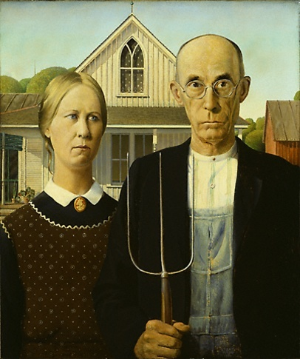

AMERICAN GOTHIC: WRITING AS PROCESS EXERCISE:
- Look carefully at the picture provided of American Gothic, the famous painting by artist Grant Wood (1892-1942). Notice the details and mood of the composition.
- Prepare to use the four process steps to write about the painting:
  - Planning
  - Drafting
  - Editing
  - Revising
  - Finishing

PLANNING AND SHAPING:
- Use single words or phrases to describe the following aspects of the painting:
  - Background/ sky/ house/ shed
  - People/ facial expressions/ hair/ eyes/ hand
  - How are the people similar? Different? What is their relationship to each other?
- Review your list of details.
- Answer this question in a single complete sentence:
  - What central impression do the details seem to convey?

DRAFTING:
- Write your sentence out at the top of a new sheet of paper.
- Write a draft of a paragraph supporting your sentence.
- Include as many details from your list as you can.

REVISING:
- DETAIL: How have the details you mentioned help create the central impression of the painting?
- ORGANIZATION: Is your paragraph organized? Coherent? Does it support your core sentence?
- WORD CHOICE: Are your words precise? Replace any fuzzy words with more precise ones.
EDITING:
- Review your paragraph for correctness of sentence structure, grammar, spelling and punctuation.
- Make any necessary changes.

Remember, Writing is a Process:
- Every writing assignment is practice for the next one
- Writing takes time
- Go through every step of the process
- Focus on your ideas first
- Focus on grammar and spelling last
- Get feedback from a peer, instructor, or tutor

Summary:
- We will not exhaust every aspect of writing Process
- We will focus on the overall process of writing
- We will not focus on rules
- We will instead focus on strategies

References:
- Alisa Cooper, South Mountain Community College
- Technical Writing Skills by Gerson and Gerson, Edition-III

Chapter 15

Writing Skills

Topic Highlights:
- What is Paragraph?
- Examples of Paragraph writing
- What is Essay?
- What makes a good essay?
- Dos and Don'ts
- How to Write an Essay?
- Essay Format

Paragraph Writing:
- Definition
- Unity
- Topical Sentence
- Supporting Details
- Relevant Exercises

What is a paragraph?
- It is a group of sentences that introduces, presents and develops one main idea about the topic.
- It can be divided into three major parts.
      - Topic Sentence (Beginning)
      - Supporting Details (Middle)
      - Closing Sentence (End)

a) The Topic Sentence:
- Normally the first sentence of the paragraph
- Conveys the overall point of view of the paragraph
- Helps the writer focus on the idea written about
- Helps the reader know about what the paragraph is all about

b) The Supporting Details
- Sentences used to support the main idea stated in the topic sentence
- Provide information about the main idea through examples
- Provide clear evidence that what the topic sentence says is trustworthy
- Strong convincing points on which the topic sentence can rely upon

c) The Concluding Sentence
- Reflection of the main idea pronounced in the topic sentence
- Sums up what the topic sentence and the supporting details talk about
- Closing sentence reminds the readers of what they have to value
- It is compulsory for the completion of the paragraph unity
- Indicates the end of a paragraph
- Prepares the reader for a smooth transition to the next paragraph if there is one

Example: 1 TOPIC SENTENCE
SUPPORTING DETAILS
CLOSING SENTENCE
There are three reasons why Canada is one of the best countries in the world. First, Canada has an excellent health care system. All Canadians have access to medical services at a reasonable price. Second, Canada has a high standard of education. Students are taught by well-trained teachers and are encouraged to continue studying at university. Finally, Canada's cities are clean and efficiently managed. Canadian cities have many parks and lots of space for people to live. As a result, Canada is a desirable place to live.
Example: 2 TOPIC SENTENCE
SUPPORTING DETAILS
CLOSING SENTENCE
I don't like tests. Every time I take a test, I feel nervous. When I study for a test, I don't know if I will be able to get a good grade. Often I worry about taking a test and can't sleep. Sometimes I daydream or draw pictures in class. After the test is over, I worry about my grade. When my teacher gives the test back to me with a grade, I still can't relax because I know I will have another test soon. Tests give me a lot of stress that is why I don't like tests.

Example: 3 TOPIC SENTENCE
SUPPORTING DETAILS
CLOSING SENTENCE
Cats are good pets. You don't have to take a cat for a walk every day like a dog. You do not have to wash cats because they know how to clean themselves. If you want to go on vacation, you can leave some food and water for your cat and it will be okay. A cat can sleep on your bed and keep you warm at night. I think these things make cats good pets.

Paragraph Writing Exercise:

Q. Write an excellent paragraph on the following topic on a separate sheet of paper.
Topic: Friendship
- Remember:
  - Make sure your paragraph has a topic sentence.
  - Make sure you provide at least 3 sentences that support your main idea.
  - Make sure you have a closing sentence.
  - Check that all your sentences focus on the main idea.
★ Circle your topic sentence. Number your supporting details. Underline the conclusion.

EssayWriting:

What is an Essay?
- An essay is an organized collection of your thoughts on a particular topic.
- An essay consists of three major parts:
          - Introduction
          - Main body
          - Conclusion
- The word “essay” is derived from the Latin verb “exigere”, which means to:
  - Examine
  - Test
  - Drive out
  - What could the purpose of an essay be given this definition?

What makes a good essay:
- Good structure:
  - clear introduction
  - well crafted middle
  - clear and appropriate conclusion
- Clear argument:
  - progression through ideas with clear indication
- Well supported by relevant evidence
- Well written:
  - grammatical;
  - correct spelling and punctuation;
  - good sentence structure
  - paragraphing and use of linking words and phrases
  - Fully referenced using Harvard system
Assessing your Work against an Example Essay:

- Read any essay and comment critically on the structure and organisation. Identify strengths and weaknesses.
    - Is there a clear introduction to guide the reader?
    - Are key concepts clearly communicated?
    - Does the writing progress/have a sense of direction?
    - Is there a clear and appropriate conclusion?
DOS & DONTS:

DOS
- Prepare well in advance
- Write a first draft, leave and come back to it later
- Keep your focus on the question
- Edit carefully for sense, spelling, grammar and punctuation

DONTS
- Write all you know about a topic
- Leave till the last minute

How to write an Essay:

- An essay can have many purposes, but the basic structure is the same no matter what.
- E.g. You may be writing an essay to argue for a particular point of view or to explain the steps necessary to complete a task.
  - Either way, your essay will have the same basic format.
- If you follow a few simple steps, you will find that the essay almost writes itself. You will be responsible only for supplying ideas, which are the important part of the essay anyway.
Don't let the thought of putting pen to paper daunt you. Get started!

Essay Format:
These simple steps will guide you through the essay writing process:
- Decide on your topic.
- Prepare an outline or diagram of your ideas.
- Write your thesis statement.
- Write the body.
- Write the main points.
- Write the subpoints.
- Elaborate on the subpoints.
- Write the introduction.
- Write the conclusion.
- Add the finishing touches.

Choosing a Topic:
You may have no choice as to your topic. If this is the case, you still may not be ready to jump to the next step. Think about the type of paper you are expected to produce. Should it be a general overview, or a specific analysis of the topic? If it should be an overview, then you are probably ready to move to the next step. If it should be a specific analysis, make sure your topic is fairly specific. If it is too general, you must choose a narrower subtopic to discuss.
For example, the topic "KENYA" is a general one. If your objective is to write an overview, this topic is suitable. If your objective is to write a specific analysis, this topic is too general. You must narrow it to something like "Politics in Kenya" or "Kenya's Culture”.
Once you have determined that your topic will be suitable, you can move on.

Writing Your Outline:
- Begin your outline by writing your topic at the top of the page.
- Next, write the Roman numerals I, II, and III, on left side of the page.
- Next to each Roman numeral, write the main ideas that you have about your topic, or the main points that you want to make.
    - If you are trying to persuade, you want to write your best arguments.
    - If you are trying to explain a process, you want to write the steps that should be followed.
    - If you are trying to inform, you want to write the major categories into which your information can be divided.
- Under each Roman numeral, write A, B, and C down the left side of the page.
- Next to each letter, write the facts or information that support that main idea.
- When you have finished, you have the basic structure for your essay and are ready to continue.

Composing a Thesis Statement:
- The thesis statement tells the reader what the essay will be about, and what point you, the author, will be making.
  - You know what the essay will be about.
  - That was your topic.
  - Now you must look at your outline or diagram and decide what point you will be making.
  - What do the main ideas and supporting ideas that you listed say about your topic?

Writing the Body Paragraphs:
- The topic you have chosen must now be:
  - explained
  - described, or
  - argued.
- Each main idea that you wrote down in your diagram or outline will become one of the body paragraphs.
- If you had three or four main ideas, you will have three or four body paragraphs.
  - Each body paragraph will have the same basic structure of writing a paragraph

Write the Introduction and Conclusion:
Your essay lacks only two paragraphs now: the introduction and the conclusion. These paragraphs will give the reader a point of entry to and a point of exit from your essay.
Don't stop just yet! One more step remains before your essay is truly finished.

Conclusion:
- The conclusion brings closure to the reader, summing up your points or providing a final perspective on your topic. All the conclusion needs is three or four strong sentences which do not need to follow any set formula. Simply review the main points (being careful not to restate them exactly) or briefly describe your feelings about the topic. Even an anecdote can end your essay in a useful way. The introduction and conclusion complete the paragraphs of your essay.

Add the Finishing Touches:
- You have now completed all of the paragraphs of your essay.
- Before you can consider this a finished product, however, you must give some thought to the formatting of your paper.
  - Check the order of your paragraphs.
  - Check the instructions for the assignment.
  - Check your writing.

Once you have checked your work and perfected your formatting,
your essay is finished.
Congratulations!

Formal Writing Rules:
- Do not use the first or second person (I, my, we, us)
- Do not use contractions (can’t, won’t, doesn’t)
- Do not use metaphors or figures of speech
- Avoid saying “The essay will discuss...” or “In my opinion...”
- Avoid using “a lot”. If you do use it, take care not to repeat it often.
- Avoid redundancy and repetition.
- Be specific. Do not be vague. Do not use words such as “things” or “many examples”.
- Always follow MLA format
- Font Style: Use size 12 pt font, Times New Roman, and standard 1” margins
- EDIT, EDIT, EDIT!
- Save your rough work.
- When writing about literature, always write in the present tense.
- I.e. “The Hamletis a novel of Shakespeare” not “The Hamlet was a novel of Shakespeare”.
- Essays should be submitted with one staple in the top left hand corner. Do not put them in folders.

MLA Format:
- Essay written in 12 pt font, 1” margins
- No separate title page. In the top left corner of the first page of your essay, write:
    - Your Name
    - Teacher’s Name
    - Course Code
    - Date Submitted
    - Double spaced
- Put your last name and page number in the top corner of each page after the title page.
- Italicize the title of the novel (if any)
- When using quotes, reference the page number in the following way:
- First quote, use the author’s name in the reference.
- “I didn't even notice then that it had more than the usual number of toes” (Wyndham 6).
Second quote from the same source, no need for the author’s name.
- “I didn’t even notice then that it had more than the usual number of toes” (6).
- Submit a Works Cited page to show the resources that you have quoted from in your essay.

The format for the Works Cited:
- Write Works Cited centered at the top of a new page. (Ensure your last name and the page number are still included in the top right corner.)
- Each entry in the works cited should be in alphabetical order according to the author’s last name.
- Last name, First name. Title of Book. City published: Publisher, Year.

References:
- www.worldofteaching.com

Chapter 16

Writing Paragraphs

Recap:
- What is Paragraph?
- Examples of Paragraph writing
- What is Essay?
- What makes a good essay?
- What is Précis?
- Technical Writing:
  - Email
  - Letter
  - Memorandum
  - Resume/CV
  - Email
- Dos and Don'ts
- Formal Writing Rules

Warm-Up:
- One partner closes his/her eyes.
- The other partner chooses an object.
- Describe the object to the other person WITHOUT mentioning the name of the object.
- The person with eyes closed can only say, “I need more details!” until they can guess what the object is.

Paragraphs:
- What is a paragraph?
- A paragraph is a group of sentences that develops an idea.
- The first sentence of a paragraph should be indented.
- The sentences in the paragraph support and give examples of the main idea.

Paragraphs: A Bad Example:
I live in a house in west Provo. I like the view from our house. We have lived there since November. We also have a car that I like very much. We were in an accident a few months ago. We hit a deer that was crossing the street at night. I felt sorry for the deer, but it cost a lot of money to repair the car.

Paragraphs: A Good Example:
My husband and I bought our first house last November, and we love it. It is located in west Provo near Utah Lake. Although we cannot see the lake from our house, we do have a beautiful view of Mount Timpanogos. Our house has three bedrooms, two bathrooms, a living room and a family room, and a large kitchen and dining area. We also have a large backyard and a small garden. We are very happy to own our own home, and I hope that we will live there for several years.

How to Wrıte a Well Organızed Paragraph?
The Writing Process:
The Writing Process is a method that helps you get started writing and helps you organize your ideas.

Thınkıng
Before you begin to write you need to think about what you are going to write.
- Then you need to organize your ideas.
- When you have organized your ideas, you write your first draft.
- After that, you revise and improve your writing.
- Finally, you edit your first draft and write the final draft.

The Three Steps in the Writing Process:
- Pre-writing: Think of ideas
  - Planning: Organize your ideas
- Drafting: Write the first draft
- Revising and Editing: Improve your writing

1. Pre-writing
Before you begin to write, you need to think of ideas to write about.
Four Ways To Organıze
Sometimes it is difficult to think of things to write about. There are four common ways to help you think of new ideas:
- Brainstorming
Example
Here is an example of what an office worker wrote when he brainstormed about the topic Daily Routine:
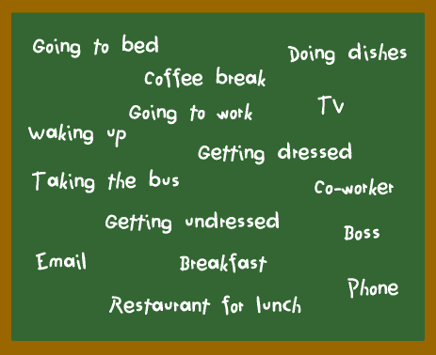
- Clustering
- Clustering is similar to brainstorming.
- You try to think of many words and phrases.
- When you make a cluster map, you write the words and phrases in groups.
Example:
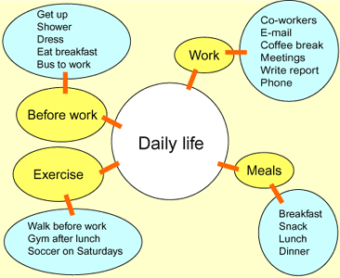

Write the topic in the centre of your page, inside a circle.
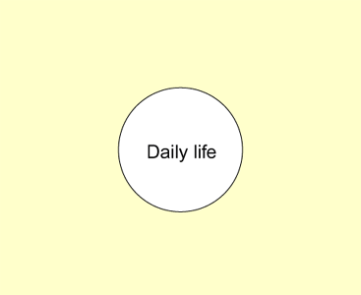
Write general ideas about the topic around the circle.
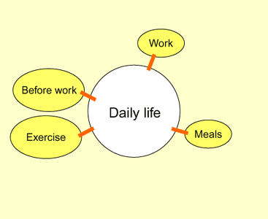
Write more ideas about each general idea

- Making Lists/ outlining
- Making lists is a way to think of new ideas.
- When you make a list, try to think of ideas in an organized way.
    - For example, you can make a list of actions, a list of places, a list of people.
Example:
Here is an example of three lists about daily routine:
- Actions
  - Wake up
  - Get up
  - Shower
  - Get dressed
  - Eat breakfast
  - Brush teeth
  - Take the bus
  - Buy coffee
- Places
  - Bedroom
  - Bathroom
  - Kitchen
  - Bus stop
  - Coffee shop
  - Office building
- People
  - Bus driver
  - Waitress
  - Co-worker
  - Boss
  - Customer
  - Friend

- Asking Yourself Questions
Asking yourself questions is another way to think of new ideas. When you answer the questions, you think of ideas.
Here is an example of some questions about daily routine :
- QUESTIONS:
- When do I get up?
- What do I do in the morning?
- When do I go to work?
- What do I do at work?
- When do I have lunch?
- Where do I have lunch?
- When do I go home from work?
- How do I get home from work?
- What do I do after work?
- What do I do in the evening?
- When do I go to bed?

Paragraph Structure:
A paragraph should have a logical structure that is easy to put into an outline:
I. Topic Sentence
II. Supporting Detail
III. Supporting Detail
IV. Supporting Detail
V. Concluding Sentence

Practicing with Paragraphs:
- Find one of your warm-up writings in your notebook.
- Choose one idea from your writing and create an outline for a well-structured paragraph using this idea.
- Write the paragraph.

Topic Sentences:
- A topic sentence is the sentence that tells the reader the main idea of the paragraph.
- The topic sentence should contain only one main idea. It should be specific and detailed.
- The topic sentence is often found at the beginning of the paragraph, but it can be in other places, too.

Topic Sentences: Good Examples:
- When I was a child, I lived in a house that had a strange atmosphere.
- There is a canyon in Northern Arizona that is the most beautiful place on Earth.
- My favorite item of clothing is a comfortable, worn pair of jeans that I have had for many years.

Topic Sentences: Bad Examples:
- I went to the Grand Canyon this winter and to Mexico in the spring of 1994.
- My friend is nice.
- I like my bedroom.

Practice with Topic Sentences:
Write a topic sentence for each of the following topics:
A) Your favorite possession
B) An interesting person you know
C) A beautiful place

Writing a Five Sentence Paragraph:
- Begin with a topic sentence:
  - State what the paragraph is about, the topic.
  - Make it interesting.
  - Be sure to indent!!!!!!
- Example:
“Last summer my family went on an amazing picnic in a park” is the topic of this paragraph.

Write three detail sentences:
- Each sentence should tell about the topic.
- Use good describing words and interesting action words.
- Example:
Last summer my family went on an amazing picnic in a park. We brought freshly made ham sandwiches, apple pie and ice cold lemonade. While we enjoyed our picnic lunch under a tree, a small gray squirrel crawled close to us. Suddenly this squirrel grabbed my delicious piece of pie off my plate and scurried off.

Ending sentence:
- Restate the topic of the paragraph.
- Keep it interesting.
- Make it a closing sentence so your reader knows this is the end of the paragraph.
- Example:
Last summer my family went on an amazing picnic in a park. We brought freshly made ham sandwiches, apple pie and ice cold lemonade. While we enjoyed our picnic lunch under a tree, a small gray squirrel crawled close to us. Suddenly this small squirrel grabbed my delicious piece of pie off my plate and scurried off. We couldn’t believe this hungry squirrel had invited himself to our family picnic!

Let’s Review:
- Write an interesting topic sentence that is indented.
- Write three detail sentences that are about the topic.
- Write a closing sentence that restates the topic.
Now you are ready to write an incredible five sentence paragraph!

What is a Paragraph?
- A paragraph is a group of sentences that tells about one subject or area.
- Each sentence in a paragraph must give information about the topic

Reasons to Write a Paragraph
- Describe something
- Tell a story
- Explain something
- To Persuade

Parts of a Paragraph:
- Topic sentence: States the main idea of the paragraph. It tells the reader what the paragraph will be about. A good topic sentence does two things: 1. It names a subject 2.) It give the focus or main point
Ex: Subject: Egypt Main Focus: Religion
Ex: Subject: Egyptian Religion Main Focus: Gods
- Supporting Details: Sentences that are connected to the main idea. They include information or details the reader needs in order to understand the topic. Sentences should be ordered in the best possible order. 3 main ways to do this is either by time, location or importance.
- Closing: Sums up the paragraph’s message. It reminds the readers of the topic.

Think of a good topic sentence for this set of details:
- Penguin Moms lay the eggs and afterwards leave to get food for 2months.
- Penguin dads incubate the egg until it hatches.
- They take turns caring for their chick and feeding in the sea.
- Once the egg hatches, the young stay sheltered in the pouch of the mother while the father brings food.

Student Examples of Topic Sentences:
- Mother and father penguins both take care of their young.
- Mother and father penguins play a very important role in raising their young.
- Penguin mom and dads are very good parents.
- Penguin parents are very protective of their young and I will show you how.

Paragraph Details:
- Topic Sentence:
Arizona has been thinking about extending the school year from May to June, but I think that they should not extend the school year.

Examples
Some details in this paragraph might be about…
  - Why Arizona is extending the school year
  - When they plan to extend the school year
  - Reasons why it is a bad idea

Think of a Closing Statement for this paragraph:
Egypt is most famous for their pyramids. There are over 100 pyramids in Egypt but that information is unknown to many people. The most popular and well known pyramids are the Pyramids of Giza. They are located in Cairo. Pyramids were tombs for pharaohs. To complete the pyramids, workers hauled and lifted millions of limestone blocks that weighed an average of 2 and 1/2 tons each. They didn’t have iron tools or wheeled vehicles. The workers carried each stone by hand, pulled them on sleds, and lifted them up mud ramps to be placed on the slowly rising structure.
- Examples of Closing Statements
  - Now we are glad that the Egyptians worked so hard so that we can admire the beauty.
  - The pyramids have been standing in Egypt for a long time, and they still stand for people to see.
  - You can see why the Egyptian would be proud of all this hard work.
  - We hope that someday scientist will be bale to figure out how Egyptians built these ancient structures.

Transitions:
Help your paragraphs flow together. They link ideas so that they relate to one another.

Summary:
- What is a Paragraph?
- Paragraph structure
- How to write a well organized paragraph?
- Examples

References:
- www.cape.k12.mo.us
- teacherweb.com/KY/NorthMiddleSchool/.../Writing-Paragraphs.ppt
- www.slideshare.net/biruterichardson/writing-paragraphs-1ppt
- http://bonny-kate-es.knox.k12tn.net/cavewebpage/prgrph.html

Chapter 17

Essay Writing

Recap:
- What is a Paragraph?
- Paragraph structure
- How to write a well organized paragraph?
- Examples

What is an Essay?
An essay is an organized collection of your thoughts on a particular topic. An essay consists of three major parts:
        - Introduction
        - Main body
        - Conclusion

Writing Process:
- Pre-writing Stage
  - Pre-writing
  - Free-writing
  - Note keeping
  - Brain storming
  - Mind Mapping
- Writing Stage
- Re-writing

Essays can be either:
  - Long or Short
  - Serious or Humorous
  - Formal or Informal
  - Can describe your opinions or be a synopsis of expert opinions.

Writers use essays to:
- Describe or define a subject (What is an Essay?)
- Compare related items in a subject (The Difference Between Apples and Oranges)
- Show cause and effect (If You Write It, They Will Read)
- Write a narrative (My Summer Vacation)
- Explain a process (How to Write an Essay)
- Deliver an argument (The Case Against Essay Questions)
- Critique (My Least Favorite Movie)

How to write an Essay?
- An essay can have many purposes, but the basic structure is the same no matter what.
- E.g. You may be writing an essay to argue for a particular point of view or to explain the steps necessary to complete a task.
  - Either way, your essay will have the same basic format.
- If you follow a few simple steps, you will find that the essay almost writes itself. You will be responsible only for supplying ideas, which are the important part of the essay anyway.
Don't let the thought of putting pen to paper daunt you. Get started!

Essay Format:
These simple steps will guide you through the essay writing process:
- Decide on your topic.
- Prepare an outline or diagram of your ideas.
- Write your thesis statement.
- Write the body.
- Write the main points.
- Write the sub points.
- Elaborate on the sub points.
- Write the introduction.
- Write the conclusion.
- Add the finishing touches.

Choosing a Topic:
You may have no choice as to your topic. If this is the case, you still may not be ready to jump to the next step. Think about the type of paper you are expected to produce. Should it be a general overview, or a specific analysis of the topic? If it should be an overview, then you are probably ready to move to the next step. If it should be a specific analysis, make sure your topic is fairly specific. If it is too general, you must choose a narrower subtopic to discuss.
For example, the topic "KENYA" is a general one. If your objective is to write an overview, this topic is suitable. If your objective is to write a specific analysis, this topic is too general. You must narrow it to something like "Politics in Kenya" or "Kenya's Culture”.
Once you have determined that your topic will be suitable, you can move on.

Organizing Your Ideas:

Writing Your Outline:
- Begin your outline by writing your topic at the top of the page.
- Next, write the Roman numerals I, II, and III, on left side of the page.
- Next to each Roman numeral, write the main ideas that you have about your topic, or the main points that you want to make.
    - If you are trying to persuade, you want to write your best arguments.
    - If you are trying to explain a process, you want to write the steps that should be followed.
    - If you are trying to inform, you want to write the major categories into which your information can be divided.
- Under each Roman numeral, write A, B, and C down the left side of the page.
- Next to each letter, write the facts or information that supports that main idea.
- When you have finished, you have the basic structure for your essay and are ready to continue.

Composing a Thesis Statement:
- The thesis statement tells the reader what the essay will be about, and what point you, the author, will be making.
  - You know what the essay will be about.
  - That was your topic.
  - Now you must look at your outline or diagram and decide what point you will be making.
  - What do the main ideas and supporting ideas that you listed say about your topic?

Writing the Body Paragraphs:
- The topic you have chosen must now be:
  - Explained
  - Described, or
  - Argued.
- Each main idea that you wrote down in your diagram or outline will become one of the body paragraphs.
- If you had three or four main ideas, you will have three or four body paragraphs.
  - Each body paragraph will have the same basic structure of writing a paragraph

Write the Introduction and Conclusion:
Your essay lacks only two paragraphs now: the introduction and the conclusion. These paragraphs will give the reader a point of entry to and a point of exit from your essay.
Don't stop just yet! One more step remains before your essay is truly finished.

Conclusion:
- The conclusion brings closure to the reader, summing up your points or providing a final perspective on your topic. All the conclusion needs is three or four strong sentences which do not need to follow any set formula. Simply review the main points (being careful not to restate them exactly) or briefly describe your feelings about the topic. Even an anecdote can end your essay in a useful way. The introduction and conclusion complete the paragraphs of your essay.

Add the Finishing Touches:
- You have now completed all of the paragraphs of your essay.
- Before you can consider this a finished product, however, you must give some thought to the formatting of your paper.
  - Check the order of your paragraphs.
  - Check the instructions for the assignment.
  - Check your writing.
Once you have checked your work and perfected your formatting, your essay is finished.
Types of Essays:
There are many different kinds of essays. The following are a some of the most common ones:
- Descriptive Essay
- Definition Essay
- Compare and Contrast Essay
- Cause and Effect Essay
- Narrative Essay
- Argumentative Essay
- Critical Essay
- Evaluation Essay
- Analysis Essay
- Reflective Essay
- Expository Essay

1. Descriptive Essay
The descriptive essay provides details about how something looks, feels, tastes, smells, makes one feel, or sounds. It can also describe what something is, or how something happened. These essays generally use a lot of sensory details. The essay could be a list-like description that provides point by point details.
Examples: A descriptive essay could describe . . .
* A tree in my backyard;
* A visit to the children's ward of a hospital;

2. Definition Essay
A definition essay attempts to define a specific term. It could try to pin down the meaning of a specific word, or define an abstract concept.
Examples: A definition essay may try and define . . .
* The meaning of an abstract concept, like love;
* The true meaning and importance of honesty;
* How the meaning of family goes deeper than just your blood relatives.

3. Compare/Contrast Essay
The compare/contrast essay discusses the similarities and differences between two things, people, concepts, places, etc.
- A comparison essay usually discusses the similarities between two things
- The contrast essay discusses the differences.
Examples: A compare/contrast essay may discuss …
* The likenesses and differences between two places, like New York City and Los Angeles;
* The similarities and differences between two religions, like Christianity and Islam;
* Two people like my brother and me

        - Cause/Effect Essay
The cause/effect essay explains why or how some event happened, and what resulted from the event.
- A cause essay usually discusses the reasons why something happened
- An effect essay discusses what happens after a specific event or circumstance.
Examples: A cause/effect essay may explain . . .
* Why a volcano erupts, and what happens afterwards;

        - Narrative Essay
The narrative essay tells a story. It can also be called a "short story."
- Conversational in style
- Tells of a personal experience
Examples: A narrative essay could tell of ...
* My brother's and my fishing trips;
* A boring trip to the grocery store;
* My near-death experience at the beach.

        - Argumentative Essay
An argumentative essay is one that attempts to persuade the reader to the writer's point of view. The writer can either be serious or funny, but always tries to convince the reader of the validity of his or her opinion.
Examples: An argumentative essay may persuade a reader that . . .
* He or she should use public transportation instead of driving
* Cats are better than dogs

        - Critical Essay
A critical essay analyzes the strengths, weaknesses and methods of someone else's work. A critical essay can be written about another essay, story, book, poem, movie, or work of art.
Examples: A critical essay may analyze . . .
* How Shakespeare presents the character, Hamlet, in his play, Hamlet;
* The strengths and weaknesses of the movie, Bol;
* The use of color in Monet's painting, Sunflowers.

        - Evaluation Essay
- Each day we face various facts and scenes, and to act adequately we need to develop our assessment of them.
- Writing an evaluation essay is a good way to size up a certain item, phenomenon, entity, or any other object.
Examples:
* A vacation spot;
* A new restaurant;
* An educational website;

        - Reflective Essay
- In reflective essay, you express your thoughts and emotions about certain events or phenomena.
- Writing this type of essay is good training to sharpen your critical thinking skills, as well as your ability to develop and express opinions on a particular topic.
Examples:
* A trip to an exotic place;
* A book that you have recently read;

        - Analysis Essay
An analysis essay assumes that you break a larger subject into subcategories
  - then examine each subcategory to form an opinion about the whole
  - explain how each subcategory is interrelated and come up with your own conclusions
Examples:
* Economic crisis and the rate of unemployment;
* Replacing School Textbooks with Laptops

        - Expository Essay
They are pieces of scholarly writing which describe or examine a process of some kind in a comprehensive way:
  - analyze a concept
  - describe and explore a written work or an event;
  - explain detailed instructions or a description of a method or procedure
Examples:
* The Influences of Culture and Environment
*The Internet and Society

Common methods of beginning: Cohesion and Coherence:
- The introduction and the conclusion, although very important, are often relatively short
- The bulk of an essay, both in form and substance, is contained in the main body
- The introduction is intended to lead the reader into the topic and clarify what the essay will specifically deal with;
    - usually consists of one paragraph
    - the amount of background information the context requires
    - Introduction will contain a key sentence (or, if necessary, more than one).
- The main body deals with the major ideas that support the statement;
    - Each main idea is presented in a separate paragraph
    - Developed with supporting ideas in the form of explanations, definitions, or similar, and illustrated with examples where appropriate or necessary.
- The conclusion brings the reader back to the purpose of the essay and draws all the points together before making a final comment on the result of the discussion.

Scratching outline for an Essay:
- What is an Outline?
  - An outline is a way of organizing key ideas
  - An outline helps to set up an essay
  - An outline is a tool to help revise an essay
- What is it?
  - An outline is a general plan of the material that is to be presented on a paper.
  - The outline shows the order of the various topics, the relative importance of each, and the relationship between the various parts.

Types of Outlines:

- Rules for Outlining
1. Subdivide topics by a system of numbers and letters, followed by a period.
Example:
I.
A.
B.
1.
2.
a.
b.
II.
A.
B.
2. Each heading and subheading must have at least two parts.
3. Headings for parts of the paper such as, Introduction and Conclusion should not be used.
4. Be consistent. Do not mix up the two types of outlines. Use either whole sentences of brief phrases, but not both.

Examples:
Sentence Outline
“Choices in College and After”
Thesis: The decisions I have to make in choosing college courses depend on larger questions I am beginning to ask myself about my life’s work.
I. I have two decisions to make with respect to choosing college courses in the immediate future.
A. One is whether to select a course in art history or in chemistry.
1. One time in my life, I planned to be a chemical engineer professionally.
2. On the other hand, I enjoy art and plan to travel and see more of it.
B. The second decision is whether to continue a third year of French beyond the basic college requirement.
1. French might be useful both in engineering and travel.
2. Furthermore, I am eager to read good books which are written in French.
3. How necessary are these considerations in the light of other courses I might take instead?
II. My problem can be put in the form of a dilemma involving larger questions about my whole future.
A. On the one hand I want to hold a highly-trained position in a money-making profession.
B. On the other hand I want to lead a certain kind of life, with capacities for values not connected with the making of money.
III. I will have to make a decision balancing the conflicting needs I have described.
A. I will hold open the professional possibilities by selecting chemistry.
B. I will improve and solidify what cultural proficiency in another language I have already gained, by electing French.

Topic Outline:
“Choices in College and After”
Thesis: The decisions I have to make in choosing college courses, depend on larger questions I am beginning to ask myself about my life’s work.
I. Two decisions described
A. Art history or chemistry
1. Professional considerations
2. Personal considerations
B. A third year of French?
1. Practical advantages of knowing a foreign language
2. Intellectual advantages
3. The issue of necessity
II. Definition of the problem
A. Decisions about occupation
B. Decisions about a kind of life to lead
III. Temporary resolution of the problem
A. To hold open a professional possibility: chemistry
B. To take advantage of cultural gains already made: French

So How to Make and Use an Essay Outline?
- An essay outline is probably the most important friend you will have while writing your essay.
- It is the skeleton of your ideas.
- It is the framework by which you will write a killer essay. And frankly, it is difficult to write one without an outline.

When you begin writing an essay outline, use the following model as a guide:
I. INTRODUCTION:
Thesis:_____________________________________________________.
II. BODY PARAGRAPH 1:
Opening Sentence:___________________________________________.
Detail 1:____________________________________________________.
Detail 2:____________________________________________________.
Detail 3:____________________________________________________.
III. BODY PARAGRAPH II:
Transition/Opening Sentence:__________________________________.
Detail 1:____________________________________________________.
Detail 2:____________________________________________________.
Detail 3:____________________________________________________.
IV. BODY PARAGRAPH III:
Transition/Opening Sentence:__________________________________.
Detail 1:____________________________________________________.
Detail 2:____________________________________________________.
Detail 3:____________________________________________________.
V. BODY PARAGRAPH IV:
Transition/Opening Sentence:__________________________________.
Detail 1:____________________________________________________.
Detail 2:____________________________________________________.
Detail 3:____________________________________________________.
VI. CONCLUSION:
Reconfirmed Thesis:_________________________________________.

How does it do that?
An Outline Organizes The Major Parts Of Your Essay:
- Thesis Statement- The sentence that tells your reader your ultimate point and what they should expect.
- Major Points- The facts that you are using to prove your main point.
- Supporting Details- The examples, facts, quotations, etc.
- Transitions- The statement or information you will use to transition form one major point to the next.
- Concluding Thoughts- Any thoughts that you would like to include at the close of your paper to wrap things up and tie it all together. NEVER INCLUDE NEW FACTS OR INFORMATION IN YOUR CONCLUSION!
References:
- http://academichelp.net/academic-assignments/essay/

Chapter 18

Précis Writing

Recap:
- What is an Essay?
- Essay Format
- How to write an Essay
- Essay Types
  - Descriptive Essay
  - Definition Essay
  - Compare and Contrast Essay
  - Cause and Effect Essay
  - Narrative Essay
  - Argumentative Essay
  - Critical Essay
  - Evaluation Essay
  - Analysis Essay
  - Reflective Essay
  - Expository Essay
- Cohesion and Coherence in Essay
- Scratching outline for an Essay
- Topic Outline
- Sentence Outline

The Précis:
A précis is a clear concise, orderly summary of the contents of a piece of writing.

What is a Précis?
- A précis is a formal summary of a non-fictional work. Précis are used to present the ideas in the original work as a thumbnail sketch.
- However, the précis must be
  - objective (That means no personal interpretation)
  - complete (All major ideas, significant arguments, support)
  - concise (one-quarter to one-fifth the size of the original)
- Précis are used in scholarly endeavors as
  - part of the research process
  - means to prevent plagiarism
- The précis
  - is a type of summarizing that insists on an exact reproduction of the logic, organization, and emphasis of the original texts.
  - details the relative order, proportions, and relationships of the original parts of a text.
- An effective précis
  - retains the logic, development, and argument of the original in much shorter form.
  - is useful when you are dealing with lengthy passages that demand careful attention to the logic and organization of an argument.

A précis is a passage:
- that is a concentration of ideas from the original piece of writing
- that is boiled down so that only the essence of the original remains

Places where a précis could be used include:
- To shorten or summarize:
- rules and regulations
- newspaper articles
- legal papers and laws,
- announcements,
- directions,
- business letters,
- speeches and conversations etc

Different Than a Paraphrase
- A paraphrase
  - says in different and simpler words exactly what the original passage has to say.
  - may be as long as the passage itself.
- A précis
  - rarely is more than one-third the length of the original selection and may be only one-fourth as long.
  - gives only the “heart” of a passage. It omits repetition and such details as examples, illustrations, and adjectives unless they are of unusual importance.

How is a précis written?
- A précis is written
  - entirely in the words of the person writing it, not in the words of the original selection.
    - Tip: Avoid the temptation to lift long phrases and whole sentences from the original.
  - from the point of view of the author whose work is being summarized.
    - Do not begin with such expressions as “This author says…” or “The paragraph means…”.
    - Begin as though you were summarizing.

The Challenge to Writing a Précis:
- Writing is only half of the challenge. The most important task is to read and fully understand the text.
- Often, we understand information we can relate to, or fit into previously-known frames of reference, values, ideas.
- However, sources often refute, expand, challenge us to think more deeply about the subject.
- A précis does not serve to argue against, to point out errors or logical fallacies, or to judge the author’s ideas.
- Therefore, it is the thinking before the writing that determines a worthy précis.

Benefits of a Précis:
- This assignment is not easy! However, it does bring benefits.
- Upon completion of the précis, especially if done well, you will never, ever forget the argument, the examples, and the development of the article.
- You will also find that skills developed in précis writing establish and hone foundational skills required for both educational and professional success.
  - analysis
  - synthesis
  - comparison
  - other key higher-order thinking skills

Goals of the Précis:
- To compress, distill, and clarify a lengthy passage, article, or book, while retaining important concepts, key words, and important data
- To remove superfluous information yet retain the core essence of the work
- To define, in brief, any key terms
- To give a brief description of methods and approaches used by the researchers
- To state the importance of the research or piece of writing
  - Why was it important to conduct this research or write on this topic?

Active Reading:
- Underline, highlight, or circle key sentences, phrases, and words.
- Read each paragraph as a unit of thought.
- Use a dictionary for words that seem important or those that you do not understand.
- As you discover them, summarize main points in a few words.
- Decide if the content is based on opinion, evidence, and/or logic and why that can be important.
Note: The italicized skills are not used when preparing to write a précis.
- Think about the subject-audience-context-purpose relationship.
- Look for evidence, logical analysis, reasoning.
- Think about your biases for and against the ideas presented.*
- Evaluate your reactions to the material.*
- Annotate: Make notes in the margins.
Note: In précis writing, you will have to disregard these reactions.
- Record reactions*, questions, and understandings of the reading.
- Organize text for reviewing, studying, or writing by adding numbers to marginal notes.
- Isolate key terms and phrases. Write them in the margins.
- Write notes on key words, phrases, or sentences. These writings can comment*, question, evaluate*, define, relate*, challenge*.

The Basic Process
Use Active Reading skills as you comb the article many times to ferret out its gist and significant details.
- Highlight the work as you read.
  - Locate the thesis statement and its sub-arguments.
  - For each point, find the specific, supporting evidence used by the author.
  - Write key words and numbers in the margin to outline the work.
- Read the work again, adding and discarding marginal notes.
  - One of the first (if not the first) difficulties to overcome in writing a précis is getting the facts straight.
  - You should not list any statements unsupported by the text.
  - Make sure to extract only factually correct information.
- Another difficulty is putting the material into your own words.
  - After reading the text three times, put the work aside; then begin writing. This will force you to use your own words without the temptation of borrowing directly from the original.
  - Check the piece for accuracy.

- Writing in your own words, begin the précis with a statement that encompasses the entire argument. Remember that the précis takes the point-of-view of the original writer. If the original is written in the first person, reflect this in the précis.
  - Not “In the Declaration of Independence, Jefferson maintains…”
  - But “An essential connection binds between how we are governed and…”
- Present the logical progression (the development) of the argument with its component parts in your own words.
  - Use your marginal numbers and key words as guides.

- Simplify.
  - Use words to replace phrases, and use phrases to replace clauses.
  - Discard unimportant ideas and illustrations.
  - Use simple figures of speech.
- Reduce the article to one-fifth to one-third of its original length, omitting nothing from the essential argument.
  - Although you should be as brief as possible, guard against being so condensed that you obscure the point of passage.
  - Nothing should be said more than once.
  - Check your draft for expression errors, repetition or vague phrasing; then write a smoother final version.
  - This is, in reality, this is the key to the whole enterprise!
- Type the précis, beginning with your abstraction of the central, informing idea of the article. Having understood and written the central idea, present the essential argument in as cogent manner as possible.
  - Clue: Once you have assimilated the article through the illustrations and examples the writer uses to make his/her abstract ideas concrete, you do not have to include these illustrations and examples in your précis!

Warning!
- Do not copy even one single sentence from the article!
- You may use the author’s key words and phrases (quoted) only to present technical terms central to the author’s arguments or support
- So, paraphrase, paraphrase, paraphrase… unless there is really, truly, no better way to express a concept than by using the author’s words.
  - You must be certain that no other statement can possibly be as pithy or as precise so as to present this idea.

A Finished Précis:
- When finished, the précis should clearly state the…
  - Position studied/argued/discussed
  - Focus or methods used to prove position
  - Ideas as understood at a deep level
  - Significance/Importance of this concept or set of concepts

Revising the Précis:
Check the draft for expression errors, repetition or vague phrasing; then write a smoother final version.
- Are the opening sentences brief and to the point? Which is best?
- Which opening sentence tends to show best what the passage expresses?
- Does the sentence following the opening sentence amplify the essentials shown in the opening sentence?
- Which précis clarifies the author’s best thoughts? Have additional thoughts been added?
- Is the précis clear to one who has not seen the original source?
- Did you retain the logical order and development of these thoughts?
- Did you emphasize the dominant thought or erroneously emphasize a minor thought?
- Did you omit any necessary facts? names? dates? places?
- Is your précis clear to one who has not seen the original?
- Are your sentences clear and well-constructed?
- Did you use third person and the past tense?
- Did you punctuate and spell correctly?
- Did you make any grammatical or rhetorical errors?

Revising the Précis:
- Read your first copy through carefully.
- Condense wherever you can, substituting single words for phrases and phrases for longer clauses.
- Use only simple figures of speech.
- Clearly and concisely express the essential points.
- Reduce verbiage while still making the point and retaining some of the flavor and spirit of the original.
- Be fair to the sentiments expressed, even if you don't agree with them.
- Rewrite neatly.

Now let’s go through some examples and be more specific:
Sentence 1
- Your first sentence in the précis should have:
- the name of author,
- the genre & title of the work,
- date in parentheses,
- an active verb (such as "assert" "argue" "suggest" "imply" "claim“) and
- a THAT clause which contains the thesis statement of the work.
- This sentence is the who & the of the original work.
Example for Sentence 1
- Phillipa Gregory’s novel, The Other Boleyn Girl (2001), implies that ambition possesses the power to corrupt and dispense true gratification, filling the heart solely with desire infused with greed and the ravenous hunger to reign.

Sentence 2: should contain:
- an explanation of how the author develops and/or supports the thesis,
- This is usually done in chronological order.
Example of Sentence 2
- Gregory develops this assertion through vivid description of life in the Tudor court and examination of cut-throat antics of a ruthless family-members of whom will execute to attain absolute power.

Sentence 3 should be:
A statement of the author’s apparent purpose, followed by an "in order" phrase.
Example for Sentence 3
- Gregory’s purpose of elaborating on ambition is to depict the outlandish lengths one will embark in order to fill a selfish void within one’s greedy and desperate soul.

Sentence 4
- Sentence 4:
A description of the intended audience and/or the relationship the author establishes with the audience.
Example for Sentence 4
- Gregory engages the average woman through the themes of scandal, conniving competition, and passionate lust, all of which evokes every woman’s desire to be a queen.

Now you are ready to start paraphrasing:
- Study each paragraph, read it to understand the main points then summarize the main points in your own words

Remember the Following:
- A précis retells the highlights so a reader will know main sections of the original
- A précis has only the essential details & they must be correct & accurate
- A précis must be an original piece of writing that is ¼ length of the original
  - A four page article will become a one page précis
  - All words in the précis must be original…A few quotes are acceptable.

Writing a Precis:
- A précis is a condensed restatement of an article, roughly ¼ the length of the original or less.
- In contrast to a summary, a précis should preserve the article’s logic and emphases, and include main examples where relevant.
- A précis of a primary-literature scientific paper should follow the standard format:
- background/hypothesis, methods, results, conclusion.
- The précis should be written from the original author’s point of view, without editorializing.

Do’s and Don'ts of Précis Writing:
- Start your précis by creating context (setting) and stating the main idea of the pieces. Then you should begin presenting the method that the original author/report used
- Always state the name of the article/document, the author and the source(is it from a magazine, book, encyclopedia, etc.)
- Do not use the word “in this article.” Use the style “Crane argues that the most significant contribution of the Czechs was…”
- When writing about history, use the past tense.
- Do not use abbreviations or contractions
- When looking are primary sources, you should make not of the origin, purpose, value and limitations of the document.
- Count your “ands”
- Avoid words like big, good, bad, little and a lot, also do not use cliché.
- Titles of texts should be put in italics or underlined.
- Make sure there is a clear “impact to the organization” mentioned. For example, if your are summarizing a new tax rule, mention what will be the consequence of it to your organization (that is what your manager will be most interested in)
- Give a recommendation s required
- Run a spell check

Writing a Precis:
1 - Read the article carefully all the way through
2 - Consider the main points
3 - Go over the article again, jotting down the main points (NOT whole sentences)
4 - Join together the points, in order, in a logical narrative
5 - Edit to place proper stress on main points, cut out extra details

By an overwhelming margin, the International Olympic Committee (IOC) selected Salt Lake City, Utah, as the site for the 2002 Winter Olympics. But based on leaks from a disgruntled employee of the local organizing committee and questions from a member of the IOC, the Salt Lake City bidders are suspected of bribing IOC members. So far, four groups have opened investigations. The IOC members serve without pay and are pledged to refuse gifts in excess of $150; but they are heavily courted and allowed to accept plane tickets, hotel accommodations, and lavish dinners. It now looks like they also took nearly $400,000 in scholarship money and financial aid to 13 students, six of whom were related to IOC members. So far no one is accepting blame; they are only citing past, similar behaviors. While the games will probably still be held in Salt Lake City, local organizers are concerned about the pull-out
of sponsors and the possibility that the IRS might begin an investigation. The IOC is investigating and some members may be forced to resign. Reform is needed.

Lets Practice one:
- http://ebookbrowse.com/how-to-write-a-rhetorical-precis-pdf-d261422642

Précis Writing:
Prevention is better than cure. It is recognized that the only way to get rid of malaria completely is to get rid of the mosquitoes which cause it. Malaria is always associated with damp and marshy land. This is not because the land is damp, but because the static water is the breeding place of the mosquitoes which begin their life as a larva in the water. Malaria does not frequently occur in dry desert countries because mosquitoes cannot breed there. The only way to destroy mosquitoes is to prevent their breeding in static water. This can be done by draining all ponds and pools. And by keeping them covered in the breeding season with a film of kerosene oil which by depriving the larva of air, kills them.
One of our most difficult problems is what we call discipline and it is really very complex. You see, society feels that it must control or discipline the citizen, shape his mind according to certain religious, social, moral and economic patterns.
Now, is discipline necessary at all? Please listen carefully. Don’t immediately say YES or NO. Most of us feel, especially while we are young, that there should be no discipline, that we should be allowed to do whatever we like and we think that is freedom. But merely to say that we should be free and so on has very little meaning without understanding the whole problem of discipline.
The keen athlete is disciplining himself the whole time, isn't he? His joy in playing games and the very necessity to keep fit makes him go to bed early, refrain from smoking, eat the right food and generally observe the rules of good health. His discipline and punctuality is not an imposition but a natural outcome of his enjoyment of athletics.

References:
- http://www.cranepsych.com/Psych/Precis.html
- http://startup.curtin.edu.au/study/writing/precis.cfm
- fc.dekalb.k12.ga.us/~Tahiti_Mitchell/.../Precis%20Powerpoint.ppt
- staff.tuhsd.k12.az.us/dbeach/Precis.ppt
- www.yorku.ca/khoffman/Psyc3010/Writing%20a%20Precis.ppt
- Adapted from work by June Olson Mountain Pointe High School (2006-07)

Chapter 19

Professional Communication
Letter Writing

Basic Letter Formats:

Letter Components:
- Writers Address
- Date
- Inside Address
- Salutation
- Letter body
- Complimentary close
- Signed name
- Typed name

Kinds of Letters:
  - Inquiry

  - Cover (transmittal)

  - Good news

  - Bad news

  - Complaint

  - Adjustment

  - Sales

Exercise-1
Write a sales letter. To do so, imagine what product or service you could provide to a potential client. Select one from your area of expertise or academic major. Write a letter using techniques discussed in the presentation.

Cover Letter:
Never send a resume without a cover letter!

Purpose of a Cover Letter:
• Used when responding to specific, advertised openings or expressing interest in organization
• Explains why you are sending the resume, how you learned about company or position
• Convinces reader to look at your resume
• Calls attention to important attributes of your background
• Shows your personality, attitude, enthusiasm and communication skills

Do’s & Don’ts of Cover Letters:
• Don’t repeat information found in resume
• Do Sum-up important qualities, areas of expertise, and motivation about field or position of interest
• Do include information about availability
• Do explain shortcomings or gaps in work experience in history
• Do try to keep the cover letter to one page; however, two pages are acceptable, especially when reflective of extensive work experience

General Structure of the Cover Letter
- Opening paragraph:
  - State why you are writing
  - how you learned of the organization or position, and
  - basic information about yourself

- Main Body paragraph
  - Tell why you are interested in employer or type of work.
  - Demonstrate that you know enough about the employer or position and relate your background to the employer or position.
  - Mention specific qualifications that make you a good fit for the employer’s needs. Refer to the fact that your resume is enclosed.

- Closing paragraph:
  - Indicate you would like opportunity to interview for a position or to talk with employer to learn more about career opportunities.
  - State how you will follow up on the letter
      - such as calling the company/employer
  - Offer to provide employer with additional information
      - such as certificates, references, etc.

- Thank the employer for his or her consideration of your letter/attached resume
(could be a brief 4th paragraph).

Formatting Concerns:
• Be sure you use standard, acceptable margins for page layout (MS Word default)
• Use business letter style (first sentences are not indented)
• Block style is acceptable, with text flush with left margin

Types of Cover Letters:
- The application letter which responds to a known job opening
- The prospecting letter which inquires about possible positions
- The networking letter which requests information and assistance in your job search

Recap:
- Letter Formats
  - Block Format
  - Simplified Format
  - Modified Block Format
- Kinds of Letters
  - Inquiry
  - Cover (transmittal)
  - Good news
  - Bad news
  - Complaint
  - Adjustment
  - Sales
- Cover Letter

Chapter 20

Professional Communication
Email Writing

Agenda:
- What is an email?
- Techniques to write effective emails
- When to use email
- Effective Subject Lines
- Email Content and Style
- Format
- Signatures
- Professionalism
- Email etiquettes

Electronic Correspondence:
- It is correspondence through “Internet”.
- Internet is also known as “The Information Superhighway”.
- It is also known as “Global Information System”.
- Linked together by global address/es.
- Supports communications through IP (Internet Protocol).
- Provide high-level services (public/private).

What is Email?
- An electronic message.
- Emails are cheap.
- Emails are quick.
- Emails are convenient.
- Examples: (Yahoo, Hotmail, G-mail, Juno, Excite etc)

Techniques for Writing Effective Email:
- Use the Correct email address:
i.e. name@gmail.com
- Provide an effective subject line:
i.e. Topic/Subject
- Limit your email message to one screen:
i.e. use “cyber speak” abbreviations

Sample Email:
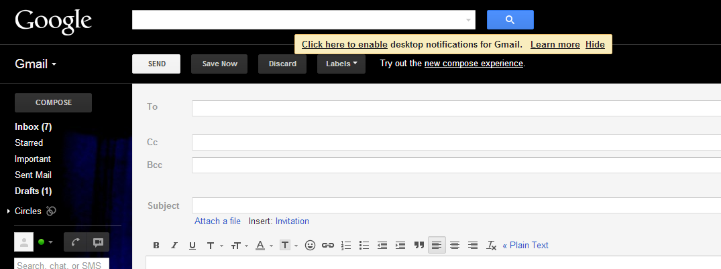

Techniques For Writing Effective Email:
- Organize your email:
- Introduction
- Discussion
- Conclusion
- Use Highlighting Techniques:
- Color
- Underline
- Bold etc
- Proofread your email
- Don’t email confidential information
- Make hard copies for future reference
- Practice etiquettes
- Be courteous
- Don’t write abusive/angry language messages
- Express emotions

Email Problems:
- Poor or incomplete documentation
- Computer limitations
- Lack of Privacy
- Misunderstandings
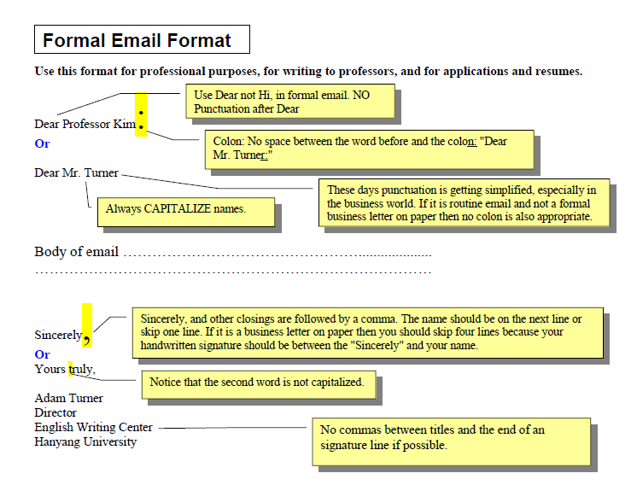
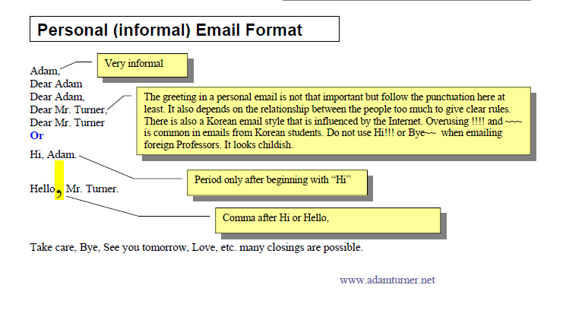
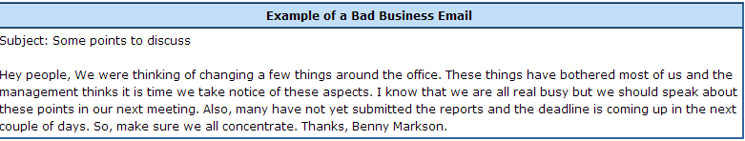
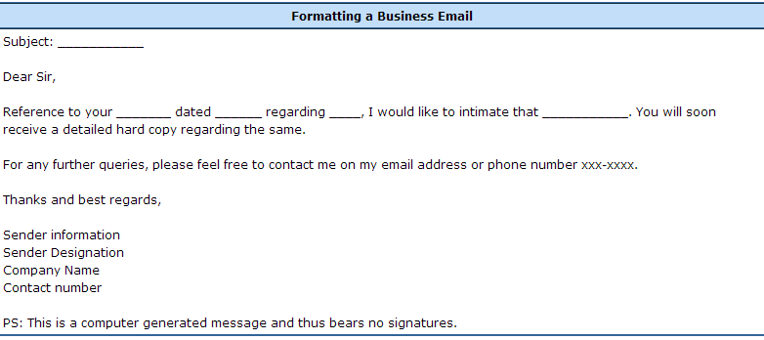
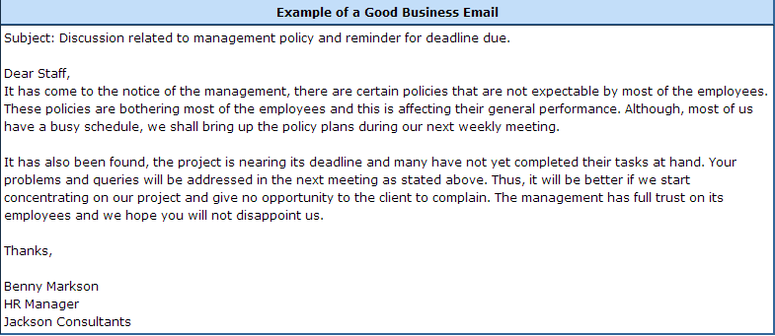
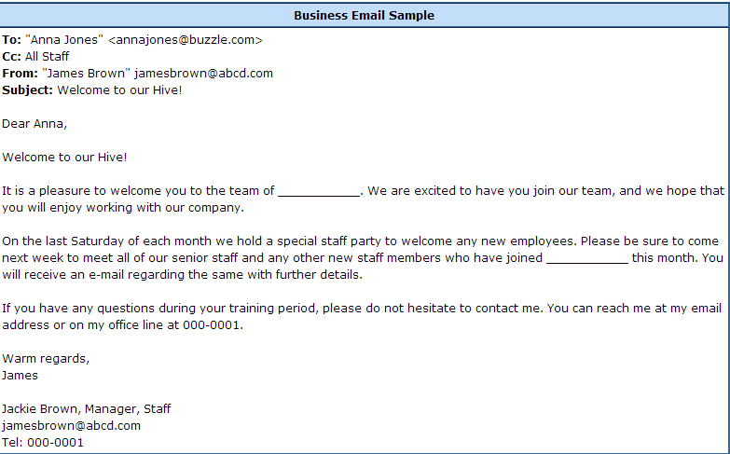

When to use email:
- If the communication will require a lot of back-and-forth discussion or if the subject is delicate or sensitive you should call or speak with the person directly.
- If a discussion is becoming emotionally charged, stop exchanging emails.
- Speak to the person directly to clear up any misunderstandings.
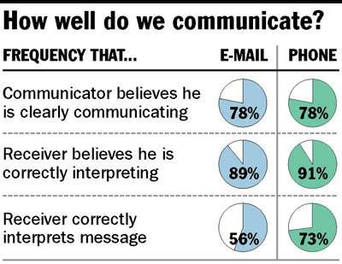

Effective subject lines:
- Clarity
- Descriptive
- Critical information

Ineffective subject lines:
Subject: | Date:
Hi | 9:17 am
Questions | 10:11 am
Meeting | 12:44 pm
One more thing........... | 3:02 pm
Some thoughts | 4:21pm
Party planning meeting rescheduled for 3pm | 9:17 am
Help: I can’t find the draft for the Smith Paper | 10:11 am
Reminder: peer-review articles due tomorrow (3/30) | 12:44 pm
Questions about Sociology 210 project | 3:02 pm
Congratulations to Jennifer for winning Nobel Prize | 4:21pm

Before you start writing, ask yourself:
Email Content
- Is this truly the correct person to contact?
- What is my goal?
- Should this conversation be held in person or over the phone?
- Use a polite and respectful greeting and closing
  - Professor Anderson,…….
  - Respectfully,....
  - Sincerely,…..
- Brevity and clarity
- Try to keep each email short
- Use paragraphs (5 sentences each)
- Is this message scannable and actionable?
- Email Content
- Use topic sentences
- One topic per email
- Provide important dates or references
- Put each action or point on its own line

Poor Email Content:
John,
Hey, I was just thinking about the meeting we had about the new workshop you were planning for next week about resume-writing. I think that we may have forgotten to include all of the students who might benefit from this workshop. There are several groups of students at the School of Public Health that were not on your list. Of course you may have added them to you list since our last meeting. Sara from the School of Public Health contacted me to ask if the students from the Epidemiology program were on our list of included students. She also wanted a list of all of the included departments from the School of Public Health. Can you send me a list of all of the included student groups? I can then send the relevant information on to Sara because she needs this information by tomorrow.
Thanks,
Rachell

Better Email Content:
John,
Can you send me a list of the students included in the resume-writing workshop by tomorrow?
We may have forgotten to include all of the students who might benefit from this workshop. There are several groups of students at the School of Public Health that were not on your list. Sara from the School of Public Health contacted me to ask if the students from the Epidemiology program were on our list. I will send her that information tomorrow after I get the list from you.
Thanks,
Rachell

Format:
- Plain-text vs HTML
Plain-text is always preferable
- Send from your university account
- DON’T TYPE IN ALL-CAPS, IT LOOKS LIKE SHOUTING

Email Signature:
- Use an appropriate signature
- Brief (4-5 lines)
- Informative
provide all contact information
- Professional
do not include pictures, quotes, animations

Professionalism:
- Always spell-check before sending
- Set your email program to automatically check before sending
- Re-read email for other spelling, grammar and punctuation errors.
- Always proofread at least once!
- Read it out loud
- Sleep on it
- Would I be comfortable having this email posted on a public bulletin board or forwarded on to my entire department?
- All laws governing copyright, offense, discrimination and other forms of written communication also apply to email.
- Complete the “TO:” line last
- Set your email program to delay sending

Remember:
- Emails are permanent
- Emails are searchable

Why is email etiquette important?
- We all interact with the printed word as though it has a personality and that personality makes positive and negative impressions upon us.
- Without immediate feedback your document can easily be misinterpreted by your reader, so it is crucial that you follow the basic rules of etiquette to construct an appropriate tone.

The elements of email etiquette:
- General format
- Writing long messages
- Attachments
- The curse of surprises
- Flaming
- Delivering information
- Delivering bad news
- Electronic Mailing Lists

General Format: The Basics:
- Write a salutation for each new subject email.
- Try to keep the email brief (one screen length).
- Return emails within the same time you would a phone call.
- Check for punctuation, spelling, and grammatical errors
- Use caps only when appropriate.
- Format your email for plain text rather than HTML.
- Use a font that has a professional or neutral look.

General Format: Character Spacing:
- Try to keep your line length at 80 characters or less.
- If your message is likely to be forwarded, keep it to 60 characters or less.
- Set your email preferences to automatically wrap outgoing plain text messages.

General Format: Lists and Bullets:
When you are writing directions or want to emphasize important points, number your directions or bullet your main points.
For example,
- Place the paper in drawer A.
- Click the green “start” button.
Another example,
- Improve customer satisfaction.
- Empower employees.

General Format: Tone:
- Write in a positive tone
“When you complete the report.” instead of “If you complete the report.”
- Avoid negative words that begin with “un, non, ex” or that end with “less” (useless, non-existent, ex-employee, undecided).
- Use contractions to add a friendly tone.
(don’t, won’t, can’t).

Attachments:
- When you are sending an attachment tell your respondent what the name of the file is, what program it is saved in, and the version of the program.
- “This file is in MSWord 2000 under the name “LabFile.”

When your message is long:
- Create an “elevator” summary.
- Provide a table of contents on the first screen of your email.
- If you require a response from the reader then be sure to request that response in the first paragraph of your email.
- Create headings for each major section.

Elevator Summary and Table of Contents:
An elevator summary should have all the main components of the email.
“Our profit margin for the last quarter went down 5%. As a result I am proposing budget adjustment for the following areas…”
Table of contents (This email contains)
A. Budget projections for the last quarter
B. Actual performance for the last quarter
C. Adjustment proposal
D. Projected profitability”

Delivering Information About Meetings, Orientations, Processes:
- Include an elevator summary and table of contents with headings.
- Provide as much information as possible.
- Offer the reader an opportunity to receive the information via mail if the email is too confusing.

Delivering Bad News:
- Deliver the news up front.
- Avoid blaming statements.
- Avoid hedging words or words that sound ambiguous.
- Maintain a positive resolve.
- Deliver the news up front:
“We are unable to order new computers this quarter due to budget cuts.”
- Avoid blaming:
“I think it will be hard to recover from this, but what can I do to help?”
- Avoid using “hedging”:
“Our pricing structure is outdated.”
- More examples of hedging are: Intents and purposes Possibly, most likely Perhaps, maybe

Writing a complaint:
- You should briefly state the history of the problem to provide context for your reader.
- Explain the attempts you made previously to resolve the problem.
- Show why it is critical for the problem to be resolved by your reader.
- Offer suggestions on ways you think it can be resolved or how you are willing to help in the matter.
- Briefly state the history:
“The current way we choose officers for our organization is not democratic. As a result, we have a popularity contest that does not always get us the best candidates.”
- Show attempts made by you thus far to resolve the issue:
“I have offered two alternatives for officer selection that still involves the votes of the members but both have been rejected by the executive board.”
- Show why it is important for your reader to get involved:
“This is a problem for two reasons. First, I am concerned that the executive board no longer protects the interests of the organization and that their actions are not in keeping with the constitution of the organization.
Second, there have been a number of complaints from the members who feel that their concerns and preferences are not being addressed by the executive board, which decreases morale and productivity.”
- Ask for help and offer a resolution:
“Please let me know what other options I may have overlooked. I am willing to meet with the department head and the executive board to seek out a solution that is fair to the members and is good for the business of the organization. ”

Do not take your reader by surprise or press them to the wall”:
- Do not wait until the end of the day to introduce a problem or concern via memo or email.
- Avoid writing a petition of concerns that you have been hiding for a long period of time.

Flaming in emails:
- Flaming is a virtual term for voicing or sending inflammatory messages in email.
- Avoid flaming because it tends to create a great deal of conflict that spirals out of control.
- Flame fights are the equivalent of food fights and tend to affect observers in a very negative way.
- What you say cannot be taken back; it is in black and white.

Keep flaming under control:
- Before you send an email message, ask yourself, “would I say this to this person’s face?”
- Calm down before responding to a message that offends you. Once you send the message it is gone.
Read your message twice before you send it and assume that you may be misinterpreted when proofreading.

Responding to a flame:
- Empathize with the sender’s frustration and tell them they are right if that is true
- If you feel you are right, thank them for bringing the matter to your attention
- Explain what led to the problem in question
- Avoid getting bogged down by details and minor arguments
- If you are aware that the situation is in the process of being resolved let the reader know at the top of the response
- Apologize if necessary

When Email Won’t Work:
- There are times when you need to take your discussion out of the virtual world and make a phone call.
- If things become very heated, a lot of misunderstanding occurs, or when you are delivering very delicate news then the best way is still face-to face.

Summary:
- What is an email?
- Techniques to write effective emails
- When to use email
- Effective Subject Lines
- Email Content and Style
- Format
- Signatures
- Professionalism
- Email etiquettes

References:
www.unc.edu/agep/documents/effective_emails.ppt
http://www.google.com.pk/url?sa=t&rct=j&q=email+writing+ppt&source=web&cd=3&cad=rja&ved=0CDkQFjAC&url=http%3A%2F%2Fwww.citehr.com%2F42066-e-mail-writing-ettiquettes-businesscommunication.html&ei=oUBdUYj8H4_Ysgb_yYDgCA&usg=AFQjCNGme998IEb8c85CuhSW94rZd2rSJg&bvm=bv.44770516,d.Yms

Chapter 21

Professional Communication
Memorandum Writing

What is Memorandum?
- Memorandum is a written correspondence only within company.
- Its an important mean by which employees communicate with each other.
- Its an informal report.

Memorandums are:
- Less threatening
- Readily accessible
- Easy to adapt
- Used for many purposes
- Can be for all levels

What should you know about Business Memos? They . . .
- are used within an organization
- usually are informal in style
- normally function as a non-sensitive communication
- are short and to-the-point
- have a business tone / no slang or jokes
- do not require a salutation (formal greeting)
- do not have a complimentary closing as does a business letter (END)
- have a format very different from a business letter
- may address one person or a group of individuals

Memos:
- Audience recognition:
- In-house
- Acronyms/Internal Abbreviations
- Style:
- Simple words
- Readable Sentences
- Specific Detail
- Highlighting Techniques
- Grammar:
- Grammatical Conversations

Formatting a Business Memo:
Basic Elements of Memorandum Format:
- Date:
- To:
- From:
- Subject:
- Memo Report:
- Names of receivers:

Memo Sample:

Guidelines for writing Memos
- Place DATE, TO, FROM, SUBECT at left hand margin
- Place DATE to the right (optional)
- Follow each item with a colon
- Lace names of people below the message
- Name the contents in subject line
- Signature must occur at right of your typed name

Memo Writing Process:

- Pre-Writing
- Clustering
- Mind mapping
- Writing
- Review your Pre-writing
- Determine your focus (topic sentence)
- Clarify your audience
- Review memo criteria (what a memo entails)
- Organize your ideas (Chronology)
- Write the draft
- Re-writing
- Add new detail for clarity (5 W’s)
- Delete dead words/phrases (conciseness)
- Simplify words/phrases
- Move information from top to bottom/bottom to up

Types of Memos:
- Student Written Memo
- Professionally Written Memo
- Professionally Written Compare-and-Contrast Memo
- Professionally Written Problem-Solution Memo
Lets Practice one!
A major project is being introduced at work. Write a Directive Memo, as a Director, informing your work team of their individual work and responsibilities. Your team comprises Marketing Manager, Assistant Manager, Finance Officer and Field Officer.

Destination:
Memos | - Internal  - Correspondence written to colleagues within a company
Letters | - External  - Correspondence written outside the business
E-mail | - Internal or external  - Correspondence written to personal friends as well as business associates

Format:
Memos | - Identification lines include:  - Date  - To  - From  - Subject  - The message follows
Letters | - Includes:  - Letter-head address  - Date  - Reader's address  - Subject  - Salutation  - Text  - Complimentary close  - Signatures
E-mail | - Identification lines include:  - Subject  - From (writer’s name, and e-mail address)  - Sent (date of transmission)  - To (reader's name and email address)  - The message follows

Audience:
Memos | - Generally high-tech or low-tech  - Mostly business colleagues
Letters | - Generally low-tech and lay readers  - Such as vendors and clients
E-mail | - Generally multiple readers with various levels of knowledge  - Could include instructors  - Company supervisors  - Subordinates as well as family and friends

Topic:
Memos | - Generally high-tech to low-tech; abbreviations and acronym often allowed
Letters | - Generally low-tech to lay; abbreviations and acronyms usually defined
E-mail | - A wide range of diverse topics determined by audience

Tone:
Memos | - Informal  - Peer audience
Letters | - More formal  - Audience of vendors and clients
E-mail | - Usually informal  - Due to the “conversational” nature of electronic communication

Attachments or Enclosures:
Memos | - Hard-copy attachments can be stapled to memo  - Complimentary copies can be sent to other readers
Letters | - Additional information can be enclosed within the envelope  - Complimentary copies can be sent to other readers
E-mail | - Computer files  - Active links and downable graphics can be attached  - Complimentary copies can be sent to other readers

Structure:
Memos | - Typically 8 ½” * 11” with 1” margins  - 80 characters per line  - 55 lines per page
Letters | - Typically 8 ½” * 11” with 1” margins  - 80 characters per line  - 55 lines per page
E-mail | - Typically one viewable screen with 60-70 characters per line  - 12-14 lines per screen  - Beyond these parameters, a reader must scroll

Security:
Memos | - If the company’s mail delivery is reliable, the memo will be placed in the reader's mailbox  - Security depends on the ethics of co-workers and whether the memo was sent within an envelope
Letters | - Privacy laws protect the letter’s content  - Once the reader opens the envelope, he or she sees exactly what the writer wrote
E-mail | - E-mail systems, like computer systems, malfunctions from time to time  - Sent email might not arrive  - The content can be the same, but the page layout could be differ  - Email can be tampered with and/or read by others with access to the system

Writing a Memo:
It’s time for your group to meet again for the final Project (assume that you are the group leader). Write a memo calling the meeting. Provide an agenda.

Recap:
- What is Memo?
- Memo Formatting
- Types of Memos
- Similarities and Differences between Memo, Letter and Email

References:
- Source: http://oregonstate.edu/dept/eli/buswrite/memos.html

Chapter 22

Professional Communication
Resume Writing

What is Resume?
- A summary of your qualifications
  - Education
  - Experiences (all types!!!)
  - Skills
- Marketing tool an advertisement on you!
  - Know Your audiences
  - Be prepared to spend ample time preparing resume

How is a Resume used?
- Most often used when applying for employment
- Can be used to apply for a co-op or internship or summer position, graduate or professional school or leadership positions in particular organizations
- A screening tool – the 10-20 second scan
- Resume Interview References Job Offer

What is CV?
- Comprehensive biographical statement
- Usually 3 or more pages in length
- Emphasizes qualifications and activities
- Should address faculty roles such as teaching, research, service, professional associations and presentations

How is CV used?
- In the United States, a curriculum vita is used primarily when applying for academic, scientific, or research positions. It is also applicable when applying for fellowships or grants
- When seeking a job in Europe, the Middle East, Africa, or Asia, expect to submit a CV rather than a resume
- Overseas employers often expect to read the type of personal information on a curriculum vitae that would never be included on an American resume, such as:
  - Date of birth and place of birth
  - Nationality
  - Marital Status
- Remember that US law on what information
- job applicants can be asked to provide does not apply outside the country

Writing an Effective Resume:
What is a Resume?
- A marketing tool
  - Your first tool for building a career
  - The first impression a prospective employer has of you
  - A selling tool that allows you to highlight to an employer how you can contribute to the company
- Request for an interview
  - Purpose of the resume is to get you an interview
  - Must capture the reader’s interest and attention
  - Must convince the employer that you have the ability to fill their position
- Your “big picture”
  - A snapshot of what you believe are your most important experiences and qualifications

Resume sections:
- Your name
- Your address
- Resume objective
- Profile or summary of qualifications
- Employment history
- Education
- Skills
- Activities

Basic Resume Formats:
- Chronological:
The chronological resume format lists work experience first, beginning with your most recent (or current) job. After tracing your work history, the chronological format continues with your education and concludes with extra skills and interests that may contribute to your ability to perform the job.
- Skills Format:
The skills resume begins with a list of skills that relate to the job for which you are applying. The skills resume format is exceptionally useful when:
1) you are applying for a job in a different field than your work experience,
2) you have large gaps in your work experience or
3) you have little or no paid work experience.
- The Combination or Functional Format:
This format is useful in highlighting skills that are relevant to a particular field of work. It is best used to demonstrate improvement and achievement within a specific field of work.

Other types of Resumes:
- A Paper/PDF Resume
  - A printed resume for use at job fairs, conferences, …
  - Should be clean, concise, professional, and pleasing to the eye
  - Use bullets, bolding, and indentation
  - Take this resume with you on job interviews, career breakfasts, …
- An Electronic Resume
  - A plain text resume for on-line submission
  - Typically must conform to employer specifications
  - Use left-justified and space indented formatting
  - If desired, use “+”, “*”, and “0” to represent bullets
- An HTML Resume
  - Typically includes links to homepage, images, …
  - Avoid this type of resume
  - Most people don’t want an employer walking around in their homepage

Resume Formats - Chronological
- Highlight your work experience in reverse chronological order
- Be sure to not leave gaps
- The most widely used format for working professionals
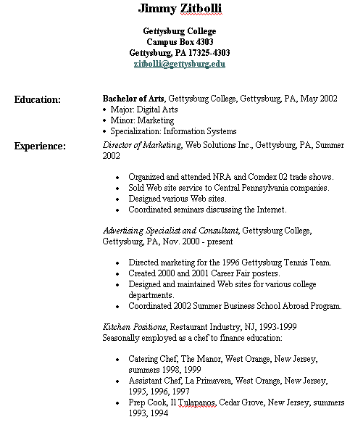

Resume Formats - Functional
- Highlight specific skills for which the market has high demand
- Seldom used by new graduates
- Frequently used to change jobs or careers
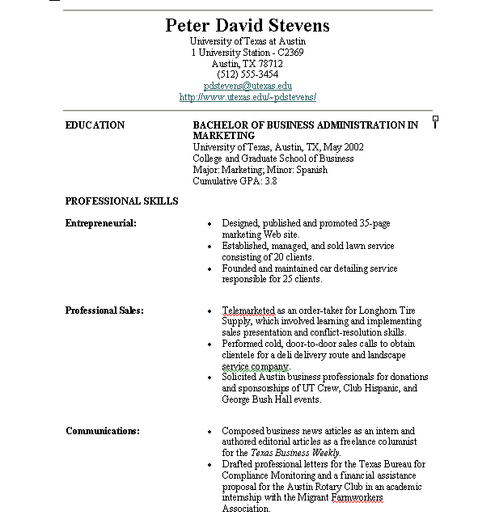

Resume Formats – Combinational:
- Highlight specific work experience
- Highlight marketable skills
- Use reverse chronological order
- The best resume style for most college students
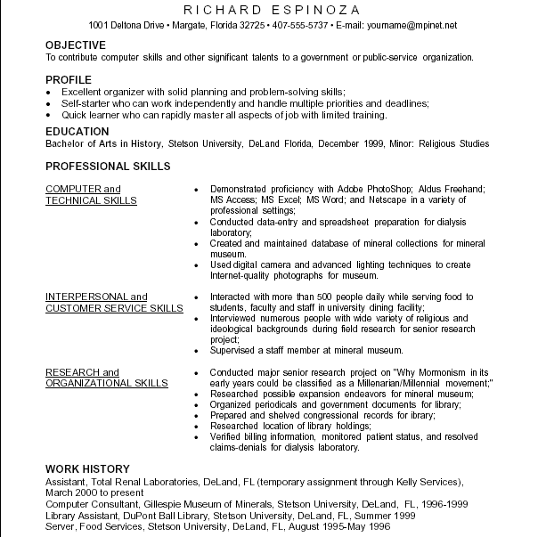

The Silver Bullet:
- What Is Your “Story”?
  - What slant can you take on your resume?
  - Do you want to emphasize internship experience?
  - Do you want to emphasize work experience?
  - Do you want to emphasize course work?
  - Do you want to emphasize project experience?
  - Do you want to emphasize research experience?
  - Do you want to emphasize personal traits?
- What is unique or interesting about your college experience?
- My Recommendation
  - If you have an interesting internship – emphasize it – if not get one!
  - Most graduates have interesting project experience
  - Build on your liberal arts education!!!
  - Demonstrate leadership, communication, cultural awareness

Standard Resume Sections
- Header
- Objective
- Education
- Honors/Activities
- Work Experience
- Relevant Courses
- Skills
- Projects
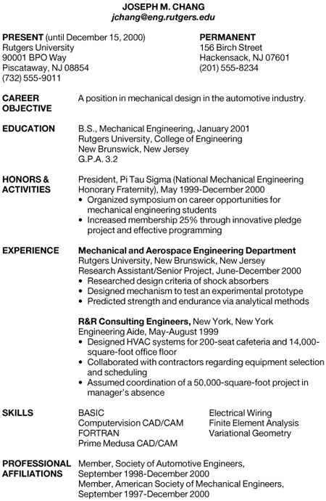

The Header Section
- The first line should be your name
  - Larger than the largest font used in body
  - Avoid using decorative fonts
  - Don’t use black or gray shaded backgrounds
  - Exclude titles Mr., Mrs., Ms., …
- Include contact address
  - Permanent address
  - Current address
- Include your email address
  - Use your UWEC email address
  - Don’t use “BIGBOY@HOT_MAIL.COM”
- Include your phone number
  - Change the message machine to be appropriate

The Objective Section
- Considered optional but I strongly suggest including it
- Make statement clear, concise, and to the point
  - Bad: “I want to get a job”
  - Weak: “To attain an internship in the computer industry.”
  - Good: “To attain an internship in the computer industry working with database or network security.”
- Avoid being overly specific to single company
  - “To attain a position at 3M Pharmaceuticals working on …”
- I prefer objectives from the company’s perspective
  - “To attain a web application programming position where knowledge of Java and the Struts framework will add value the overall development process.”

The Honors/Activities Section
- Should only contain honors and awards earned during your time in college
- You can include academic or extracurricular items
  - I prefer only academic or service-related items
- Include a brief description if not self-evident from title
  - “Award given to top performer on the capstone exam”
- Don’t include hobbies or activities not related to the job or your story
  - Good to include leadership positions in CS-related organizations
  - Good to list membership in CS-related organizations
- Don’t include volunteer work unless there is a direct and positive link with the job or your story

The Work Experience Section
- Dedicated to most recent and relevant employment
- Format
  - Employer and location on the first line
    - Don’t need name of supervisor, complete address, or contact information
  - Position and time-span on the second line
    - Use only year, not month and year (avoids time gaps)
- Each position should have at least two bullets
  - Explain role and contributions
  - Don’t emphasize duties but rather emphasize Outcomes
    - “Increased efficiency of … by 20%”
    - “Improved user navigation experience on …”
  - Descriptions should be consistent in wording
- Watch the tense
  - Current job uses present tense
  - Former jobs use past tense

The Relevant Courses Section
- The keyword is relevant courses
  - Don’t include Foundations of Computing
  - Don’t include Algorithms and Data Structures
  - Focus on courses the are either unique or would normally be considered elective
    - Computer Security
    - Computer Graphics
    - Artificial Intelligence
    - Computer Networks
    - Database Systems
    - Data Mining
  - Employers will assume you have had the rest

The Skills Section
- This is where you emphasize your technical skills
  - Programming Languages
    - Put in order of familiarity
    - Can use “Exposure to:” as the only modifier if you wish
  - Platforms
    - Nice to list Windows and Linux
  - Packages
    - Eclipse, Oracle 9i, MS SQL Server, Clear Case, Rational Rose, …
    - We make a concerted effort to use “real” products so make a concerted effort to list them
  - Development Methodologies
    - Rational Unified Process, Extreme Programming, Agile Development

The Projects Section
- Used correctly, this section can set you apart from other new graduates
  - Most new grads don’t get the opportunity to use this section
- Show any lengthy, impressive, or relevant projects to which you have made real contribution
- Each project should have at least two bullets (focus on outcomes)
“Market Basket Analysis System
    - Designed and implemented a Java application for predicting future purchases based on a probabilistic analysis of past purchase records
    - Deployed system as a web service using XML and SOAP and an Oracle database on the backend
    - Used synchronized threads to increase overall throughput of the system to handle up to 50 client requests per second”

Supporting Documentation:
Cover Letter:
Cover Letter (1)
- Why do I need to write a cover letter?
  - Use the cover letter to focus attention on elements of your background that are particularly relevant to the company
  - Letter acts as your verbal introduction to the employer
- Send it to a person, not a place
  - Avoid “To Whom It May Concern,”
  - Worst case “Dear Recruiter:”
- First sentence should tell why you are writing
  - “I am writing in regard to your posting listed on …”
  - “Dr. Wagner at UW – Eau Claire suggested that I …”
  - “As you may recall, I spoke with you briefly at …”
  - If uninvited, indicate why you are interested in the company

Cover Letter (2)
- Highlight your skills
  - Use two to three paragraphs to given in-depth description of your selling points
  - Each paragraph should be stand alone (could be moved to different location in text)
- Close with a promise of action
  - If possible, indicating that you will be contacting them in the near future to set up a mutually acceptable meeting time or to further discuss your qualifications
  - Nice if you can say “during my Winter Break, between December 28 and January 12, I will be in your Minneapolis. I will contact your office when I arrive to arrange a possible meeting time”
Cover Letter (3)
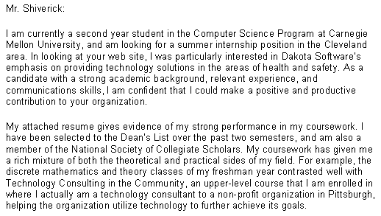
References
- Prepare a separate reference sheet
  - Use same paper as the resume itself
  - Bring reference sheet (and resume) with you to any interviews, job fairs, career breakfasts, …
  - Do not mail reference sheet with resume and cover letter
- Reference sheet is a stand-alone document
  - Should include your Header from the resume
  - Try to arrange contact information in pleasing fashion
- Use professional references only
  - Pick individuals that think highly of you
  - Pick individuals that are familiar with your work
- Always ask your references before using their names
  - Be prepared to give supporting materials – courses, projects, …
  - Ask again if it has been a while

Scannable Resumes:
- Most large employers will scan your resume into a central database
- Tips to assist the scanning process
  - Don’t use italics, underlining, or graphics
  - Use bold only for headers
  - Use “scanner-friendly” fonts (Serif or Sans Serif fonts)
    - Times New Roman, Courier, Helvetica, or Arial are good examples
    - Font sizes of between 9 and 12
  - Use black ink on white background
- Tips to assist the retrieval process
  - Most lookup is keyword-based
  - Samples: Unix, C++, Java, hardware, networking, trouble-shooting, testing, security, data mining, …

Tips on Delivery of Your Resume:
- Posting Online
  - “rules” are still emerging
  - Common mistake – formatting that doesn’t make the trip
    - Convert to text only
    - Use PDF if allowed
    - Proofread carefully after conversion
  - If they ask about salary, leave it empty
  - If they force salary, be honest but don’t shoot for the moon
- Emailing your resume
  - Attach resume as a PDF document (or Word document)
    - 75 – 80% of companies are running Windows
  - Also include text version in the email message
    - Attachments can get dropped or filtered
  - Test before deploy
    - Send to at least three friends, ask them to print it and send it back to you

Miscellaneous Tips (1)
Use action words in your descriptions
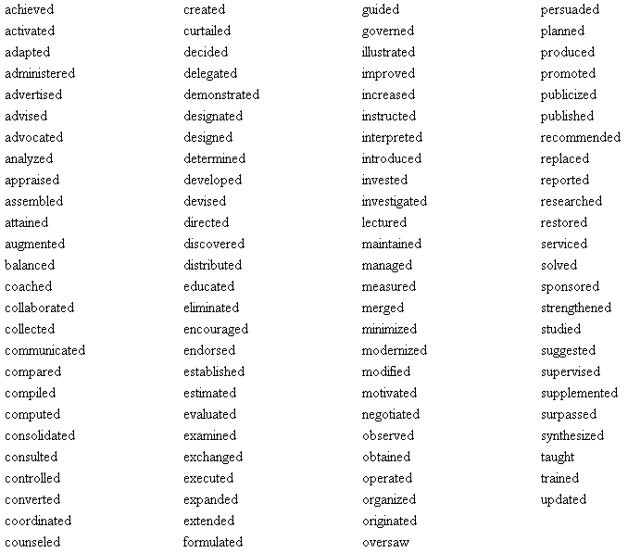

Miscellaneous Tips (2)
- Act like a professional
  - Avoid cutesy or inappropriate graphics, images, formats, …
- One page only
  - You are a fresh graduate, don’t assume that the one-page rule doesn’t apply to you!
- Stick to the truth
  - Don’t sprinkle buzzwords in that you really don’t understand
  - It speaks volumes about your character when you can’t explain your own resume
- Focus on achievements and results
  - Laundry lists of duties are not impressive

Miscellaneous Tips (3)
- Use easy-to-read language
  - Winston Churchill - “Use short, old words.”
- Get the words and punctuation correct
  - Errors and “broken English” are the kiss of death
- Follow the instructions
  - If the company asks for specific information, then give it to them
- Follow up
  - If you said you would call, then call
- Maintain a consistent writing style
  - Avoid “To apply …” then “Applying …”
- Avoid the use of “I” or “my”

Miscellaneous Tilts/lists (1)
- USE ALL CAPITAL LETTERS
  - Much harder to read
- Avoidwhitespace
  - Use white space (not borders) to break sections apart
- Include a picture of yourself
  - You’re not THAT good looking!
- Miscellaneous Tilts/ Lists (1)
- Use several fonts to catch their attention
  - Creates a “ransom note” effect
- Print your resume on “day glow” paper
  - Be professional
- Illogical Order Use
  - Resume is a story – put most interesting parts at the beginning

Miscellaneous Tilts (2)
- Focus on you and your needs
  - Employers have better things to do than hear about you
  - They want to know “what can you do for me”
- Use templates to construct your resume
  - Give cookie-cutter look
  - Lacks flexibility to your “silver bullet”
- Use superlatives to emphasis your work
  - Great performance as …
  - Stick to the facts and figures – not an evaluation of yourself
- Use long flowing sentences
  - Short and to the point
  - Sentence fragments are fine if they are understandable – BUT NOT IN THE COVER LETTER!!!!!

Don’t Make These Famous Mistakes
- “Education: Curses in liberal arts, curses in computer science, curses in accounting”
  - “Personal: Married, 1992 Chevrolet”
- “Proven ability to track down and correct erors.”
- “Disposed of $2.5 billion in assets”
- “Accomplishments: Oversight of entire department”
- Cover Letter: “Thank you for your consideration. I hope to hear from you shorty!”

Good Resume Examples:
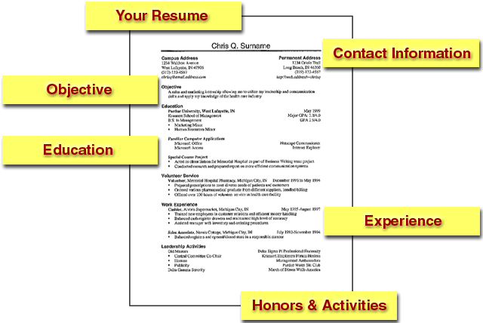
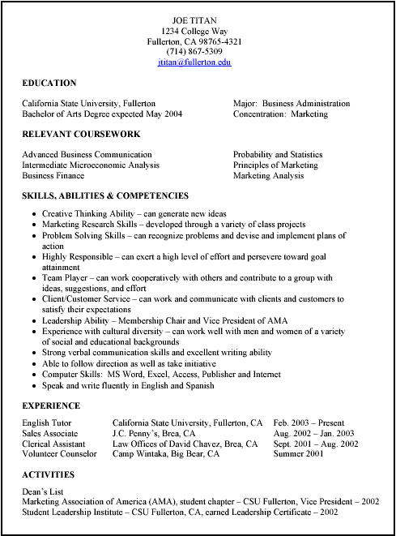
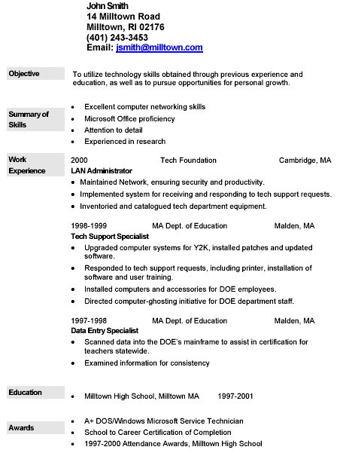

Bad Example Resume:
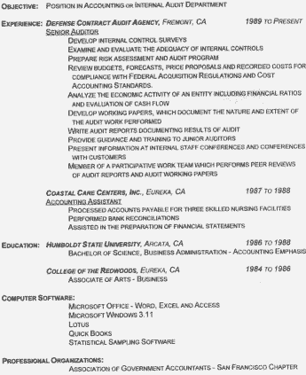
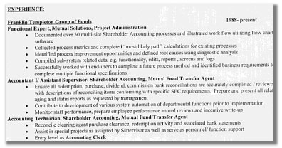

Summary:
- Role of the Resume
- Types of Resumes
- Resume Formats
- Resume Sections
- Additional Documentation
- Miscellaneous Tips
- Miscellaneous Tilts
- Sample Resumes

References:
- (http://www.sc.edu/career/tipsheets.html)

Chapter 23
Communication Skills

What is Speaking?
Speaking is an interactive process of constructing meaning that involves producing and receiving and processing information. ((Brown, 1994; Burns & Joyce, 1997).
- Its form and meaning are dependent on the context in which it occurs, including:
  - the participants themselves
  - their collective experiences
  - the physical environment and
  - the purposes for speaking
- Speaking is:
  - Spontaneous
  - open-ended
  - Evolving
  - Unpredictable (not always)
- the expected discourse sequence includes:
  - a statement of need
  - response to the need
  - offer of appreciation
  - acknowledgement of the appreciation, and
  - a leave-taking exchange

What a Good Speaker Does?
- Speakers must be able to anticipate and then produce the expected patterns of specific discourse situations.
- They must also manage discrete elements such as turn-taking, rephrasing, providing feedback, or redirecting (Burns & Joyce, 1997).
- What a Good Speaker Does?
- Other skills and knowledge that instruction might address include the following:
  - producing the sounds,
  - stress patterns,
  - rhythmic structures, and
  - intonations of the language;
  - using grammar structures accurately;
    - assessing characteristics of the target audience,
    - including shared knowledge or shared points of reference,
    - status and power relations of participants,
    - interest levels, or
    - differences in perspectives

Tips to practice Speaking
- Dialogue
- Role plays
- Drills
- Speaking with an outline
- Monologue
- Short Speech

30 - Tips for a Beginner in Public Speaking
- Why Speak in Public?
  - The ability to speak in front of audience is considered as a sign of Self-confidence.
- Public Speaking
  - Matter
  - Language
  - Style
- #1
  - Start with a proper GREETING to the judges and audience
- #2
  - ORGANISE your speech into three basic parts
  - Attractive - INTRODUCTION
  - Meaningful - MAIN SPEECH
  - Clear & Crisp - CONCLUSION
- #3
  - MAKE the introduction BRIEF but ATTENTION GATHERING
- #4
  - OPEN your speech with any one of the four techniques :
  - Quotation
  - Example
  - Definition
  - Humour ( HUMOUR is little difficult to deliver ; unless you are good at telling jokes, DON’T try this technique )
- #5
  - MAKE NO more than THREE major points in a three minutes speech
- #6
  - STRUCTURE the points as under
  - a) MAKE a single & clear statement of your point
  - b) ELABORATE the point in few sentences
- c) Give one or two examples to support the point (sequence may vary c,a,b..)
- #7
  - BALANCE the points to consider all aspects of situation.
  - Public Speaking
- #8
  - EMPHASIZE your arguments but don’t show bias.
- #9
  - MOVE from one point to another -LOGICALLY & SMOOTHLY
- #10
  - END with a word of thanks.
- #11
  - AVOID grammatical faults
- #12
  - USE correct pronunciation
- #13
  - USE the right word as far as possible ( You should have / develop a good vocabulary to do this )
- #14
  - PREFER simple sentences. Similarly prefer direct speech (active voice) to reported speech (passive voice)
  - Public Speaking
- #15
  - CITE specific example instead of making generalizations.
- #16
  - CREATE word pictures
  - Example - say : “My friend Ram”, instead of “a friend”
  - Say : “It is hard as maths to me” , not weakly “it is hard”
- #17
  - USE pauses appropriately (when you make an important / major point - it will sink into the minds of your audience well)
- #18
  - SPEAK fluently
- #19
  - AVOID : Putting on an unnatural / foreign accent
- #20
  - AVOID : Use of big words to show off jargon, slang & cliches
- #21
  - TAKE a good look at the audience, judges and the arrangements while you are waiting for your turn to speak.
- #22
  - WALK at your normal pace to the dais / speaker podium when called to speak
- #23
  - STAND erect, but not stiff
- #24
  - LOOK at judges, audience and take a deep breath.
- #25
  - SMILE at the most friendly face (pretty / handsome one) you can see in the audience - if you prefer ! Now begin speaking.
- #26
  - KEEP your voice at a level that suits the size of the audience and the hall / room
- #27
  - SPEAK at your natural speed (like when you talk to your friends or at home)
- #28
  - LOOK at different sections of the audience once in a while. (Don’t stare at someone or a particular object in the room)
- #29
  - ALLOW your hands the natural gestures they are used to, while you speak.
- #30
  - After you finish your speech pause briefly, take a couple of steps back and then RETURN to your seat.

Activity:
- Street Light

Strategies for Developing Speaking Skills:
- Using minimal responses
Language learners who lack confidence in their ability to participate successfully in oral interaction often listen in silence while others do the talking.
These types of learners must: Begin with minimal responses that they can use in different types of exchanges
  - Predictable
  - idiomatic phrases
- They help to indicate:
    - Understanding
    - agreement
    - doubt, and
    - other responses to what another speaker is saying.
- Recognizing scripts
  - Some communication situations are associated with a predictable set of spoken exchanges -- a script. Greetings, apologies, compliments, invitations, and other functions that are influenced by social and cultural norms often follow patterns or scripts. So do the transactional exchanges involved in activities such as obtaining information and making a purchase. In these scripts, the relationship between a speaker's turn and the one that follows it can often be anticipated.
  - Instructors can help students develop speaking ability by making them aware of the scripts for different situations so that they can predict what they will hear and what they will need to say in response. Through interactive activities, instructors can give students practice in managing and varying the language that different scripts contain.
  - Strategies for Developing Speaking Skills
- Using language to talk about language
  - Language learners are often too embarrassed or shy to say anything when they do not understand another speaker or when they realize that a conversation partner has not understood them. Instructors can help students overcome this reticence by assuring them that misunderstanding and the need for clarification can occur in any type of interaction, whatever the participants' language skill levels. Instructors can also give students strategies and phrases to use for clarification and comprehension check.
  - By encouraging students to use clarification phrases in class when misunderstanding occurs, and by responding positively when they do, instructors can create an authentic practice environment within the classroom itself. As they develop control of various clarification strategies, students will gain confidence in their ability to manage the various communication situations that they may encounter outside the classroom.

Recap:
- What is Speaking?
- What makes a Good Speaker?
- 30 Tips to improve Public Speaking
- Strategies for Developing Speaking Skills

References:
- file:///C:/Users/Administrator/Desktop/speaking/What%20speaking%20is.htm
- file:///C:/Users/Administrator/Desktop/speaking/Strategies%20for%20Developing%20Speaking%20Skills.htm

Chapter 24
Communication Skills
Speaking Skill (Pronunciation)

Recap:
- What is Speaking?
- What makes a Good Speaker?
- 30 Tips to improve Public Speaking
- Strategies for Developing Speaking Skills

Why Learn Pronunciation?
- It improves pronunciation and intonation.
- It helps us understand the emotions people want to transmit according to their tone of voice.
- It helps us transmit our own emotions when speaking.
- It helps to become more fluent and to speak more natural.
- It provides new vocabulary.
- It makes us think in the target language.
- We learn different accents in the target language.
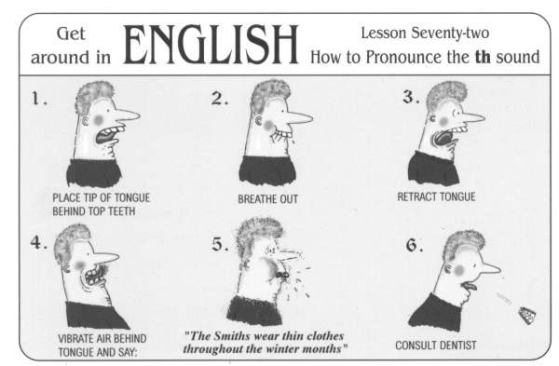

SPEECH – THE ESSENCE OF LANGUAGE:
Speech is the basic form of language. This leads to the conclusion that speech should be emphasized in second language teaching ... (Hector Hammerly)
Activity: Homophones!:
- Write the words being dictated.
- Did you write the words in the same way?
- Some words in English are pronounced exactly the same, but differ in Spelling.
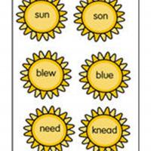

Find 14 mistakes in this text:
“As a buoy , there was nothing I liked more than to spend my time on the beech . There was a good selection of baize as my home was on a peninsula and so it was always possible to find a plaice sheltered from the wind wile enjoying the best of the weather . Each day was a succession of swimming until I was frozen followed by lying on the hot sand until my body was warmed by the son and then it was back to the see again. “

- Toward the end of the day, as the waters rose over the warm sands, I wood billed a large damn to defy the waives . But , in spite of all my efforts, I almost never one this unequal contest. There was a time when , whether by design or chance, I had placed my castle at the turn of the tied and so it survived the waves only to be beaten down by the feat of holiday-makers as they returned home at the end of the day.
- As a buoy boy , there was nothing I liked more than to spend my time on the beech beach . There was a good selection of baize bays as my home was on a peninsula and so it was always possible to find a plaice place sheltered from the wind wile while enjoying the best of the weather . Each day was a succession of swimming until I was frozen followed by lying on the hot sand until my body was warmed by the son sun and then it was back to the see sea again.
- Toward the end of the day, as the waters rose over the warm sands, I wood would billed build a large damn dam to defy the waives waves. But, in spite of all my efforts, I almost never one won this unequal contest. There was a time when, whether by design or chance, I had placed my castle at the turn of the tied tide and so it survived the waves only to be beaten down by the feat feet of holiday-makers as they returned home at the end of the day.

Activity: Tongue twisters!
- Tongue Twisters can be a good pronunciation practice!
- How fast can you say this tongue twister without making a mistake?
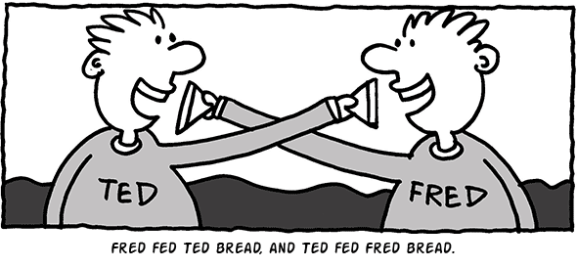

Find 19 mistakes in this text:
It was one of those October daze when it was a pleasure to be alive . The sky was blew and the heir cold and sharp with a cent of wet earth as the mourning sun warmed the chilled countryside . And then I court site of a lonely bie struggling to find the pollen of a final flour . Wear had he bean , this sad worker , doomed so soon to dye ? I marvelled at his energy as he climbed along so many bear storks . Finding nothing, he flue on and disappeared from cite . I continued my walk to a country in where , sitting outside , I contentedly sipped my bier , musing all the wile on the mixed fortunes of life .
- It was one of those October daze days when it was a pleasure to be alive . The sky was blew blue and the heir air cold and sharp with a cent scent of wet earth as the mourning morning sun warmed the chilled countryside . And then I court caught site sight of a lonely bie bee struggling to find the pollen of a final flour flower . Wear Where had he bean been , this sad worker , doomed so soon to dye die ? I marvelled at his energy as he climbed along so many bear bare storks stalks . Finding nothing, he flue flew on and disappeared from cite sight . I continued my walk to a country in inn where , sitting outside , I contentedly sipped my bier beer , musing all the wile while on the mixed fortunes of life .

Minimal pairs:
- blessed blast
- commended commanded
- deft daft
- left laughed
- lest last
- leather lather
- pest passed
- vest vast

Activity: Intonation!
- When we communicate, we use words, body language, and intonation.
- What do you think is most important?
- The teacher will say the same sentence with different intonation.
- How does the meaning of the sentence change?
- Why is it so important to use intonation?
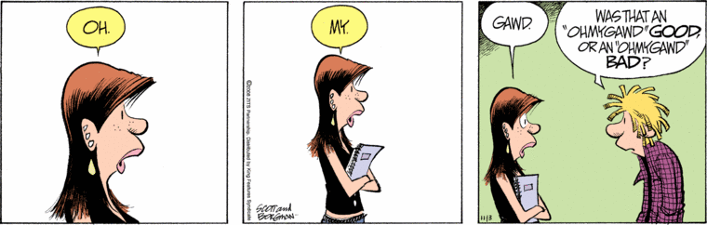
SPELLING INTERFERENCE
The higher the spelling inconsistency is, the more negative the influence on pronunciation will be.
The English spelling does not serve as a guide to pronunciation. On the contrary, it can often be misleading.

Are students of English as a foreign language the only ones that suffer?

PHONOLOGY:
- Phonology analyzes the sound patterns of language.
- Different languages have different phonological systems.
- A clear understanding of the differences will provide guidance and prevent interference.
The main phonological differences between Portuguese and English are:
- Phonetic signaling
- Phonemes (vowels & consonants)
- Phonological rules
- Rhythm & vowel reduction
- Word stress

PHONETIC SIGNALING:
- Phonetic signaling in linguistics is the quantity of sound produced per meaning.
- Different languages have different levels of phonetic signaling.
- For example:
  - It takes 1 syllable to say “dog” while it takes 3 syllables to convey the same meaning in Portuguese: “cachorro”.

Try it yourself:
- Take the syllable as the unit of sound and the word as the unit of meaning.
- List a few common words from your surroundings in English and Portuguese.
Add the total number of syllables for each language.

In other words:
It’s as if somebody accustomed to driving his car at 80 km/h on well-marked roads needed to drive a different car under different traffic rules on poorly-marked roads at 120 km/h.

What are the tips on good English pronunciation?
Word Stress
Example: coming, letter, beautiful, report, myself, forget, remember, explosion modernization
Sentence stress
In a normal English sentence certain words are stressed and certain words are unstressed.
Normally stressed are content words. Normally unstressed are form words.

Examples:
1. Janet has gone to the Baker’s.
2. I saw your brother yesterday.
3. Would you like a glass of beer?
4. I must be going. My wife’s waiting for me at the corner of the street.

Rhythm:
Stress gives a natural rhythm to spoken English.
- The rhythm of spoken English is determined by the occurrence of stressed syllables. Stressed syllables occur at more or less equal intervals in English. The other syllables in a sentence are reduced or blended to accommodate the regular beat of the stressed syllables.
1. As a general rule English tries to avoid having stresses too close together.
2. English stresses tend to recur at regular intervals.

Stress patterns:

Stress timed language:

Weak forms:

Intonation:
Function 1: It indicates grammatical meaning, in much the same way as punctuation does in the written language.
1. He lives in London. 3. He lives in London. Where?
2. He lives in London. 4. He lives in London. Where?
Function 2: It can also indicate the speaker’s attitude.
1. Really?
2. What’s your name?

Four basic tune movements:
- Fall
- Rise
- Fall-rise
- Rise-fall
Example:
1. His name is Peter. (a straightforward statement)
2. His name is Peter. (a polite question)
3. His name is Peter. (I don’t believe you.)
4. His name is Peter. (to convey certainty)

Speech-flow:
Stress, rhythm and intonation should really be considered as a whole, for they are very closely connected elements of a single aspect of the language that we might call Speech-flow.
Seasons
Spring is green, summer is bright, autumn is golden, winter is white. Year in year out, we work and fight, for a new world, of red sunlight

It’s a Small World:
It’s a world of laughter,a world of tears.
It’s a world of hopes; it’s a world of fears.
There’s so much that we share
That it’s time we’re aware
It’s a small world after all.

Edelweiss /#eidlvais/:
Edelweiss,edelweiss, every morning you greet me.
Small and white, clean and bright,
You look happy to meet me.
Blossom of snow,
May you bloom and grow, bloom and grow forever.
Edelweiss, edelweiss, bless my homeland forever.

My last but best tip:
Practice, practice and practice
Practice 1:
Rain
The rain is raining all around,
It falls in field and tree.
It rains on the umbrellas here,
And on the ships at sea
Practice 2:
Bed in Summer
In winter I get up at night,
And dress by yellow candle-light.
In summer quite the other way,
I have to go to bed by day.

I have to go to bed and see,
The birds still hopping on the tree,
Or hear the grown-up people’s feet,
Still going past me in the street.

And does it not seem hard to you,
When all the sky is clear and blue,
And I should like so much to play,
To have to go to bed by day?
--Robert Louis Stevenson

References
- www.nse.cn/nse/jp/09082702.ppt
- www.sk.com.br/pronunciation.ppt
- www.jjy.cq.cn/uploadfile/201111/20111125171943574.ppt
- www2.vobs.at/ludescher/pdf%20files/Pronunciation%20exercises.pdf

Chapter 25
Communication Skills
Speaking with an Outline

Agenda:
- Importance of outlining speeches
- Differences between the preparation outline and the speaking outline
- Construct a preparation outline following the guidelines in the text
- Construct a speaking outline following the guidelines in the text

Preview:
- Definition of the Preparation Outline
- Guidelines for the Preparation Outline
- Definition of the Speaking Outline
- Guidelines for the Speaking Outline

What is the preparation outline?
A detailed outline developed during the stage of speech preparation.

Preparation Outline:
- Helps you put your speech together
- Stage at which you decide:
  - how you will organize main points and supporting material in the body,
  - what you will say in the introduction, and
  - what you will say in the conclusion.

Guidelines for the Preparation Outline:
- State the specific purpose
- Identify the central idea
- State your method of organization
- Label the introduction, body, and conclusion (Outline them separately.)
- Use a consistent pattern of symbolization and indentation.
- State main points and 1st level subpoints (A, B, C etc.) in full sentences.
- Label transitions, internal summaries, and internal previews.
- Attach a bibliography.
- Give your speech a title, if desired.

Visual Framework:
The pattern of symbolization and indentation in a speech outline that shows the relationship among a speaker’s ideas.
- Example of Visual Framework
I. Main point
  - Subpoint
  - Subpoint
1. Sub-subpoint
2. Sub-subpoint
II. Main point Subpoint
  - Subpoint
1. Sub-subpoint
2. Sub-subpoint
  - Subpoint
1. Sub-subpoint
2. Sub-subpoint
  - Subpoint

Speaking Outline:
A brief outline used to jog a speaker’s memory during the presentation of a speech.

Guidelines for the Speaking Outline:

- Follow the visual framework used in the preparation outline.
- Make sure the outline is plainly legible.
- Keep the outline as brief as possible.
- Give yourself cues for delivering the speech.

Outlining the Speech:
Outlines Are Essential To Effective Speeches
- Help Place Related Items Together
- Help Ensure The Natural Flow Of Ideas From One To Another
- Help Create Coherent Structure

The Preparation Outline
  - A Detailed Outline Used To Plan A Speech

Process of Building the Preparation Outline Brings Together All of the Major Elements of the Speech
  - Title
  - Specific Purpose
  - Central Idea
  - Introduction
  - Connectives
  - Main Points – in full declarative sentences
  - Supporting Points – in full declarative sentences
  - Conclusion
  - Bibliography

- Label The Introduction, Body, & Conclusion
- Use A Consistent Pattern Of Symbolization And Indentation
  - Follow a clear Visual Framework.
Visual Framework:
The pattern of symbolization and indentation in a speech outline that shows the relationships among the ideas of the speech.
- State Main Points And Sub-Points In FULL DECLARATIVE SENTENCES.
- Label Transitions, Internal Previews, Internal Summaries, & Signposts
- Attach A Bibliography
- Give Your Speech A Title, If One Is Desired
  - A Brief Outline Used To Deliver The Speech
  - Primary Purpose:
    - To help the speaker remember what to say
- Key Words & Phrases
- Cues For Delivery
- Particularly Effective For Extemporaneous Delivery

Guidelines for Creating the Speaking Outline:
- Follow The Same Visual Framework Used In The Preparation Outline
  - Should Be Plainly Legible
- Should Be As Brief As Possible
- Should Include Cues For Delivering The Speech

Importance of Communication:
- Class Presentations
- Field Research
- Business Communications
- Public Speaking
- Fear of Public Speaking
- Population
    - No.1 fear=Public Speaking
    - Fear No.2=Death
- Stage fright
-In spotlight
-unprepared
-inexperienced

Effective Communication:
- Preparation
  - research -non-research
  - format -speak on what you know
  - -Notes- outline main points
-note cards vs. full sized paper
Sample Speech Outline:
I. Introduction
    - Thesis
II. Body
    - support arguments
III. Conclusion
    - review

- Practice
- Practice makes perfect
- Revision
- get time right

- Presence
-nervousness- fright is common
-Body language
-voice tone
-gestures
-eye contact
-positive attitude
- Preparation

Things You Shouldn’t Do:
- Read directly from notes
- Read directly from screen
- Turn back on audience
- Slouch, hands in pockets
- No um, ah, you know’s
- No nervous gestures
- Talk too fast,
- Talk too quietly

Things You Should Do
- Eye contact
- Can glance at notes
- Appropriate gestures
- Rhetorical questions to involve audience

Ten Successful Tips (Control the “Butterflies”):

- Know the room- become familiar with the place of presentation
- Know the audience- greet or chat with the audience before hand. It’s easier to speak to friends than to strangers
- Know your material-increased nervousness is due to un-preparedness
- Control the “Butterflies”
- Relaxation- relax entire body by stretching and breathing so as to ease the tension
- Visualize giving your speech-Visualize yourself giving your speech from start to finish. By visualizing yourself successful, you will be successful
- Control the “Butterflies”
- People want you to succeed- the audience is there to see you succeed not to fail
- Don’t apologize- by mentioning your nervousness or apologizing, you’ll only be calling the audience’s attention to mistakes
- Control the “Butterflies”
- Concentrate on your message-not the medium. Focus on the message you are trying to convey and not on your anxieties
- Turn nervousness into positive energy-nervousness increases adrenaline, transform it into vitality and enthusiasm
- Control the “Butterflies”
- Gain experience- experience builds confidence, which is key to effective public speaking

Public Speaking:
Public Speaking Produces Anxiety in Most People (People’s Biggest Fears)
3. Death
2. Snakes
1. Public Speaking

Overcoming Speech Anxiety:
- Acknowledge Your Fear
- Act Confident
- Channel Nervous Energy
- Overcoming Speech Anxiety (con’t)
- Practice, Practice, Practice
- Simulate Setting at Home
- Ask Friends to Be Practice Audience
- Overcoming Speech Anxiety (con’t)
- Visualize Your Success
- Use Deep-breathing Techniques
- Focus on Message, not Fear
- Give Yourself a Mental Pep Talk

Understand Audience and Listening:
- People Think Faster Than Hear
- Have Short Attention Span
- Jump to Conclusions
- Easily Distracted

Listening Remedies:
- Keep Speech Focused
- Divide Speech into Compact Segments
- Analyze Audience Carefully
- Adapt to Situation

Understand Audience Memory:

- Understand The Speech Context

The Audience:
- Size
- Demographics
- Beliefs and Values
- Receptive/Antagonistic

Context - The Setting:
- Indoor/Outdoor
- Size and Shape of Room
- Arrangement of Seating
- Equipment Available
- Lighting
- Acoustics

Understand & Define Your Purpose:
- Inform
- Inspire / Persuade
- Entertain
- Introduce
- Accept
- Pay Tribute

Understand the Speech Making Process:
- Choosing/Narrowing a Topic
- Researching Topic
- Organizing Your Speech
- Developing an Outline
- Rehearsing Speech
- Delivering Speech

Choosing an Appropriate Topic:
- Is It Important to You?
- Is It Important to Your Audience?
- Will It Hold Audience’s Attention?
- Is It Manageable in the Time Available?
- Is It Appropriate for Oral Presentation?
- Is It Clear?

Develop Central Idea:
Write a one sentence summary of speech.
- Generate Main Idea
  - Does It Have Logical Divisions?
  - Are There Reasons Why It Is True?
  - Can You Support It?
- Narrowing a Topic - Example
Protecting the Environment
Water Quality in My State
Well Water Problems
Utilizing Home Well Assessments to Reduce Contamination Risk
- Getting Topic Feedback
  - From Members of Potential Audience
  - From Friends
  - From Family
- Researching Topic and Finding Supporting Material
  - Sources of Supporting Material
  - Types of Supporting Material
  - Tests of Supporting Material
- Sources of Supporting Material
  - Libraries
    - Books
    - Periodicals
    - Newspapers
    - Reference Materials
    - CD-ROM Data Bases
    - Government Documents
  - The Internet/World Wide Web
  - Search Engines
    - Infoseek
    - Yahoo
    - Lycos
    - HotBot
    - Google, etc.
  - Online Libraries

Types of Supporting Material:
- Common Knowledge
- Direct Observation
- Examples & Illustrations
- Explanations & Descriptions
- Documents

Tests of Supporting Material:
- Is Information Specific?
- Is Source an Expert?
- Is Source Unbiased?
- Is Information Timely?
- Is Information Relevant to Point Made?
- Does Information Support the Point?
- Is Information Timely?

Special Considerations for Online Information:
- In Physical Print, Quality Is Controlled by Experts
  - Journals - Peer Review
  - Periodicals - Editors
  - Published Texts - Editors, Librarians
- Online, Must Do Own Quality Control
  - Beware! Everything On the Web Is Not ALL True

Organizing Your Speech:
- Chronological
- Topical
- Cause-Effect
- Problem-Solution
- Comparison- Contrast

Types of Outlines:
- Preliminary Outline (Rough-Draft)
  - Main points to research
- Preparation Outline
  - Title & Topic
  - Purpose
  - Introduction
  - Main and Sub-Points
  - Transitions
  - Conclusion
  - Support/Evidence
- Speaker’s Outline
  - Introduction
  - Main Point
  - Support
  - Transitions
  - Conclusion

Ethics in Speech Preparation – Researching:
- Take Accurate Notes When Researching
- Record Complete Source Citations
- Credit Source of Ideas
- When in Doubt, Cite Source
- Don’t Use Someone Else’s Speech!

Types of Introductions:
- Identification with Audience
- Reference to Situation
- Statement of Purpose
- Statement of Importance of Topic
- Surprise Audience with Claim or Statistic
- Types of Introductions (con’t)
- Story
- Question
- Quotation
- Humor

Functions of Introductions:
- Get Attention
- Introduce Topic
- Provide Motivation
- Establish Credibility
- Preview Speech

Types of Conclusions:
- Summary
- Quotation
- Personal Reference
- Challenge to Audience
- Offer Vision of the Future
- Types of Conclusions
- Story
- Question
- Quotation
- Humor

Functions of Conclusions:
- Summarize Speech
- Reemphasize Main Idea
- Motivate Response
- Provide Closure

Methods of Delivery:
- Manuscript Reading
- Memorized
- Impromptu
- Extemporaneous

Delivering Speech – Beginning:
- Walk Calmly with Confidence to Front
- Establish Eye Contact
- Smile Naturally
- Deliver Introduction

Delivering Speech – During:
- Use Effective Eye Contact
- Use Effective Language
- Use Effective Gestures
- Be Enthusiastic
- Use Conversational Style
- Use Notes As Needed

Delivering Speech – Ending:
- “Frame” the Speech
- Pause before Returning to Seat
  - But Don’t Ask for Questions
- Accept Applause Graciously

Elements of Vocal Delivery:
- Speech Rate and Pauses
- Volume
- Pitch
- Quality of Voice
- Pronunciation and Articulation

Elements of Physical Delivery or Body Language:
- Appearance
- Posture
- Facial Expression
- Eye Contact
- Movement
- Gestures

Rehearsing Speech:
- Recreate Setting
- Practice Without Memorizing
- Time Speech
- Practice Out Loud
- Practice Standing Up
- Watch Yourself
- Practice Gestures
- Practice Eye Contact
- Practice Volume

Plan, Prepare, Polish, Practice, Present:
- The better you know your material the less anxious you’ll be about presenting it.
- Smile and act natural.
- Don’t apologize for being nervous. No one will know you’re nervous unless you call attention to it.

References:
- www.calstatela.edu/faculty/jpark/presentations.ppt
- faculty.swosu.edu/cindy.../Ch10%20Outlining%20the%20Speech.ppt
- speakersplatform.wikispaces.com/file/.../OUTLINING+THE+SPEECH.ppt
- www.georgia4h.org/public/edops/.../4-H%20Public%20Speaking.ppt

Chapter 26
Presentation Skills
How to make/deliver a Presentation?

“Great speakers aren’t born, they are trained.”
Presenting is a Skill Developed through experience and training.

Agenda
- Introduction
- Planning Your Presentation
- The Presentation Sequence
- Effective Presentation Techniques
- Creating Effective Visual Aids
- The ‘Three’ Stage Process

Definitions:
- Presentation
“Something set forth to an audience for the attention of the mind “
- Effective
“…producing a desired result”

#1 Fear:
- Feared More Than Death!
- THE FACTS: Shaky hands, blushing cheeks, memory loss, nausea, and knocking knees
- NORMAL!

Causes of the Anxiety:
- Fear of the Unknown OR Loss of Control
- Fight or Flight Mode
- No Backup Plan
- No Enthusiasm For Subject
- Focus of Attention

Effective Presentations:
- Control Anxiety – Don’t Fight It
- Audience Centered
- Accomplishes Objective
- Fun For Audience
- Fun For You
- Conducted Within Time Frame

Part 2:
Planning Your Presentation
- Determine Purpose
- Assess Your Audience
  - “Success depends on your ability to reach your audience.”
  - Size
  - Graphics
  - Knowledge Level
  - Motivation
- Plan Space
  - Number of Seats
  - Seating Arrangement
  - Audio/Visual Equipment
  - Distracters
- What Day and Time?
  - Any Day!
  - Morning
- Organization
  - Determine Main Points (2-5)
  - Evidence
  - Prepare Outline

Presentation Outline:
- Keyword Reminders
- Conversational Flow
- Flexibility
- More Responsive to Audience

Why Give A Presentation?
Three Main Purposes
- Inform
- Persuade
- Educate

Part 3:
The Presentation Sequence

#1: Build Rapport
- … relation marked by harmony or empathy
    - Audience members who trust you and feel that you care
- Start Before You Begin
    - Mingle; Learn Names
    - Good First Impression
- People Listen To People They Like

#2: Opening Your Presentation
- Introduce Yourself – Why Should They Listen
- Get Attention, Build More Rapport, Introduce Topic
      - Humor
      - Short Story
      - Make Audience Think
      - Invite Participation
- Get Audience Response

#3…Completing the Opening
- Clearly Defining Topic
- If Informative…
    - Clear parameters/ground rules for content within time
- If Persuasive…
    - What’s the problem
    - Who cares
    - What’s the solution
- Overview

#4: Presenting Main Points (Solution)
- Supporting Evidence
- Examples
- Feedback & Questions From Audience
- Attention to, and Focus on, Audience (Listening)

#5: Concluding Your Presentation
Goal
- Inform audience that you’re about to close
- Summarize main points
- Something to remember or call-to-action
- Answer questions

Part 4:
Effective Presentation Techniques
Presentation Style:
3 Elements
- Vocal Techniques
  - Loudness
  - Pitch
  - Pause
- Deviations From the Standard for Emphasis
- Presentation Style
3 Elements

- Body Language
- Eye Contact, Gestures, Posture
- Use of Space
  - Can Everyone See You?
  - Movement

Common Problems
- Verbal fillers
    - “Um”, “uh”, “like”
    - Any unrelated word or phrase
- Swaying, rocking, and pacing
- Hands in pockets
- Lip smacking
- Failure to be audience-centered

5 Presentation Tips:
- Smile
- Breathe
- Water
- Notes
- Finish On Or Under Time

Part 5:
Creating Effective Visual Aids
Why need visuals?
Visual Aids
- Enhance Understanding
- Add Variety
- Support Claims
- Lasting Impact

Visual Aids – Examples:
- PowerPoint Slides
- Overhead Projector
- Graphs/Charts
- Pictures
- Films/Video
- Flip Charts
- Sketches

Visual Aids Should…
- Supplement presentation
- Outline of main points
- Serve audience’s needs, not speaker’s
- Simple and clear

Part 6:
The ‘Three’ Stage Process

Stage 1: Creation
- Tend to be overlooked by many but is crucial
  - Selecting a topic
  - Setting Clear Objectives & Specific Goals
  - Conducting Research
  - Audience Analysis
  - Creating an Outline
  - Using Microsoft PowerPoint
  - Inserting Content
  - Using Appropriate media
  - Prepare Additional Material
  - Confirmation Process

Stage 2: Preparation
- Rehearsals
- Sleep
- Dress for the Occasion
- Arrive early

Stage 3: Presenting Effectively
- At the beginning of the Presentation:
  - Introduce self, title, background (if necessary)
  - Setting the theme: Involve the Audience
  - Explain ground rules
  - Specify Agenda/Outline
- Use the PowerPoint slides as Guide
- Involve the Audience
- Start presentation on time
- Have confidence
- Eye Contact: Look at
- Body Movements: Gestures
- Voice: Effective Pitch
- Poise: Standing/ Sitting
- Handling Questions
- Reminders

Recap
- Follow the three stage process
- Be clear about the purpose of your presentation
- Rehearse well, maintain eye contact, be comfortable
- Follow the PowerPoint creation tips & tricks
- Provide appropriate amount of information in time allocated
- Answer the questions confidently at the end of presentation

Summary
- Introduction to Presentation Skills
- Planning Your Presentation
- The Presentation Sequence
- Effective Presentation Techniques
- Creating Effective Visual Aids
- The ‘Three’ Stage Process

Chapter 27
Presentation Skills
DOS & DON’TS

DO’S & DON’TS:
- Clean & Simple Slides
    - Keeping 1/3rd of a slide clear is a good idea
- Effective Content
- Format appropriately
- Title & Text placements are consistent
- Charts 7 Tables are labeled

DON’T:
- Choose Serif fonts like Times New Roman
- They are harder to read on a screen
For Instance: Business communication is different from other types of communication. It always needs to be clear and concise, and most of the time it needs to be fast. But fast or slow, when you give a speech or presentation, or send an email or memo, remember that you’re giving them information, but you also want them to do something with it.

Do:
- Use san-serif fonts like:
  - Ariel
  - Gil Sans, or
  - Century Gothic
- They are easier on the eye
Example:
- Ariel
Business communication is different from other types of communication. It always needs to be clear and concise, and most of the time it needs to be fast. But fast or slow, when you give a speech or presentation, or send an email or memo, remember that you’re giving them information, but you also want them to do something with it.

DON’T:
Underline Words for emphasis:
  - People mistake these for hyperlinks and they are harder to read.

DO:
- Vary a font’s size
- style or
- color for emphasis or
- group words together
*But avoid doing it all on one slide

DON’T:
Use visually complex fonts
Especially a variety of them

DO:
Choose easy to read fonts
&
Stay in a font family

DON’T:
Use fonts that are smaller than 24 points
Any smaller and it can’t be read easily from a distance

Text Tips
- Text slides should be brief:
  - No more than eight words per line
  - No more than eight lines per slide
  - Fewer words will force an explanation rather than reading slide word for word

Font Analysis
- Font and Transition
- If you use small font your audience wont be able to read from the slide
- CAPITALIZE ONLY WHEN NECESSARY. IT IS DIFFICULT TO READ.
- Don’t use complicated/ distracting transitions.
- Don’t use a complicated font. Stick to sans serif fonts (without twiddles) like arial.

Text Tips
- Titles should be 36-40 point
Title (40 points)
- Body text should be at least 24 points
Body Text (24 points)
- Use sans serif font such as Arial

DO:
Back up about 2 feet Watch your presentation
See if you can read everything

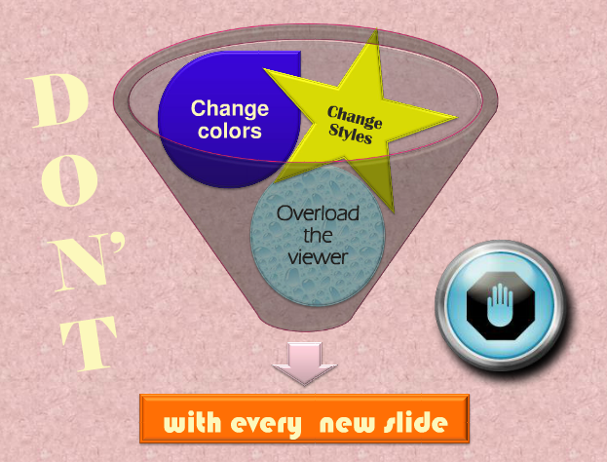

DO:
- Choose a color palette & layout style
- And stick with it


DON’T:
Fill up the screen with lots and lots information written in sentence form. Or even bullet after bullet after bullet. The visuals in your presentation should help guide your speaking, not replace it. People can read faster than they can speak, and they don’t want to hear you just read from the slides. Plus, the more you put on a slide, the smaller the text will get and the smaller the text gets, the harder it is to read. Then, you will annoy your audience as they try to follow along, but falter in their attempts. An annoyed audience is not a happy audience and an unhappy audience won’t really give you the attention your hard and carefully researched presentation deserves. In other words, did you really read all of this? Would you expect your audience to?

Too much Text
- This page contains too many words for a presentation slide. It is not written in point form, making it difficult both for your audience to read and for you to present each point. In short, your audience will spend too much time trying to read this paragraph instead of listening to you. Eventually it will make your slide wordy and boring. You will loose your audience’s attention before you even reach the end of your………………………
- aaaaaaaa…. First slide.

DO:
Choose only key points to highlight Follow a
- 7 words / 6 lines guideline
- Make every slide matter

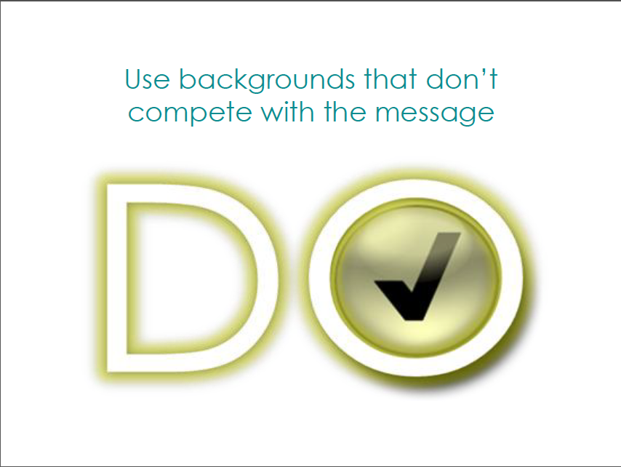
DON’T:
Go crazy with sound effects and animations*
*Imagine many things spinning & whizzing around on the page

DO:
Change the pace by adding Relevant video and website links*
*Just make sure you’ve loaded those pages ahead of time

DON’T:
Include werds that are spellled incorractly
Include incorrect information

Spelling & Grammar:
- Avoid Spelling and Grammar mistakes
  - Proof-read careful your slides for:
      - Smelling mistakes
      - The use of repaetd words
      - Grammatical errs you might have make
- Please have someone else check your presentation, as English is not your first Language!

DO:
Check your spelling
Proofread each slide
Make sure all information is correct

DON’T:
Simply read off the screen
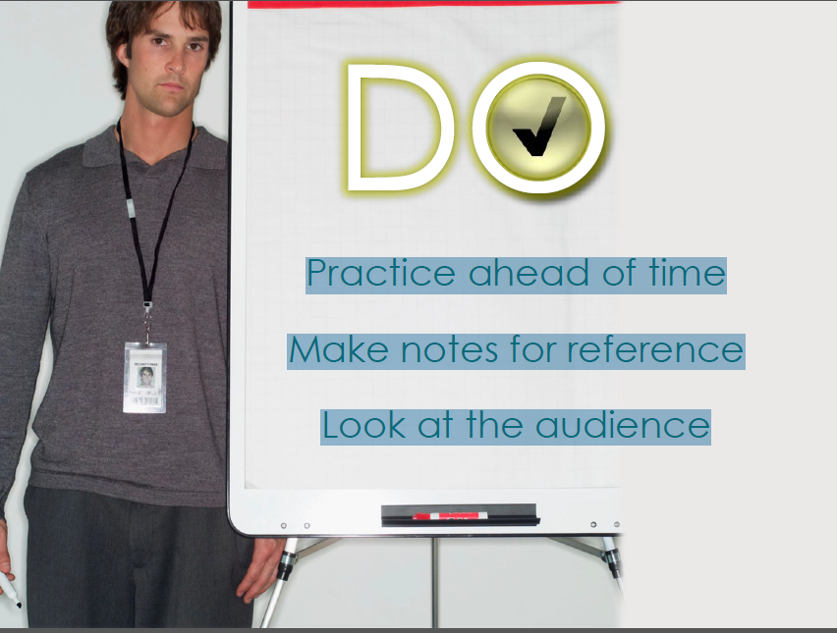

DON’T:
Use Excessive Bullet Points

Background and Colors:
- Which of the following is most readable?
- Why?
Dark Background with light text
Light Background with light text
Dark Background with Dark text
Light Background with dark text
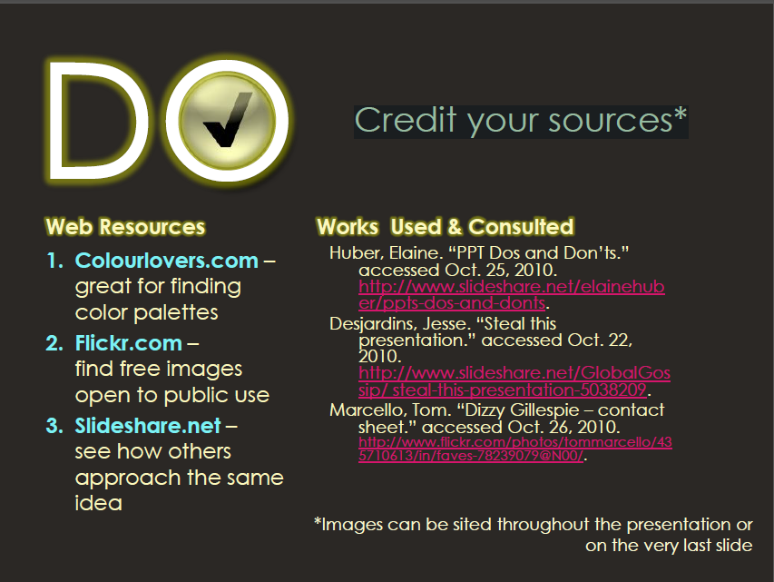

References:
Reference in the same way you would in a written assignment
- Citation: freeloading means individuals, believing that their contributions will not be valued. Contribute less effort to achieving goals when working in a group than if they were working alone. (Kerr, 1983)
- Direct Quoting: “Most effective speakers are flexible, able to adapt the manner of their speaking to the particular context” (Stott, Young & Bryan, 2001:3)
- Diagrams and Images:
Adair’s (1987)
Interlocking
Needs of a Team

DO:
- Save your work frequently (Ctrl+S)
- Backup your work frequently (every day, if possible)
- Store each presentation and its associated files in its proper folder

DON’T
- Rely on the program's Autosave feature.

DO
- use the powerful UNDO command (CTRL+Z) to experiment and learn to use the software
- ask for help when you need it
- maintain a good relationship with someone who knows more about PowerPoint than you do

DON’T:
- Run experiments at the last minute.
  - Run experiments before you save a separate copy of your file.
- Panic and start banging your head on the monitor. It won't help
  - (personal experience talking!)

EXAMPLE
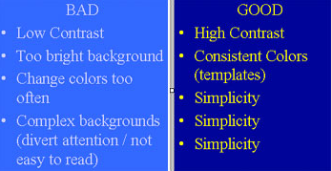

RECAP
- DON’T
Forget to review your main points
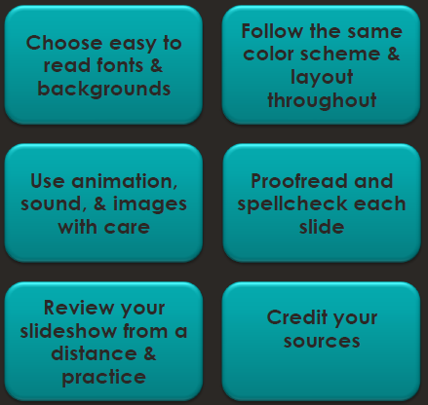

DO
- Be brief
  - no more than 8 bullets/points per slide
- Use appropriate fonts:
  - big (min. 28pts) and clear (sans-serif). If possible, test your slides:
  - run the slide show and see if you can read your slides from the last row of the room where you will be presenting.
- Use appropriate colors
  - not too bright, high contrast, consistent.
  - Remember that what looks good on your monitor does not necessarily look good on the big screen.
- Create contrast using font size, colors

DON’TS
- Put everything you present on the slides.
  - Remember that slides are just a visual aid -- if you overload them, the audience will end up trying to read the slides and not paying attention to you.
- Use different colors / fonts on every single slide.
- Use bright background colors that will strain your audience's eyes
- Use too many animation effects!
  - They are VERY distracting for the audience and make you look like a show-off. Use animation only to make a point and not to make your presentation more interesting (use content to do that!)

References:
- http://www.slideshare.net/covs/ppt-dos-and-donts
- http://gethelp.library.upenn.edu/workshops/biomed/ppt/dodont.html

Chapter 28
How to make a Presentation? The Process

Recap- DO’s:
- Be brief
  - no more than 8 bullets/points per slide
- Use appropriate fonts:
  - big (min. 28pts) and clear (sans-serif). If possible, test your slides:
  - run the slide show and see if you can read your slides from the last row of the room where you will be presenting.
- Use appropriate colors
  - not too bright, high contrast, consistent.
  - Remember that what looks good on your monitor does not necessarily look good on the big screen.
- Create contrast using font size, colors

Recap-DON’TS
- Put everything you present on the slides.
  - Remember that slides are just a visual aid -- if you overload them, the audience will end up trying to read the slides and not paying attention to you.
- Use different colors / fonts on every single slide.
- Use bright background colors that will strain your audience's eyes
- Use too many animation effects!
  - They are VERY distracting for the audience and make you look like a show-off. Use animation only to make a point and not to make your presentation more interesting (use content to do that!)

The ‘Three’ Stage Process:

Stage 1: Creation:
- Tend to be overlooked by many but is crucial
- Selecting a topic
- Setting Clear Objectives & Specific Goals
- Conducting Research
- Audience Analysis
- Creating an Outline
- Using Microsoft PowerPoint
- Inserting Content
- Using Appropriate media
- Prepare Additional Material
- Confirmation Process

Stage 2: Preparation:
- Rehearsals
- Sleep
- Dress for the Occasion
- Arrive early

Stage 3: Presenting Effectively:
- At the beginning of the Presentation:
  - Introduce self, title, background (if necessary)
  - Setting the theme: Involve the Audience
  - Explain ground rules
  - Specify Agenda/Outline

- Use the PowerPoint slides as Guide
- Involve the Audience
- Start presentation on time
- Have confidence
- Eye Contact: Look at
- Body Movements: Gestures
- Voice: Effective Pitch
- Poise: Standing/ Sitting
- Handling Questions
- Reminders

1. How to Create Power Point Presentation?
1. Minimize the number of slides.
- To maintain a clear message and to keep your audience attentive and interested, keep the number of slides in your presentation to a minimum.
2. Choose a font style that your audience can read from a distance.
- Choosing the right font style, such as Arial, helps to get your message across.
- Avoid narrow fonts, such as Arial Narrow, and avoid fonts that include fancy edges, such as Times.
3. Keep your text simple by using bullet points or short sentences.
- Use bullets or short sentences, and try to keep each to one line; that is, without text wrapping.
- You want your audience to listen to you present your information, rather than read the screen.
- Some projectors crop slides at the edges, so long sentences may be cropped.
- You can remove articles such as "a" and "the" to help reduce the word count on a line.
4. Use art to help convey your message.
- Use graphics to help tell your story. Don't overwhelm your audience by adding too many graphics to a slide, however.
5. Make labels for charts and graphs understandable.
- Use only enough text to make label elements in a chart or graph comprehensible.
6. Make slide backgrounds subtle and keep them consistent.
- Choose an appealing, consistent template or theme that is not too eye-catching. You don't want the background or design to detract from your message.
7. Use high contrast between background color and text color.
- Themes automatically set the contrast between a light background with dark colored text or dark background with light colored text.
8. Check the spelling and grammar.
- To earn and maintain the respect of your audience, always check the spelling and grammar in your presentation.

2. How to Make a PPT Presentation?
Theme/Template Method For PC (Office 2010)

About Microsoft PowerPoint
- A versatile presentation tool
- Predefined presentation formats
- Variety of layouts and views
- The ability to edit and modify
- Create text
- charts and graphics
- Incorporate objects like:
- clip art
- Images
- audio & video
- Create special effects and slide transitions

  - Open PowerPoint

  - On the tab at the upper left side of your screen, hit the "File" tab.
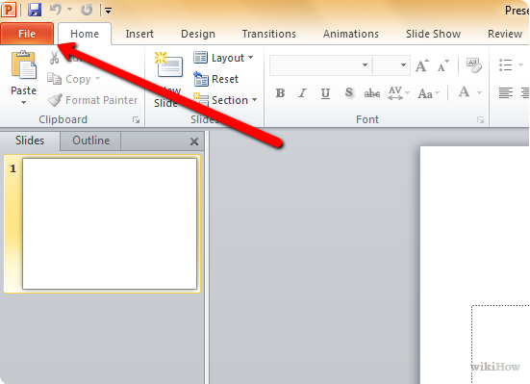

  - On the vertical toolbar to the left, hit the "New" tab
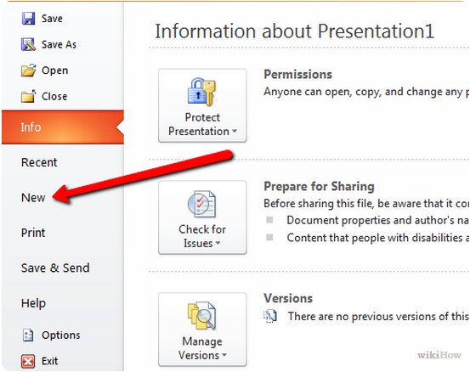

  - If you wish to use a template, click on the "Sample templates" box
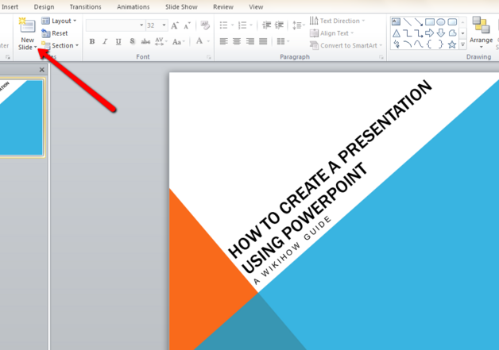
  - Click on the template you want to use, depending on the purpose of your presentation.
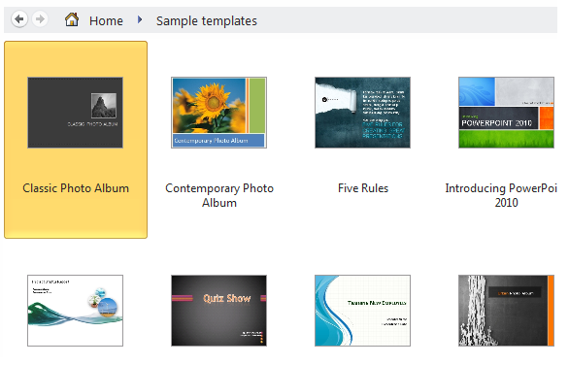

  - If you wish to use a theme, click on the "Themes" box in the "New" tab
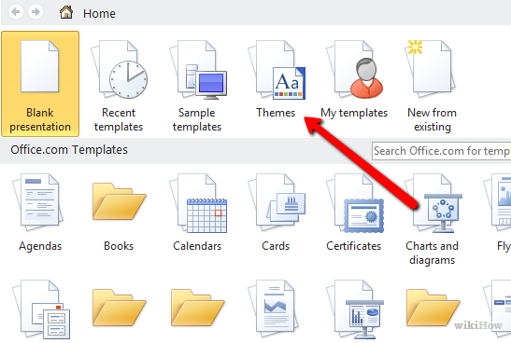

  - Click on the specific template or theme you want to work with from the list of choices
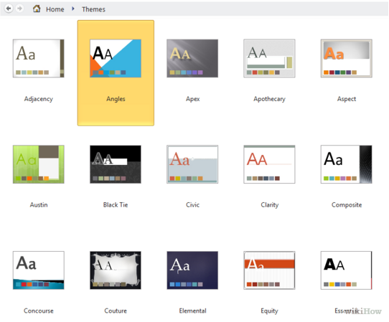
  - Once your theme is loaded, click on the "Click to add title" and "Click to add subtitle" boxes and add the title and subtitle (if necessary) of your own presentation.

  - After deciding on a title, click on the "New Slide" button in the "Slides" tab up top.
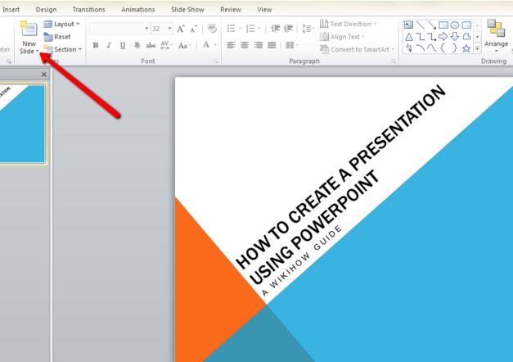
  - Continue adding information and pictures as you see fit
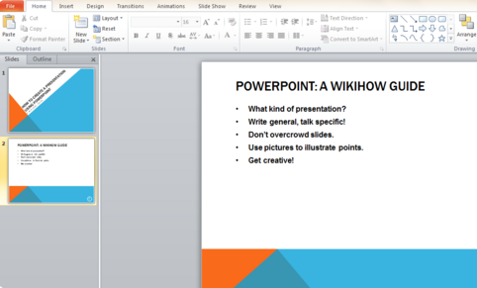
  - Once you are finished with your PowerPoint presentation, go to "File > Save As" and save your file so that you can retrieve it later.
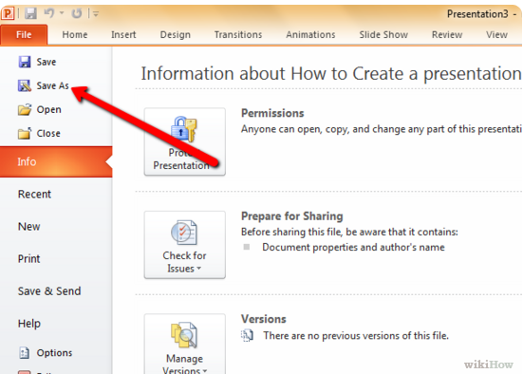
  - When you want to view your presentation as a series of slides, click on the "Slide Show" tab and then click on "From Beginning" top left.
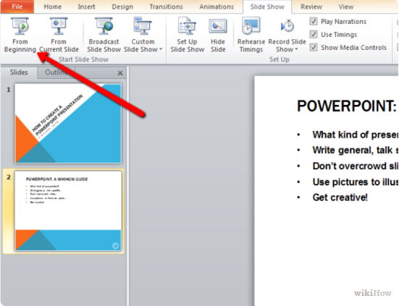

3. How to Deliver the Presentation?

1. Show up early and verify that your equipment works properly.
- Make sure that all equipment is connected and running.

2. Don't assume that your presentation will work fine on another computer.
- Disk failures, software version mismatches, lack of disk space, low memory, and many other factors can ruin a presentation.
- If the computer that you plan to give your presentation on does not belong to you, make sure that it has adequate disk space so that you don't have to present from a CD.

3. Verify that the projector's resolution is the same as the computer on which you created your presentation.
- If the resolutions don't match, your slides may be cropped, or other display problems can occur.

- Turn your screen saver off.
- Keep your audience focused on the content of your presentation.

- Check all colors on a projection screen before giving the actual presentation.
- The colors may project differently than what appears on your monitor.

- Ask your audience to hold questions until the end.
- Questions are an excellent indicator that people are engaged by your subject matter and presentation skills.
- But if you save questions until the end of the presentation, you will get through your material uninterrupted. Also, early questions are often answered by ensuing slides and commentary.

7. Avoid moving the pointer unconsciously.
- When you are not using the pointer, remove your hand from the mouse. This helps to stop you from moving the pointer unconsciously, which can be distracting.

- Do not read the presentation.
- Practice the presentation so that you can speak from bullet points. The text should be a cue for the presenter rather than the full message for the audience.

- Stay on time.
- If you plan a certain amount of time for your presentation, do not go over. If there is no time limit, take less time rather than more to ensure that people stay engaged.

- Monitor your audience's behavior.
- Each time that you deliver a presentation, monitor your audience's behavior.
- If you observe people focusing on your slides, the slides may contain too much data or be confusing or distracting in some other way.
- Use the information you learn each time to improve your future presentations.
References:

- http://www.wikihow.com/Create-a-PowerPoint-Presentation
- http://office.microsoft.com/en-us/powerpoint-help/tips-for-creating-and-delivering-an-effective-presentation-HA010207864.aspx

Chapter 29
Nonverbal Communication in Presentations

Introduction to Communication:
- Communication in general is process of:
- Sending
- Receiving

- These messages enable humans to share:
- Knowledge
- Attitudes, and
- Skills.

- Communication is composed of two dimensions –
- Verbal Communication
- Nonverbal Communication

Presentation skills, conversation skills and writing skills are the three keys to effective communication.
The Lecture defines some tips for using non verbal communication to improve your presentation skills.

Components of Communication:

Verbal Messages:

Categories in Non-Verbal Messages:

Categories in Non-Verbal Messages:

Para verbal Messages:
- Messages that we transmit through the tone, pitch, and pacing of our voices.
- It is how we say something, not what we say.

According to the social anthropologist, Edward T. Hall,
in a normal conversation between two persons, less than 35% of the social meanings is actually transmitted by words. So, at least 65% of it is conveyed through the body
(non-verbal channel).

Definition of Nonverbal Communication:
- Non-spoken context within where all face-to-face communication takes place.
- Every conscious or subconscious behavior is covered with meaning without which all verbal communication would be ambiguous.

Nonverbal Communication:
Non-verbal communication includes:
- Pitch
- Speed
- Tone
- Voice volume
- Gestures
- Facial expressions
- Body posture
- Stance/ Attitude
- Eye movements
- Dress and appearance
Nonverbal Communication:
It also includes:
- Touch
- Glance
- Vocal tone
- Pause (silence)
- Intonation
- Smell
- Word choice and syntax
- Sounds (paralanguage)

Have you ever heard anyone say;
His actions spoke so loudly I couldn't hear what he said?
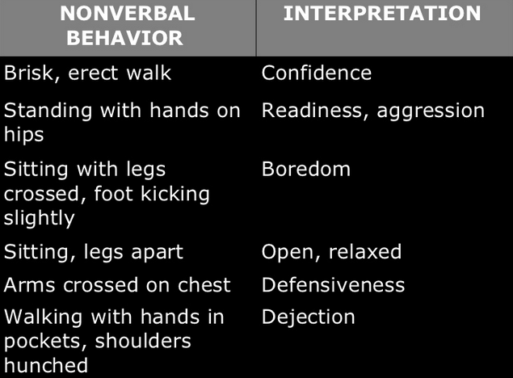

A Small Exercise:
So What Does This Mean?

So What does This Mean?

So What does This Mean?

How to work on Nonverbal Communication during Presentations?
First Impressions
- You have only a few seconds to make a good impression. So make your “audience" at the centre of the universe:
- face them
- give direct eye contact
- palms outwards
- open arms
- a big smile and a firm
- but not bone-crushing handshake
- First impressions are also about your:
- Dress
- Hair
- Shoes and
- Air of confidence
- Be aware that others are rushing to judgment about you - especially important if you are going for a PRESENTATION!!!

Eye contact
- Eye Contact helps indicates your interest in the people in the audience.
- It increases your credibility.
- When you make eye contact with people in the audience, you increase your chances of getting your message across.
- Eye contact helps you establish a connection with the audience.
- When you make eye contact with people as you are speaking, you build one to one bonds with them.

Smiles are Powerful:
- Always try to keep a smile on your face when you are speaking.
- Smiling makes a speaker more warm, likable and friendly.
- When you smile, people see you as happy -- and this makes them more receptive to you.
- People react positively to smiles.
- When you smile, the audience smiles and a smiling audience is a receptive audience.
- Smiling will help you get your points across and accepted.

Gestures:
- Gestures are another important form of non verbal communication.
- But you have to be careful with gestures.
- Practice your talks in front of a mirror.
- Watch your natural gestures.
- Then enhance them.
- Strengthen your gestures.
- Big rooms demand BIG gestures.
- However tone them down –
- Depending on the audience.
- Making your gestures natural and reflective of what you’re saying.
- Try to avoid choppy, sudden gestures when you’re speaking. Focus on making your gestures fluid.

Posture and Body Orientation:
- Always stand up straight and look directly at the audience; it indicates confidence.
- Slumped shoulders and facing towards the floor.
- If you're using slides, speak to the audience, not the slide. It's OK to look at a slide -- especially if you want to draw the audience's attention to it, but always turn back to the audience after a few seconds.
- Tall and erect communicates energy and purpose whereas slouched and hunched implies tired and lacking in energy.

- Looking up is generally regarded as indicative of optimism whilst persistently looking downward suggests secrecy or insecurity.

Hands and Arms:
- Some guidelines...
- Palms turned outwards imply warmth and friendship.
- Don't point; it is aggressive and perceived as such - especially if you do it in an irritated way.
- Examples:
- Gordon Brown uses his hands a lot but he will gesture with the backs of his hands turned towards the audience in a way is suggestive of "giving".
- Tony Blair would pull his fingers together into a point and make slight movements.

Proximity:
- Many speakers get away from the platform and walk the room.
- This means that they get up close and personal with people in the audience.
- Use of wireless device to advance slides,
- People feel that you’re part of them
- Having a conversation with them
- Appear more natural!!!

Be aware of the space between you and others:
- Cultural norms vary between countries and are also different for:
- Friends v strangers
- Children v adults.
- If someone is backing away from you, then you are too close.

Your Voice:
- Be animated
- Avoid speaking in a monotone.
- Show excitement for your material with your voice
- Always practice talks out loud
- It will improve your impact with your audience.
- Using your arms in an animated way can bring:
- Energy
- enthusiasm and
- a bit of fun to the proceedings.

Use body language as a Tool:
- Active nodding and eye contact is especially useful to indicate interest when someone else is speaking.
- If your friend is speaking and you are doodling, yawning, looking around aimlessly or reading notes, then it undermines their credibility.
- Need to be boss? Be the first to offer a handshake, the last to go through the door.
- Put yourself at the head of the table; head up with a purposeful manner.
  - Need to sweet-talk audience?
  - Make them feel in control
  - give them the best seat/position
  - use soft, smiley body language

Mirroring tactics can create empathy?
- Signal similarity.
  - Show that you have something in common –
  - Everyone likes dealing with people they can empathize with.
  - Make every non-verbal approach
- dress code
- formality of manner
- presentation style
- Precisely reflect your audience.
- Synchronize with the other party!
  - It’s true that:
    - Matching others' movements makes them feel in sync with you
  - Just don't make it too obvious.
    - Instead, nod when they're emphasizing an important point
    - Smile when their words indicate pleasure

Sincerity:
People will judge you sincere if they think you are listening to them so look for signs that someone wants to speak and invite them to contribute.
Example:
- Politicians sometimes touch their heart to underpin their sincerity or commitment to a key point.
- Don't overplay this though or it will look cheesy and completely insincere.

Reading "tells“…
- Quite often...
- Closed expressions & gestures
- leaning back
- Closed body language
- folded arms
  - suggests the audience may be bored. (etc)
  - they may be unconvinced
  - whereas open body language and leaning forward suggests interest.
- The word to remember here is "may". Reading body language is not a science of certainty.

Reading the audience: don't rush to conclusions:
- Be cautious of reading too much into innocent gestures.
  - Folded arms, for example, may simply mean that someone in the audience is cold or likes to fold their arms.
- Look for groups of gestures –
  - if someone has angled their body away from you
  - is looking out the window
  - then yes, you may well have lost their interest.

If you use these non verbal communication ideas you'll become someone whose presentations carry an impact -- and you'll be on your way to career and life success.
Nonverbal Communication:
- Introduction to Communication
- Components of communication
  - Verbal
  - nonverbal
  - Para verbal
- Definition of nonverbal communication
- Exercise
- How to work on Nonverbal Communication during Presentations?
  - First Impressions
  - Eye contact
  - Smiles are powerful
  - Gestures
  - Body postures and orientation
  - Hand and arms
  - Proximity
  - Voice
  - Body language as a tool
  - Sincerity
  - Reading your Audience

References:
- http://EzineArticles.com/3675164
- www.readysetpresent.com
- http://www.slideshare.net/deepakagarwal7/non-verbal-communication-and-use-of-body-language-presentation
- http://EzineArticles.com/?expert=Bud_Bilanich
- www.skillsworkshop.net

Chapter 30
Verbal Communication during Presentations

Nonverbal Communication:
- Introduction to Communication
- Components of communication
  - Verbal
  - nonverbal
  - Para verbal
- Definition of nonverbal communication
- Exercise
- How to work on Nonverbal Communication during Presentations?
  - First Impressions
  - Eye contact
  - Smiles are powerful
  - Gestures
  - Body postures and orientation
  - Hand and arms
  - Proximity
  - Voice
  - Body language as a tool
  - Sincerity
  - Reading your Audience

Verbal Messages:
Paraphrasing | a brief, concise statement reflecting the content of the speakers message
Reflecting Feeling | a statement, in a way that conveys understanding, of the feeling that the listener has heard
Summarizing | a statement of the main ideas and feelings to show understanding
Questioning | asking open questions to gain information, encourage the speaker to tell her story, and gain clarification

    - The following tips are a starting point to help you think about how you can improve your verbal communications skills, whether in planned or unplanned situations!
- 1. Read more…
Simply increasing what you read (business texts, novels, newspapers etc) can improve your vocabulary, help you express ideas clearly and eliminate weaknesses in your language skills.
- 2. Think about the words…
    - Too many words will bore your listener, take up too much time and result in you losing credibility.
    - There is no need to waffle!
    - Remember not to use words that people don’t understand (they may not even tell you that they don’t understand what you are saying), as you may appear intimidating and make them feel inferior.
- 3. Prepare (if you can) …
You would spend time planning what you would say if you were writing. Think:
  - how to make it accessible to as many audience as possible.
  - Use approaching situation
  - Take time out to think about the questions you may be asked and
  - what answers you may need to give.
  - Be prepared for awkward questions and situations where you may need to explain something in a different way.
- 4. Listen and be interested…
Listening more and talking less means you will understand and bring your listener into the conversation.
  - This helps them to trust you and make them feel that you really understand their needs.
  - When they talk, be interested and show your interest.
  - This will improve the rapport you are trying to build.
  - Using note-taking skills like Mind Mapping can help you to take more effective and memorable notes.
- 5. Be aware of non-verbal communication traps
  - The impact of the words you say is only a small element of the communication you are giving.
  - You should make sure that your words, their tone, the gestures you make, facial expressions and body language you use, are all relevant to your conversation.
Non-Verbal Messages
1. Account for about 55% of what is perceived and understood by others.
2. Are conveyed through our facial expressions as well as our postures and gestures.

- 6. Honesty is the best policy
  - Promising something that is not possible will break down any trust that you have developed.
  - Telling someone that you "don’t know –
    - but can find out" is more positive than just trying to give an answer you hope is effective.
- 7. Show and seek some understanding
  - Look for understanding from your audience. It’s easier to back track at certain points in your conversation than revisit the whole conversation again – or you risk getting the wrong results because your audience did not understand!
    - You can use this when delivering or receiving a message.
    - Occasional summaries and confirmation questions can be extremely useful.
- 8. Think about perspectives
  - Think about what you are saying from the other person's perspective.
  - Just because you understand what you mean, it doesn’t mean that they will.
- 9. Develop your skills
  - There are a number of techniques you can learn to help improve your verbal communication skills.
  - These include:
    - The skills to develop plans you can use to formulate responses whether planned or impromptu.
    - Learn the techniques you need to be more effective during these interactions. Mind Mapping will help you to take and make notes – it will also help you do a lot more during your business day.

How to Create Effective Presentations:
- Focus on the purpose
- Focus on your Audience
- Satisfy document requirements
  - Documentation style
  - Visuals
  - data
- Get to the point ; be Concise
- Provide accurate information (Research)
- Express yourself clearly (Grammar; Proofreading)
- Format your slides carefully (be neat and leave white space)
- Manage your time efficiently (Meet deadlines)

    - 7 Cs 0F Communication:
  - Completeness:
Business message is complete when it contains all facts the reader or listener needs for the reaction you desire. As you strive for completeness, keep the following guidelines in mind;
- Provide all necessary information
- Answer all questions asked
- Give something extra when desirable
Answer all questions that are asked. Give something extra when desirable. Check for five Ws & one H (Who, What, When, Where, Why and How). Answering the five W’s helps make messages clear. Look for questions: some may even appear buried within a paragraph. Locate them and then answer precisely. Use your good judgment in offering additional material if the sender’s message was incomplete.
Exercise: You are the president of an industry association and have received the following inquiry from an out of town member:
“I think I would like to attend my first meeting of the association, even though I am not acquainted with your city. Will you please tell me where the next meeting is being held?”

How would you reply to this letter keeping in mind Completeness of the message?

  - Conciseness
    - Eliminate wordy expressions.
    - Include only relevant statements
      - be focused
      - Shorten & avoid long explanations
      - avoid gushing politeness
    - Avoid unnecessary repetitions
    - use short forms the second time
    - use pronouns
Eliminate Wordy Expressions:
Use single words in place of phrases. Even Winston Churchill made extensive use of simple, one syllable words.

Exercise 1:
- Find single word substitutes for the phrases:
    - With regard to about
    - Despite the fact that although
    - At the present writing now
    - Is of opinion that thinks
    - In the first place first
    - At a rapid rate fast

  - Consideration
Consideration means preparing every message with the message receivers in mind; try to put yourself in their place.
- You are considerate
- you do not lose your temper
- you do not accuse and you do not charge them without facts
- the thoughtful consideration is also called “you-attitude”.
- Focus on YOU instead of I & WE
- Show reader benefit & interest
- Emphasize on positive & pleasant
- Apply integrity & ethics

  - CONCRETENESS
Communicating concretely means being specific, definite, and vivid rather than vague and general. Often it means using donatives (direct, explicit, often dictionary based) rather than connotative words (ideas or notions suggested by or associated with a word or phrase)

Use Specific Facts and Figures
It is desirable to be precise and concrete in both written and oral business communication.
- Example

  - CLARITY
Getting the meaning from your head to the head of your reader (accurately) is the purpose of clarity. Of course you know it is not simple. We all carry around our own unique interpretations, ideas, experiences associated with words.

Choose precise, concrete and familiar words
Unfamiliar: After our perusal of pertinent data, the conclusion is that a lucrative market exists for the subject property.
Familiar: The data we studies show that your property is profitable and in high demand.

Construct Effective Sentences and Paragraphs
At the core of clarity is the sentences. This grammatical statement, when clearly expressed, moves thoughts within a paragraph. Important characteristics to consider are:
  - Length
  - Unity
  - Coherence
  - Emphasis

Ex : Use simple words
- Subsequent later
- Accede agree
- Endeavour try
- Supersede replace
- Disclose show

  - COURTESY
True courtesy involves being aware not only of the perspective of others, but also their feelings. Courtesy stems from a sincere you-attitude. The following are suggestions for generating a courteous tone;
- Be sincere , tactful, thoughtful and appreciative
- Omit expressions that hurt , irritate, or insult
- Grant apologies graciously

  - CORRECTNESS
At the core of correctness is proper grammar, punctuation, and spelling. However a message may be perfect grammatically and mechanically but still insult or lose a customer.
- Use the right level of language
- Check accuracy of facts, figures and words
- Maintain acceptable writing mechanics
- Choose non discriminatory language
- Use parallel language

    - Effective Verbal Communication
1. Know you audience
- You need to listen.
  - If you are talking to a small group of people in an informal discussion, listening to what other people are saying, or not saying, is your best tool.
  - If you are addressing a large group of people you want to find out as much as possible about the people you are going to talk to.
- Do your homework.
- What are their burning questions?
- What is their knowledge to the subject that you are going to talk about?
- Do they have an opinion in any direction and is their passion?
2. Know your topic
- This might sound like an obvious statement. But you would be surprised if you know how many unprepared performances or presentations that are held every minute.
  - Read, Google, listen to others etc.
  - Again, do your homework.
  - What are your feelings about a certain issue?
  - Why?
  - List all the potential questions to your topic.
- This is probably one of the most important tip for effective verbal communication.
3. Plan your presentation
- Make up a storyboard or make a mind map.
- Be creative and lay out all the threads to your topic that you can possible think of.
  - What background material do you have for the topic?
  - Is there a particular angle that you like?
  - What material/knowledge do you lack?
- Biggest reason for not having effective verbal communication is that people say to much.
- They have so many things that they want to get across.
- Your biggest challenge is now to cut down the material to a minimum.
- If you will do a PowerPoint presentation a good ground rule is to have one slide per 2-5 minutes.
- Because when you are passionate about something you build up knowledge and you don’t want to miss anything important.
  - But think about the audience and your knowledge about them.
  - What do they want to know?
  - what would they benefit from knowing?
  - Are there parts of the subject that really more than they need to know, for you to get your point across?
4. Own the room
- If possible it is always good to see the room where your presentation will take place.
- There are a number of things that can disturb you in the first couple of minutes of your presentation.
  - How big is the room?
  - how are the chairs placed?
  - Is there a stage?
  - Do you need a microphone?
  - Where will that be placed?
  - Who will flip the slides in your presentation?
  - Can you do that yourself, if so, how?
  - If you need special equipment, where will they be placed?
  - Will there be spotlights? And so on.
- Find out as much as you can before hand, so you have control.
- 4. Own Your Room (cont…)
- If you are a part of a larger program, it is very good to sit in on other presentations.
- This will be beneficial to you for to main reasons.
  - You will get a better feeling for the audience. Are they open, serious, emotional etc.
  - B. You will get a better feeling for the room.

Summary:
- Tips to improve your verbal communications skills
- 7 C’s of Communication
- Effective verbal communication

References:
- http://www.illumine.co.uk/write-speak-influence/verbcom-info/nine-ways-to-improve-verbal-communication.html
- http://www.communicationtoolbox.com/effective-verbal-communication.html

Chapter 31
Creating Effective Visual Aids
Presentation Skills

What are Visual Aids?
- Visual aids are an important part of many presentations.
- The most commonly used media are the flipchart and computer-based presentation programs.

The Purpose of Using Visual Aids in your Presentations
- The Purpose of Using Visual Aids should be:
  - To support your ideas and improve audience comprehension of your presentation
  - To add variety to your presentation by giving the audience a break from listening and letting to see something.
  - To help illustrate complex ideas or concepts and help in reinforcing your ideas.

Presentations and Visual Aids
- While you usually submit a written version of your work, you may also be expected to present it to your class orally.
- This can be a great opportunity to learn presentation technologies such as:
- Posters
- PowerPoint or “prezi”.
- You can make visual aids to support your:
  - spoken delivery
    - ranging from basic points to more complex multimedia creations incorporating:
    - film clips
    - Pictures
    - graphics and
    - Animations

Why use Visual Aids?
- Preparation for your presentation should involve design of any visual aids which help your audience to understand what you are saying.
- Images and diagrams can convey messages and information which, if spoken, would take longer to explain and be harder to digest.
- However, don't assume that you can flash up a diagram and the audience will immediately understand what it means.
- Why use Visual Aids?
- Audience needs time and clear explanations to make sense of your material.

Visual stimuli combined with your oral delivery also make the presentation more memorable.
- They are also a good way of maintaining your audience's interest and attention.
- Make sure they support and complement what you are saying, not directly repeat, contradict or distract from your speech.
- The main types of visual aids are:
  - Whiteboard
  - flip chart
  - overhead projector (OHP)
  - PowerPoint (or other presentation software)
  - Video
  - Props
  - Handouts
  - Posters
  - yourselves demonstrating an action or in a role play
Which types of visual aid might you use in your next presentation?
For example: Consider whether PowerPoint is the best way to show a detailed diagram or would a handout be better? What might you use a flip chart for?

Example: Posters
- These can be made on PowerPoint or Microsoft Word.
- They’re not difficult to design, but:
  - before you decide to make one
  - check how you will get it printed
  - as that can be expensive if you have to pay a printer.

What makes an Effective PowerPoint Presentation?
- You will probably have your own ideas about this, so think about how you feel about PowerPoint as a member of the audience and list good and poor techniques.
- Here are some highlights, common pitfalls and techniques for making the most of PowerPoint including aspects using as:
  - PowerPoint as a script
  - Designing accessible visual aids
  - Effective diagrams and graphs
  - Referencing

We will watch the sample Presentation at the end!!!

Using your Visual Aids
Here are a few suggestions for making most effective use of your carefully designed visual aids:
1. Be careful not to stand in front and obscure the view of your audience.
2. Avoid reading from the large projector screen as this means you turn your back to the audience obscuring eye contact and reducing projection of your voice.
    - If you need to read directly from the text look at the PC or laptop screen.
3. Try making brief notes on index cards, including any details like dates, statistics or names that you need to get right. No-one will expect you to speak without an aide memoir.
- Be sure to interact with the information on your visual aids by pointing to specific points or part of diagrams etc. This helps the audience to make links between your speech and detail on the visual aids.
- Think about what you want the audience do with any handouts. If they need them during the session hand them out when necessary. If they are for future reference consider handing them out at the end to avoid them causing distraction. Advise the audience of what you plan to do.

Contingency Plans
- Whenever you use technology in a presentation you run the risk of technical problems. You can reduce the risk of this impacting on your presentation by:
  - Making sure you have your PowerPoint presentation saved in a few formats.
    - memory stick
    - CD
    - e-mailed to an easily accessible e-mail account
- Prepare OHP transparencies and/or handouts in case technical issues mean that you can't use the computer and/or projector.
- If you want to show a website, you could use screen captures rather than risking going online.
- Make sure all the hardware and software you need will be available, e.g:
  - Speakers
  - access to internet
  - multimedia software
  - spare bulb, if you're using an OHP!
- Practice with any multimedia, ideally in the venue you will be presenting in.
- Be aware that PowerPoint presentations created on an Apple Mac operating system may not be compatible with the PC/laptop that you are required to present on. You may need to check this compatibility.

10 Tips for Using Visual Aids
- Plan your presentation before creating visual aids.
  - Know what you want the audience to do as a result of hearing your presentation.
  - Then figure out what they need to know to do what you want them to do.
  - Then create a simple outline that logically and clearly develops your main points.
  - Finally, create visual aids to support your message.
- Use visual aids sparingly.
They are aids to your presentation – not its sum and substance.
Use them to highlight and support your key points.
- Make them visible to the entire audience.
  - Projecting an image people can’t see is as senseless as speaking so softly people can’t hear.
- Talk to the audience, not to the aid.
  - Look at the audience at least 80% of the time.
  - Avoid turning your back to the audience.
- Avoid laser pointers.
  - Your aid should be so clear that your audience can easily follow along.
  - Use your hand, if necessary.
  - (If you absolutely have to use a pointer, set it down after you are finished. Holding on to it will only encourage you to use it for every point on every slide.)
- Explain the content of the aid when you first show it.
  - As soon as you show people an object, they will look at it – even if you’re talking about something else.
  - Don’t make them divide their attention.
- When you finish with the aid, remove it, cover it, or turn it off.
  - When using PowerPoint, tap the B key and the screen will go to black.
  - Tap any other key and the screen light up again.
- Limit the amount of material on any one aid.
- Use each slide to convey a single point.
- Bullet points – no more than four or five per slide –
  - explain,
  - illustrate, or
  - substantiate that one point.
- Avoid clip art from well-known sources.
- It’s almost always boring and amateurish.
- DO use:
  - Images
  - graphs, and
  - charts,
- whenever possible and appropriate.
- Be prepared to give your presentation without your visual aids.
- Murphy’s Law –
"if anything can go wrong, it will"
- -- applies in spades to anything involving technology and an audience.
  - Have a backup plan in case something goes wrong.
  - Take a hard copy of your slides.

Learn about Visual Aids with the example:
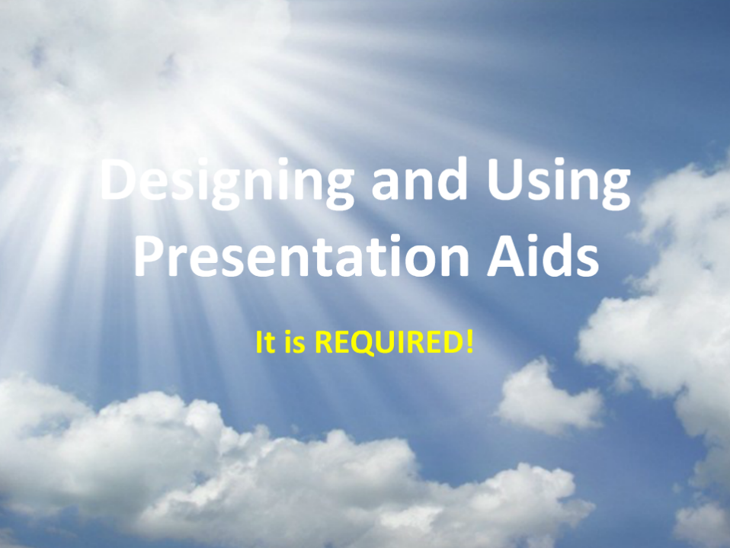
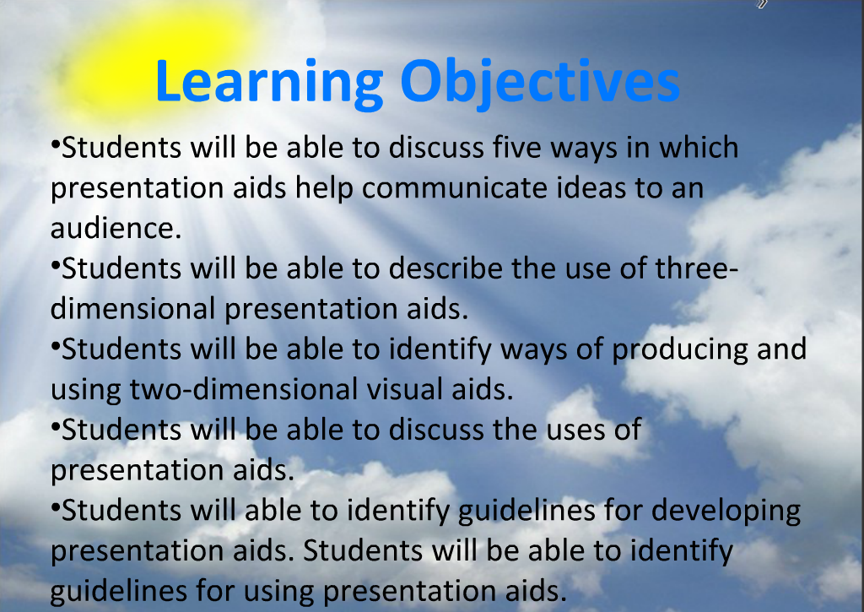
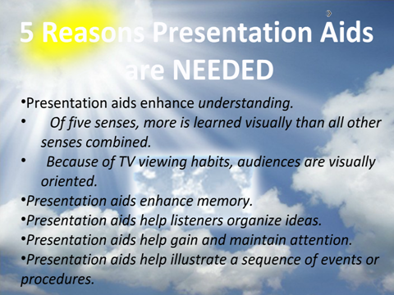
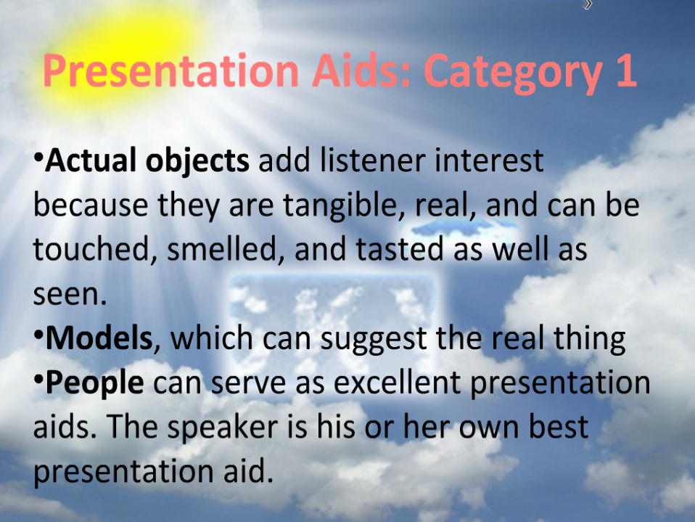
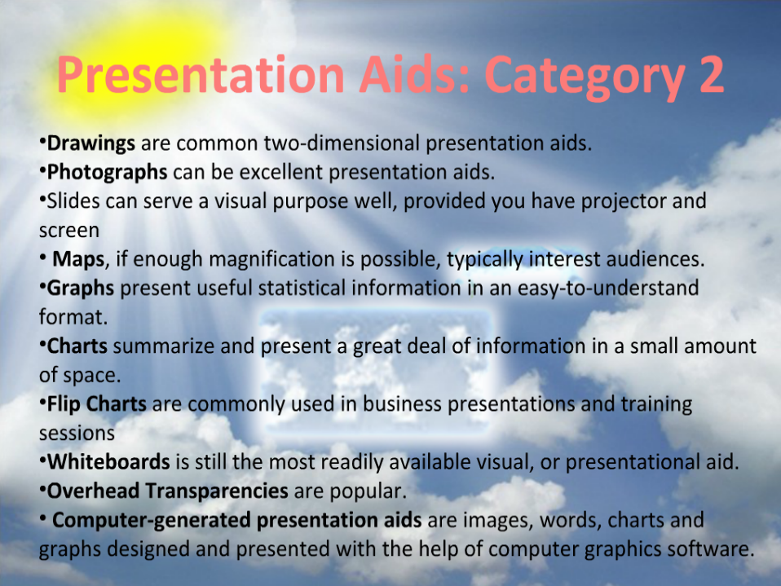
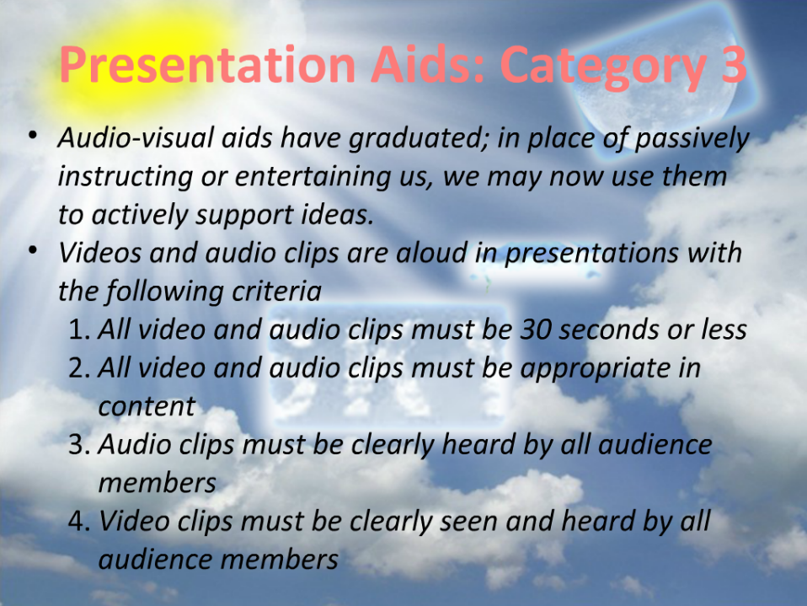
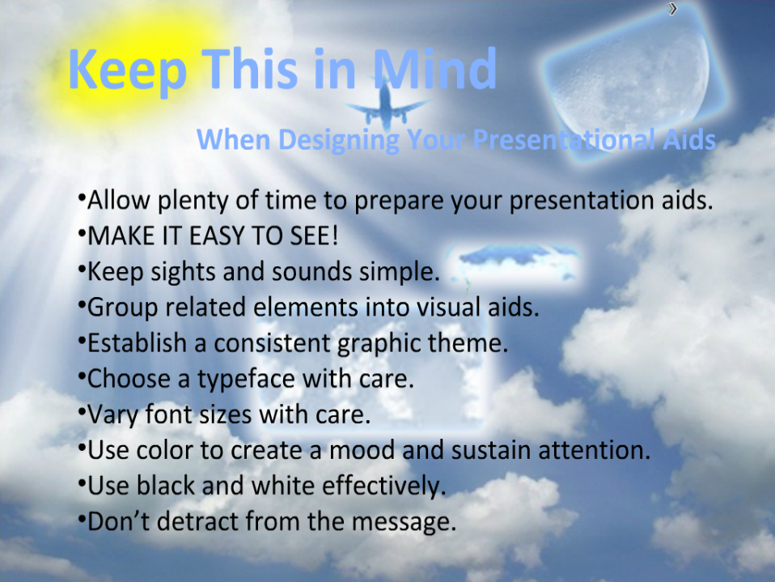

Summary
- What are visual aids?
- Why use visual aids?
- Purpose of visual aids
- 10 Tips for Using Visual Aids
- Contingency plans
- Example: Designing and using Visual Aids

References:
- http://powerpoint.wiziq.com/topic/757-powerpoint-presentations-visual-aids
- http://www.toastmasters.org/MainMenuCategories/FreeResources/NeedHelpGivingaSpeech/TipsTechniques/VisualAidsPowerPoint.aspx
- http://www.brunel.ac.uk/learnhigher/giving-oral-presentations/designing-visual-aids.shtml

Chapter 32
How to Overcome Nervousness When Doing PowerPoint Presentation?

Introduction
- POWERPOINT is widely used in our lives like school works or business reports.
- Making a PowerPoint slideshow not an easy thing to do, but as compared to presenting it in front of large audience, it is nothing.
- It is natural that people will feel nervous when speaking in front of people.
- Even the president, no matter how well-prepared he is, he will still be nervous.
- Doing PowerPoint presentation should be easier than directly public speaking, for PowerPoint can help you to remember the contents and it could switch people’s focus from you a little bit.
- Control Your Emotions:
The best speakers should learn to control their emotions and no longer feel awkward when hundreds of eyes are watching them.
- Eye Contact:
Scientific study indicates that it is true that the eyes could cause pressure on you. However, they have to manage to overcome the nervousness, fear and anxiety that public speaking used to trigger.

Do your knees feel like Gumby's when you have to get up and speak in front of a group?

Do you feel like the next words out of your mouth are going to be the dumbest words ever uttered by a human?

According to the book of Lists, the fear of speaking in public is the #1 fear of all fears. The fear of dying is #7!
- Over 41% of people have some fear or anxiety dealing with speaking in front of groups. People who have this fear can experience all kinds of symptoms:
  - Sweaty palms
  - Accelerated heart rate
  - memory loss and
  - even difficulty in breathing
Some of the world's most famous presenters have freely admitted to nervousness and stage fright. Mark Twain said it best:

"There are two types of speakers: those that are nervous and those that are liars".

How to Overcome Nervousness?
Think of it as the 9 P's Prior Proper Preparation Prevents Poor Performance of the Person Putting on the Presentation.
- Know the room - become familiar with the place in which you will speak.
  - Arrive early and walk around the room including the speaking area.
  - Stand at the lectern, speak into the microphone.
  - Walk around where the audience will be seated.
  - Walk from where you will be seated to the place where you will be speaking.
- Know the Audience - If possible, greet some of the audience as they arrive and chat with them. It is easier to speak to a group of friends than to a group of strangers.
- Know Your Material - If you are not familiar with your material or are uncomfortable with it, your nervousness will increase. Practice your speech or presentation and revise it until you can present it with ease.
- Learn How to Relax - You can ease tension by doing exercises.
    - Sit comfortable with your back straight.
    - Breathe in slowly, hold your breath for 4 to 5 seconds, then slowly exhale.
    - To relax your facial muscles, open your mouth and eyes wide, then close them tightly.
- Visualize Yourself Speaking –
Imagine yourself walking confidently to the lectern as the audience applauds.
Imagine yourself speaking, your voice loud, clear and assured.
When you visualize yourself as successful, you will be successful.
- Realize People Want You To Succeed –
All audiences want speakers to be:
    - Interesting
    - Stimulating
    - informative and
    - entertaining
They want you to succeed - not fail.
- Don't apologize For Being Nervous –
    - Most of the time your nervousness does not show at all.
    - If you don't say anything about it, nobody will notice.
    - If you mention your nervousness or apologize for any problems you think you have with your speech, you'll only be calling attention to it.
    - Had you remained silent, your listeners may not have noticed at all.
- Concentrate on Your Message – not the medium –
  - Your nervous feelings will dissipate if you focus your attention away from your anxieties and concentrate on your message and your audience, not yourself.
- Turn Nervousness into Positive Energy –
  - the same nervous energy that causes stage fright can be an asset to you.
  - Harness it, and transform it into vitality and enthusiasm.
- Gain Experience –
  - Experience builds confidence, which is the key to effective speaking.
  - Most beginning speakers find their anxieties decrease after each speech they give.
- If the fear of public speaking causes you to prepare more, then the fear of speaking serves as its own best antidote.
- Remember, "He who fails to prepare is preparing for failure - so Prepare, Prepare, Prepare"

Fear of speaking in public regularly comes high up in surveys of human fears!
- Nerves? What Nerves?
- Nervousness usually feels worse than it looks (that's if people notice at all).
- Your image of yourself may be worsened by nerves, but it probably does not look that way to others.
- Your nervousness might not be as bad as you think.

Change your Thinking
- Live through your nerves, accept them, know the signs of bad nerves, and change your thinking about them. You need to put something between the nervous symptoms and the negative thinking that they can lead to - if you let them.
- Try to focus on your material - not the detail but the 'big picture' - or think about something else entirely.
  - Try thinking about any everyday thing that is not too demanding:
    - What are you going to cook tonight?
    - What shopping do you need?
    - What book are you reading at the moment?
    - Or think of your next holiday.

It's not about You
- Although your nerves may try to tell you otherwise, the presentation is not really about you. It is about the topic.
  - You need to focus the audience's attention on the topic and not on you.
  - So begin with composing yourself so that you can direct the audience's attention to your material.
  - Audiences are supportive of people who are nervous. The audience is not your enemy.
  - Think about your audience as your supporter.
  - It is not you vs. them.
  - Remember that your listeners want you to succeed.
  - They are not there to trip you up.

Relax
- Do some deep breathing:
  - holding the breaths for a few seconds
  - then letting them out slowly
    - this helps to make the body look relaxed, even if it doesn’t necessarily feel relaxed
- Relax your shoulders.
- Keep your hands still or do something like reading or making notes.

Start Slowly
- Allow yourself to speak more slowly than normal, especially at the beginning, so you can collect your thoughts.
  - Look at people and establish a rapport with the audience, by accepting them into the space that you are in charge of: your presentation.
- If you read from a script, look for an opportunity to break from your script early on and talk directly to the audience for a moment.

Forgive Yourself and Move on
- Everyone makes mistakes and there is no perfect presentation. All human communication is full of small breakdowns, glitches and repairs.
- Be forgiving of yourself.
  - You may forget something, make a mistake, cough, forget a word, or lose your bearings momentarily. Don't panic at these moments. Stay calm. Don't let them destroy your presentation. It's only one moment.

Audiences
- Don't let yourself be distracted by individuals in the audience who give you a hard time while you are talking or who constantly interrupt. If this happens, insist on taking questions at the end. Also, don't be distracted by unusual behavior in the audience. Audiences are, after all, human.
  - Imagine any one of your audience fell asleep and start snoring during a
  - Do not take any notice.
  - The rest of the audience, thankfully, did not fall asleep.

Prepare
- Go to the room early and make sure you have everything you need (projector, memory stick, paper, water).
  - If you have to use a microphone, test it.
  - Look for wires and other obstacles to avoid.
- Plan where you will put your materials and where you will stand so the audience sees both you and your resources.

And enjoy..
- Try to enjoy your presentation and convey interest, enthusiasm or confidence, even if it's a very serious topic.
- This will relax you and help to get the message across more clearly.

This is what irritates people during presentations:
- the speaker was nervous
- the speaker was disorganised
- the speaker never looked at me
- the speaker had bad accent
- the speaker did not sound enthusiastic
- the speaker was monotonous
- the visuals were bad
- I was irritated by his/her clothing
- the speaker was speaking too softly
- the speech was confused; I didn’t know what
- he/she was trying to tell me

So…. Different aspects
To avoid any negative outcome the following aspects are important in making a presentation:
- Preparation and planning
- Language of presentations
- Visuals/equipment
- the presentation itself

Preparation at home
When you plan your presentation you need to answer the following questions:
- Who is my audience
(how much do they know about my topic?)
- How am I going to organise my topic?
(it needs to tell a story)
- How long should my presentation be?
(you will have time limits and you need to say everything within that limit)
- What visual support shall I use?
(PowerPoint, transparencies, models, objects...?)
- Adapting the Language
Plan you presentation carefully:
This is the basic sstructure of a talk:

This means that you need to plan every part carefully.

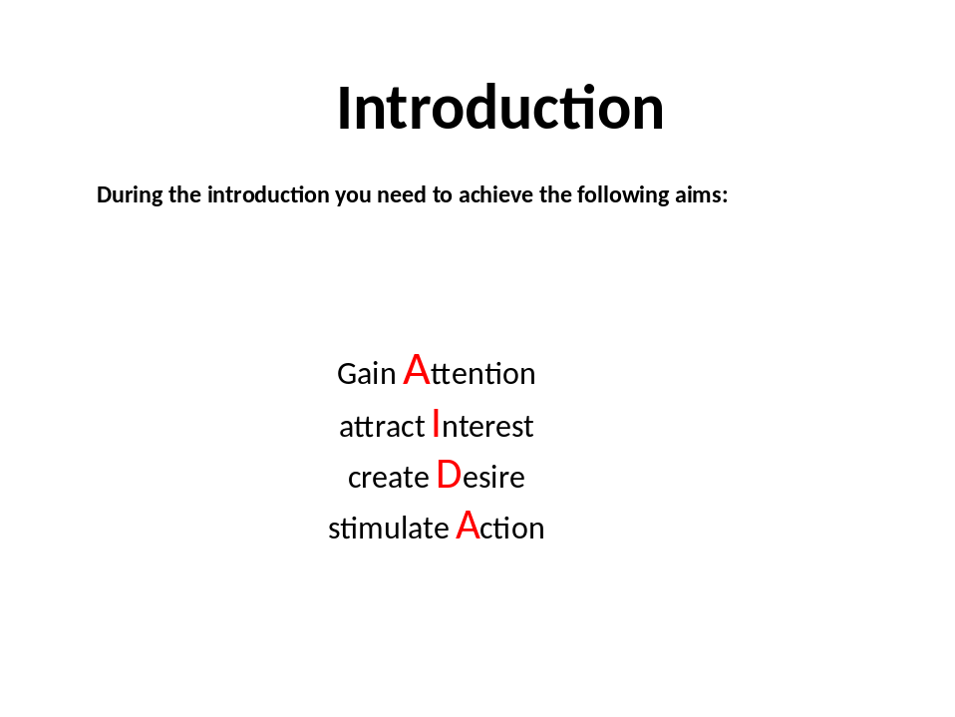
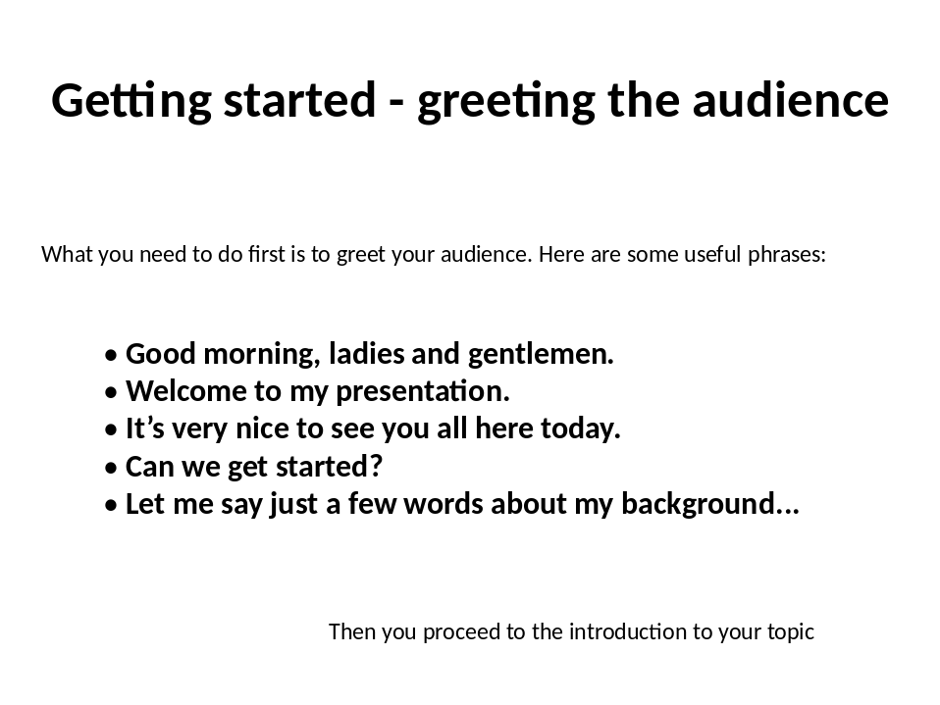
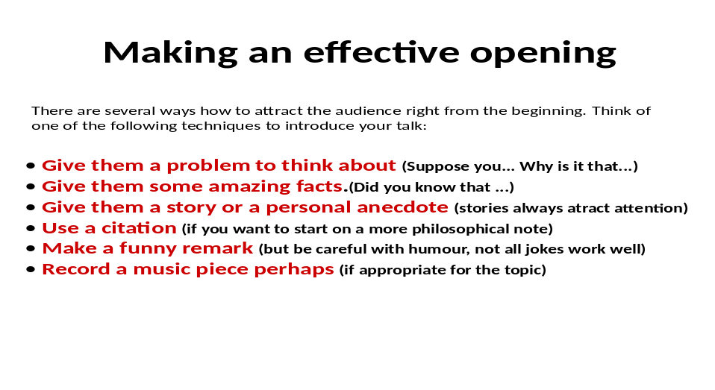
Some useful phrases:
- What I want to do this morning is to …..
- My talk will take about 30 minutes.
- During my presentation, I’m going to be focusing on four main areas.
- I’ll be giving out copies of my transparencies at the end.
- If you have any questions, or comments you’d like to make, please don’t hesitate to stop me.

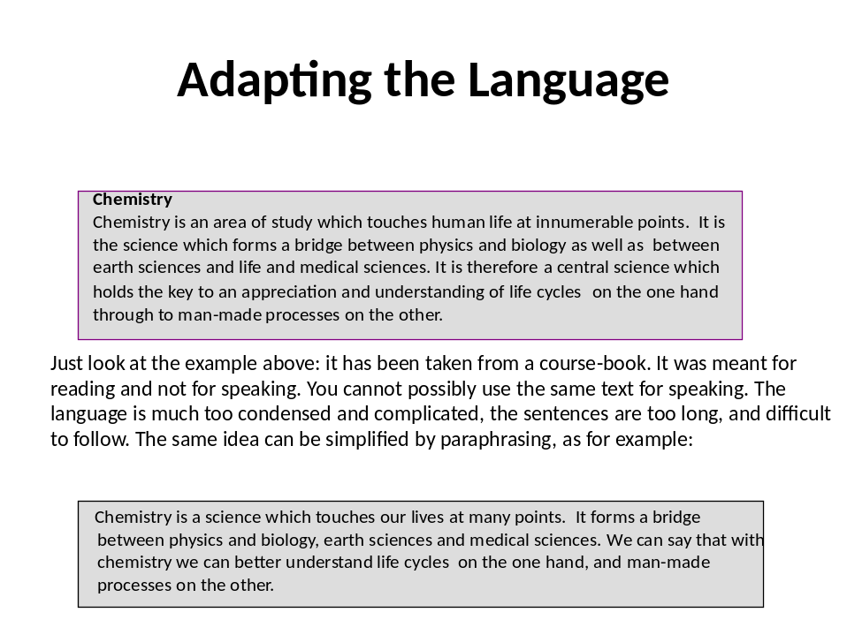
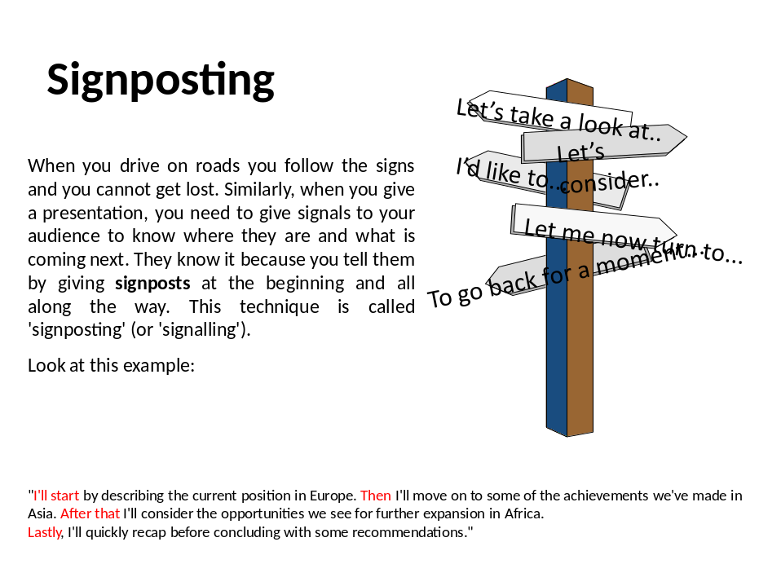
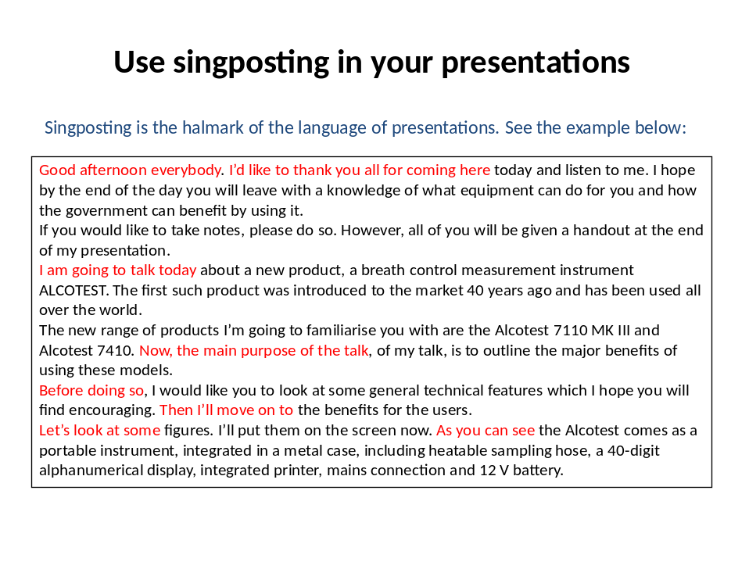
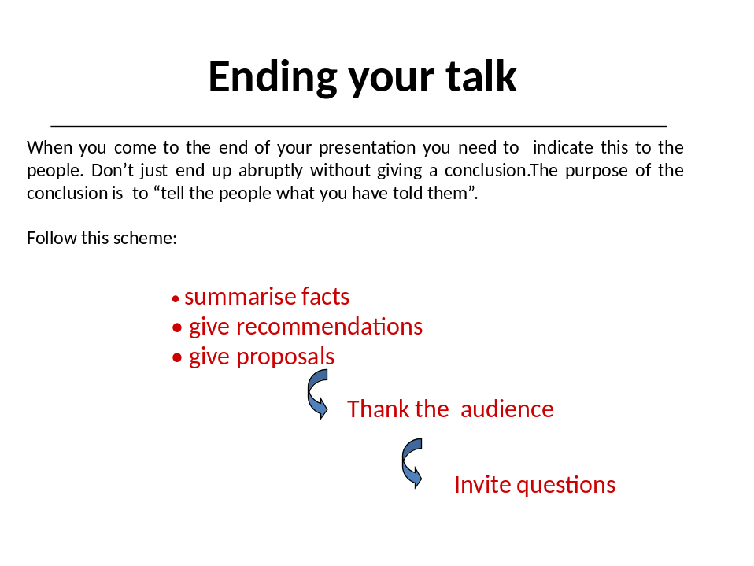
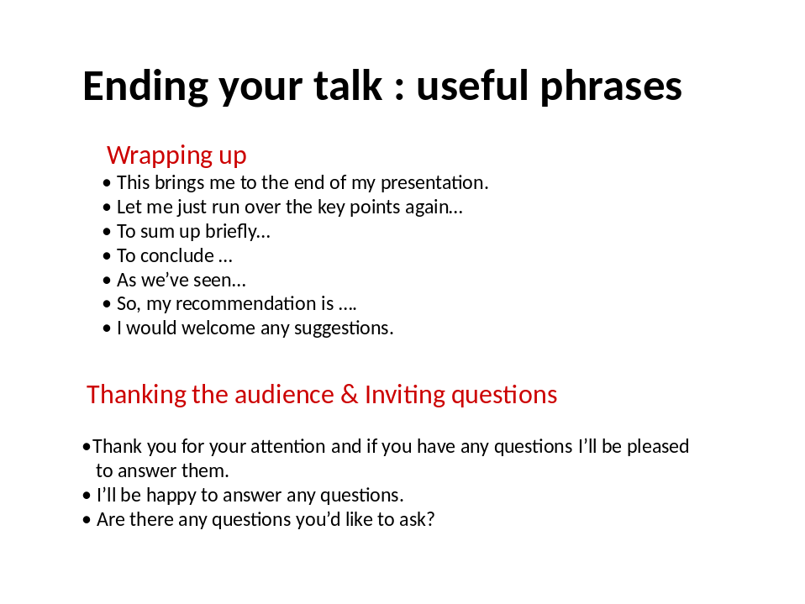
PRESENTER AS AN “ACTOR”:
- When you come to stand on the podium you become the actor of your presentation. During your presentation you are going to speak and not read from your notes. This means using your voice, and also your body language. What is importnat is that you establish eye contact with each member of your audience.
- Each person should feel that you are speaking directly to him or her. You need to think in advance:
        - Where shall I stand?
        - How shall I keep eye contact?
        - Where shall I keep my hands?
        - What if I get lost?
        - How to manage audience phobia?
- Most speakers are a little nervous during a presentation but there are some strategies to control your nerves.
- Also, you need to be aware of your body language. Open the links to learn more about these.

Conclusion:
Consider this in preparing your presentation:
- Simplify the text.
- Focus your material. You can’t say everything.
- Use transitions (signsposting) to move smoothly.
- Use examples, anecdotes, statistics to support your message.
- Use a lot of visuals to reinforce the message.
- Consider timing.
- Apply the KISS principle.
- Practise alone and with the whole group.

References
- http://www.dvd-ppt-slideshow.com/blog/how-to-overcome-nervousness-when-doing-powerpoint-presentation/
- http://www.ljlseminars.com/anxiety.htm
- http://presenting2007.blogspot.com/2007/02/notes-on-being-nervous.html

