Formation and initial growth.

Many businesses begin with finance contributed by their owners and owners’ families. If they start as unincorporated businesses, the distinction between owners’ capital and owners’ loans is almost irrelevant. If it starts as an incorporated business, or turns into one, then there are important differences between share capital and loans. Share capital is more or less permanent and can give suppliers and lenders some confidence that the owners are being serious and are willing to risk significant resources. If the owners’ friends and families do not themselves want to invest (perhaps they have no money to invest) then the owners will have to look for outside sources of capital. The main sources are:
- bank loans and overdrafts
- leasing/hire purchase
- trade credit
- government grants, loans and guarantees
- venture capitalists and business angels
- invoice discounting and factoring
- retained profits.

Bank loans and overdrafts

In the current economic climate, start-up businesses are likely to find it difficult to raise a bank loan, particularly if the business and its owners have no track record at all. Banks will certainly require:
- A business plan, including cash flow forecasts.
- Personal guarantees and charges on personal assets.

The personal guarantees and charges on personal assets get round the company’s limited liability which would otherwise mean that if the company failed, the bank might be left with nothing. This way the bank can ask the guarantors to pay back the loans personally, or the bank can seize the charged assets that were used for security.

Note that overdrafts are repayable on demand and many banks have a reputation of pre-emptively withdrawing overdraft facilities, not when a business is in trouble, but when the bank fears more difficult times ahead.

On a more positive note, where it is known that the need for finance is temporary, an overdraft might be very suitable because it can be repaid by the borrower at any time.

Leasing and hire purchase

In financial terms, leasing is very like a bank loan. Instead of receiving cash from the loan, spending it on buying an asset and then repaying the loan, the leasing company buys the asset, makes it available to the lessee and charges the lessee a monthly amount. Leasing can often be cheaper than borrowing because:

- Large leasing companies have great bargaining power with suppliers so the asset costs them less than it would cost the lessee. This can be partially passed on to the leasee.

- Leasing companies have effective ways of disposing of old assets, but lessees normally do not.

- If the lease payments are not made, the leasing company has a form of built-in security insofar as it can reclaim its asset.

- The cost of finance to a large, established leasing company is likely to be lower than the cost to a start-up company.

It is important for businesses to try to decide whether loan finance or a lease would be cheaper. (This is a separate topic in the Paper F9 syllabus, but it is not covered in this article.)

Trade credit

This simply means taking credit from suppliers – typically 30 days. That is obviously a very short period, but it can be very helpful to new businesses. Typically, credit suppliers to new businesses will want some sort of reference, either from a bank or from other suppliers (trade references). However, some will be prepared to offer modest credit initially without references, and as trust grows this can be increased.

Government grants, loans and guarantees

Governments often encourage the formation of new businesses and, from time to time and from region to region, help is offered. Government grants are usually very small, and direct loans are rare because governments see loan provision as the job of financial institutions.

Currently in the UK, the Government runs the Enterprise Finance Guarantee Scheme (EFGS). This is a loan guarantee scheme intended to facilitate additional bank lending to viable small and medium-sized entities (SMEs) with insufficient security for a normal commercial loan. The borrower must be able to demonstrate to the lender that they should be able to repay the loan in full. The Government provides the lender with a guarantee for which the borrower pays a premium.

The scheme is not a mechanism through which businesses or their owners can choose to withhold the security a lender would normally lend against; nor is it intended to facilitate lending to businesses which are not viable and that banks have declined to lend to on that basis.

EFGS supports lending to viable businesses with an annual turnover of up to £25m seeking loans of between £1,000 and £1m.

Venture capitalists and business angels

These are either companies (usually known as venture capitalists) or wealthy individuals (business angels) who are prepared to invest in new or young businesses. They provide equity (private equity as opposed to public equity in listed companies), not loans. The equity is not normally secured on any assets and the private equity firm faces the risk of losses just like the other shareholders. Because of the high risk associated with start-up equity, private equity suppliers typically look for returns on their investment in the order of 30% pa. The overall return takes into account capital redemptions (for example preference shares being redeemed at a premium), possible capital gains on exiting their investment (for example through sale of shares to a private buyer or after listing the company on a stock exchange), and income through fees and dividends.

Typically, venture capitalists will require 25%–49% of the equity and a seat on the board so that their investment can be monitored and advice given. However, the investors do not seek to take over management of their investment.

Invoice discounting and factoring

Before these methods can be used turnover usually has to be in the region of at least $200,000. Amounts due from customers, as evidenced by invoices, are advanced to the company. Typically 80% of an invoice will be paid within 24 hours. In addition to this service, factors also look after the administration of the company’s receivables ledger.

Fees are charged on advancing the cash (roughly at overdraft interest rates), and also factors will charge about 1% of turnover for running the receivables ledger (the exact amount depends on how many invoices and customers there are). Credit insurance can be taken out for an additional fee. Unless that is taken out the invoicing company remains liable for any bad debts.

Retained profits

Retained profits are no good for start-ups, and often no good for the first few years of a business’s life when only losses or very modest profits are made. However, assuming the business is successful, profits should be made and retaining those in the business can allow the company to repay debt capital and to invest in expansion.

How much capital is needed?

Capital is needed:
- for investment in non-current assets
- to sustain the company through initial loss-making periods
- for investment in current assets.

Cash-flow forecasts are an essential tool in planning capital needs. Typically, suppliers of capital will want forecasts for three to five years. One of the biggest dangers facing new successful businesses is overtrading, where they try to do too much with too little capital. Most businesses know that capital will be needed to finance non-current assets, but many overlook that finance is also needed for current assets.

Look at this example:
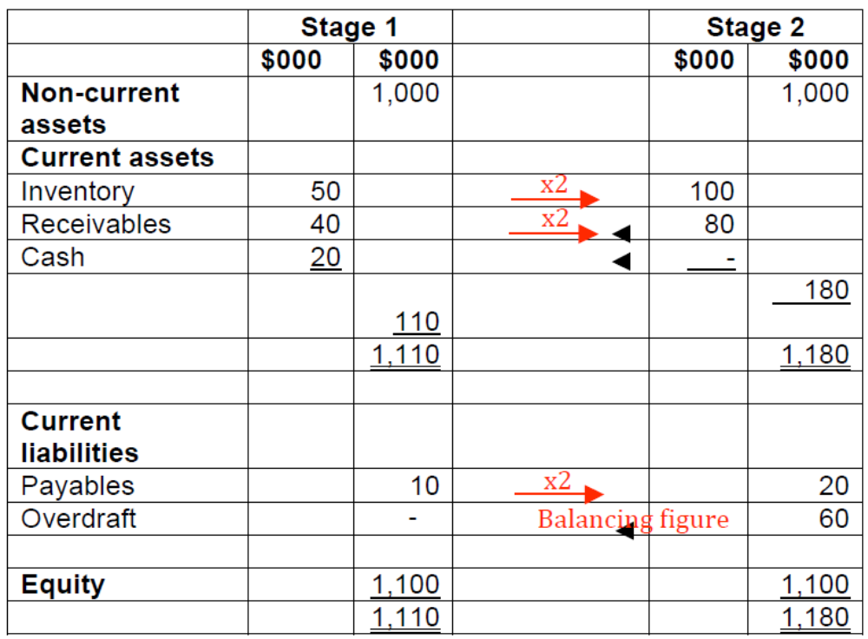

This company starts with a healthy liquidity position (Stage 1). Business then doubles, without investing in more non-current assets and without raising more equity capital. It is a reasonable assumption that if turnover doubles then so will inventory, receivables and payables (Stage 2). But here this forces the company to rely on an overdraft (probably unexpected and unplanned) to finance its net current assets. Relying permanently on overdraft finance is precarious and the company would be advised to seek some more permanent form of capital.

When capital is raised, the company has to decide what to do with it, and there are two main uses:
- invest in non-current assets

- invest in current assets, including leaving it as cash.

The more capital invested in non-current assets, the greater should be the profit-earning potential of the business. However, leaving too little cash in current assets increases the risk that the company will have liquidity problems. On the other hand, leaving too much capital in current assets is wasteful: cash will earn modest interest (but investors want higher returns from a company), and cash tied up in inventory often causes costs (storage, damage, obsolescence). So, the company has to decide on its working capital policy. An aggressive policy is one which maintains relatively low working capital compared to another company; a conservative policy is one which maintains relatively high working capital. Which policy is appropriate partly depends on the nature of the business. If the business is one where trading cash flows are very predictable then it should be able to survive with an aggressive policy. If, however, cash flows are erratic and unpredictable the company would be wise to build a margin of safety into its cash management. Additionally, if the company foresees a period of losses, it will need to keep cash available (probably earning interest in a deposit account) to see it through its lean years.

Note that companies do not have to have actually raised capital to have it available for emergency use. What they need is a pre-agreed right to borrow a certain amount on demand. That is known as a line of credit. Many of us make use of lines of credit in our personal lives, but there we call them credit cards. So we don’t have to have $1,000 sitting in the bank in case our car needs a major repair, but it’s comforting to know that if repairs are necessary, we can pay for them immediately. Of course, the credit card debt will have to be repaid at some time, but repayments can be spread.

Long, medium and short-term capital

Capital can be short, medium or long-term. Definitions vary somewhat, but the following are often seen:

- Short term – up to two years. For example, overdrafts, trade credit, factoring and invoice discounting

- Medium term – two to five or six years. For example, term loans, lease finance.
- Long term – over five years, or so, to permanent.

In general, it makes sense to match the length of the finance to the life of the asset (the matching principle) and, again, we often apply this in our own lives, where we would use a 25-year mortgage to buy an apartment, a 3–5-year loan to buy a car, and a credit card to pay for a holiday.
Within a business context:

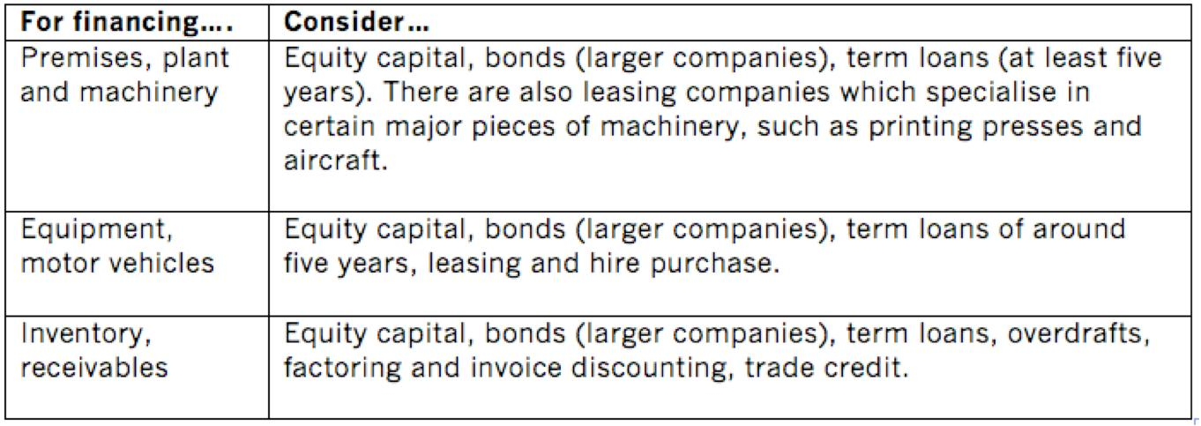

Note that long-term capital (equity and bonds) can be used to fund all classes of asset. Although each piece of inventory and each receivable are very short-life assets, in total there will normally be fairly stable amounts of each that have to be permanently funded. Therefore, it makes sense to fund most of those assets by long-term capital and to use short-term capital to fund seasonal peaks. One of the problems with short-term finance is that is comes to an end quickly and if finance is still needed then more has to be renegotiated. Long-term capital is either permanent or comes up for renewal relatively rarely.

Mature companies

Once a company has existed profitably for some time and grown in size, additional sources of finance can become available, in particular:
- public equity
- public debt
- bonds.

Public equity

Some stock exchanges provide different sorts of listings. For example:

- London Stock Exchange: The Main Market and the Alternative Investment Market (AIM). AIM focuses on helping smaller and growing companies raise the capital they need for expansion.

- NASDAQ: This is an electronic stock exchange in the US and has the NASDAQ National Market for large, established companies (market value at least $70m) and the NASDAQ Capital market for smaller companies.
On the London Stock Exchange the main differences are;
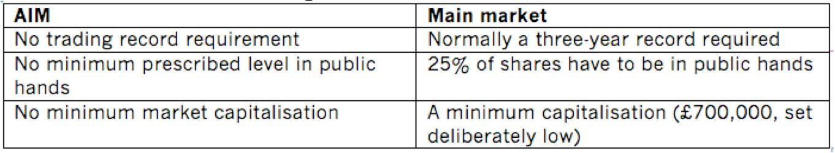

An initial public offering is the first occasion on which shares are offered to the public. A company seeking a listing has to issue a prospectus, which is a legal document describing the shares being offered for sale, and including matters such as a description of the company's business, recent financial statements, details of the directors and their remuneration.

Shares can be listed via:

- An offer for sale at fixed price: a company offers shares for sale at a fixed price directly to the public, for example in newspaper advertisements. In fact, the shares are usually first sold to an issuing house which sells them on to the public.

- An offer for sale by tender: investors are asked to bid, and all who bid more than the minimum price that all shares can be sold at will be sold shares at that minimum price.

- A placing: shares are offered to a selection of institutional investors. Because less publicity is needed, these are cheaper than offers for sale and are therefore suited to smaller IPOs.

- An introduction: this is rare and only happens when shares are already widely held publically. No money is raised.

Subsequent issues of equity will be rights issues where existing shareholders are offered new shares in proportion to existing holdings. The shares are offered at below their current market value to make the offer look attractive, but in theory, no matter at what price right issues are made and no matter whether shareholders take up or dispose of their rights, shareholders will end up neither better nor worse off. Wealth is neither created nor destroyed just by moving money from a shareholder’s bank account to the company’s.

Gaining a listing opens up a huge source of potential new capital. However, with listing come increased scrutiny, comment and responsibility. Although this will help the standing and respectability of the company the founders of the company, having been used to running their own company in their own way, often resent outside interference – even though that is to be expected now that ownership of their shares is more widespread.

Public debt

This refers to quoted bonds or loan notes: instruments paying a coupon rate of interest and whose market value can fluctuate. Usually the bonds will be secured either by fixed or floating charges and can be redeemable or irredeemable. Well-secured bonds in companies that are not too highly geared are low risk investments and bonks holders will therefore require relatively low returns. The cost of the bonds to the borrower falls even more after tax relief on interest is taken into account.

Convertible bonds

Convertibles start life as loan capital and can later be converted, at the lenders’ option, into shares. They are a clever and useful device, particularly for younger companies, because:

- In the very early days of the company’s life, investors might not want to risk investing in equity, but might be prepared to invest in the less risky debentures. However, debentures never hold out the promise of massive capital gains.

- If the company does not do so well, the investors can stick with their safe convertible loan stock.

- If the company does well, the investors can opt to convert and to take part in the capital growth of the shares.

Convertible bonds therefore offer a ‘wait and see’ approach. Because they allow later entry to what might turn out to be a growth stock, the initial interest rate they have to offer is lower than with pure bonds – and that’s good for the company that is borrowing.

Gearing

When deciding what sorts of finance to issue, companies must always bear in mind the average cost of their finance. This article does not go into gearing considerations in any detail except to point out that some borrowing can lower the cost of capital.

If there is no borrowing, all finance will be equity and that is high cost to compensate for the high risk attaching to it. Debt finance is cheap because it has lower risk and enjoys tax relief on interest.

Therefore, introducing some debt into the finance mix begins to pull down the average cost of capital. However, at very high levels of gearing the increased risk of default pushes up both the cost of debt and the cost of equity, and the average cost of finance starts to rise. Somewhere, there is an optimum gearing ratio with the cheapest mix of finance.

The previous paragraph briefly described the traditional theory of gearing. Modigliani and Miller suggested an alternative view, but the very precise conditions and restrictions their theories require are not often found in practice.

