Strategic consideration
Investment projects can be classified into three categories on the basis of how they influence the investment decision process: independent projects, mutually exclusive projects and contingent projects.
An independent project is one the acceptance or rejection of which does not directly eliminate other projects from consideration or affect the likelihood of their selection. For example, management may want to introduce a new product line and at the same time may want to replace a machine which is currently producing a different product. These two projects can be considered independently of each other if there are sufficient resources to adopt both, provided they meet the firm's investment criteria. These projects can be evaluated independently and a decision made to accept or reject them depending upon whether they add value to the firm.
Two or more projects that cannot be pursued simultaneously are called mutually exclusive projects - the acceptance of one prevents the acceptance of the alternative proposal. There- fore, mutually exclusive projects involve 'either-or' decisions - alternative proposals cannot be pursued simultaneously. For example, a firm may own a block of land which is large enough to establish a shoe manufacturing business or a steel fabrication plant. If shoe manufacturing is chosen the alternative of steel fabrication is eliminated. A car manufac- turing company can locate its manufacturing complex in Sydney, Brisbane or Adelaide. If it chooses Adelaide, the alternatives of Sydney and Brisbane are precluded.
Mutually exclusive projects can be evaluated separately to select the one which yields the highest net present value to the firm. The early identification of mutually exclusive alternatives is crucial for a logical screening of investments. Otherwise, a lot of hard work and resources can be wasted if two divisions independently investigate, develop and initiate projects which are later recognized to be mutually exclusive.
A contingent project is one the acceptance or rejection of which is dependent on the decision to accept or reject one or more other projects. Contingent projects may be com- plementary or substitutes. For example, the decision to start a pharmacy may be contingent upon a decision to establish a doctors' surgery in an adjacent building. In this case the projects are complementary to each other. The cash flows of the pharmacy will be enhanced by the existence of a nearby surgery and conversely the cash flows of the surgery will be enhanced by the existence of a nearby pharmacy.
In contrast, substitute projects are ones where the degree of success (or even the suc- cess or failure) of one project is increased by the decision to reject the other project. For example, market research indicates demand sufficient to justify two restaurants in a shopping complex and the firm is considering one Chinese and one Thai restaurant. Customers visiting this shopping complex seem to treat Chinese and Thai food as close substitutes and have a slight preference for Thai food over Chinese. Consequently, if the firm establishes both restaurants, the Chinese restaurant's cash flows are likely to be adversely affected. This may result in negative net present value for the Chinese restaurant. In this situation, the success of the Chinese restaurant project will depend on the decision to reject the Thai restaurant proposal. Since they are close substi- tutes, the rejection of one will definitely boost the cash flows of the other. Contingent projects should be analysed by taking into account the cash flow interactions of all the projects.
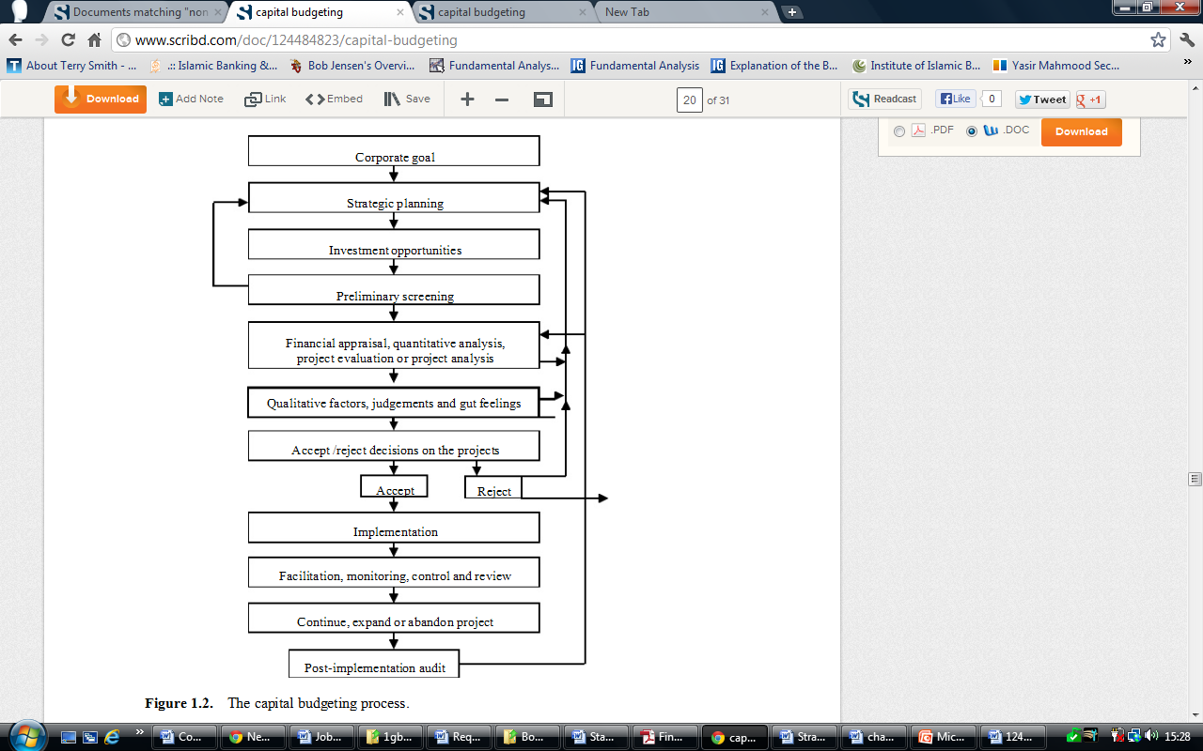

The capital budgeting process

Capital budgeting is a multi-faceted activity. There are several sequential stages in the process. For typical investment proposals of a large corporation, the distinctive stages in the capital budgeting process are depicted, in the form of a highly simplified flow chart, in Figure 1.2.

Strategic planning

A strategic plan is the grand design of the firm and clearly identifies the business the firm is in and where it intends to position itself in the future. Strategic planning translates the firm's corporate goal into specific policies and directions, sets priorities, specifies the structural,

strategic and tactical areas of business development, and guides the planning process in the pursuit of solid objectives. A firm's vision and mission is encapsulated in its strategic planning framework.
There are feedback loops at different stages, and the feedback to 'strategic planning' at the project evaluation and decision stages - indicated by upward arrows in Figure 1.2 - is critically important. This feedback may suggest changes to the future direction of the firm which may cause changes to the firm's strategic plan.

Identification of investment opportunities

The identification of investment opportunities and generation of investment project pro- posals is an important step in the capital budgeting process. Project proposals cannot be generated in isolation. They have to fit in with a firm's corporate goals, its vision, mission and long-term strategic plan. Of course, if an excellent investment opportunity presents itself the corporate vision and strategy may be changed to accommodate it. Thus, there is a two-way traffic between strategic planning and investment opportunities.
Some investments are mandatory - for instance, those investments required to satisfy particular regulatory, health and safety requirements - and they are essential for the firm to remain in business. Other investments are discretionary and are generated by growth oppor- tunities, competition, cost reduction opportunities and so on. These investments normally represent the strategic plan of the business firm and, in turn, these investments can set new directions for the firm's strategic plan. These discretionary investments form the basis of the business of the corporation and, therefore, the capital budgeting process is viewed in this book mainly with these discretionary investments in mind.
A profitable investment proposal is not just born; someone has to suggest it. The firm should ensure that it has searched and identified potentially lucrative investment opportuni- ties and proposals, because the remainder of the capital budgeting process can only assure that the best of the proposed investments are evaluated, selected and implemented. There should be a mechanism such that investment suggestions coming from inside the firm, such as from its employees, or from outside the firm, such as from advisors to the firm, are 'listened to' by management.
Some firms have research and development (R&D) divisions constantly searching for and researching into new products, services and processes and identifying attractive investment opportunities. Sometimes, excellent investment suggestions come through informal processes such as employee chats in a staff room or corridor.

Preliminary screening of projects

Generally, in any organization, there will be many potential investment proposals generated. Obviously, they cannot all go through the rigorous project analysis process. Therefore, the identified investment opportunities have to be subjected to a preliminary screening process by management to isolate the marginal and unsound proposals, because it is not worth spending resources to thoroughly evaluate such proposals. The preliminary screening may

involve some preliminary quantitative analysis and judgements based on intuitive feelings and experience.

Financial appraisal of projects

Projects which pass through the preliminary screening phase become candidates for rigorous financial appraisal to ascertain if they would add value to the firm. This stage is also called quantitative analysis, economic and financial appraisal, project evaluation, or simply project analysis.
This project analysis may predict the expected future cash flows of the project, analyse the risk associated with those cash flows, develop alternative cash flow forecasts, examine the sensitivity of the results to possible changes in the predicted cash flows, subject the cash flows to simulation and prepare alternative estimates of the project's net present value.
Thus, the project analysis can involve the application of forecasting techniques, project evaluation techniques, risk analysis and mathematical programming techniques such as lin- ear programming. While the basic concepts, principles and techniques of project evaluation are the same for different projects, their application to particular types of projects requires special knowledge and expertise. For example, asset expansion projects, asset replacement projects, forestry investments, property investments and international investments have their own special features and peculiarities.
Financial appraisal will provide the estimated addition to the firm's value in terms of the projects' net present values. If the projects identified within the current strategic framework of the firm repeatedly produce negative NPVs in the analysis stage, these results send a message to the management to review its strategic plan. Thus, the feedback from project analysis to strategic planning plays an important role in the overall capital budgeting process. The results of the quantitative project analyses heavily influence the project selection or investment decisions. These decisions clearly affect the success or failure of the firm and its future direction. Therefore, project analysis is critically important for the firm. This book focuses on this complex analytical stage of the capital budgeting process, that is, financial
appraisal of projects (or simply, project analysis).

Qualitative factors in project evaluation

When a project passes through the quantitative analysis test, it has to be further evaluated taking into consideration qualitative factors. Qualitative factors are those which will have an impact on the project, but which are virtually impossible to evaluate accurately in monetary terms. They are factors such as:

• the societal impact of an increase or decrease in employee numbers
• the environmental impact of the project
• possible positive or negative governmental political attitudes towards the project
• the strategic consequences of consumption of scarce raw materials
• positive or negative relationships with labour unions about the project

• possible legal difficulties with respect to the use of patents, copyrights and trade or brand names
• impact on the firm's image if the project is socially questionable.

Some of the items in the above list affect the value of the firm, and some not. The firm can address these issues during project analysis, by means of discussion and consultation with the various parties, but these processes will be lengthy, and their outcomes often unpredictable. It will require considerable management experience and judgemental skill to incorporate the outcomes of these processes into the project analysis.
Management may be able to obtain a feel for the impact of some of these issues, by estimating notional monetary costs or benefits to the project, and incorporating those values into the appropriate cash flows. Only some of the items will affect the project benefits; most are externalities. In some cases, however, those qualitative factors which affect the project benefits may have such a negative bearing on the project that an otherwise viable project will have to be abandoned.

The accept/reject decision

NPV results from the quantitative analysis combined with qualitative factors form the basis of the decision support information. The analyst relays this information to management with appropriate recommendations. Management considers this information and other relevant prior knowledge using their routine information sources, experience, expertise, 'gut feeling' and, of course, judgement to make a major decision - to accept or reject the proposed investment project.

Project implementation and monitoring

Once investment projects have passed through the decision stage they then must be imple- mented by management. During this implementation phase various divisions of the firm are likely to be involved. An integral part of project implementation is the constant monitor- ing of project progress with a view to identifying potential bottlenecks thus allowing early intervention. Deviations from the estimated cash flows need to be monitored on a regular basis with a view to taking corrective actions when needed.

Post-implementation audit

Post-implementation audit does not relate to the current decision support process of the project; it deals with a post-mortem of the performance of already implemented projects. An evaluation of the performance of past decisions, however, can contribute greatly to the improvement of current investment decision-making by analysing the past 'rights' and
'wrongs'.
The post-implementation audit can provide useful feedback to project appraisal or strat- egy formulation. For example, ex post assessment of the strengths (or accuracies) and weaknesses (or inaccuracies) of cash flow forecasting of past projects can indicate the level

of confidence (or otherwise) that can be attached to cash flow forecasting of current invest- ment projects. If projects undertaken in the past within the framework of the firm's current strategic plan do not prove to be as lucrative as predicted, such information can prompt management to consider a thorough review of the firm's current strategic plan.

