Three Generative grammars
Noam Chomsky demonstrated that some kinds of generative grammars are intrinsically more powerful than others. He proved that Finite state grammars are less powerful than phrase structure grammars and Phrase structure grammars are less powerful than transformational grammars. He gave three models of generative grammars.
- Finite state grammar
If the grammar is to consist of a finite set of rules operating upon a finite vocabulary and
is to be capable of generating an infinite set of sentences, it means that some of the rules must be applicable more than once in generating the same sentences. These rules and structures they generate are called recursive.
The simplest grammars capable of generating infinite set of sentences by means a finite number of recursive rules operating upon finite vocabulary are called finite state grammars.
Sentences are made/generated by means of choices made from left to right. Every different sequence of words (well formed) is a different sentence.
- Transformational & Phrase structure grammar
Transformational Generative Grammar (TGG) consists of not only transformational rules but includes a set of phrase structure rules as well. Transformational rules depend upon the previous application of the phrase structure rules. Transformational rules have the effect not only of converting one string of elements into another, but in principle, of changing the associated phrase marker. They are also formally more heterogeneous and more complex than phrase-structure rules. Chomsky states that two properties of language must be taken into account for searching the right generative grammar.
A. Recursiveness
B. Constituent – structure
Both are present in phrase structure grammar.
Function of PS grammar is to generate strings of symbols and to assign to each a labelled bracketing. This labelled bracketing is called “phrase markers”.
[ on [ the [ wooden table ]]]
[pp[p on] [NP [Art the] [N [ A wooden] [N table]]]]

Chomsky followed a deductive approach in giving theoretical account of grammar.
Competence/performance
The competence of a native speaker enables a speaker to produce an infinite number of sentences from a finite set. The sentences generated are grammatical & meaningful equally.
Structuralists focus on ‘Form’ whereas TG talks about form and meaning both.
Form is important in generation of sentences. Language is productive, complex and arbitrary. TG grammar is both transformational and generative
Role of transformational grammar:
- Analyses the sentences
- Divides them into parts
- Demonstrates function of various parts
- Rearranges them
- Shows interrelatedness between sentences
- It is the most powerful among the three types.
TGG shows that only a meaningful form is not important but meaning is also important. It also shows how sentences are related to one another in a sentence. TGG takes each part of sentence and talks about its role. It is different from structural grammar.
TG is not a mathematical grammar. The processes it describes are not mathematical
processes and the symbols it describes are not used with their mathematical meaning.
Chomsky’s grammar is a generative grammar of the transformational type. He means that
among the rules are those for transforming one type of sentences into another (affirmative
into negative, simple into compound or complex, and so forth).
TG consists of two levels of representations of the structure of sentences which includes an
underlying more abstract form, termed ‘deep structure’, and the actual form of the sentence
produced called ‘surface structure’. Surface structures are derived from deep structures by a
series of transformations
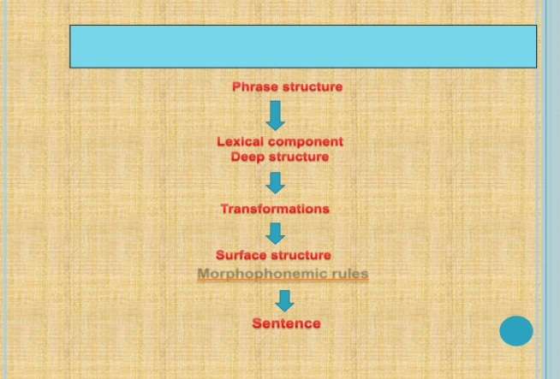
- Deep structure – an abstract representation of a sentence . It can be represented in the form of a hierarchical tree diagram , or ‘phrase structure tree, depicting the abstract grammatical relationship between the words and phrases within a sentence.
- Surface structure – version of a sentence that can be heard or spoken
Example: The dog bit the cat (Deep structure)
The cat was bitten by the dog
( surface structure)
It’s a system of formal rules specifying how deep structures are to be transformed into surface structures.
The ‘rules’ in TG do not tell us how to produce language – they tell us the order in which to put words and phrases. TGG allows us to generate an infinite number of sentences via transformations. Grammatical transformations are the rules relating deep and surface structures.

