The Direct Method
Lecture # 4
The direct method was an answer to the dissatisfaction with the older GTM, which teaches students grammar and vocabulary through direct translations and thus focuses on the written language. There was an attempt to set up conditions that imitate mother tongue acquisition, which is why the beginnings of these attempts were called the natural method. At the turn of the 18th and 19th centuries, Sauveur and Franke proposed that language teaching should be undertaken within the target-language system, which was the first stimulus for the rise of the direct method.
The direct method of teaching, sometimes called the natural method. Not limited to but often used in teaching foreign languages, the method refrains from using the learners' native language and uses only the target language. It was established in Germany and France around 1900. Characteristic features of the direct method are:
- Teaching concepts and vocabulary through pantomiming, real-life objects and other visual materials
- Teaching grammar by using an inductive EXPERIENCE
- The teacher is calling the class to order as we find seats toward the back of the room. He has placed a big map of the United States in the front of the classroom. He asks the students to open their books to a certain page number. The lesson is entitled 'Looking at a Map.' As the students are called on one by one, they read a sentence from the reading passage at the beginning of the lesson. The teacher points to the part of the map the sentences describes after each has read his sentence. The passage begins:
- We are looking at a map of the United States. Canada is the country to the north of the United States, and Mexico is the country to the south of the United States. Between Canada and the United Stares arc the Great Lakes. Between Mexico and the United States is the Rio Grande
- approach (i.e. having learners find out rules through the presentation of adequate linguistic forms in the target language)
- Centrality of spoken language (including a native-like pronunciation)
- Focus on question-answer patterns
Experience:
The teacher is calling the class to order as we find seats toward the back of the room. He has placed a big map of the United States in the front of the classroom. He asks the students to open their books to a certain page number. The lesson is entitled 'Looking at a Map.' As the students are called on one by one, they read a sentence from the reading passage at the beginning of the lesson. The teacher points to the part of the map the sentence describes after each has read his sentence.
Read the reaming part of the class room experience from your text “Techniques and Principles in Language Teaching” by Diane Larsen-Freeman page # 18-21.
Let us review techniques employed in the Direct Method of Teaching English.
Reading Aloud:
Students take turns reading sections of a passage, play, or dialog out loud. At the end of each student’s turns, the teacher uses gestures, pictures, and other teaching aids, examples, or other means to make the meaning of the section clear.
Question and Answer Exercise:
Question and Answer exercises are conducted in the target language; the teacher asks questions and the students are expected to reply in full sentences so that they practice with new words and grammatical structures. Students can ask questions and also can reply question asked by teacher and other students.
Getting Students to Self-Correct
Unlike GTM, the teacher in DM has the students self-correct by asking them to make a choice between what they said and an alternate answer he supplied. There are some ways to help student self-correct themselves. The teach can repeat what the student has said wrong; this repetition makes students give a second thought to their sentences, so they correct their mistakes. Another way is that the teacher stops before the error. When teacher stops before an error; this signals that there is an error or mistake.
Conversation Practice
The teacher asks number of questions to students in the target language, which the students have to comprehend to be able to answer correctly. These questions can be individual to a specific student or they could be to the class. E.g the teacher can ask question to Ali…….
Ali: What do you know about pollution?
Well students: what do you say about the global warming?
Teacher’s question contain a particular grammar structure. Later, the students were able to ask each other their own questions using the same grammatical structure.
Fill in the Blanks Exercise:
This is an important exercise in DM. All the linguistic items are in the target language; moreover, no explicit grammar rule would be applied. The students would induce the grammar rule they need to fill in the blanks from examples and practice with earlier parts of the lesson.
Dictation
The teacher reads the passage three times. The first time the teacher reads it at a normal speed, while the students just listen. The second time, he reads the passage phrase by phrase, pausing long enough to allow students to write down what they have heard. The last time teacher again reads at a normal speed, and students check their work.
Map Drawing
As you have read in the experience, the class included one example of a technique to give students listening comprehension practice. The students were given a map with the geographical feature unnamed. Then the teacher gave the students the following directions:
- Find the mountain range in the west
- Write the words ‘Rocky Mountains’ across the mountain range
The teacher gave instructions for all the geographical features of the United States so that students would have a completely labeled map if thy followed his instructions correctly.
The students then instructed the teacher to do the same with a map he had drawn on the blackboard. Each student could have a turn giving the teacher instructions for finding and labeling one geographical feature.
Paragraph Writing
The teacher in the class asked the students to write a paragraph in their own words on the major geographical features of the United States. They could have done this from memory, or they could have used the reading passage in the lesson as a model. So, the method also focuses on writing skill as we have just seen in the paragraph writing exercise.

The Direct Method
Lecture # 5
Principles of the Direct Method:
- Classroom instructions are conducted exclusively in the target language.
- Only everyday vocabulary and sentences are taught during the initial phase; grammar, reading and writing are introduced in intermediate phase.
- Oral communication skills are built up in a carefully graded progression organized around question-and-answer exchanges between teachers and students in small, intensive classes.
- Grammar is taught inductively.
- New teaching points are introduced orally.
- Concrete vocabulary is taught through demonstration, objects, and pictures; abstract vocabulary is taught by association of ideas.
- Both speech and listening comprehensions are taught.
- Correct pronunciation and grammar are emphasized.
- Student should be speaking approximately 80% of the time during the lesson.
- Students are taught from inception to ask questions as well as answer them.
Reviewing the Principles:
Let us discuss how this method deals with Ten Important Questions (TIQs).
1: What are the goal of teachers who use Direct Method?
Teacher who use direct method in the class intend that students learn how to communicate in the target language. This can be achieved by motivating students to think in the target language.
2: What is the role of the teacher and the students in Direct Method?
Although the teacher directs the class activities, the student’s role is more active than do the students in Grammar Translation Method. The teacher and the students are more like partners in the teaching/learning process. The students and the teachers interact more in the target language.
3: What are some of the characteristics of the teaching Learning process?
Teachers who use the Direct Method believe students need to associate meaning and the target language directly. In order to do this, when the teacher introduces a new target language word or phrase, he demonstrates its meaning through the use of Realia.
Realia are objects and material from everyday life used as teaching aids. “the industrial English language course makes extensive and varied use of realia, such as specifications, extracts from company brochures, manuals, diagrams, etc." The teacher never translates any word or phrase into the students’ native language. Students’ speak in the target language a great deal and communicate as if they were in real situations (e.g. one unit would consist of language that people would use at a bank, another of the language that they use when going shopping) or topics (such as geography, money, or the weather). Grammar is taught inductively; that is the students are presented with examples and they figure out the rule or generalization from examples. An explicit grammar rule may never be given. Students practice vocabulary by using new words in complete sentences.
4: What is the nature of student-teacher and student-student interaction?
The initiation of the interaction goes both ways, from teacher to students and from student to teacher, although the latter is often teacher­ directed. Students converse with one another as well.
5: How are the feelings of students dealt with?
There are no principles of the method which relate to this area.
6: How is language viewed and culture viewed?
Language is primarily spoken, not written. Therefore, students study common, everyday speech in the target language. They also study culture consisting of the history of the people who speak the target language, the geography of the country or countries where the language is spoken, and information about the daily lives of the speakers of the language.
7: What areas of language and skills are emphasized?
Vocabulary is given more importance over grammar. All the four skills of language have been given due importance; oral communication has been seen as basic. The reading and writing exercises are based on what the students practice orally first. Pronunciation also receives attention right from the beginning of the course. Language is learnt to communicate so this method serves the purpose in the best way.

8: What is the role of the students’ native language?
The students' native language should not be used in the classroom. There is no room for the native language of the students in the class.
9: How is evaluation accomplished?
We did not actually see any formal evaluation in the class we observed; however, in the Direct Method, students are asked to use the language, not to demonstrate their knowledge about the language. They are asked to do so using both oral and written skills. For example, the students might be interviewed orally by the teacher or might be asked to write a paragraph about something they have studied.
10: How does the teacher respond to student errors?
The teacher, employing various techniques, tries to get students to self-correct whenever possible.
Conclusion:
Now that you have considered the principles and the techniques of the Direct Method, somewhat, sec what you can find of use for your own teaching situation.
Do yon agree that the goal of target language instruction should be to teach students how to communicate in the target language? Does it make sense to you that the students' native language should not be used to give meaning to the target language? Do you agree that the culture that is taught should be about people's daily lives in addition to the fine arts? Should students b encouraged to self-correct? Are there any other principles of the Direct Method which you believe in? Which ones?
Is dictation a worthwhile activity? Have you used question-and-answer exercises and conversation practice as described here before? If not, should you? Is paragraph writing a useful thing to ask students to do? Should grammar be presented inductively? Are there my other techniques of the Direct Method which you would consider adopting? Which ones?

Lecture # 6
Differences between Grammar Translation Method and Direct Method
Direct Method and Grammar Translation Method are the two oldest methods for teaching foreign languages. Grammar Translation Method first appeared in the 18th century and was originally used for teaching old languages like Greek, Latin then failed in language for communication purposes. After that, Direct Method was built with the attempts to overcome the weakness of the Grammar Translation Method. As a result of that, there are many differences in the principles of these two methods which will be summarized into three following main ones.
The first and foremost difference between the Direct Method and The Grammar Translation method is the goals of the teachers using them. In Grammar translation Method, the teachers’ fundamental purpose is to help the students read and appreciate literature written in the target language. To be able to do this students have to learn a lot about the grammar rules and vocabularies. On the contrary, the teachers who use the Direct Method intend that the students learn how to communicate in the target language. It is very important that the students are believed to think in the target language.
In addition, due to the different teaching goals, there is a great disparity in teaching and learning process of the Grammar Translation Method and the Direct Method. In a typical Grammar Translation Method class, students are taught to translate from one language to another. They are also asked to memorize the native language equivalents for the target language vocabulary words. In contrast, the native language should not be used in the classroom. The students need to associate the meaning and the target language directly. To help the students to do this, the teacher demonstrates the meanings through pictures, realia, or pantomime. In other words, translation is never used in this type of class.
Another obvious difference between the two methods is the dealing with grammar. Grammar is taught deductively in the GTM, whereas the grammar is taught inductively in the direct method of foreign language teaching.
- GTM encourages use of mother tongue, DM discourages it.
Grammar translation considers employing mother tongue an important element for teaching and learning a foreign language, whereas the direct method suggests that a foreign language can best be learnt by using the target language in the class.
- GTM considers translation an essential L2 learning strategy, DM considers it a barrier in learning L2.
- GTM aims to teach the literature of target language and improve knowledge of mother tongue, DM aims to teach communication in target language
- GTM makes use of only literary passages, but DM allows the use of passages relating to history, geography, cultures, community etc.
- GTM considers literary language superior to the ordinary language, DM emphasizes the importance of language of ordinary communication
- GTM focuses on the building of reading and writing skills, DM considers speaking and listening as primary language skills
- Evaluation in GTM is written, in DM evaluation is both written and oral.
- GTM emphasizes on explicit deductive rule based grammar teaching, DM aims at implicit inductive grammar teaching through practice of particular sentences.
- GTM encourages grammar rule memorization, DM may never teach grammar rules
- GTM builds vocabulary through vocabulary list memorization, DM encourages using vocabulary in meaningful sentences
- GTM considers memorization a useful learning strategy, DM completely disregards it
- GTM depends on reading passages altogether, DM makes allowance for realia, pictures, charts, maps and writing board.
- Role of teacher in GTM is autocratic, in DM teacher allows more freedom and participation of students
- Interaction in GTM is restricted to Teacher-student pattern, DM allows student-student interaction as well.
- Correction is done by the teacher in GTM, in DM self- correction is encouraged.

Lecture # 7
The Audio1-Lingual Method:
Introduction and Principles
INTRODUCTION
The Audio-Lingual Method, like the Direct Method we have just examined, is also an oral-based approach. However, it is very different in that rather than emphasizing vocabulary acquisition through exposure to its use in situations, the Audio-Lingual Method drills students in the use of grammatical sentence patterns. It is also, unlike the Direct Method, has a strong theoretical base in linguistics and psychology. Charles Fries ( 1945) of the University of Michigan led the way in applying principles from in developing the method, and for this reason, it has sometimes been referred to as the 'Michigan Method.' Later in its development, principles from behavioral psychology (Skinner 1957) were incorporated. It was thought that the way to acquire the sentence pat­ terns of the target language was through conditioning-helping learners to respond correctly to stimuli through shaping and reinforcement. Learners could overcome the habits of their native language and form the new habits required to be target language speakers. In order to come to an understanding of this method, let us now enter a classroom where the Audio-Lingual Method is being used. We will sit in on a beginning level English class in Mali. There are thirty-four students, thirteen to fifteen years of age. The class meets for one hour a day, five days a week.
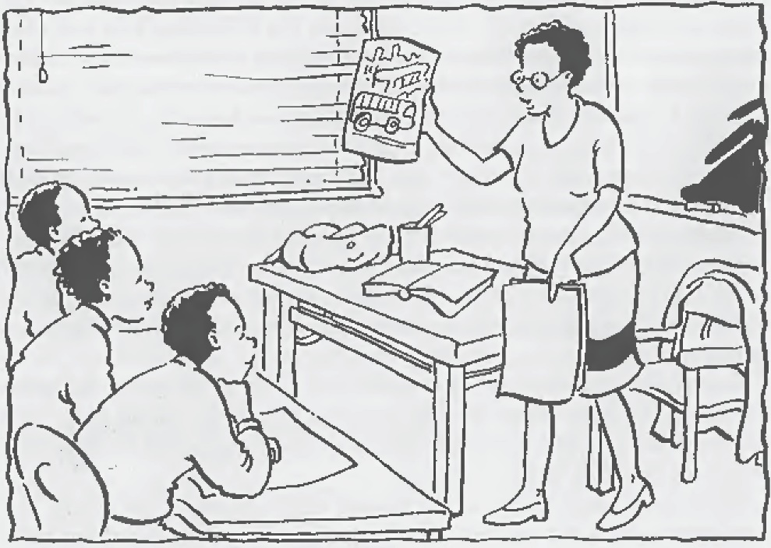

EXPERIENCE:
As we enter the classroom, the first thing we notice is that the students are attentively listening as the teacher is presenting a new dialog, a conversation between two people. The students know they will he expected to eventually memorize the dialog the teacher is introducing. All of the teacher's instructions are in English. Sometimes she uses actions to convey meaning, but not one word of the students' native language is uttered. After she acts out the dialog, she says:
'All right, class. 1am going to repeat the dialog now. Listen carefully, but no talking please. Two people are walking along a sidewalk in town. They know each other, and as they meet, they stop to talk. One of them is named Sally and the other one is named Bill. I will talk for Sally and for Bi II. Listen to their conversation:
Sally: Good morning, Hill.
Bill: Good morning, Sally.
Sally: How are you?
Bill: Fine, thanks. And you?
Sally: Fine. Where are you going?
Bill: I'm going to the post office.
Sally: I am too. Shall we go together?
Bill: Sure. Let's go.
Listen one more time. This time try to understand all that I am saying.' Now she has the whole class repeat each of the lines of the dialog after her model. They repeat each line several times before moving on to the next line. When the class comes to the line, 'l'm going to the post office,' they stumble a bit in their repetition. The teacher, at this point, stops the repetition and uses a backward build-up drill (expansion drill). The purpose of this drill is to break down the troublesome sentence into smaller parts. The teacher starts with the end of the sentence and has the class repeat just the last two words. Since they can do this, the teacher adds a few more words, and the class repeats this expanded phrase. Little by little the teacher builds up the phrases until the entire sentence is being repeat TEACHER
Teacher: Repeat after me: post office.
Class: Post .office.
Teacher: To the post office.
Class: To the post office.
Teacher: Going to the post office.
Class: Going to the post office.
Teacher: I'm going to the post office.
Class: I'm going to the post office.
Through this step-by-step procedure the teacher is able to give the students help in producing the troublesome line. Having worked on the line in small pieces, the students are also able to take note of where each word or phrase begins and ends in the sentence.
Read the remaining part of the class room experience from your text page number 32-39
Let us review the principles of ALM; these principles have been inferred from the classroom observations:
- Language forms do not occur by themselves; they occur most naturally within a context.
- The native language and the target language have separate linguistic systems. They should be kept apart so that the students' native
- Language interferes as little as possible with the students' attempts to acquire the target language.
- One of the language teacher's major roles is that of a model of the target language. Teachers should provide students with a good model. By 1isten i ng to how it is supposed to sound, students should be able to mimic the model.
- Language learning is a process of habit formation. The more often something is produced the stronger the habit and the greater the learning.
- It is important to prevent learners from making errors. Errors lead to the formation of bad habits. When errors do occur, they should be immediately corrected by the teacher.
- The purpose of language learning is to learn how to use the language to communicate.
- Positive reinforcement helps the students to develop correct habits.
- Students should learn to respond to both verbal and nonverbal stimuli.
- Students should 'overlearn,' i.e. learn to answer automatically without stopping to think.
- The teacher should be like an orchestra leader-conducting, guiding, and controlling the students' behavior in the target language.
- The major objective of language teaching should be for students to acq11ire the structural patterns;
- The learning of a foreign language should be the same as the acquisition of the native language. We do not need to memorize rules in order to use our native language. The rules necessary to use the target language will be figured out or induced from examples.
- The major challenge of foreign language teaching is getting students to overcome the habits of their native language. A comparison between the native and target language will tell the teacher in what areas her students will probably experience difficulty.
- Speech is more basic to language
- Language cannot be separated from culture. Culture is not only literature and the laws, but also the everyday behavior of the people who use the target language. One of the teacher's responsibilities is to present information about that culture.

Lecture # 8
The Audio-Lingual Method:
Reviewing Principles and Techniques
At this point, we should turn to the ten questions we have answered for each method we have considered so far.
1: What are the goals of teachers who use the Audio-Lingual Method?
Teachers want their students to be able to use the target language communicatively. In order to do this, they believe students need to over learn the target language to learn to use it automatically without stopping to think. Their students achieve this by forming new habits in the target language and by overcoming the old habits of their native language.
2: What is the role of the teacher? What is the role of the students?
The teacher is like an orchestra leader, directing and controlling the language behavior of her students. She is also responsible for providing her students with a good model for imitation. Students arc imitators of the teacher's model or the tapes she supplies of model speakers. They follow the teacher's directions and respond as accurately and as rapidly as possible.
3: What are some characteristics of the teaching/learning process?
New vocabulary and structures are presented through a dialogs. The dialogs are learned through imitation and repetition. Drills (such as repetition, backward build-up, chain, substitution, transformation, and question-and-answer) are conducted based upon the patterns present in the dialog. Students' successful responses arc positively rein forced. Grammar is induced from the examples given; explicit grammar rules are not provided. Cultural information is contextualized in the dialogs or presented by the teacher. Students' reading and written work is based upon the oral work they did earlier.
4: What is the nature of student-teacher interaction? What is the nature of student-student
interaction?
There is student-to-student interaction in chain drills or when students take different roles in dialogs, but this interaction is teacher-directed. Most of the interaction is between teacher and students and is initiated by the teacher.
5: How are the feelings of the students dealt with?
There are no principles of the method that relate to this area.
6: How is the language viewed? How is the culture viewed?
The view of language in the Audio-Lingual Method has been influenced by descriptive linguists. Every language is seen as having its own unique system. The system is comprised of several different levels: phonological, morphological, and syntactic. Each level has its own distinctive patterns. Everyday speech is emphasized in the Audio-Lingual Method. The level of complexity of the speech is graded, however, so that beginning students are presented with only simple patterns. Culture consists of the everyday behavior and lifestyle of the target language speakers.
7: What areas of language are emphasized? What Language skills are emphasized?
Vocabulary is kept to a minimum while the students are mastering the sound system -and grammatical patterns. A grammatical pattern is not the same as a sentence. For instance, underlying the following three sentences is the same grammatical pattern:
Meg called,
The Blue jays won,
The team practiced.
The natural order of skills presentation is adhered to: listening, speaking, reading, and writing. The oral/aural skills receive most of the attention. What students write they have first been introduced to orally. Pronunciation is taught from the beginning, often by students working in language laboratories on discriminating between members of minimal pairs.
8: What is the role of the students' native language?
The habits of the students' native language arc thought to interfere with the students' attempts to master the target language. Therefore, the target language is used in the classroom, not the students' native language. A contrastive analysis between the students' native language and the target language will reveal where a teacher should expect the most interference.

9: How is evaluation accomplished?
The answer to this question is not obvious because we did not actually observe the students in this class taking a formal test. If we had, we would have seen that it was discrete-point in nature, that is, each question on the test would focus on only one point of the language at a time. Students might be asked to distinguish between words in a minimal pair; for example, or to supply an appropriate verb form in a sentence.
10: How does the teacher respond to student errors?
Student errors are to be avoided if possible through the teacher's aware
REVIEWING THE TECHNIQUES
If you agree with the above answers, you may wish to implement the following techniques; of course, even if yon do not agree, there may be techniques described below that you are already using or can adapt to your approach.
Dialog memorization
Dialogs or short conversations between two people are often used to begin a new lesson. Students memorize the dialog through mimicry; students usually take the role of one person in the dialog, and the teacher the other. After the students have learned the one person's lines, they switch roles and memorize the other person's part. Another way of practicing the two roles is for half of the class to take one role and the other half to take the other. After the dialog has been memorized, pairs of individual students might perform the dialog for the rest of the class.
ln the Audio -Lingual Method, certain sentence patterns and grammar points are included within the dialog. These patterns and points are later practiced in drills based on the lines of the dialog.
Backward build-up (expansion) drill
This drill is used when a long line of a dialog is giving students trouble. The teacher breaks down the line into several parts. The students repeat a part of the sentence, usually the last phrase of the line. Then, following the teacher's cue, the students expand what they are repeating part by part until they are able to repeat the entire line. The teacher begins with the part at the end of the sentence (and works backward from there) to keep the intonation of the line as natural as possible. This also directs more student attention to the end of the sentence, where new information typically occurs.
Repetition drill:
Students are asked to repeat the teacher's model as accurately and as quickly as possible. This drill is often used to teach the lines of the dialog.

Chain drill
A chain drill gets its name from the chain of conversation that forms around the room as students, one-by-one, ask and answer questions of each other. The teacher begins the chain by greeting a particular student, or asking him a question. The student responds, then turns to the student sitting next to him. The first student greets or asks a question of the second student and the chain continues. A chain drill allows some controlled communication, even though it is limited. A chain drill also gives the teacher an opportunity to check each student's speech.
Single-slot substitution drill
The teacher says a line, usually from the dialog. Next, the teacher says a word or a phrase--called the cue. The students repeat the line the teacher has given them, substituting the cue into the line in its proper place. The major purpose of this drill is to give the students practice in finding and filling in the slots of a sentence.
Multiple-slot substitution drill
This drill is similar to the single slot substitution drill. The difference is that the teacher gives cue phrases, one at a time that fit into different slots in the dialog line. The students must recognize what part of speech each cue is, or at least, where it fits into the sentence, and make any other changes, such as subject-verb agreement. They then say the line, fitting the cue phrase into the line where it belongs.
Transformation drill
The teacher gives students a certain kind of sentence patterns, an affirmative sentence for example. Students are asked to transform these sentence into a negative sentence. Other examples of transformation to ask of students for changing a statement into a question, an active sentence into a passive one, or direct speech into reported speech.
Question -and-answer drill
This drill gives students practice with answering questions. The students should answer the teacher's questions very quickly. Although we did not see it in our lesson here, it is also possible for the teacher to cue the students to ask questions as well. This gives students practice with the question pattern.

Use of minimal pairs
The teacher works with pairs of words which differ in only one sound; for example, 'ship/sheep.' Students are first asked to perceive the difference between the two words and later to be able to say the two words. The teacher selects the sounds to work on after she has done a contrastive analysis, a comparison between the students' native language and the language they are studying.
Complete the dialog.
Selected words are erased from a dialog students have learned. Students complete the dialog by filling the blanks with the missing words.
Grammar game
Games like the supermarket alphabet game described in this chapter are used in the Audio-Lingual Method. The games are designed to get students to practice a grammar point within a context. Students are able to express themselves, although it is rather limited in this game. Notice there is also a lot of repetition in this game.
Conclusion
We've looked at both the techniques and the principles of the Audio­ Lingual Method. Try now to make the bridge between this book and your teaching situation. Does it make sense to you that language acquisition results from habit.

Lecture # 9
The Silent Way
INTRODUCTION
Although people did learn languages through the Audio-Lingual Method (and indeed it is still practiced today), one problem with it was students' inability to readily transfer the habits they had mastered in the classroom to communicative use outside it. Furthermore, the idea that learning a language meant forming a set of habits was seriously challenged in the early 1960s. Linguist Noam Chomsky argued that language acquisition could not possibly take place through habit formation since people create and understand utterances they have never heard before. Chomsky pro ­ posed instead that speakers have a knowledge of underlying abstract rules, which allow them to understand and create novel utterances. Thus, Chomsky reasoned, language must not be considered a product of habit formation, but rather of rule formation. Accordingly, language acquisition must be a procedure whereby people use their own thinking processes, or cognition, to discover the rules of the language they are acquiring. The emphasis on human cognition led to the establishment of the Cognitive Approach (C. Murcia 1991). Rather than simply being responsive to stimuli in the environment learners were seen to be much more actively responsible for their own learning, engaged in formulating hypotheses in order to discover the rules of the target language. Errors were inevitable and were signs that learners were actively testing their hypotheses. For a while in the early 1970s there was great interest in applying this new Cognitive Approach to language teaching and materials were developed with deductive (learners arc given the rule and asked to apply it) and inductive (learners discover the rules from the examples and then practice it) grammar exercises. However, no language teaching method ever really developed directly from the Cognitive Approach; instead , number of 'innovative methods' emerged.
Although Caleb Caleb Gattegno’s Silent Way did not stem directly from the Cognitive Approach, it shares certain principles with it. For example, one of the basic principles of the Silent Way is that 'Teaching should be subordinated to learning.' In other words, Gattegno believed that to teach means to serve the learning process rather than to dominate it. This principle is in keeping with the active search for rules ascribed to the learner in the Cognitive Approach. Gattegno looked at language learning from the perspective of the learner by studying the way babies and young children learn. He concluded that learning is a process which we initiate by ourselves by mobilizing our inner resources (our perception, aware­ ness, cognition, imagination, intuition, creativity, etc.) to meet the challenge at hand. In the course of our learning, we integrate into ourselves whatever 'new' that we create, and we use it as a stepping stone for further learning.
In order to explore the Silent Way, we will observe the first day of an English class in Brazil. There are twenty-four secondary school students in this class. The class meets for two hours a day, three days a week.

EXPERIENCE
As we take our seats, the teacher has just finished introducing the Silent Way in Portuguese. The teacher walks to the front of the room, takes out a metal pointer and points to a chart hanging above the blackboard. The chart has a black background and is covered with small rectangular blocks arranged in rows. Each block is a different color. This is a sound-color chart. Each rectangle represents one English sound. There is a white horizontal line approximately halfway down the chart separating the upper rectangles, which represent vowel sounds, from those below the line, which represent consonant sounds.
Without saying anything, the teacher points in succession to each of five blocks of color 'above the line. There is silence. The teacher repeats the pattern, pointing to the same five blocks of color. Again, no one says anything. The third time the teacher docs the pointing, he says /a/ as he touches the first block.
The teacher continues and taps the four other blocks of color with the pointer. As he does this, several students say /e/, /i/, /o/, /u/. He begins with these vowels since they are the ones students already know. (These five sounds are the simple vowels of Portuguese and every Brazilian schoolchild learns them in this order.) Read the remaining part of the experience from your text: page 53-57
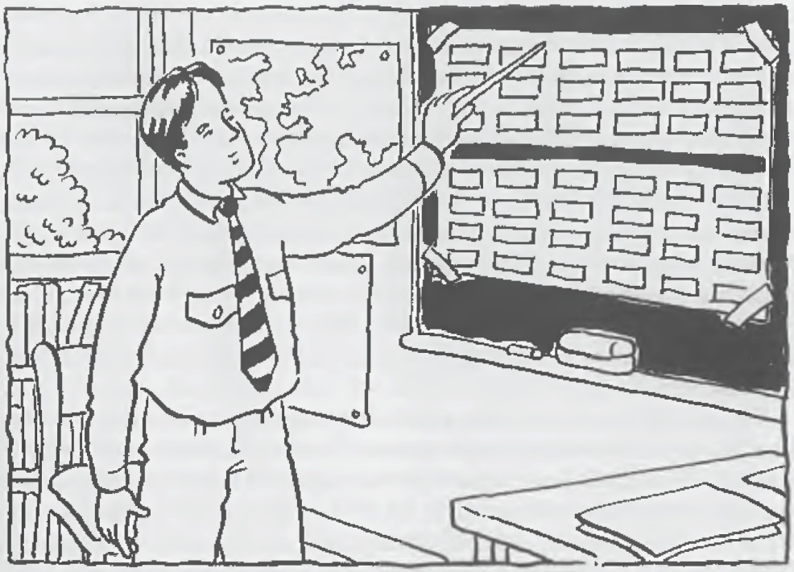
Let us review the principles of this method; these principles have been inferred from the classroom experience. Please read the observations from your text.

Principles
- The teacher should start with something the students already know and build from that to the unknown.
- Languages share a number of features, sounds being the most basic.
- Language learners are intelligent and bring with them the experience of already learning a language. The teacher should give only what help is •necessary.
- Language is not learned by repeating after a model. Students need to develop their own 'inner criteria for correctness-to trust and robe responsible for their own production in the target language.
- Students' actions can tell the teacher whether or not they have learned a specific linguistic item or not.
- Students should learn to rely on each other and themselves.
- The teacher works with the students while the students work on the language.
- The teacher makes use of what students already know. The more the teacher does for the students what they can do for themselves, the less they will do for themselves.
- Learning involves transferring what one knows to new contexts.
- Reading is worked on from the beginning but follows from what students have learned to say.
- Silence is a tool. It helps to foster autonomy, or the exercise of initiative. It also removes the teacher from the center of attention, so he can listen to and work with students. The teacher speaks, but only when necessary. Otherwise, the teacher gets out of the way so that it is the students who receive the practice in using the language.
- Meaning is made clear by focusing students’ perceptions, not through translation.
- Students can learn from one another. The teacher’s silence encourages group cooperation.
- If the teacher praises or criticizes students, they will be less self-reliant. The teacher’s actions can interfere with students’ developing their own criteria.
- Errors are important and necessary to learning. They show the teacher where things are unclear.
- If students are simply given answers rather than being allowed to self- correct, they won’t retain them.
- Students need to learn to listen to themselves.
- At the beginning, the teacher needs to look for progress, not perfection. Learning takes place in time. Students learn at different rates.
- A teacher’s silence frees the teacher to closely observe the students’ behavior.
- Students learn to give due attention to their teacher; which is very important for learning a language through this way.
- Students should receive a great deal of meaningful practice without repetition.
- The elements of the language are introduced logically, expressing upon what students already know.
- Students gain autonomy in the language by exploring it and by making choice.
- Language is for self- expression.
- The teacher can gain valuable information from students feedback; e.g he can learn what to work on next. Students learn how to accept responsibility for their own learning.
- Some learning takes place naturally as we sleep. Students will naturally work on the day’s lesson then.
- The syllabus is composed of linguistic structures.
- The structures of the syllabus are not arranged in a linear fashion, but rather are constantly being recycled.
- The skills of speaking, reading, and writing reinforce one another.
Lecture # 10
The Silent Way
REVIEWING THE PRINCIPLES:
As you can see, the Silent Way has a great many principles. Perhaps we can come to a fuller understanding of them if we consider the answers to our ten questions.
1: What are the goals of teachers who use the Silent Way?
Students should be able to use the language for self-expression to express their thought, perceptions, and feelings. In order to do this, they need to develop independence from the teacher, to develop their own inner criteria for correctness. Students become independent by relying on themselves. The teacher, therefore, should give them only what they absolutely need to promote their learning.
2: What is the role of the teacher? What is the role of the students?
The teacher is a technician or engineer. 'Only the learner can do the learning,' but the teacher, relying on what his students already know, can give what help is necessary, focus the students' perceptions, 'force their awareness,' and 'provide exercises to insure their facility' with the language. The teacher should respect the autonomy of the learners in their attempts at relating and interacting with the new challenges. The role of the students is to make use of what they know, to free themselves of any obstacles that would interfere with giving their utmost attention to the learning task, and to actively engage in exploring the language. As Gattegno says, “The teacher works with the student; the student works on the language.”
3: What are some characteristics of the teaching/learning process?
Students begin their study of the language through its basic building blocks, its sounds. These are introduced through a language-specific sound-color chart. Relying on what sounds students already know from their knowledge of their native language, teachers lead their students to associate the sounds of the target language with particular colors. Later, these same colors are used to help students learn the spellings that correspond to the sounds (through the color-coded Fidel charts) and how to read and pronounce words properly (through the color-coded word charts). The teacher sets up situations that focus student attention on the structures of the language. The situations provide a vehicle for students to perceive meaning. The situations sometimes call for the use of rods and sometimes do not; they typically involve only one structure at n time. With minimal spoken cues, the students are guided to produce the structure. The teacher works with them, striving for pronunciation that would be intelligible to a native speaker of the target language. The teacher uses the students' errors as evidence of where the language is unclear to students and, hence, where to work.
The students receive a great deal of practice with a given target language structure without repetition for its own sake. They gain autonomy in the language by exploring it and making choices. The teacher asks the students to describe their reactions to the lesson or what they have learned. This provides valuable information for the teacher and encourages students to rake responsibility for their own learning. Some further learning rakes place while they sleep.
4: What is the nature of student-teacher interaction? What is the nature of student-student
interaction?
For much of the student-teacher interaction, the teacher is silent. He is still very active, however, setting up situations to 'force awareness,' listening attentively to students' speech, and silently working with them on their production through the use of nonverbal gestures and the tools he has available. When the teacher does speak, it is to give clues, not to model the language. Student-student verbal interaction is desirable (students can learn from one another) and is therefore encouraged. The teacher's silence is one way to do this.
5: How are the feelings of the students dealt with?
The teacher constantly observes the students. When their feelings interfere, the teacher tries to find ways for the students to overcome them. Also, through feedback sessions at the end of lessons, students have an opportunity to express how they feel. The teacher takes what they say into consideration and works with the students to help them overcome negative feelings which might otherwise interfere with their learning. Finally, because students are encouraged throughout each lesson to cooperate with one another, it is hoped that a relaxed, enjoyable learning environment will be created.
6: How is language viewed? How is culture viewed?
Languages of the world share number of features. However, each language also has its own unique reality, or spirit, since it is the expression of a particular group of people. Their culture, as reflected in their own unique world view, is inseparable from their language.

7: What areas of language are emphasized? What language skills are emphasized?
Since the sounds are basic to any language, pronunciation is worked on from the beginning. It is important that students acquire the melody of the language. There is also a focus on the structures of the language, although explicit grammar rules may never be supplied. Vocabulary is somewhat restricted at first. There is no fixed, linear, structural syllabus. Instead, the teacher starts with what the students know and builds from one structure to the 1iext. As the learners' repertoire is expanded, previously introduced structures are continuously being recycled. The syllabus develops according to learning needs. All four skills are worked on from the beginning of the course, although there is a sequence in that students learn to read and write what they have already produced orally. The skills reinforce what students are learning.
8: What is the role of the students' native language?
Meaning is made clear by focusing the students' perceptions, not by translation. The students' native language can, however, be used to give instructions when necessary, to help a student improve his or her pronunciation, for instance. The native language is also used (at least at beginning levels of proficiency) during the feedback sessions. More important, knowledge students already possess of their native language can be exploited by the teacher of the target language. For example, the teacher knows that many of the sounds in the students' native language will be similar, if not identical, to sounds in the target language; he assumes, then, that he can build upon this existing knowledge to introduce the new sounds in the target language.
9: How is evaluation accomplished?
Although the teacher may never give a formal test, he assesses student learning all the time. Since 'teaching is subordinated to learning,' the teacher must be responsive to immediate learning needs. The teacher's silence frees him to attend to his students and to be aware of these needs. The needs will be apparent to a teacher who is observant of his students' behavior. One criterion of whether or not students have learned is their ability to transfer what they have been studying to new contexts. The teacher docs not praise or criticize student behavior since this would interfere with students' developing their own inner criteria. He expects students to learn at different rates. The teacher looks for steady progress, not perfection.
10: How does the teacher respond to student errors?
Student errors are seen as a natural, indispensable part of the learning process. Errors are inevitable since the students are encouraged to explore the language. The teacher uses student errors as a basis for deciding where further work is necessary. The teacher works with the students in getting them to self-correct. Students are not thought to learn much if the teacher merely supplies the correct language. Students need to learn to listen to themselves and to compare their own production with the developing inner criteria. If the students are unable to self-correct and peers cannot help, then the teacher would supply the correct language, but only as a last resort.
Reviewing the Techniques and The Materials:
Many of the ideas in this chapter may be new to you, Some of these ideas may be immediately attractive to you, whereas others may not, Give yourself time to think about all of them before you decide their value to you.
In the review that follows, the materials surveyed in this chapter (the charts and rods) have been included. While you may not have access to the actual materials discussed here, the materials may suggest ideas you can use.
Sound-color chart
The chart contains blocks of color, each one representing a sound in the target language. The teacher, and later the students, points to blocks of color on the chart to form syllables, words, and even sentences. Although we did not see it in this lesson, sometimes the teacher will tap a particular block of color very hard when forming a word. In this way the teacher can introduce the stress pattern for the word. The chart allows students to produce sound combinations in the target language without doing so through repetition. The chart draws the students' attention and allows them to concentrate on the language, not on the teacher. When a particular sound contrast is new for students and they can't perceive which sound of the two they are producing, the sound-color chart can be used to give them feedback on which sound they are making. Finally, since the sound-color chart presents all of the sounds of the target language at once, students know what they have learned and what they yet need to learn. This relates to the issue of learner autonomy.
Teacher's Silence
The teacher gives just as much help as is necessary and then is silent. Or the teacher sets up an unambiguous situation, puts a language structure into circulation (for example, 'Take a rod'), and then is silent. Even in error correction, the teacher will only supply a verbal answer us a last resort.
Peer correction
Students are encouraged to help another student when he or she is experiencing difficulty. It is important that any help be offered in cooperative manner, not a competitive one. The teacher monitors the aid so that it is helpful, nor interfering.
Rods:
Rods can be used to provide visible actions or situations for any language structure, to introduce it, or to enable students to practice using it. The rods trigger meaning: Situations with the rods can be created in such a way that the meaning is made clear; then the language is connected to the meaning. At the beginning level, the rods can be used to teach colors and numbers. Later on they can be used for more complicated structures; for example, statements with prepositions ('The blue rod is between the green one and the yellow one') and conditionals ('If you give me a blue rod, then I'll give you two green ones'). They can be used abstractly as well; for instance, for students to make a dock when learning to tell time in the target language, to create a family tree or to make a floor plan of their house, which they later describe to their classmates. Sometimes teachers will put the rods down on the desk in a line, using a different rod to represent each word in a sentence. By pointing to each rod in turn, while remaining silent, the teacher can elicit the sentence from the students. The rods are therefore very versatile. They can be used as rods or more abstractly to represent other realities. They allow students to be creative and imaginative, and they allow for action to accompany language.
Self-correction gestures
We already examined some self-correction techniques in the chapter on the Direct Method. Some of the particular gestures of the Silent Way could be added to this list. For example, in the class observed, the teacher put his palms together and then moved those outwards to signal to students the need to lengthen the particular vowel they were working on. In another instance, the teacher indicated that each of his fingers represented a word in a sentence and used this to locate the trouble spot for the student.
Word chart
The teacher, and later the students, points to words on the wall charts in a sequence so that they can read loud the sentences they have spoken. The way the letters are colored (the colors from the sound­ color chart are used) helps the students with their pronunciation. There are twelve English charts containing about 500 words. The charts contain the functional vocabulary of English. Although we did not see them in this lesson, students also work with Silent Way wall pictures and books to further expand their vocabularies and facility with the language.
Fidel charts
The teacher, and later the students, point to the color-coded Fidel charts in order that students associate the sounds of the language with their spelling. for example, listed together and colored the same as the color block for the sound ley/ are ay, ea, ei, eigh, etc., showing that these are all ways of spelling the /ey/ sound in English (e.g. in the words 'su,' 'steak,' 'v.cil,' 'weigh'). Because of the large number of ways sounds in English can be spelled, there are eight Fidel charts in all. There are a number of charts available in other languages as well.
Structured feedback
Students are invited to make observations about the day's lesson and what they have learned. The teacher accepts the students' comments in a non-defensive manner, hearing things that will help give him direction for where he should work when the class meets again. The students learn to take responsibility for their own learning by becoming aware of and con­ trolling how they use certain learning strategies in class. The length and frequency of feedback sessions vary depending on the teacher and the class.

CONCLUSION: -
We have avoided referring to the Silent Way as a method since Caleb Gattegno says it is not one. Proponents of the Silent Way claim its principles are far-reaching, affecting not only education, bur the way one perceives the living of life itself. Nevertheless, there clearly are implications for language teaching and you should ask yourself whether there are implications for you. Do you believe teaching should be subordinated to learning? Does it make sense to you that learners should be encouraged to be independent

