Lecture 27
M.A. K. Halliday
A Brief Life History
Halliday was born and raised in England. His fascination for language was nurtured by his parents: his mother, Winifred, had studied French, and his father, Wilfred, was a dialectologist, a dialect poet, and an English teacher with a love for grammar and Elizabethan drama. In 1942, Halliday volunteered for the national services' foreign language training course. He was selected to study Chinese on the strength of his success in being able to differentiate tones. After 18 months' training, he spent a year in India working with the Chinese Intelligence Unit doing counter-intelligence work. In 1945 he was brought back to London to teach Chinese. He took a BA Honours degree in Modern Chinese Language and Literature (Mandarin) through the University of London. This was an external degree, with his studies conducted in China. He then lived for three years in China, where he studied under Luo Changpei at Peking University and under Wang Li at Lingnan University, before returning to take a PhD in Chinese Linguistics atCambridge under the supervision of Gustav Hallam and then J. R. Firth. Having taught languages for 13 years, he changed his field of specialisation to linguistics, and developed systemic functional linguistics, including systemic functional grammar, elaborating on the foundations laid by his British teacher J. R. Firth and a group of European linguists of the early 20th century, the Prague school. His seminal paper on this model was published in 1961.
Halliday's first academic position was Assistant Lecturer in Chinese, at Cambridge University, from 1954 to 1958. In 1958 he moved to Edinburgh, where he was Lecturer in General Linguistics until 1960, and then Reader from 1960 to 1963. From 1963 to 1965, he was the director of the Communication Research Center at University College, London. During 1964, he was also Linguistic Society of America Professor, at Indiana University. From 1965 to 1971, he was Professor of Linguistics at UCL. In 1972–73 he was Fellow, Center for Advanced Study in the Behavioural Sciences, at Stanford, and in 1973–74 Professor of Linguistics at the University of Illinois. In 1974 he briefly moved back to Britain as Professor of Language and Linguistics at Essex University. In 1976 he moved to Australia as Foundation Professor of Linguistics at the University of Sydney, where he remained until he retired in 1987.
Halliday has worked in various regions of language study, both theoretical and applied, and has been especially concerned with applying the understanding of the basic principles of language to the theory and practices of education. He received the status of Emeritus Professor of the University of Sydney and Macquarie University, Sydney, in 1987. He has honorary doctorates from University of Birmingham (1987), York University (1988), the University of Athens (1995), Macquarie University (1996), and Lingnan University (1999)

Linguistic Theories
Halliday is notable for his grammatical theory and descriptions, outlined in his book An Introduction to Functional Grammar, first published in 1985. A revised edition was published in 1994, and then a third, in which he collaborated with Christian Matthiessen, in 2004. But Halliday’s conception of grammar – or ‘lexicogrammar’ (a term he coined to argue that lexis and grammar are part of the same phenomenon) – is based on a more general theory of language as a social semiotic resource, or a ‘meaning potential’. Halliday follows Hjelmslev and Firth in distinguishing theoretical from descriptive categories in linguistics. He argues that ‘theoretical categories, and their inter-relations, construe an abstract model of language...they are interlocking and mutally defining. The theoretical architecture derives from work on the description of natural discourse, and as such ‘no very clear line is drawn between ‘(theoretical) linguistics’ and ‘applied linguistics’.Thus, the theory ‘is continually evolving as it is brought to bear on solving problems of a research or practical nature’. Halliday contrasts theoretical categories with descriptive categories, defined as ‘categories set up in the description of particular languages’. His descriptive work has been focused on English and Chinese.
Halliday rejects explicitly the claims about language associated with the generative tradition. Language, he argues, "cannot be equated with 'the set of all grammatical sentences', whether that set is conceived of as finite or infinite". He rejects the use of formal logic in linguistic theories as "irrelevant to the understanding of language" and the use of such approaches as "disastrous for linguistics". On Chomsky specifically, he writes that "imaginary problems were created by the whole series of dichotomies that Chomsky introduced, or took over unproblematized: not only syntax/semantics but also grammar/lexis, language/thought, competence/performance. Once these dichotomies had been set up, the problem arose of locating and maintaining the boundaries between them."

Halliday’s concepts about Grammar
Halliday's first major work on the subject of grammar was "Categories of the theory of grammar", published in the journal Word in 1961.In this paper, he argued for four "fundamental categories" for the theory of grammar: unit, structure, class, and system. These categories, he argued, are "of the highest order of abstraction", but he defended them as those necessary to "make possible a coherent account of what grammar is and of its place in language" In articulating the category unit, Halliday proposed the notion of a rank scale. The units of grammar formed a "hierarchy", a scale from "largest" to "smallest" which he proposed as: "sentence", "clause", "group/phrase", "word" and "morpheme".]Halliday defined structure as "likeness between events in successivity" and as "an arrangement of elements ordered in places' Halliday rejects a view of structure as "strings of classes, such as nominal group + verbalgroup + nominal group" among which there is just a kind of mechanical solidarity" describing it instead as "configurations of functions, where the solidarity is organic".

Grammar as systemic
Halliday's early paper shows that the notion of "system" has been part of his theory from its origins. Halliday explains this preoccupation in the following way: "It seemed to me that explanations of linguistic phenomena needed to be sought in relationships among systems rather than among structures – in what I once called "deep paradigms" – since these were essentially where speakers made their choices". Halliday's "systemic grammar" is a semiotic account of grammar, because of this orientation to choice. Every linguistic act involves choice, and choices are made on many scales. Systemic grammars draw on system networks as their primary representation tool as a consequence. For instance, a major clause must display some structure that is the formal realization of a choice from the system of "voice", i.e. it must be either "middle" or "effective", where "effective" leads to the further choice of "operative" (otherwise known as 'active') or "receptive" (otherwise known as "passive").

Grammar as "functional"
Halliday's grammar is not just systemic, but systemic functional. He argues that the explanation of how language works "needed to be grounded in a functional analysis, since language had evolved in the process of carrying out certain critical functions as human beings interacted with their ... 'eco-social' environment".Halliday's early grammatical descriptions of English, called "Notes on Transitivity and Theme in English – Parts 1–3"[ include reference to "four components in the grammar of English representing four functions that the language as a communication system is required to carry out: the experiential, the logical, the discoursal and the speech functional or interpersonal". The "discoursal" function was renamed the "textual function". In this discussion of functions of language, Halliday draws on the work of Bühler and Malinowski. Halliday's notion of language functions, or "metafunctions", became part of his general linguistic theory.

Introduction to the Systemic-Functional Model of Language
1 What is Systemic Functional Linguistics
Systemic-Functional Linguistics (SFL) is an approach to language developed mainly by M.A.K. Halliday in the U.K. during the 1960s, and later in Australia. The approach is now used world-wide, particularly in language education, and for purposes of discourse analysis. While many of the linguistic theories in the world today are concerned with language as a mental process, SFL is more closely aligned with Sociology: it explores how language is used in social contexts to achieve particular goals. In terms of data, it does not address how language is processed or represented within the human brain, but rather looks at the discourses we produce (whether spoken or written), and the contexts of the production of these texts. Because it is concerned with language use, SFL places higher importance on language function (what it is used for) than on language structure (how it is composed).
1. According to this approach ‘Functional’: focus on what things do rather than how the things are composed (structural)
- Structure-informed Analysis
a handful of rice

head of NP
- Function-informed Analysis
  - A handful of rice
Quantifier
. Systemic separates Choices and Structure:
- Speech consists of what choices we can make and show to what extent these choices are contextually conditioned
- According to Halliday, ,structure is an output device, the mechanism for expressing the choices that have been made’
- For Systemic Functional Linguistics, unit/ Grammatical unit has following levels:
- Sentence <…..Clause <……Phrase (group) <………Word <.........Morpheme
- The choice of unit which is based on meanings that we want to convey rather than structure so choice is an initial and different step from structure
- Levels of Language:
- 1st level is unit
- 2nd level is structure
- 3rd level is class
- 4th level is system
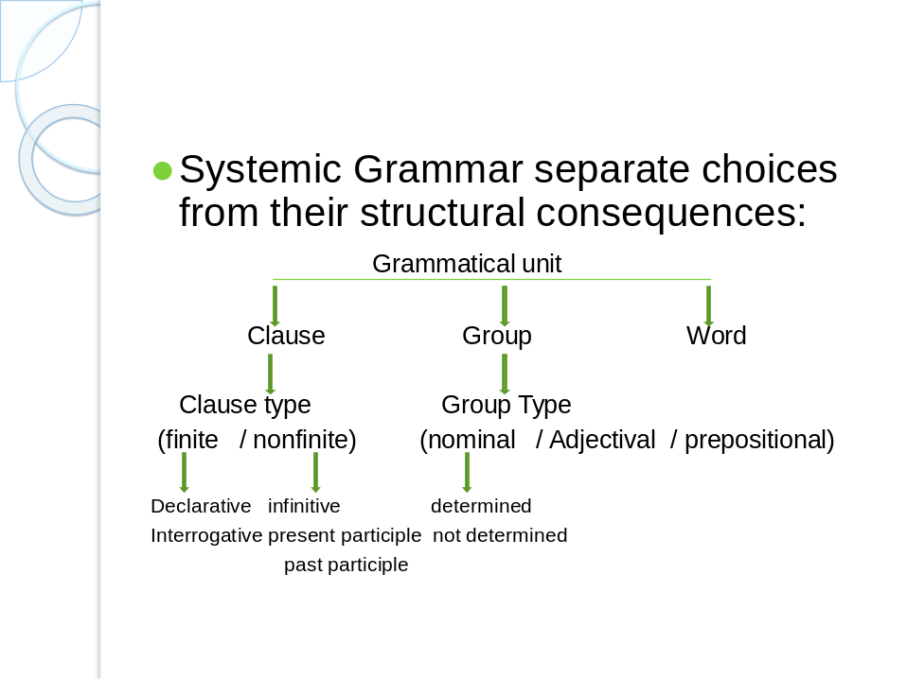
- A “systemic” approach allows you to focus on meaningful choices in language (e.g., active vs. passive) without needing to think of the particular structure that realizes it.
- Basic tenet: “meaning implies choice
- A grammar consists of a set of choices, or “systems”, organized as a tree (some choices depend on others): For example ‘voice’ is a system with two choices: ‘active’ and ‘passive’. What meaning you want to convey will be represented through your choice
Metafunctions of Language

A metafunction is one which is capable of describing one or more other functions. A better way of describing the metafunction of language is to followHalliday.
People do different things with language. They intend to achieve by talking and writing, and by listening and reading, different aims and different purposes. Halliday conceives of language as social semiotic, that is to say, language is a system of signs developed to expresssocial meanings. Function can regarded as the use of language. However, we can interpret it as a fundamental property of language. The organization of every language can be explained in terms of a functional theory. One requirement of language is that it should provide the means for people to act upon their environment, to classify and organize it and so bring it under control by a process of what we might call conceptual projection.
In Halliday's words, language has to have an ideational function. Another necessity is for language to provide a means for people to interact with each other, for the first person to cope with the second person, to establish a basis for cooperative action social relations: so language needs to discharge an interpersonal function as well. Language also helps to relate text to context and has certain phonological and thematic features of texture. This means that language has textual function, too. These functions will be reflected within the abstract systems of the linguistic code.
1 Ideational function
2Interpersonal function
3Textual function
These terms are interpreted as functional components of the semantic system. They are present in every use of language in every social context. A text is a product of all three. The three metafunctions of language are closely related to context and realized in the lexicogrammar of language. They are interwoven in discourse. According to Halliday, every sentence in a text is multifunctional and has three metafunctions simultaneously. This is the essential nature of a functional theory.
1 Ideational Function
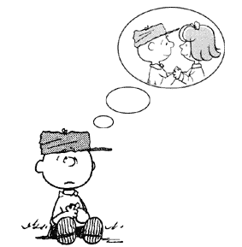
From the general functions of language we can see that there is a common mental or conceptualizing process involved. In using language to identify things, or as an instrument of thought, or to provide a record, we are using language as a symbolic code to represent theworld around us. The ideational function, then, is the content function of language and allows us to conceptualize the world for our own benefit and that of others. It is through this function the language encodes the cultural experience and the speaker encodes his own individual experience of the things of the world and his own consciousness. The ideational function is divided into experiential function and logical function. In a sense we bring the world into being linguistically. For example,
Leave a kiss within the cup, and I'll not ask for wine.
In the first half of the sentence there are an action (leave), a thing and a circumstantial element (within the cup). So we have the representation of an action, a thing that is acted upon, and a place. In the second half, there is a doer (I). The action is ask for and the thing is wine. The whole sentence represents some phenomenon in the real world. These could be said to display the experiential meaning of the sentence. Moreover, we have to account for the word 'and', which shows the two halves of the sentence are related in some way. Here, 'and' expresses the logical meaning of the sentence. However, we know that the sentence is in fact an imaginative representation of experience. Halliday refers to this as metaphorical
2 Interpersonal Function

As we have seen in the previous section, several general functions are concerned with the relationship between the speaker and other people or things. We not only to use language toconceptualize the world but also using language as a personal medium. According to Halliday, the interpersonal component represents the speaker's meaning potential as an intruder. It is the participatory function of language. It is through language that the speaker intrudes himself into the context of situation. He expresses his own attitudes and judgements and seeks to influence the attitudes and behaviour of others. The interpersonal function expresses the role relationships associated with the situation. We gain much of our sense of identity, of who and what we are, from our relationships both with animate and inanimate things, and language is an essential part of that personalizing process. We could say that rather than bringing the world into being, this function is concerned with the way we bring ourselves into being linguistically. Look at the example again:
Leave a kiss within the cup, and I'll not ask for wine.
According to Halliday, the sentence is not only a representation of reality, but also an interaction between speaker and hearer. The two halves of the sentence have a different function. The first half is a request and the second half is an offer. Here, we are considering the sentence from the point of view of its function in the process of social interaction. The sentence means: "I request you to do something, and I undertake no to do something else."
3 Textual Function
Language has the function which enables the other two functions to operate, namely, the function which represents the speaker's text-forming potential. This function relates our abilities to construct texts out of our utterances and writings. Halliday calls it the textual function. We can see it as using language to bring texts into being. This function expresses the relation of language to the verbal and nonverbal situational environment. When we speak or write we don't normally confine ourselves to single phrases or sentences, we string these together to make a connected sequence. And there are words in our language which are particularly designed to enable us to do that.
Leave a kiss within the cup, and I'll not ask for wine.
Since this example is in fact a line of verse, its texture relies on rhythm and intonation and it has a particular metric structure. When this line is put back into the verse, we can find its thematic pattern of development and the semantic and grammatical balance.

