Lecture 24
Language and Brain

Where Is Language in the Brain?
Brain activity is like the activity of a huge city. A city is organized so that people who live in it can get what they need to live on, but you can't say that a complex activity, like manufacturing a product, is "in" one place. Raw materials have to arrive, subcontractors are needed, the product must be shipped out in various directions. It's the same with our brains. We can't say that all of language is "in" a particular part of the brain; it's not even true that a particular word is "in" just one spot in a person's brain. But we can say that listening, understanding, talking, and reading each involve activities in certain parts of the brain much more than other parts.
Most of these parts are in the left side of your brain, the left hemisphere, regardless of what language you read and how it is written. We know this because aphasia (language loss due to brain damage) is almost always due to left hemisphere injury in people who speak and read Hebrew, English, Chinese, or Japanese, and also in people who are illiterate. But areas in the right side are essential for communicating effectively and for understanding the point of what people are saying. If you are bilingual, your right hemisphere may be somewhat more involved in your second language than it is in your first language.

How is the brain organized?
Science has always been interested in how the brain processes information. Phrenology, popular in the Victorian Era of the 1800s, attempted to map elements of personality and mental ability in the brain. Character, the theory goes, is located in certain portions of the brain. These in turn dictate the shape of the skull, depending upon how fully each is developed. Reading the shape of the skull is an empirical science, we're told, built up on years of refinement. But then we're given the data, and now the story becomes pretty frightening.
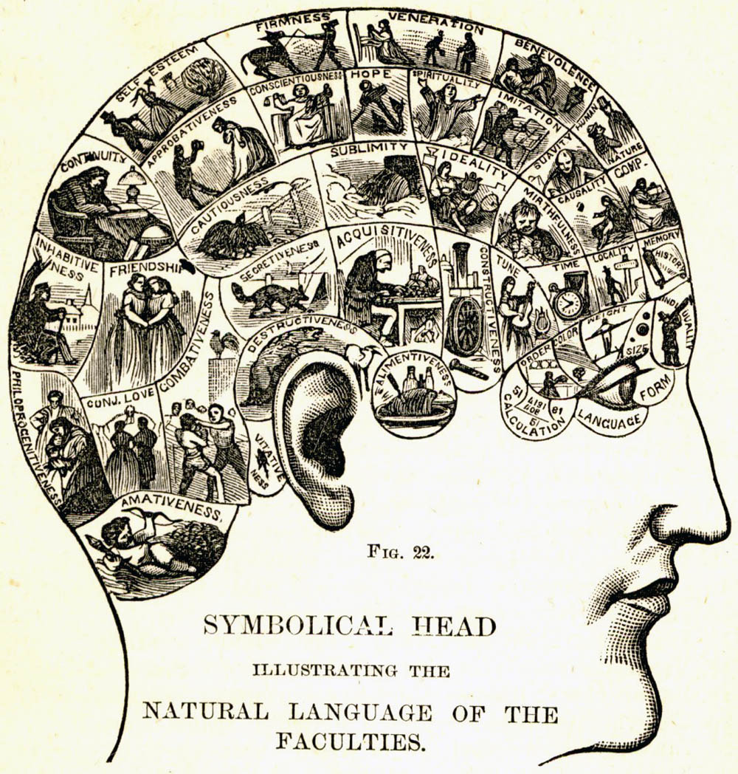
Plate from How to Read Character: A New Illustrated Hand-book of Phrenology and Physiognomy (1891)published by The Fowler/Wells Company.
The data consist of the author's own drawings. For example, we're shown skulls of a male and female (where the adjective white is implied but not stated) along with skulls identified as Negro and American Indian. The features that Wells imagines for each are built into the drawings. Throughout the book, we find countless pairs of heads. A sketch of a white man shows a high protruding forehead. Next to him is a "negro" with a low forehead. This is evidence that people with the foreheads of white people are highly reflective and those without it are not. The head of Harvard naturalist Louis Agassiz is supposed to exemplify perception. Alas, that's the same Agassiz who argued that the black race was the result of separate creation by God.
Easily we can see that phrenology was not based on science. We have since learned much more about the brain, and in just the last 30 years, thanks to technology.

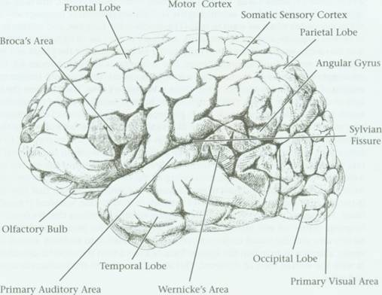
The left hemisphere of the human brain. "Map of the Human Cortex," figure by Carol Donner from "Specializations of the Human Brain," by Norman Geschwind
As you can see from the drawing above, the cortex is not flat but covered with bumps and indentations. The bumps on the surface of the brain are called gyri (singular: gyrus) and the depressions are called fissures. Scientists use certain fissures to demarcate particular areas of the brain. One of the most prominent of these is the Sylvian Fissure, the large horizontal fold located in the middle of each hemisphere separating the temporal lobe from the frontal lobe of the brain.
Several portions of the cortex are specialized to perform particular functions that play a role in language use.
- The cortexes
  - The auditory cortex (referred to as "Primary Auditory Area" in the drawing above) is located next to the Sylvian Fissure. The auditory cortex is responsible for receiving and identifying auditory signals and converting them into a form that can be interpreted by other areas of the brain.
  - The visual cortex (in the figure referred to as "Primary Visual Area") is located in the lower back of each hemisphere. This area receives and interprets visual stimuli and is thought to be the storage site for pictorial images.
  - The motor cortex is found in the upper middle of each hemisphere, perpendicular to the Sylvian Fissure. This part of the brain is responsible for sending signals to your muscles, including those of your face, jaw, and tongue, to make them move. The fissure between the motor cortex and the somatic sensory cortex also separates the frontal lobe from the parietal lobe.
- The language centers of the brain-parts of the cortex, as far as we know, are used only for the production and comprehension of language. In contrast to the other areas we have introduced here, these centers are found only in the hemisphere that is specialized for language: for approximately 90 percent of the right-handed peopleand 90 percent of the left-handed people, this is the left hemisphere. The opposing hemisphere does not have these language centers.
  - The first of these language centers that we will introduce Broca's area. Located at the base of the motor cortex, this language center appears to be responsible for organizing the articulatory patterns of language and directing the motor cortex when we want to talk. (This involves the face, jaw, and tongue in the case of spoken language, and the hands, arms, and body in the case of signed language.) Broca's area also seems to control the use of inflectional morphemes, like the plural and past tense markers, as well as function morphemes, like determiners and prepositions. This is a very important function with respect to the formations of words and sentences
  - Wernicke's area is located near the back section of the auditory cortex. This section of the brain is involved in the comprehension of words and the selection of words when producing sentences.
Wernicke's area and Broca's area are connected by a bundle of nerve fibers called the arcuate fasciculus. Like the corpus collosum, these nerve fibers allow the two areas of the brain they connect to share information. Without them, we would not be able to look up words in our mental lexicon (via Wernicke's area) and then say them (via Broca's area.) (Think of the mental lexicon as a dictionary, located in the brain, containing all the words an individual knows, including what each word means and how to pronounce it. Recognize, however, that this dictionary is not tangible but rather some abstract network of information scattered throughout the brain. We cannot point to it, but we have strong reasons to believe that it exists.) The final language center is the angular gyrus. This area, located between Wernicke's area and the visual cortex, converts visual stimuli into auditory stimuli (and vice versa), allowing us to match the spoken form of a word with the object it describes, as well as the written form of the words,. This ability is crucial to the human capacity to read and write.

How does information flow in the brain?
Now how do all of these areas of the brain work together to process language? As far as we know, that depends on what type of stimulus (auditory, visual, etc.) is involved and what type of linguistic result (speaking, reading, understanding, etc.) is desired.

What happens when you say a word?
To produce a spoken word, the person first chooses a word from the mental dictionary. This processes of access the lexicon activates Wernicke's area, which then interprets the lexical entry, identifying the meaning of the word, how to pronounce it, and so on. The phonetic information for the word (how to pronounce it) is sent via the arcuate fasciculus to Broca's area. Then Broca's area determines what combination of the various articulators is necessary to produce each sound in the word and instructs the motor cortex which muscles to move.

Producing a spoken word
Step 1 | Wernicke's area | activated when accessing the lexicon; interprets lexical entry
Step 2 | Arcuate fasciculus | phonetic information sent from Wernicke's area to Broca's area
Step 3 | Broca's area | interprets information received from arcuate fasciculus, transmits artculatory information to motor cortex
Step 4 | Motor cortex | directs movement of muscles to pronounce the word

What happens when you read a word?
To read a word, you first take the stimulus into the visual cortex via the eyes., The angular gyrus them associates the written form of the word with an entry in the mental dictionary, which releases information about the word into Wernicke's area. Wernicke's area then interprets the entry and gives you the meaning of the word.

Reading a word
Step 1 | Visual cortex | processes information perceived by the eyes
Step 2 | Angular gyrus | associates written form of word with lexical entry
Step 3 | Wernicke's area | activated during lexical access, makes available meaning and pronunciation of word

What happens when you understand and repeat a word?
Before reading ahead, can you figure out how you understand and repeat a word just said to you? First, the stimulus is brought into the auditory cortex through the ears. Wernicke's area is activated as that auditory stimulus is matched to a word in your mental lexicon. If you have an image or written form associated with the word, the angular gyrus will activate the visual cortex and you will have a picture of the item and its spelling available to you. Meanwhile, Wernicke's area interprets the entry from the dictionary and sends the phonetic information about the word to Broca's area, which coordinates the necessary articulatory commands and gives them to the motor cortex.

Hearing and repeating a word out loud
Step 1 | Auditory cortex | processes information perceived by ears
Step 2 | Wernicke's area | interprets auditory stimulus and matches information to a lexical entry. Arcuate fasciculus phonetic information sent from Wernicke's area to Broca's area
Step 3 | Broca's area | interprets information received from arcuate fasciculus; transmits articulatory information to motor cortex
Step 4 | Motor cortex | directs movement of muscles to pronounce the word
That each of these processes happen in seconds successfully thousands of times a day is most amazing.

What are the two hemispheres?
There are two hemispheres in your brain, the right and the left. At first glance, these hemispheres appear to be mirror images of one another, but closer examination reveals that they are highly specialized regions that serve differing functions. This specialization is referred to as lateralization (lateral means "side").
Each of the brain's hemispheres is responsible for different cognitive functions. For most individuals, the left hemisphere is dominant in the areas of analytic reasoning, temporal ordering, arithmetic, and language processing. The right hemisphere is in charge of processing music, perceiving nonlinguistic sounds, and performing tasks that require visual and spatial skills or pattern recognition.
The right hemisphere is the creative half, it can "see" the whole out of parts, thus allowing us to connect puzzle parts together. The perceptual functions of the right hemisphere are more specialized for the analysis of space and geometrical shapes and forms, elements that are all present at the same time (not so sequential like language). The right hemisphere also plays and important role in the comprehension of emotion. In an experiment where subjects were shown pictures of a faces with strong facial expression, the right hemisphere was able to discern the expression more accurately then the left hemisphere. In addition, an experiment was done where subjects listened to verbal messages said with different emotions. The messages were presented to each ear separately. When presented to the left hemisphere, the subject was more accurate with regards to the verbal content of the message. However the right hemisphere was more accurate at identifying the emotional tone of the voice.
Jan Ehrenwald (1900 - 1988) classified important differences between the hemispheres as follows:

General Left-right brain attributes
Hemisphere | Left | Right
Thinking | Abstract, linear, analytic | Concrete, holistic
Cognitive style | Rational, logical | Intuitive, artistic
Language | Rich vocabulary, good grammar and syntax; pose | no grammar, syntax; prosody, poor vocabulary metaphoric, verse
Executive capacity | Introspection, will, initiative, sense of self, focus on trees | Low sense of self, low initiative, focus on forest
Specialized functions | Reading , writing, arithmetic, sensory-motor skills | Music, rich dream imagery, good face recognition
Time experience | Sequentially ordered, measured | "Lived" time, primitive time sense
Spatial orientation | Relatively poor | Superior , also for shapes, wire figures
Psychoanalytic aspects | Secondary process, ego functions, consciousness; superego? | Primary process, dream-work, free assoc. hallucinations?
Lateralization happens in early childhood and can be reversed in its initial stages if there is damage to a part of the brain that is crucially involved in an important function. For example, if a very young child whose brain was originally lateralized so that language functions were in the left hemisphere receives severe damage to the language centers, the right hemisphere can develop language centers to compensate for the loss. After a certain period, however, lateralization is permanent and cannot be reversed, no matter how severely the brain is damaged.
The connections between the brain and the body are almost completely contralateral (contra means "opposite" and thus contralateral means "opposite side"). This means that the right side of the body is controlled by the left hemisphere, while the left side of the body is controlled by the right hemisphere. It is also important to realize that this contralateral connection means that sensory information from the right side of the body is received by the left hemisphere, while sensory information from the left side of the body is received by the right hemisphere. Sensory information can be any data one gathers through hearing, seeing, touching, tasting, or smelling.
Further evidence for contralateralization comes from so-called split-brain patients. Normally, the two hemispheres are connected by the corpus callosum, but for certain kinds of severe epilepsy, the corpus callosum used to be surgically severed, preventing the two hemispheres from transmitting information to each other. The patient can say the name of the object. However, if an object is placed in the same patient's left hand, he or she usually cannotidentify the object verbally. Can you explain why? When the object is in the subject's right hand, the left hemisphere is experiencing the heightened sensory activity associated with holding the object. But without a fully functioning corpus callosum, the two hemispheres cannot share information, and the right hemisphere does not receive any inputconcerning the object. Conversely, when the object is placed in the subject's left hand, only the right hemisphere experiences the sensory feedback associated with holding the object. Because the subject receiving input in the left hand is unable to state the name of the object, we infer that the mental abilities and memory store needed to name the object are not available to the right hemisphere.

What Are Some Types Of Speech and Language Disorders?
Disorders differ somewhat depending on whether the patient is a child or an adult. Although some disorders are the result of birth defects, the disorders in adults tend to be because of brain injury suffered during accidents and strokes.
Stuttering: an interruption in the flow or rhythm of speech characterized by hesitations, repetitions, or prolongations or sound, syllables, words, or phrases
Articulation disorders: difficulties with the way sounds are formed and strung together, usually characterized by substituting one sound for another (such as "wabbit" for "rabbit"), omitting a sound ("han" for "hand") or distorting a sound ("shlip" for "sip")
Voice disorders: characterized by inappropriate pitch (too high, too low, never changing or interrupted by breaks); loudness (too loud or not loud enough); or quality (harsh, hoarse, breathy or nasal).
Dysgraphia: a neurological disorder that causes a person's writing to be distorted or incorrect. In children, the disorder generally emerges when they are first introduced to writing. They make inappropriately sized and spaced letters, or write wrong or misspelled words, despite thorough instruction. Children with the disorder may have other learning disabilities, however, they usually have no social or other academic problems
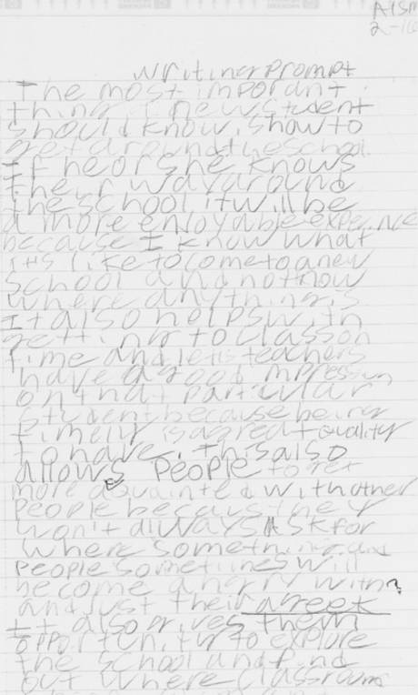
Example of dysgraphia by an 18 year old white male. The student was diagnosed with mild cerebral palsy at age six, repeated first grade, and was a recipient of special education services beginning in early elementary. He exhibited extremely poor gross and fine motor skills and was described by his teachers as a loner, socially isolated from his peers, and suffering from poor self esteem. The student’s school attendance was regular, and he participated in all class assignments
Aphasia: loss of speech and language abilities resulting from head injury (children and adults) or stroke (adults)
Childhood Apraxia: a motor speech disorder. Children have difficulty saying sounds and words due to the brain's inability to send instructions to the muscles of the vocal tract
Delayed Language: characterized by a marked slowness in the development of the vocabulary and grammar necessary for expressing and understanding thoughts and ideas
Orofacial Myofunctional Disorder: the location of the tongue too forward in the mouth makes speech difficult

WHAT CAUSES OF SPEECH AND LANGUAGE DISORDERS?
Some of the causes are related to hearing loss, cerebral palsy and other neuromuscular disorders, severe head injury, stroke, viral disease, mental retardation, certain drugs, physical impairments such as cleft lip or palate, vocal abuse or misuse, and inadequate speech and language models; frequently, however, the cause is unknown.

WHAT ARE THE SIGNS OF A SPEECH OR LANGUAGE DISORDER?
A disorder might be suspected when a person's speech or language is markedly different from that of others of the same age, sex, or ethnic group; when a person's speech and/or language is difficult to understand; when a person is overly concerned about his or her own speech; or when a person frequently avoids communicating with others. Remember that just because your child isn't communicating at the same rate as others of his/her age doesn't mean your child has a disability!
Speech-language pathologists are specialists in human communication, its development, and its disorders. They are professionally educated to evaluate and treat persons with communication problems. The clinical methods used will vary depending upon the nature and severity of the problem, the age of the individual, and the individual's awareness of the problem

WHAT IS A LANGUAGE-BASED LEARNING DISABILITY?
A language-based learning disability is not the same as a speech and language disorder. While both will require therapy, language-based learning disabilities are problems with age-appropriate reading, spelling, and/or writing. This disorder is not about how smart a person is. Most people diagnosed with learning disabilities have average to superior intelligence. Dyslexia has been used to refer to the specific learning problem of reading. The term language-based learning disability, or just learning disabilities, is better because of the relationship between spoken and written language
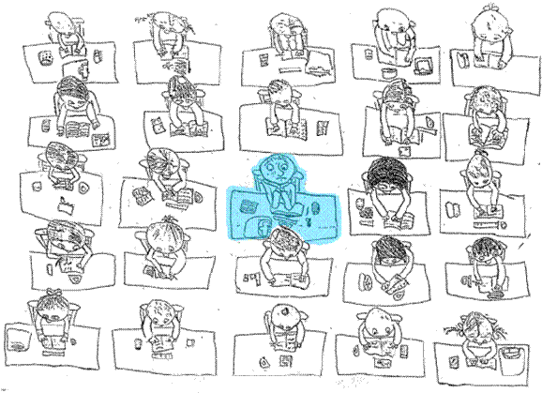
"One in twenty five" by Lawrence Cockrill aged 11 years, describing what it's like to be dyslexic
The child with dyslexia has trouble almost exclusively with the written (or printed) word. The child who has dyslexia as part of a larger language learning disability has trouble with both the spoken and the written word. These problems may include difficulty with the following:
- Expressing ideas clearly, as if the words needed are on the tip of the tongue but won't come out. What the child says can be vague and difficult to understand (e.g., using unspecific vocabulary, such as "thing" or "stuff" to replace words that cannot be remembered). Filler words like "um" may be used to take up time while the child tries to remember a word.
- Learning new vocabulary that the child hears (e.g., taught in lectures/lessons) and/or sees (e.g., in books)
- Understanding questions and following directions that are heard and/or read
- Recalling numbers in sequence (e.g., telephone numbers and addresses)
- Understanding and retaining the details of a story's plot or a classroom lecture
- Reading and comprehending material
- Learning words to songs and rhymes
- Telling left from right, making it hard to read and write since both skills require this directionality
- Letters and numbers, memorizing the times table, telling time, mixing up the order of numbers that are a part of math calculations
- Learning the alphabet, spelling
- Identifying the sounds that correspond to letters, making learning to read difficult
- Mixing up the order of letters in words while writing
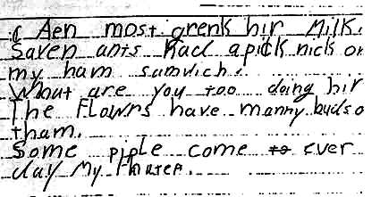

Writing sample from an 8 year old student with dyslexia. The passage says:
Ann must drink her milk. The flowers have many buds on them. Seven ants had a picnic on my ham sandwich. What you you two doing here? Some people come every day to see my father."

For more on other childhood disorders -- including Attention Deficient/Hyperactivity Disorder, Autism, Traumatic Brain Injury, and Selective Mutism-- visit the American Speech-Language-Hearing Association's website.

What are the most common speech and language disorders in adults?
Approximately 70 percent of the people with damage to the left hemisphere experience aphasia, an inability to perceive, process, or produce language because of physical damage to the brain. Aphasia is found in only approximately 1 percent of people suffering from damage to the right hemisphere. This provides additional support for the view that language is localized in the left side of the brain.

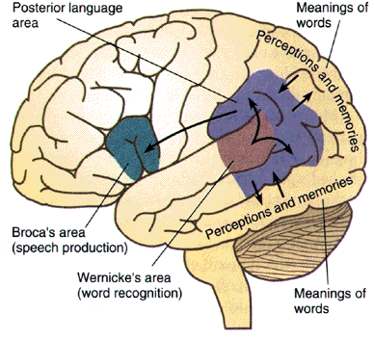
Aphasia: disturbance in the comprehension or production of speech caused by brain damage:
Broca's Aphasia Wernicke's Aphasia

As you might guess, the linguistic skills that are affected as a result of aphasia depend on where the brain damage is suffered. Broca's area is responsible for speech production (close to motor areas). Individuals with Broca's aphasia, a damage to Broca's area, suffer from an inability to plan the motor sequences used in speech or sign. When they attempt to produce language, they speak haltingly and have a hard time forming complete words. They also display a tendency for telegraphic speech, or speech without inflections and function words such as to and the, although the basic word order is correct.

Typical clinical symptoms of Broca's aphasics
"Yes ... Monday ... Dad, and Dad ... hospital, and ... Wednesday, Wednesday, nine o'clock and ... Thursday,ten o'clock ... doctors, two, two ... doctors and ... teeth, yah. And a doctor ... girl, and gums, and I."
"Me ... build-ing ... chairs, no, no cab-in-ets. One, saw ... then, cutting wood ... working ..."
Broca's aphasia seems to result in primarily expressive disorders. Accordingly, comprehension of the speech of others is not too much of a problem for Broca's aphasics, although they may have some difficulty matching the correct semantic interpretation to the syntactic order of the sentence. For instance, comprehension is likely to break down when the sequence of words is extremely important to the understanding of their message, as in reversible passives such as the lion was killed by the tiger. A Broca's aphasic is quite likely to understand this as identical to the active sentence the lion killed the tiger.
Wernicke's area is responsible for speech comprehension (close to auditory areas.) Wernicke's aphasia, on the other hand, results in primarily receptive disorders: it is very difficult for a patient with this problem to understand the speech of others. As you might expect, this often results in the Wernicke's aphasic misinterpreting what others sayand responding in an unexpected way. Moreover, because the Wernicke's patient has trouble interpreting words from his or her mental dictionary, he or she has a tendency to produce semantically incoherent speech. These two effects result in the type of speech you see in the example in (8). Wernicke's patients also often speak in circumlocutions, or expressions that people use when they are unable to name the word they want. For example, the patient may say what you drink for water and what we smell with for nose. The syntactic order of words is also altered. I know I can saymay become I know can I say. That patients with Wernicke's aphasia are unable to comprehend the speech of others is demonstrated by the fact that they often cannot follow simple instructions, such as stand up, turn to your right, and so on.
For more information on other adult disorders, including stroke, conduction aphasia, alexia, agraphia, and oral cancer -- visit the ASLA website.
What are the most common speech and language disorders in adults?
Approximately 70 percent of the people with damage to the left hemisphere experience aphasia, an inability to perceive, process, or produce language because of physical damage to the brain. Aphasia is found in only approximately 1 percent of people suffering from damage to the right hemisphere. This provides additional support for the view that language is localized in the left side of the brain.
As you might guess, the linguistic skills that are affected as a result of aphasia depend on where the brain damage is suffered. Broca's area is responsible for speech production (close to motor areas). Individuals with Broca's aphasia, a damage to Broca's area, suffer from an inability to plan the motor sequences used in speech or sign. When they attempt to produce language, they speak haltingly and have a hard time forming complete words. They also display a tendency for telegraphic speech, or speech without inflections and function words such as to and the, although the basic word order is correct.
Typical clinical symptoms of Broca's aphasics
"Yes ... Monday ... Dad, and Dad ... hospital, and ... Wednesday, Wednesday, nine o'clock and ... Thursday, ten o'clock ... doctors, two, two ... doctors and ... teeth, yah. And a doctor ... girl, and gums, and I."
"Me ... build-ing ... chairs, no, no cab-in-ets. One, saw ... then, cutting wood ... working ..."
Broca's aphasia seems to result in primarily expressive disorders. Accordingly, comprehension of the speech of others is not too much of a problem for Broca's aphasics, although they may have some difficulty matching the correct semantic interpretation to the syntactic order of the sentence. For instance, comprehension is likely to break down when the sequence of words is extremely important to the understanding of their message, as in reversible passives such as the lion was killed by the tiger. A Broca's aphasic is quite likely to understand this as identical to the active sentence the lion killed the tiger.
Wernicke's area is responsible for speech comprehension (close to auditory areas.) Wernicke's aphasia, on the other hand, results in primarily receptive disorders: it is very difficult for a patient with this problem to understand the speech of others. As you might expect, this often results in the Wernicke's aphasic misinterpreting what others sayand responding in an unexpected way. Moreover, because the Wernicke's patient has trouble interpreting words from his or her mental dictionary, he or she has a tendency to produce semantically incoherent speech. These two effects result in the type of speech you see in the example in (8). Wernicke's patients also often speak in circumlocutions, or expressions that people use when they are unable to name the word they want. For example, the patient may say what you drink for water and what we smell with for nose. The syntactic order of words is also altered. I know I can saymay become I know can I say. That patients with Wernicke's aphasia are unable to comprehend the speech of others is demonstrated by the fact that they often cannot follow simple instructions, such as stand up, turn to your right, and so on.

