Lecture 11
Syntax: Paradigmatic view: Phrases
So, what is syntax? You’ve probably heard of it before, but never really known what it was. Syntax is basically the structure of sentences. Sentences have to follow certain structural rules in order to make sense. You can’t just throw any words together to make a sentence!
Order words make sense need to… this doesn’t make sense!
Words need order to make sense…. Ahh! Much better!
So what is the structure of a sentence? How do we know what is supposed to go where? We all have tacit knowledge of sentence structure. This means we seem to instinctively know things but can't quite explain them. We can tell the first sentence doesn’t make any sense, but the second sentence is perfectly fine. So let’s investigate what sentences are made up of in order to understand the structure.

Phrases
Sentences are made up of smaller phrases. There are several difference types of phrase that can be used in a sentence, but the two phrases which must be used in a sentence for it to make sense are a noun phrase and a verb phrase.
In a phrase, we must have a word which is called the head. This is the core of the phrase, what the phrase can’t exist without. So in a phrase like ‘the dog’ or ‘ran far away’, in the first phrase ‘dog’ is the head because it is the main part of the phrase, and in the second phrase ‘ran’ is the head because it is essential for the phrase to exist. We can have ‘dog ran’, which isn’t grammatical, but this still makes sense since we can understand that the dog ran. But we can’t have ‘the far away’, this makes no sense to us!

Modifiers
So ‘the’ and ‘far away’ have to be given a name to distinguish them from the head. We call thesemodifiers. They modify the head and give it specific meaning. The determiner ‘the’ modifies the ‘dog’ because it lets us know which dog we are referring to. The phrase ‘far away’ modifies the verb ‘ran’ by letting us know the extent to which the dog ran.
Don’t worry, this will all become a lot easier with some practise. Let’s look at some types of phrases now!

Noun Phrase
A noun phrase is usually the person or thing that is performing the verb in the sentence. It may also be the person or thing that the verb is being done to in a sentence.
The person doing the verb in a sentence is known as the subject. For example, in the sentence ‘Tom pushed the car’, 'Tom' is the subject of the sentence as he is pushing the door. 'The car' is the object in the sentence as the door is the object that the verb is being done to. Both of these are noun phrases.
A noun phrase has to be made up of a noun, such as a name or a tangible object. Sometimes, a determiner is needed in a noun phrase, for example ‘a cat’, ‘the dog’. 'A' and 'The' are called determiners because they tell us which person or thing is involved in the sentence.

Syntax Trees
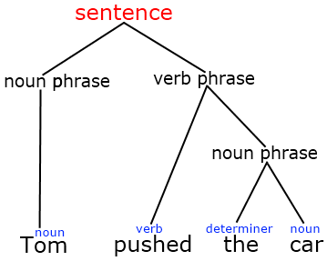
To explain sentence structures, we draw trees. Sounds silly, right? You’ll soon find out that it's a lot more complicated than it looks. Let’s start with this noun phrase. We know a noun phrase is made up of a determiner and a noun. First, we must label what parts of speech each of these are.
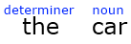
Next, we can draw two lines to join them together, creating a noun phrase!
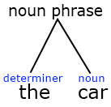
If we look at a proper noun, we find it is a little bit different. A proper noun does not need a determiner, so we can go straight to making it another noun phrase!
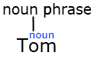
Now, we can draw noun phrases for both 'Tom' and 'The Car' in our sentence! But we aren’t quite finished yet, now we need to talk about verb phrases.

Verb Phrases
Now that we have made some noun phrases, we can move on to verb phrases. The good news is a basic verb phrase can be made up of one word. The bad news is not every sentence has a basic verb phrase. For now let's look at the basic verb phrase.
So we’ve looked at the noun phrases of this sentence, now how does the verb phrase fit in? Well first, we identify the verb and label its part of speech.

Next, we can label it as a verb phrase. This is connected to the noun phrase 'The Car', so we connect them and write the label above. But why is this the case?

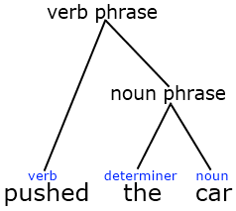

We need to link all of this together. In this sentence, we must join up all of the phrases to make a tree that says 'Sentence' at the top. But we can’t just simply join up the lines, we need a structure! In order to figure out the structure, we need to look at constituents and relationships in a tree next.

Constituents
So, what is a constituent? A constituent is a word or a group of words that function together as a unit. Don’t be worried, this sounds scary but it’s actually really easy! We can figure out what words or groups of words are constituents by performing tests on them. There are four tests which can be used on any suspected constituent. These are:
Omission – Create the same sentence but take away the word/words we are testing.
Replacement – Can we replace the word/words with just a single word?
Standalone – Can we form a question using the sentence, and the answer be the word/words being tested?
Movement – Can we move the position of the word/words in the sentence and have the sentence still make sense without changing the meaning?
Let’s do some examples of these tests so you can see how they work.
First, omission. If we take the sentence ‘He sat down in the car’, we can use the omission test to figure out the constituents in the sentence. Let’s take ‘in the car’ as our constituent. If we take this away, does the sentence still make sense grammatically?
‘He sat down in the car.’
‘He sat down.’
The sentence still makes sense. Therefore, ‘in the car’ is likely to be a constituent; however we can’t be certain yet. It is always important to do more than one constituency test to figure out if the word/words are constituents. It could pass one and fail the other three!
Next, let’s do replacement. We take ‘He sat down in the car’ and replace ‘in the car’ with just one word. Useful words to try and use in a replacement test are pronouns (he, she, it, this, that etc).
‘He sat down in the car.’
‘He sat down there.’
The sentence makes sense once again! So ‘in the car’ has passed two constituency tests, but let’s try another test first, just to make sure.

Time for the standalone test. We need to form a question using the rest of the sentence, and have the answer only be the word/words we are testing.
‘Where did he sit down?’
‘In the car.’
Success! It surely must be a constituent now. But we’ll do the final test just in case.
The final test is movement. Can we move the words we are testing to see if the sentence still makes sense?
‘He sat down in the car.’
‘It was in the car that he sat down.’
Once again the sentence makes sense. Now we have done these constituency tests, we know that ‘in the car’ is a constituent of the sentence ‘He sat down in the car.’ But be careful, just because it is a constituent here does not mean it is a constituent in every other sentence.

Relationships in Trees
So now we can identify constituents, let’s go back to our tree. There are several important relationships in a syntax tree that we need to know about.
Domination – phrases can dominate words in a sentence tree. But how do we know which phrases dominate what? A tree has a hierarchical structure, which means that a node or label dominates all that is below it. Sounds complicated, huh? Just look at the picture below and we will explain everything.
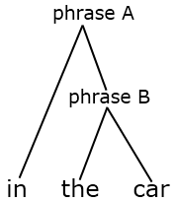
We can see here that phrase A dominates phrase B and ‘in’. We know this because phrase A is above phrase B and it is above the word ‘in’. When a phrase is directly above something, we call this immediate domination. Phrase A immediately dominates phrase B and ‘in’, but it does not immediately dominate ‘the’ or ‘car’. But it is important to remember that even though it doesn't immediately dominate ‘the’ or ‘car’, it still dominates ‘the’ and ‘car’ because it is above them in the tree structure.

Naming Phrases
So, we looked before at verb phrases and noun phrases, but these aren’t the only types of phrases you can have in a tree. We can also have adjective phrases, adverb phrases and prepositional phrases. We’ll quickly talk about how these are different to the other phrases.
Adjective Phrases - since phrases are named after the head, adjective phrases are simply phrases where the head of the phrase is an adjective. So for example the sentence ‘The big red car drove away’ contains the adjective phrase 'The big red car'. This includes the adjectives 'big' and 'red'.
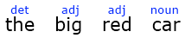

An adjective phrase can contain more than one adjective, so we can make 'big red' into a phrase.
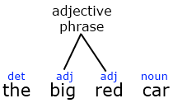
Next, we join this adjective phrase to the noun ‘car’ to make a noun phrase. But that's not all, since we have to add the determiner ‘The’ to complete the phrase. From there we can continue to build up the tree.

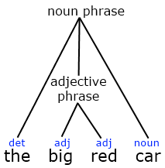
Adverb Phrases - these work a lot like adjective phrases. They are found near to verbs (adverbs describe the verb after all), such as ‘immediately’ in the sentence ‘he sat down immediately’. They are very easy to recognise, and often form adverb phrases containing just one word: the adverb itself. But be careful, adverbs can appear in a sentence and not be an adverb phrase! They are often used to modify an adjective, such as ‘the immediately recognisable man’. Here, the adverb ‘immediately’ does not form an adverb phrase, but modifies the adjective in the adjective phrase ‘immediately recognisable’.
Prepositional Phrases - another type of phrase that is very common in sentence structures. They may seem complicated at first but they will get easier to recognise with some practise. If we take the sentence ‘The cat slept in the kitchen’, we can break it down and analyse it to see where the prepositional phrase is.

Having labelled each word with its part of speech, we can see we have the preposition ‘in’ in this sentence. So let’s start putting it together. Hopefully by now, you can see that ‘the cat’ is a noun phrase, and you can connect it. You should have seen that ‘the kitchen’ is also a noun phrase, and you can join it up as well.
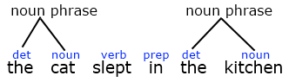
Okay, so now let’s join up ‘in’. When we connect ‘in’ and the noun phrase ‘the kitchen’, we create a new phrase. This phrase is immediately dominating the noun phrase and the preposition ‘in’. Therefore, we have made a preposition phrase. The noun phrase ‘the kitchen’ is modifying the location of where the cat slept, meaning it is modifying the word ‘in’. So we know that ‘in’ is the head of this phrase, making it a preposition phrase.
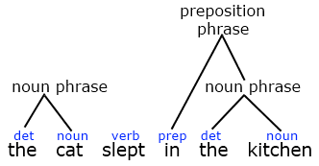
But we aren’t quite finished yet! The preposition phrase ‘in the kitchen’ modifies the verb ‘slept’. So we now join up the verb ‘slept’ and the preposition phrase ‘in the kitchen’ to make a new a phrase. Can you guess what phrase we make here?
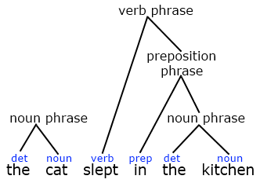
We make a verb phrase! This is because the verb is the head of the phrase and ‘in the kitchen’ modifies it. So now we have a noun phrase and a verb phrase left, and we can join them together to make a sentence.
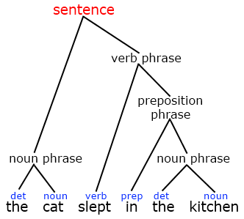
Usually when you want to join a word to a phrase, the word you are adding will be the head of the phrase, meaning that whatever part of speech it is, the phrase will be named after that part of speech. So if we join a noun to an adjective phrase, we will make a noun phrase. And if we join a verb to a noun phrase, we will make a verb phrase.
Click here to try out an interactive tree exercise.

Co-ordinate Phrases
Co-ordinate phrases are rare phrases that do appear in English. You will have used them already, when you say things like ‘fish and chips’, ‘Max and Ben’, and pretty much any situation where you join two nouns together using the conjunction ‘and’. So how do we deal with these?
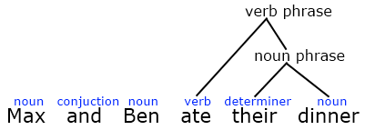
Here we have the sentence ‘Max and Ben ate their dinner.’ We have labelled the words, and we can construct the tree for the verb phrases, but we need to make a noun phrase for ‘Max and Ben’. So how do we make the noun phrase? Well, ‘Max’ and ‘Ben’ are both proper nouns, meaning that they don’t need a determiner. So here we just simply join ‘Max’, ‘and’, and ‘Ben’ together at the same time.
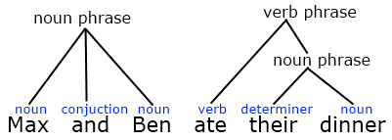

We can then label this as a noun phrase and join it to the verb phrase as a sentence!
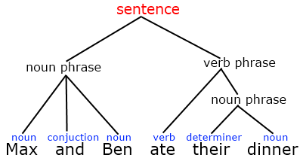
But what if we don’t have proper nouns? Let’s take the sentence ‘The boy and the girl ate their tea.’ Again, we form the verb phrase, but what do we do to make the noun phrase? If you can work it out now, write it down and then check your answer with the tree below.
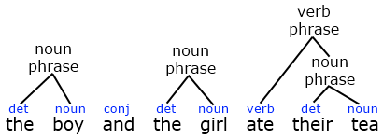
We created two separate noun phrases. We have the noun phrase ‘the boy’ and the noun phrase ‘the girl’, with ‘and’ sitting in the middle of them. Now, we can join them up like we did with the proper nouns, making a noun phrase that we can use to complete the sentence!
