Chapter 9

Introduction to Economic Fluctuations

Instructor: Prof. Dr.Qaisar Abbas

Time horizons
- Long run: Prices are flexible, respond to changes in supply or demand
- Short run: many prices are “sticky” at some predetermined level

In Classical Macroeconomic Theory
- Output is determined by the supply side:
  - supplies of capital, labor
  - technology
- Changes in demand for goods & services (C, I, G ) only affect prices, not quantities.
- Complete price flexibility is a crucial assumption, so classical theory applies in the long run.

When prices are sticky
…output and employment also depend on demand for goods & services, which is affected by
  - fiscal policy (G and T )
  - monetary policy (M )
  - other factors, like exogenous changes
in C or I.

The model of aggregate demand and supply
- the paradigm that most mainstream economists & policymakers use to think about economic fluctuations and policies to stabilize the economy
- shows how the price level and aggregate output are determined
- shows how the economy’s behavior is different in the short run and long run
Aggregate demand
- The aggregate demand curve shows the relationship between the price level and the quantity of output demanded.
- For this chapter’s intro to the AD/AS model, we use a simple theory of aggregate demand based on the Quantity Theory of Money.

The Quantity Equation as Agg. Demand
- Recall the quantity equation
M V = P Y
and the money demand function it implies:
(M/P )^{d} = k Y
where V = 1/k = velocity.
- For given values of M and V, these equations imply an inverse relationship between P and Y:

The downward-sloping AD curve
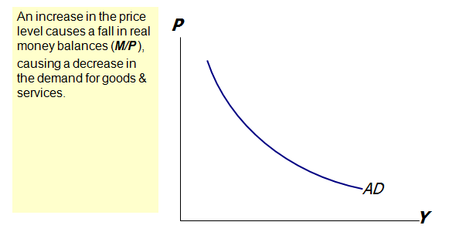
Shifting the AD curve
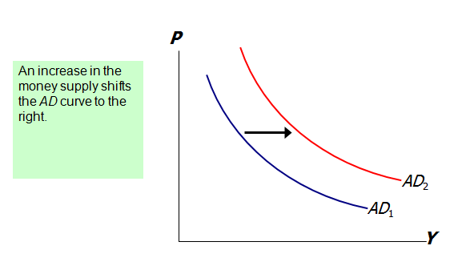
Aggregate Supply in the Long Run
- 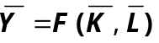In the long run, output is determined by factor supplies and technology

- is the full-employment or natural level of output, the level of output at which the economy’s resources are fully employed.
- “Full employment” means that unemployment equals its natural rate.

Aggregate Supply in the Long Run
- In the long run, output is determined by factor supplies and technology

- Full-employment output does not depend on the price level, so the long run aggregate supply (LRAS) curve is vertical:

The long-run aggregate supply curve
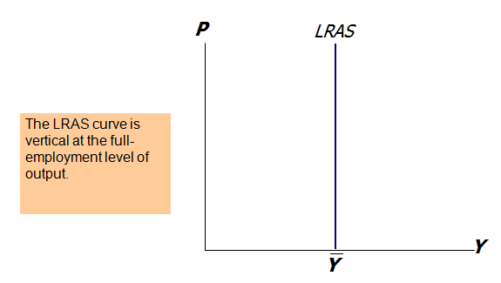
Long-run effects of an increase in M
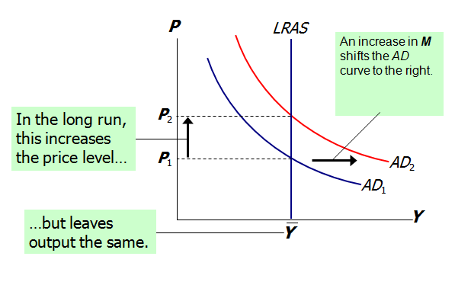
Aggregate Supply in the Short Run
- In the real world, many prices are sticky in the short run.
- For now we assume that all prices are stuck at a predetermined level in the short run…
- …and that firms are willing to sell as much as their customers are willing to buy at that price level.
- Therefore, the short-run aggregate supply (SRAS) curve is horizontal:

The short run aggregate supply curve
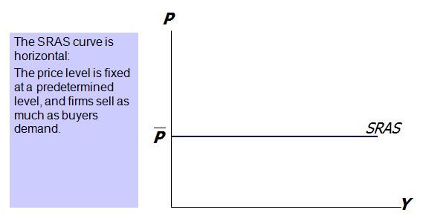

Short-run effects of an increase in M
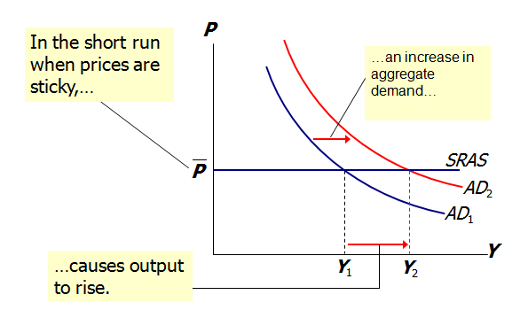

The SR & LR effects of ΔM > 0
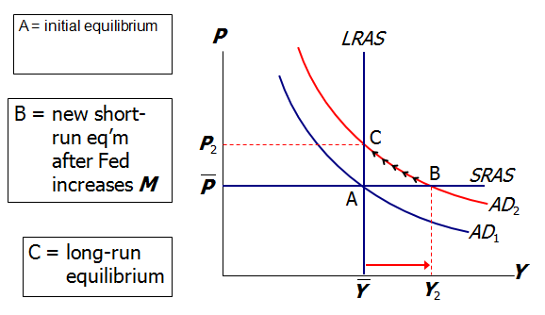
Shocks
shocks: exogenous changes in aggregate supply or demand
- Shocks temporarily push the economy away from full-employment.
- An example of a demand shock:
exogenous decrease in velocity
- If the money supply is held constant, then a decrease in V means people will be using their money in fewer transactions, causing a decrease in demand for goods and services:

The effects of a negative demand shock
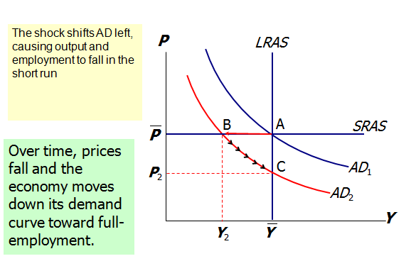

Supply shocks
A supply shock alters production costs, affects the prices that firms charge. (also called price shocks)
Examples of adverse supply shocks:
  - Bad weather reduces crop yields, pushing up food prices.
  - Workers unionize, negotiate wage increases.
  - New environmental regulations require firms to reduce emissions.
Firms charge higher prices to help cover the costs of compliance.
(Favorable supply shocks lower costs and prices.)

Stabilization policy
- def: policy actions aimed at reducing the severity of short-run economic fluctuations.
- Example: Using monetary policy to combat the effects of adverse supply shocks:

Stabilizing output with monetary policy
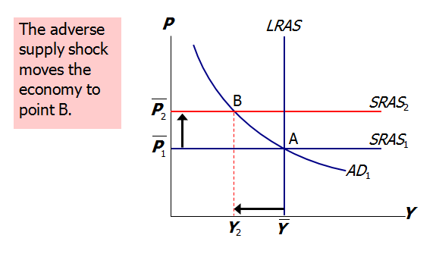
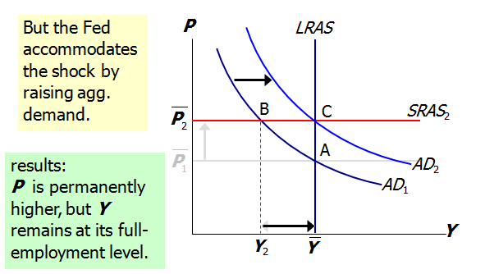
Summary
- Long run: prices are flexible, output and employment are always at their natural rates, and the classical theory applies.
- Short run: prices are sticky, shocks can push output and employment away from their natural rates.
- Aggregate demand and supply: a framework to analyze economic fluctuations
- The aggregate demand curve slopes downward.
- The long-run aggregate supply curve is vertical, because output depends on technology and factor supplies, but not prices.
- The short-run aggregate supply curve is horizontal, because prices are sticky at predetermined levels.
- Shocks to aggregate demand and supply cause fluctuations in GDP and employment in the short run.
- The Fed can attempt to stabilize the economy with monetary policy.

