Chapter 8

Open Economy
Instructor: Prof. Dr.Qaisar Abbas

Open economy
In an open economy, spending need not equal output and saving need not equal investment.
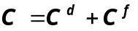Preliminaries
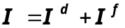

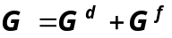
- EX = exports = foreign spending on domestic goods
- IM = imports = C f + I f + G f = spending on foreign goods
- NX = net exports (a.k.a. the “trade balance”) = EX – IM

- GDP = expenditure on domestically produced g & s
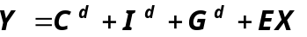
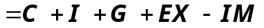
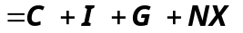

The national income identity in an open economy
Y = C + I + G + NX
or, NX = Y – (C + I + G )
Trade surpluses and deficits
NX = EX – IM = Y – (C + I + G )
Trade surplus
- output > spending and exports > imports
- Size of the trade surplus = NX
Trade deficit
- spending > output and imports > exports
Size of the trade deficit = –NX
International capital flows
- Net capital outflows
=S – I
=net outflow of “loanable funds”
=net purchases of foreign assets the country’s purchases of foreign assets minus foreign purchases of domestic assets
- When S > I, country is a net lender
When S < I, country is a net borrower

Link between trade & cap. flows
NX = Y – (C + I + G )
Implies
NX = (Y – C – G ) – I
= S – I
Trade balance = net capital outflows
Thus, a country with a trade deficit (NX < 0) is a net borrower (S < I ).
Saving and Investment in a Small Open Economy
An open-economy version of the loanable funds model includes

Saving and Investment
National Saving: The Supply of Loanable Funds
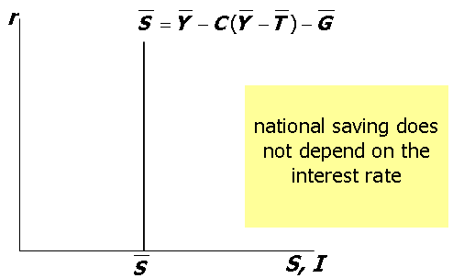

Assumptions re: capital flows
- domestic & foreign bonds are perfect substitutes (same risk, maturity, etc.)
b. perfect capital mobility:
no restrictions on international trade in assets
c. economy is small:
cannot affect the world interest rate, denoted r*

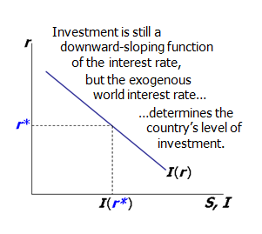
Investment: The Demand for Loanable Funds

If the economy were closed…
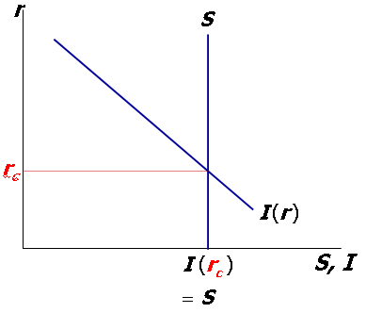
But in a small open economy…

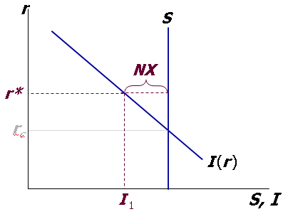

Three Experiments
- Fiscal policy at home
- Fiscal policy abroad
- An increase in investment demand
1. Fiscal policy at home
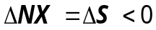
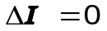
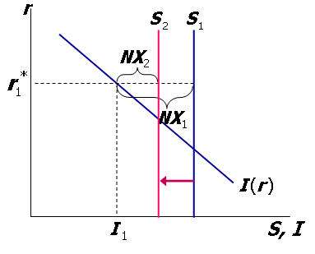

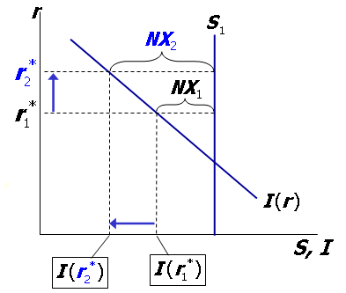
2. Fiscal policy abroad

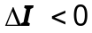
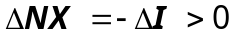

3. An increase in investment demand
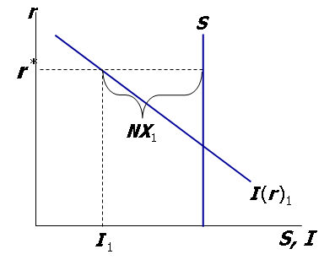

An increase in investment demand
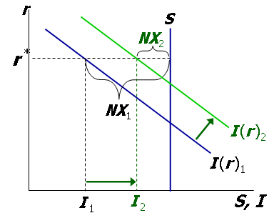
The nominal exchange rate
e = nominal exchange rate, the relative price of domestic currency in terms of foreign currency (e.g. Yen per Dollar)

The real exchange rate
= real exchange rate, the relative price of domestic goods in terms of foreign goods (e.g. Japanese Big Macs per U.S. Big Mac)

Exchange rate
Understanding the units of ε
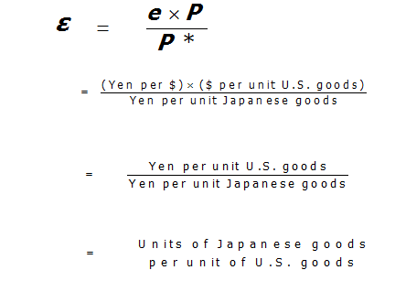
- ε in the real world & our model
- In the real world:
We can think of ε as the relative price of
a basket of domestic goods in terms of a basket of foreign goods
- In our macro model:
There’s just one good, “output.”
So ε is the relative price of one country’s output in terms of the other country’s output
- How NX depends on ε
- ↑ε ⇒ U.S. goods become more expensive relative to foreign goods
  - ↓EX, ↑IM
  - ↓NX

The net exports function
The net exports function reflects this inverse relationship between NX and ε:
NX = NX (ε )

The NX curve for the U.S.
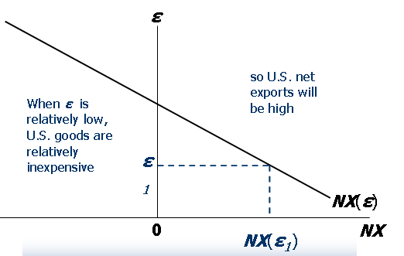

The NX curve for the U.S.
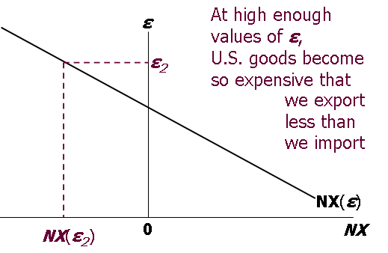
How ε is determined
- The accounting identity says NX = S – I
We saw earlier how S - I is determined:
  - S depends on domestic factors (output, fiscal policy variables, etc)
  - I is determined by the world interest
rate r *
  - So, ε must adjust to ensure

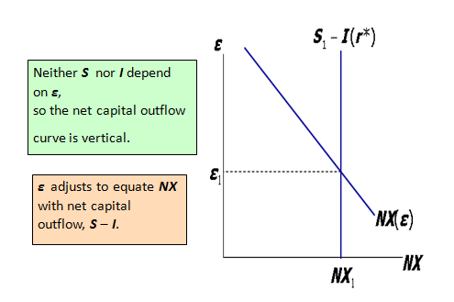
Interpretation: supply and demand in the foreign exchange market
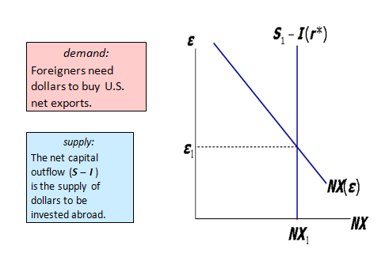
Four experiments
- Fiscal policy at home
- Fiscal policy abroad
- An increase in investment demand
- Trade policy to restrict imports

1. Fiscal policy at home
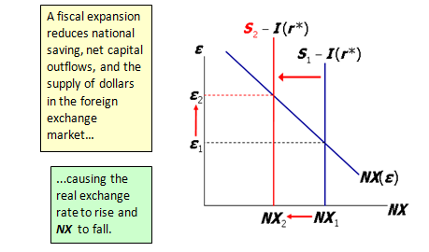

2. Fiscal policy abroad
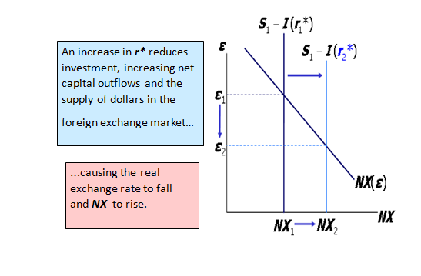
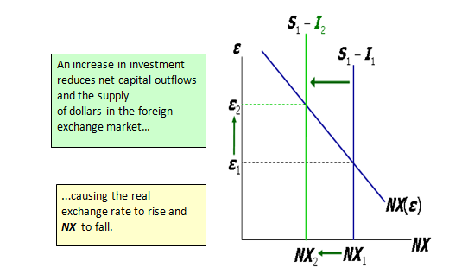
3. An increase in investment demand

4. Trade policy to restrict imports
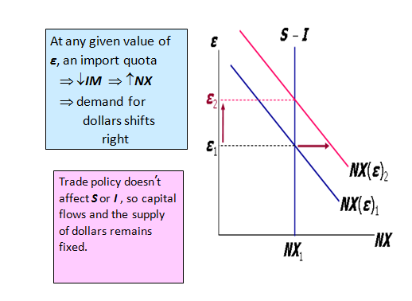
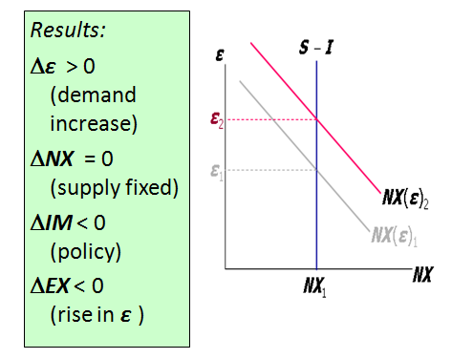

The Determinants of the Nominal Exchange Rate
- Start with the expression for the real exchange rate:
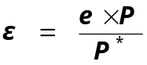

- 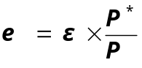Solve it for the nominal exchange rate:

- So e depends on the real exchange rate and the price levels at home and abroad…
- …and we know how each of them is determined:
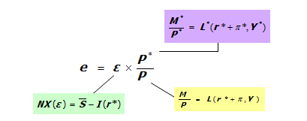
- 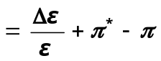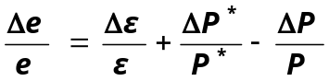We can rewrite this equation in terms of growth rates

- For a given value of ε, the growth rate of e equals the difference between foreign and domestic inflation rates.

Purchasing Power Parity (PPP)
Two definitions:
  - a doctrine that states that goods must sell at the same (currency-adjusted) price in all countries.
  - the nominal exchange rate adjusts to equalize the cost of a basket of goods across countries.
Reasoning:
- arbitrage, the law of one price
- Solve for e : e = P*/ P
- PPP implies that the nominal exchange rate between two countries equals the ratio of the countries’ price levels.
- 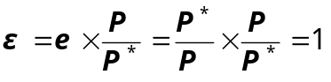If e = P*/P, then

- and the NX curve is horizontal:
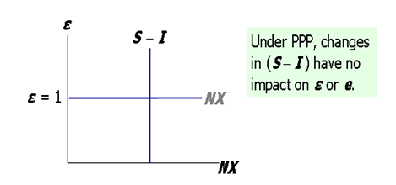
Does PPP hold in the real world?
No, for two reasons:
1. International arbitrage not possible.
    - nontraded goods
    - transportation costs
2. Goods of different countries not perfect substitutes.
Nonetheless, PPP is a useful theory:
  - It’s simple & intuitive
  - In the real world, nominal exchange rates have a tendency toward their PPP values over the long run.

Summary
- Net exports--the difference between
  - exports and imports
  - a country’s output (Y )
and its spending (C + I + G)
- Net capital outflow equals
  - purchases of foreign assets
minus foreign purchases of the country’s assets
  - the difference between saving and investment
- Exchange rates
  - nominal: the price of a country’s currency in terms of another country’s currency
  - real: the price of a country’s goods in terms of another country’s goods.
  - The real exchange rate equals the nominal rate times the ratio of prices of the two countries.
- How the real exchange rate is determined
  - NX depends negatively on the real exchange rate, other things equal
  - The real exchange rate adjusts to equate
NX with net capital outflow
- How the nominal exchange rate is determined
  - e equals the real exchange rate times the country’s price level relative to the foreign price level.
  - For a given value of the real exchange rate, the percentage change in the nominal exchange rate equals the difference between the foreign & domestic inflation rates.

