Chapter 7

Money and Inflation
Instructor: Prof. Dr.Qaisar Abbas

The connection between money and prices
- Inflation rate is the percentage increase in the average level of prices.
- Price is the amount of money required to buy a good.
- Because prices are defined in terms of money, we need to consider the nature of money, the supply of money, and how it is controlled.
- Money is the stock of assets that can be readily used to make transactions.

Money
Money: functions
1.medium of exchange
we use it to buy stuff
2. store of value
transfers purchasing power from the present to the future
3. unit of account
the common unit by which everyone measures prices and values

Money: types
1. Fiat money
It has no intrinsic value
Example: the paper currency we use
2. Commodity money
It has intrinsic value
Examples: gold coins, cigarettes in P.O.W. camps

The money supply & monetary policy
- The money supply is the quantity of money available in the economy.
- Monetary policy is the control over the money supply.

The central bank
- Monetary policy is conducted by a country’s central bank.
- In the U.S., the central bank is called the Federal Reserve (“the Fed”).
- In Pakistan, the central bank is called the State bank of Pakistan.

The Quantity Theory of Money
- A simple theory linking the inflation rate to the growth rate of the money supply.
- Begins with a concept called “velocity”…
Velocity
- basic concept: the rate at which money circulates
- definition: the number of times the average dollar bill changes hands in a given time period
- example: In 2001,
- $500 billion in transactions
- money supply = $100 billion
- The average dollar is used in five transactions in 2001
- So, velocity = 5
- 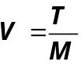This suggests the following definition:

where
V = velocity
T = value of all transactions
M = money supply
Use nominal GDP as a proxy for total transactions.
Then,
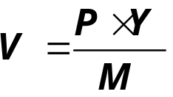
Where
P = price of output (GDP deflator)
Y = quantity of output (real GDP)
P ×Y = value of output (nominal GDP)
- The quantity equation
M x V = P x Y
- follows from the preceding definition of velocity.
- It is an identity: it holds by definition of the variables.
Money demand and the quantity equation
- M/P = real money balances, the purchasing power of the money supply.
- A simple money demand function:
(M/P )d = k Y
where
k = how much money people wish to hold for each dollar of income.
(k is exogenous)
- money demand: (M/P )d = k Y
- quantity equation: M ×V = P ×Y
- The connection between them: k = 1/V
- When people hold lots of money relative to their incomes (k is high), money changes hands infrequently (V is low).
Back to the Quantity Theory of Money
- starts with quantity equation assumes V is constant & exogenous:
- With this assumption, the quantity equation can be written as
- How the price level is determined:
  - With V constant, the money supply determines nominal GDP (P ×Y )
  - Real GDP is determined by the economy’s supplies of K and L and the production function (chap 3)
  - The price level is
P = (nominal GDP)/(real GDP)
- The growth rate of a product equals the sum of the growth rates.
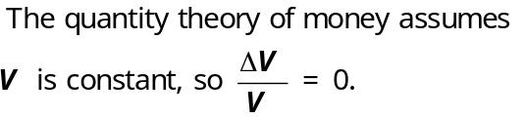
- 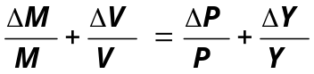The quantity equation in growth rates:

- 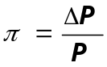Let π (Greek letter “pi”) denote the inflation rate:

- The result from the preceding slide was:
- Solve this result for π to get
- Normal economic growth requires a certain amount of money supply growth to facilitate the growth in transactions.
- Money growth in excess of this amount leads to inflation.
- ΔY/Y depends on growth in the factors of production and on technological progress (all of which we take as given, for now).
- Hence, the Quantity Theory of Money predicts a one-for-one relation between changes in the money growth rate and changes in the inflation rate.

Seigniorage
- To spend more without raising taxes or selling bonds, the govt can print money.
- The “revenue” raised from printing money is called seigniorage
(pronounced SEEN-your-ige)
- The inflation tax
Printing money to raise revenue causes inflation. Inflation is like a tax on people who hold money.
Inflation and interest rates
- Nominal interest rate, i not adjusted for inflation
- Real interest rate, r adjusted for inflation:
r = i − π
The Fisher Effect
- The Fisher equation:
i = r + π
- S = I determines r .
- Hence, an increase in π causes an equal increase in i.
- This one-for-one relationship is called the Fisher effect.

Two real interest rates
- = actual inflation rate
- (not known until after it has occurred)
- πe = expected inflation rate
- i – πe = ex ante real interest rate:
what people expect at the time they buy a bond or take out a loan
- i – π = ex post real interest rate:
what people actually end up earning on their bond or paying on their loan

Money demand and the nominal interest rate
- The Quantity Theory of Money assumes that the demand for real money balances depends only on real income Y.
- We now consider another determinant of money demand: the nominal interest rate.
- The nominal interest rate i is the opportunity cost of holding money (instead of bonds or other interest-earning assets).
- 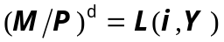Hence, ↑i ⇒ ↓ in money demand.

- (M/P )d = real money demand, depends
  - negatively on i
    - i is the opp. cost of holding money
- positively on Y
    - higher Y ⇒ more spending
⇒ so, need more money
- (L is used for the money demand function because money is the most liquid asset.)
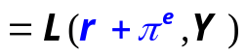

- When people are deciding whether to hold money or bonds, they don’t know what inflation will turn out to be.
- Hence, the nominal interest rate relevant for money demand is r + πe.
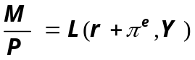Equilibrium

What determines what

variable how determined (in the long run)
M exogenous (the Fed)
r adjusts to make S = I
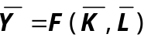
Y
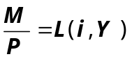 P adjusts to make

How P responds to ΔM

For given values of r, Y, and πe, a change in M causes P to change by the same percentage --- just like in the Quantity Theory of Money.
What about expected inflation?
- Over the long run, people don’t consistently over- or under-forecast inflation, so πe = π on average.
- In the short run, πe may change when people get new information.
- EX: Suppose Fed announces it will increase M next year. People will expect next year’s P to be higher, so πe rises.
- This will affect P now, even though M hasn’t changed yet.

How P responds to Δπe

- 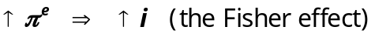For given values of r, Y, and M ,
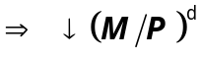
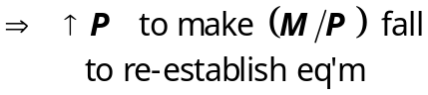

The classical view of inflation
- The classical view
- A change in the price level is merely a change in the units of measurement.

- The social cost of inflation fall into two categories:
- costs when inflation is expected
- Additional costs when inflation is different than people had expected.
The costs of expected inflation:
1. shoeleather cost
- def: the costs and inconveniences of reducing money balances to avoid the inflation tax.
↑π ⇒ ↑i
⇒ ↓ real money balances
- Remember: In long run, inflation doesn’t affect real income or real spending.
- So, same monthly spending but lower average money holdings means more frequent trips to the bank to withdraw smaller amounts of cash.

2. menu costs
def: The costs of changing prices.
Examples:
  - print new menus
  - print & mail new catalogs
- The higher is inflation, the more frequently firms must change their prices and incur these costs.

3. relative price distortions
Firms facing menu costs change prices infrequently.
Example:
- Suppose a firm issues new catalog each January. As the general price level rises throughout the year, the firm’s relative price will fall.
- Different firms change their prices at different times, leading to relative price distortions…
- …which cause microeconomic inefficiencies
in the allocation of resources.

4. unfair tax treatment
- Some taxes are not adjusted to account for inflation, such as the capital gains tax.
- Example:
  - 1/1/2001: you bought $10,000 worth of Starbucks stock
  - 12/31/2001: you sold the stock for $11,000, so your nominal capital gain was $1000 (10%).
  - Suppose π = 10% in 2001. Your real capital gain is $0.
  - But the govt requires you to pay taxes on your $1000 nominal gain!!

Additional cost of unexpected inflation
Arbitrary redistributions of purchasing power
- Many long-term contracts not indexed, but based on πe.
- If π turns out different from πe, then some gain at others’ expense.
- Example: borrowers & lenders
  - If π > πe, then (r − π) < (r − πe)
and purchasing power is transferred from lenders to borrowers.
  - If π < πe, then purchasing power is transferred from borrowers to lenders.
Increased uncertainty
- When inflation is high, it’s more variable and unpredictable: π turns out different from πe more often, and the differences tend to be larger (though not systematically positive or negative)
- Arbitrary redistributions of wealth become more likely.
- This creates higher uncertainty, which makes risk averse people worse off.

One benefit of inflation
- Nominal wages are rarely reduced, even when the equilibrium real wage falls.
- Inflation allows the real wages to reach equilibrium levels without nominal wage cuts.
- Therefore, moderate inflation improves the functioning of labor markets.

Hyperinflation
- def: π ≥ 50% per month
- All the costs of moderate inflation described above become HUGE under hyperinflation.
- Money ceases to function as a store of value, and may not serve its other functions (unit of account, medium of exchange).
- People may conduct transactions with barter or a stable foreign currency.

What causes hyperinflation?
- Hyperinflation is caused by excessive money supply growth:
- When the central bank prints money, the price level rises.
- If it prints money rapidly enough, the result is hyperinflation.

Why governments create hyperinflation
- When a government cannot raise taxes or sell bonds, it must finance spending increases by printing money.
- In theory, the solution to hyperinflation is simple: stop printing money.
- In the real world, this requires drastic and painful fiscal restraint.

Summary
- Money
  - the stock of assets used for transactions
  - serves as a medium of exchange, store of value, and unit of account.
  - Commodity money has intrinsic value, fiat money does not.
  - Central bank controls money supply.
- Quantity theory of money
  - assumption: velocity is stable
  - conclusion: the money growth rate determines the inflation rate.
- Nominal interest rate
  - equals real interest rate + inflation rate.
  - Fisher effect: nominal interest rate moves one-for-one w/ expected inflation.
  - is the opp. cost of holding money
- Money demand
  - depends on income in the Quantity Theory
  - more generally, it also depends on the nominal interest rate;
  - if so, then changes in expected inflation affect the current price level.
- Costs of inflation
  - Expected inflation
shoeleather costs, menu costs, tax & relative price distortions, inconvenience of correcting figures for inflation
  - Unexpected inflation
all of the above plus arbitrary redistributions of wealth between debtors and creditors
- Hyperinflation
  - caused by rapid money supply growth when money printed to finance govt budget deficits
  - stopping it requires fiscal reforms to eliminate govt’s need for printing money

