Chapter 6

Unemployment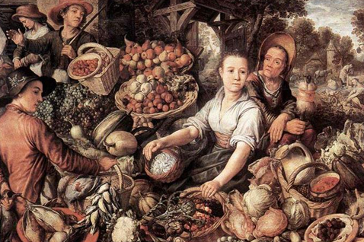
Instructor: Prof. Dr.Qaisar Abbas

Natural rate of unemployment
- the average rate of unemployment around which the economy fluctuates.
- In a recession, the actual unemployment rate rises above the natural rate.
- In a boom, the actual unemployment rate falls below the natural rate.
A first model of the natural rate
Notation:
L = # of workers in labor force
E = # of employed workers
U = # of unemployed
U/L = unemployment rate
Assumptions
1. L is exogenously fixed.
2. During any given month,
s = fraction of employed workers that become separated from their jobs,
f = fraction of unemployed workers that find jobs.
s = rate of job separations
f = rate of job finding
(both exogenous)
The transitions between employment and unemployment
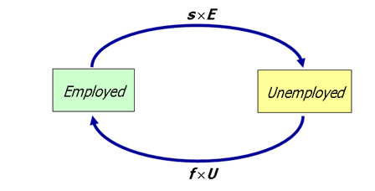
The steady state condition: the labor market is in steady state, or long-run equilibrium, if the unemployment rate is constant.
The steady-state condition is:
Solving for the “equilibrium” U rate
f ×U = s ×E
= s ×(L –U )
= s ×L – s ×U
Solve for U/L:
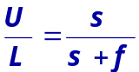 (f + s)×U = s ×L
so,

How Is Unemployment Measured?
- Based on the answers to the survey questions, each adult is placed into one of three categories:
Employed
Unemployed
Not in the labor force
- The BLS considers a person an adult if he or she is over 16 years old.
- A person is considered employed if he or she has spent most of the previous week working at a paid job.
- A person is unemployed if he or she is on temporary layoff, is looking for a job, or is waiting for the start date of a new job.
- A person who fits neither of these categories, such as a full-time student, homemaker, or retiree, is not in the labor force.

Labor Force
- The labor force is the total number of workers, including both the employed and the unemployed.
- The BLS defines the labor force as the sum of the employed and the unemployed.
The Breakdown of the Population
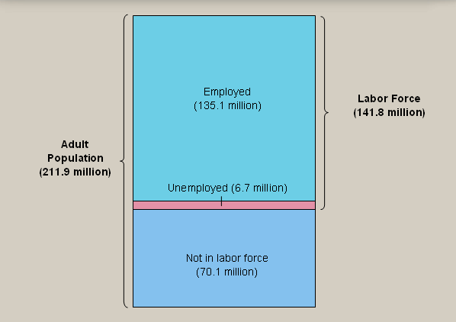

- The unemployment rate is calculated as the percentage of the labor force that is unemployed.
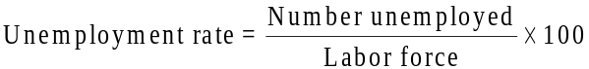

- 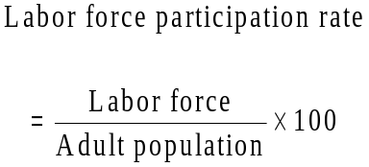The labor-force participation rate is the percentage of the adult population that is in the labor force.

- If job finding were instantaneous (f = 1),
- then all spells of unemployment would be brief, and the natural rate would be near zero.
- There are two reasons why f < 1:
- job search
- wage rigidity
Frictional unemployment
- caused by the time it takes workers to search for a job
- occurs even when wages are flexible and there are enough jobs to go around
- occurs because
  - workers have different abilities, preferences
  - jobs have different skill requirements
  - geographic mobility of workers not instantaneous
  - flow of information about vacancies and job candidates is imperfect

Sectoral shifts
- def: changes in the composition of demand among industries or regions
- example: Technological change
increases demand for computer repair persons, decreases demand for typewriter repair persons
- example: A new international trade agreement causes greater demand for workers in the export sectors and less demand for workers in import-competing sectors.
- It takes time for workers to change sectors, so sectoral shifts cause frictional unemployment.
more examples:
- Late 1800s: decline of agriculture, increase in manufacturing
- Late 1900s: relative decline of manufacturing, increase in service sector
- 1970s energy crisis caused a shift in demand away from huge gas guzzlers toward smaller cars.
- In our dynamic economy, smaller (though still significant) sectoral shifts occur frequently, contributing to frictional unemployment.
- Govt programs affecting unemployment
Govt employment agencies:
disseminate info about job openings to better match workers & jobs
Public job training programs:
help workers displaced from declining industries get skills needed for jobs in growing industries
Unemployment insurance (UI)
- UI pays part of a worker’s former wages for a limited time after losing his/her job.
- UI increases search unemployment, because it:reduces the opportunity cost of being unemployed, reduces the urgency of finding work hence, reduces f.
- The longer a worker is eligible for UI,
the longer the duration of the average spell of unemployment.
Benefits of UI
By allowing workers more time to search, UI may lead to better matches between jobs and workers, which would lead to greater productivity and higher incomes.

Wage rigidity
Unemployment from real wage rigidity
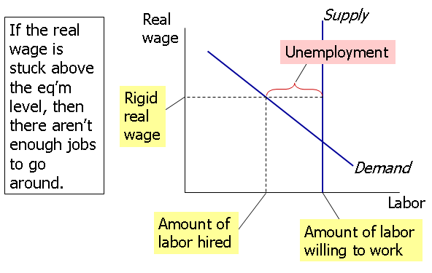
Reasons for wage rigidity
1.Minimum wage laws
2.Labor unions
3.Efficiency wages (employers offer high wage as incentive for worker productivity and loyalty)
The minimum wage
- The minimum wage is well below the eq’m wage for most workers, so it cannot explain the majority of natural rate unemployment.
- However, the minimum wage may exceed the eq’m wage of unskilled workers, especially teenagers.
- If so, then we would expect that increases in the minimum wage would increase unemployment among these groups.
Labor unions
- Unions exercise monopoly power to secure higher wages for their members.
- When the union wage exceeds the eq’m wage, unemployment results.
- Employed union workers are insiders whose interest is to keep wages high.
- Unemployed non-union workers are outsiders and would prefer wages to be lower (so that labor demand would be high enough for them to get jobs).

The duration of unemployment
# of weeks unemployed | # of unemployed persons as % of  total # of unemployed | amount of time these workers spent unemployed  as % of total time all workers spent unemployed
1-4 | 39% | 6.5%
5-14 | 31% | 20.5%
15 or more | 30% | 73.0%

- More spells of unemployment are short-term than medium-term or long-term.
- Yet, most of the total time spent unemployed is attributable to the long-term unemployed.
- This long-term unemployment is probably structural and/or due to sectoral shifts among vastly different industries.
- Knowing this is important because it can help us craft policies that are more likely to succeed.

Summary
- The natural rate of unemployment
  - the long-run average or “steady state” rate of unemployment
  - depends on the rates of job separation and job finding

- Frictional unemployment
  - due to the time it takes to match workers with jobs
  - may be increased by unemployment insurance

- Structural unemployment
  - results from wage rigidity - the real wage remains above the equilibrium level
  - causes: minimum wage, unions, efficiency wages

- Duration of unemployment
  - most spells are short term
  - but most weeks of unemployment are attributable to a small number of long-term unemployed persons

