Chapter 5

Economic Growth – II
Instructor: Prof. Dr.Qaisar Abbas

Introduction
In the Solow model,
  - the production technology is held constant
  - income per capita is constant in the steady state.
Neither point is true in the real world:
  - 1929-2001: U.S. real GDP per person grew by a factor of 4.8, or 2.2% per year.
  - examples of technological progress abound

Examples of technological progress
- 1970: 50,000 computers in the world
2000: 51% of U.S. households have 1 or more computers
- The real price of computer power has fallen an average of 30% per year over the past three decades.
- The average car built in 1996 contained more computer processing power than the first lunar landing craft in 1969.
- Modems are 22 times faster today than two decades ago.
- Since 1980, semiconductor usage per unit of GDP has increased by a factor of 3500.
- 1981: 213 computers connected to the Internet
2000: 60 million computers connected to the Internet

Tech. progress in the Solow model
- A new variable: E = labor efficiency
- Assume:
Technological progress is labor-augmenting: it increases labor efficiency at the exogenous rate g:
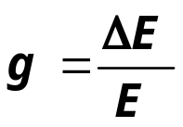

- We now write the production function as:

- where L × E = the number of effective workers.
- Hence, increases in labor efficiency have the same effect on output as increases in the labor force.
- Notation:
y = Y/LE = output per effective worker
k = K/LE = capital per effective worker
- Production function per effective worker:
y = f(k)
- Saving and investment per effective worker:
s y = s f(k)
- (δ + n + g)k = break-even investment: the amount of investment necessary to keep k constant.
- Consists of:
  - k to replace depreciating capital
- n k to provide capital for new workers
- g k to provide capital for the new “effective” workers created by
technological progress

Tech. progress in the Solow model
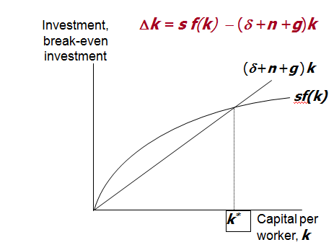

Steady-State Growth Rates in the Solow Model with Tech. Progress
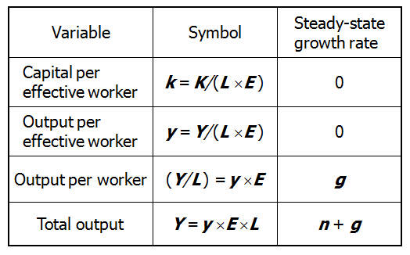

The Golden Rule
To find the Golden Rule capital stock, express c* in terms of k*:
c* = y* − i*
= f (k* ) − (δ + n + g) k*
c* is maximized when
MPK = δ + n + g
or equivalently,
MPK − δ = n + g
- In the Golden Rule Steady State, the marginal product of capital net of depreciation equals the pop. growth rate plus the rate of tech progress.

Policies to promote growth
Four policy questions:
- Are we saving enough? Too much?
- What policies might change the saving rate?
- How should we allocate our investment between privately owned physical capital, public infrastructure, and “human capital”?
- What policies might encourage faster technological progress?

Evaluating the Rate of Saving
- Use the Golden Rule to determine whether our saving rate and capital stock are too high, too low, or about right.
- To do this, we need to compare
(MPK − δ ) to (n + g ).
- If (MPK − δ ) > (n + g ), then we are below the Golden Rule steady state and should increase s.
- If (MPK − δ ) < (n + g ), then we are above the Golden Rule steady state and should reduce s.

Evaluating the Rate of Saving
To estimate (MPK − δ ), we use three facts about the U.S. economy:
1. k = 2.5 y
The capital stock is about 2.5 times one year’s GDP.
2. δ k = 0.1 y
About 10% of GDP is used to replace depreciating capital.
3. MPK × k = 0.3 y
Capital income is about 30% of GDP

1. k = 2.5 y
2. δ k = 0.1 y
3. MPK × k = 0.3 y
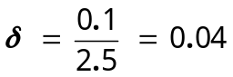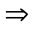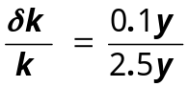

1. k = 2.5 y
2. δ k = 0.1 y
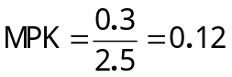3. MPK × k = 0.3 y
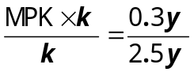
- Hence, MPK − δ = 0.12 − 0.04 = 0.08
- MPK − δ = 0.08
- U.S. real GDP grows an average of 3%/year, so n + g = 0.03
- Thus, in the U.S.,
MPK − δ = 0.08 > 0.03 = n + g
- Conclusion: The U.S. is below the Golden Rule steady state: if we increase our saving rate, we will have faster growth until we get to a new steady state with higher consumption per capita.

2. Policies to increase the saving rate
- Reduce the government budget deficit
(or increase the budget surplus)
- Increase incentives for private saving:
  - reduce capital gains tax, corporate income tax, estate tax as they discourage saving
  - replace federal income tax with a consumption tax
  - expand tax incentives for IRAs (individual retirement accounts) and other retirement savings accounts

3. Allocating the economy’s investment
- In the Solow model, there’s one type of capital.
- In the real world, there are many types,
which we can divide into three categories:
  - private capital stock
  - public infrastructure
  - human capital: the knowledge and skills that workers acquire through education
- How should we allocate investment among these types?
Allocating the economy’s investment: two viewpoints
1. Equalize tax treatment of all types of capital in all industries, then let the market allocate investment to the type with the highest marginal product.
2. Industrial policy: Govt should actively encourage investment in capital of certain types or in certain industries, because they may have positive externalities (by-products) that private investors don’t consider.
Possible problems with industrial policy
- Does the govt have the ability to “pick winners” (choose industries with the highest return to capital or biggest externalities)?
- Would politics (e.g. campaign contributions) rather than economics influence which industries get preferential treatment?

4. Encouraging technological progress
- Patent laws: encourage innovation by granting temporary monopolies to inventors of new products
- Tax incentives for R&D
- Grants to fund basic research at universities
- Industrial policy:
encourage specific industries that are key for rapid tech. progress

Growth empirics: Confronting the Solow model with the facts
Solow model’s steady state exhibits balanced growth - many variables grow at the same rate.

  - Solow model predicts Y/L and K/L grow at same rate (g), so that K/Y should be constant.
This is true in the real world.
  - Solow model predicts real wage grows at same rate as Y/L, while real rental price is constant.
Also true in the real world.
Convergence
- Solow model predicts that, other things equal, “poor” countries (with lower Y/L and K/L ) should grow faster than “rich” ones.
- If true, then the income gap between rich & poor countries would shrink over time, and living standards “converge.”
- In real world, many poor countries do NOT grow faster than rich ones. Does this mean the Solow model fails?
- No, because “other things” aren’t equal.
  - In samples of countries with similar savings & pop. growth rates,
income gaps shrink about 2%/year.
  - In larger samples, if one controls for differences in saving, population growth, and human capital, incomes converge by about 2%/year.
- What the Solow model really predicts is conditional convergence - countries converge to their own steady states, which are determined by saving, population growth, and education. And this prediction comes true in the real world.

Factor accumulation vs. Production efficiency
Two reasons why income per capita are lower in some countries than others:
1. Differences in capital (physical or human) per worker
2. Differences in the efficiency of production (the height of the production function)
Studies:
  - both factors are important
  - countries with higher capital (phys or human) per worker also tend to have higher production efficiency
- Factor accumulation vs.
Production efficiency

Explanations:
  - Production efficiency encourages capital accumulation
  - Capital accumulation has externalities that raise efficiency
  - A third, unknown variable causes cap accumulation and efficiency to be higher in some countries than others

Endogenous Growth Theory
- Solow model:
  - sustained growth in living standards is due to tech progress
  - the rate of tech progress is exogenous
- Endogenous growth theory:
  - a set of models in which the growth rate of productivity and living standards is endogenous

A basic model
- Production function: Y = A K, where A is the amount of output for each unit of capital (A is exogenous & constant)
- Key difference between this model & Solow: MPK is constant here, diminishes in Solow
- Investment: s Y
- Depreciation: δ K
- Equation of motion for total capital:
DK = s Y − δ K
DK = s Y − δ K
- 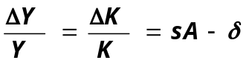Divide through by K and use Y = A K , get:

- If s A > δ, then income will grow forever, and investment is the “engine of growth.”
- Here, the permanent growth rate depends on s. In Solow model, it does not.

Does capital have diminishing returns or not?
- Yes, if “capital” is narrowly defined (plant & equipment).
- Perhaps not, with a broad definition of “capital” (physical & human capital, knowledge).
- Some economists believe that knowledge exhibits increasing returns.

A two-sector model
- Two sectors:
  - manufacturing firms produce goods
  - research universities produce knowledge that increases labor efficiency in manufacturing
- u = fraction of labor in research
(u is exogenous)
- Mfg prod func: Y = F [K, (1-u )E L]
- Res prod func: DE = g (u )E
- Cap accumulation: DK = s Y − δ K
- In the steady state, mfg output per worker and the standard of living grow at rate
ΔE/E = g (u ).
- Key variables:
s: affects the level of income, but not its growth rate (same as in Solow model)
u: affects level and growth rate of income
- Question:
Would an increase in u be unambiguously good for the economy?

Three facts about R&D in the real world
1. Much research is done by firms seeking profits.
2. Firms profit from research because
  - new inventions can be patented, creating a stream of monopoly profits until the patent expires
  - there is an advantage to being the first firm on the market with a new product
3. Innovation produces externalities that reduce the cost of subsequent innovation.
Much of the new endogenous growth theory attempts to incorporate these facts into models to better understand tech progress.

Is the private sector doing enough R&D?
- The existence of positive externalities in the creation of knowledge suggests that the private sector is not doing enough R&D.
- But, there is much duplication of R&D effort among competing firms.
- Estimates: The social return to R&D is at least 40% per year. Thus, many believe govt should encourage R&D

Summary
1. Key results from Solow model with tech progress
  - steady state growth rate of income per person depends solely on the exogenous rate of tech progress
  - the U.S. has much less capital than the Golden Rule steady state
2. Ways to increase the saving rate
  - increase public saving (reduce budget deficit)
  - tax incentives for private saving
3. Productivity slowdown & “new economy”
  - Early 1970s: productivity growth fell in the U.S. and other countries.
  - Mid 1990s: productivity growth increased, probably because of advances in I.T.
4. Empirical studies
  - Solow model explains balanced growth, conditional convergence
  - Cross-country variation in living standards due to differences in cap. accumulation and in production efficiency
5. Endogenous growth theory: models that
  - examine the determinants of the rate of tech progress, which Solow takes as given
  - explain decisions that determine the creation of knowledge through R&D

