Chapter 4

Economic Growth – 1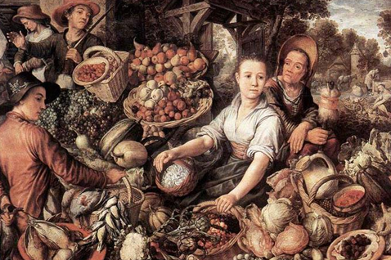
Instructor: Prof. Dr.Qaisar Abbas

Selected poverty statistics
In the poorest one-fifth of all countries,
- daily caloric intake is 1/3 lower than in the richest fifth
- the infant mortality rate is 200 per 1000 births, compared to 4 per 1000 births in the richest fifth.
- In Pakistan, 85% of people live on less than $2/day
- One-fourth of the poorest countries have had famines during the past 3 decades. (none of the richest countries had famines)
- Poverty is associated with the oppression of women and minorities

Estimated effects of economic growth
- A 10% increase in income is associated with a 6% decrease in infant mortality
- Income growth also reduces poverty. Example:
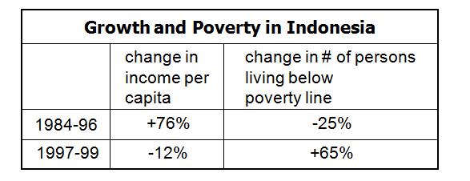

Huge effects from tiny differences
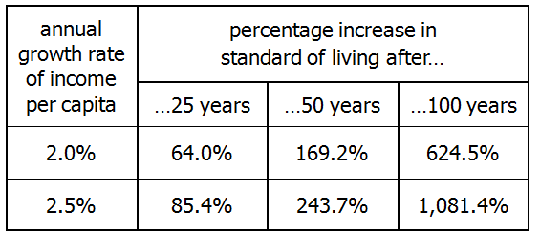
In rich countries like the U.S., if government policies or “shocks” have even a small impact on the long-run growth rate, they will have a huge impact on our standard of living in the long run…

If the annual growth rate of U.S. real GDP per capita had been just one-tenth of one percent higher during the 1990s, the U.S. would have generated an additional $449 billion of income during that decade.

The lessons of growth theory
These lessons help us
  - understand why poor countries are poor
  - design policies that
can help them grow
  - learn how our own growth rate is affected by shocks and our government’s policies

The Solow Model
- Robert Solow won Nobel Prize for contributions to the study of economic growth. It is a major paradigm which is widely used in policy making and a benchmark against which most recent growth theories are compared. The Solow Growth Model is designed to show how growth in the capital stock, growth in the labor force, and advances in technology interact in an economy, and how they affect a nation’s total output of goods and services.
- major paradigm:
  - widely used in policy making
  - benchmark against which most recent growth theories are compared
How Solow model is different
- K is no longer fixed: investment causes it to grow, depreciation causes it to shrink.
- L is no longer fixed: population growth causes it to grow.
3. The consumption function is even simpler.
- No G or T (only to simplify presentation; we can still do fiscal policy experiments)
5. Cosmetic differences.

The production function
- In aggregate terms: Y = F (K, L )
- Define: y = Y/L = output per worker
k = K/L = capital per worker
- Assume constant returns to scale:
zY = F (zK, zL ) for any z > 0
- Pick z = 1/L. Then
Y/L = F (K/L , 1)
y = F (k, 1)
y = f(k) where f(k) = F (k, 1)

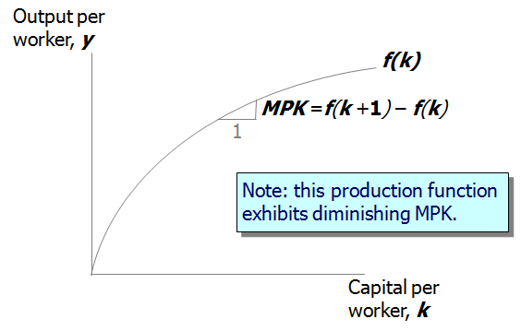

The national income identity
- Y = C + I (remember, no G )
- In “per worker” terms:
y = c + i
- where c = C/L and i = I/L

The consumption function
- s = the saving rate,
the fraction of income that is saved
(s is an exogenous parameter)
- Note: s is the only lowercase variable that is not equal to its uppercase version divided by L
- Consumption function: c = (1–s)y
(per worker)

Saving and investment
- saving (per worker) = y – c
= y – (1–s)y
= sy
- National income identity is y = c + i
Rearrange to get: i = y – c = sy
(investment = saving)
- Using the results above,
i = sy = sf(k)

Output, consumption, and investment
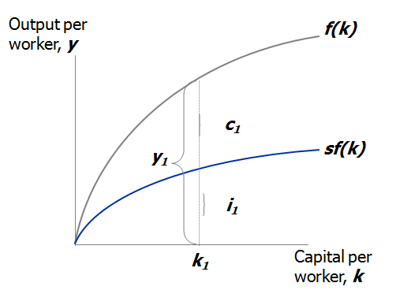

Depreciation
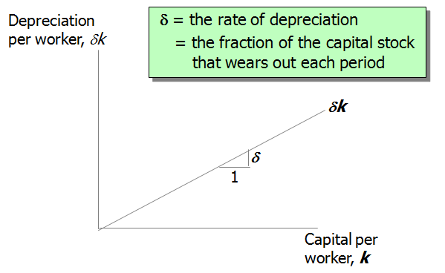
Capital accumulation
- The basic idea: Investment makes the capital stock bigger, depreciation makes it smaller.
- Change in capital stock = investment – depreciation
Δk = i – δk
- Since i = sf(k) , this becomes:

The equation of motion for k

- The Solow model’s central equation
- Determines behavior of capital over time…
- …which, in turn, determines behavior of all of the other endogenous variables because they all depend on k. E.g.,

income per person: y = f(k)
consump. per person: c = (1–s) f(k)

The steady state

If investment is just enough to cover depreciation
[sf(k) = δk ],
then capital per worker will remain constant:
Δk = 0.
This constant value, denoted k*, is called the steady state capital stock.
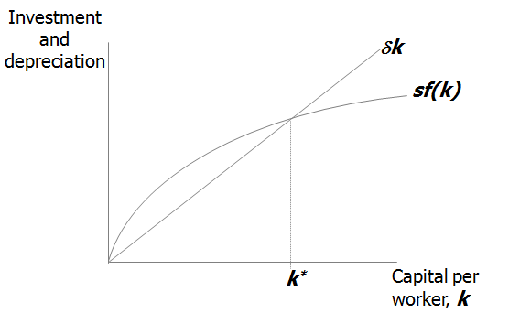
Moving toward the steady state
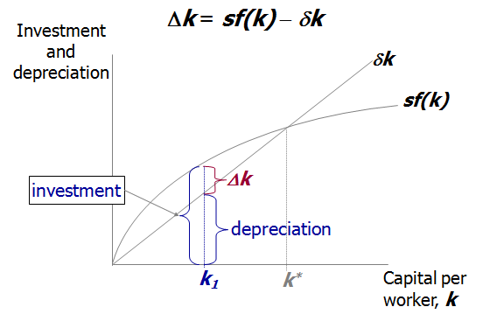
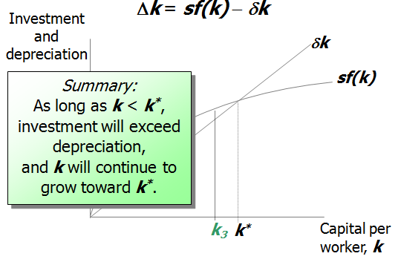
An increase in the saving rate
An increase in the saving rate raises investment, causing the capital stock to grow toward a new steady state.
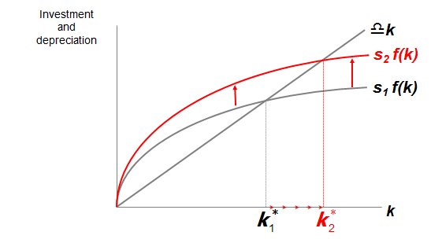
Prediction
- Higher s ⇒ higher k*.
- And since y = f(k) ,
higher k* ⇒ higher y* .
- Thus, the Solow model predicts that countries with higher rates of saving and investment will have higher levels of capital and income per worker in the long run.

The Golden Rule: introduction
- Different values of s lead to different steady states. How do we know which is the “best” steady state?
- Economic well-being depends on consumption, so the “best” steady state has the highest possible value of consumption per person:
c* = (1–s) f(k*)
- An increase in s
  - leads to higher k* and y*, which may raise c*
  - 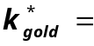reduces consumption’s share of income (1–s),
which may lower c*
the Golden Rule level of capital, the steady state value of k that maximizes consumption.
- To find it, first express c* in terms of k*:
c* = y* − i*
= f (k*) − i*
= f (k*) − δk*
- In general:
i = Δk + δk
- In the steady state: i* = δk* because Δk = 0.

The Golden Rule Capital Stock
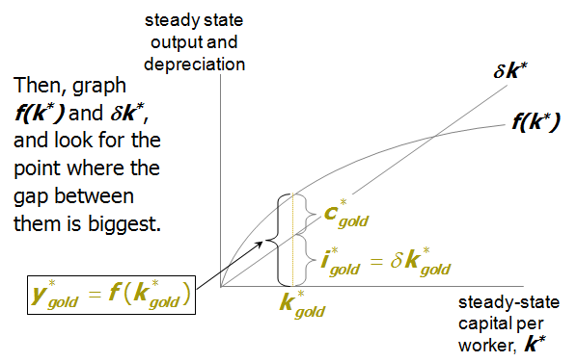

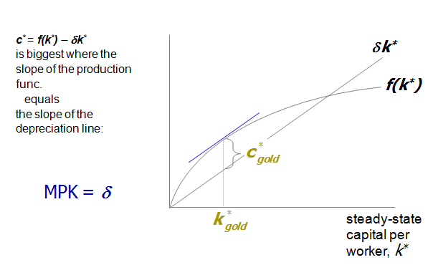
Use calculus to find golden rule
- We want to maximize: c* = f(k*) − δk*
- From calculus, at the maximum we know the derivative equals zero.
- Find derivative: dc*/dk*= MPK− δ
- Set equal to zero: MPK− δ = 0 or MPK = δ

The transition to the Golden Rule Steady State
- The economy does NOT have a tendency to move toward the Golden Rule steady state.
- Achieving the Golden Rule requires that policymakers adjust s.
- This adjustment leads to a new steady state with higher consumption.
- But what happens to consumption during the transition to the Golden Rule?

Starting with too much capital
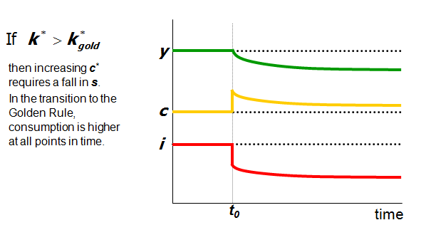
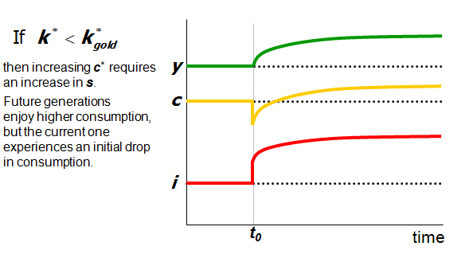
Population Growth
- 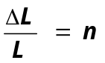Assume that the population--and labor force-- grow at rate n. (n is exogenous)

- EX: Suppose L = 1000 in year 1 and the population is growing at 2%/year (n = 0.02).
Then ΔL = n L = 0.02 × 1000 = 20,
so L = 1020 in year 2.
Break-even investment
(δ + n)k = break-even investment,
- the amount of investment necessary to keep k constant.
- Break-even investment includes:
- δ k to replace capital as it wears out
  - n k to equip new workers with capital
(otherwise, k would fall as the existing capital stock would be spread more thinly over a larger population of workers)

The equation of motion for k
- With population growth, the equation of motion for k is
Δk = s f(k) − (δ + n) k
The Solow Model diagram
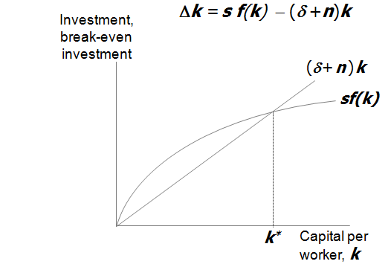
The impact of population growth
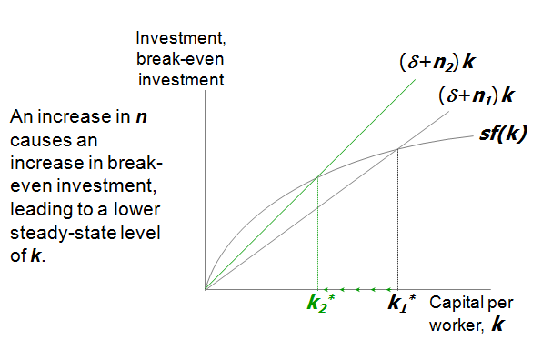
Prediction
- Higher n ⇒ lower k*.
- And since y = f(k) ,
lower k* ⇒ lower y* .
- Thus, the Solow model predicts that countries with higher population growth rates will have lower levels of capital and income per worker in the long run.

The Golden Rule with Population Growth
To find the Golden Rule capital stock, we again express c* in terms of k*:
c* = y* − i*
= f (k* ) − (δ + n) k*
c* is maximized when
MPK = δ + n
or equivalently,
MPK − δ = n

- In the Golden Rule Steady State, the marginal product of capital net of depreciation equals the population growth rate.

Summary
- The Solow growth model shows that, in the long run, a country’s standard of living depends
  - positively on its saving rate.
  - negatively on its population growth rate.

  - An increase in the saving rate leads to
  - higher output in the long run
  - faster growth temporarily
  - but not faster steady state growth.

