Chapter 3

National Income:
Where it Comes From and Where it Goes 
Instructor: Prof. Dr.Qaisar Abbas

Outline of model
A closed economy, market-clearing model
Supply side
  - factor markets (supply, demand, price)
  - determination of output/income
Demand side
  - determinants of C, I, and G
Equilibrium
  - goods market
  - loanable funds market

Factors of production
K = capital, tools, machines, and structures used in production
L = labor, the physical and mental efforts of workers

The production function
- denoted Y = F (K, L)
- shows how much output (Y ) the economy can produce from
K units of capital and L units of labor.
- reflects the economy’s level of technology.
- exhibits constant returns to scale.

Returns to scale
- Initially Y₁ = F (K₁ , L₁ )
Scale all inputs by the same factor z:
K₂ = zK₁ and L₂ = zL₁
(If z = 1.25, then all inputs are increased by 25%)

Assumptions of the model
- Technology is fixed.
- 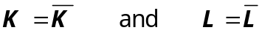The economy’s supplies of capital and labor are fixed at

Determining GDP
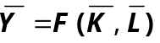Output is determined by the fixed factor supplies and the fixed state of technology:

The distribution of national income
- Determined by factor prices, the prices per unit that firms pay for the factors of production.
- The wage is the price of L
- The rental rate is the price of K.
- Notation
W = nominal wage
R = nominal rental rate
P = price of output
W /P = real wage
(measured in units of output)
R /P = real rental rate

How factor prices are determined
- Factor prices are determined by supply and demand in factor markets.

Demand for labor
- Assume markets are competitive: each firm takes W, R, and P as given
- Basic idea:
A firm hires each unit of labor if the cost does not exceed the benefit.
Cost = real wage
benefit = marginal product of labor

Marginal product of labor (MPL)
def:
The extra output the firm can produce using an additional unit of labor (holding other inputs fixed):
MPL = F (K, L +1) – F (K, L)

The MPL and the production function
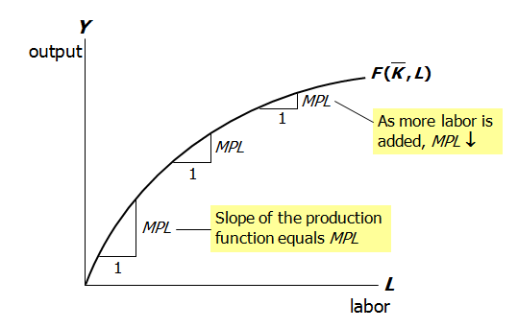

Diminishing marginal returns
- As a factor input is increased, its marginal product falls (other things equal).
- Intuition:
↑L while holding K fixed
  - fewer machines per worker
⇒ lower productivity

MPL and the demand for labor
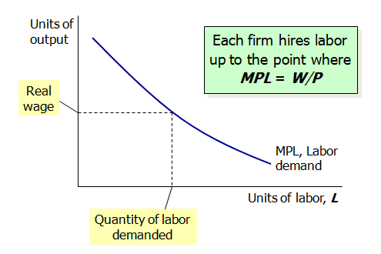
Determining the rental rate
We have just seen that MPL = W/P
The same logic shows that MPK = R/P :
- diminishing returns to capital: MPK ↓ as K ↑
- The MPK curve is the firm’s demand curve for renting capital.
- Firms maximize profits by choosing K such that MPK = R/P .

The Neoclassical Theory of Distribution
- It states that each factor input is paid its marginal product . It is accepted by most economists.

Demand for goods & services
Components of aggregate demand:
C = consumer demand for g & s
I = demand for investment goods
G = government demand for g & s
(closed economy: no NX )

Consumption, C
- def: disposable income is total income minus total taxes: Y – T
- Consumption function: C = C (Y – T )
Shows that ↑(Y – T ) ⇒ ↑C
- def: The marginal propensity to consume is the increase in C caused by a one-unit increase in disposable income.

The consumption function
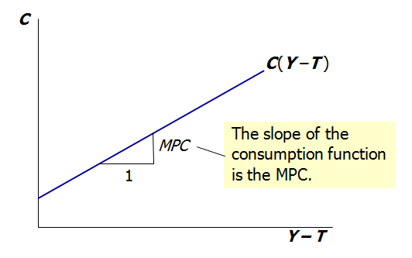

Investment, I
- The investment function is I = I (r ),
where r denotes the real interest rate, the nominal interest rate corrected for inflation.

- The real interest rate is
- the cost of borrowing
- the opportunity cost of using one’s own funds to finance investment spending.

So, ↑r ⇒ ↓I

The investment function
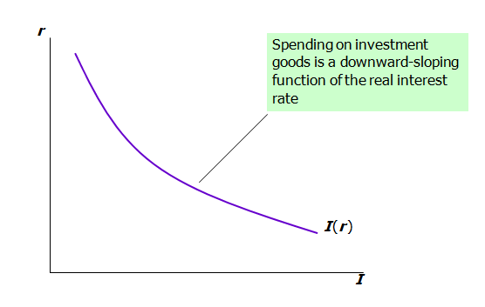

Government spending, G
- G includes government spending on goods and services.
- G excludes transfer payments
- Assume government spending and total taxes are exogenous:

The market for goods & services
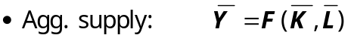

The real interest rate adjusts to equate demand with supply.

The loanable funds market
A simple supply-demand model of the financial system.
One asset: “loanable funds”
  - demand for funds:investment
  - supply of funds: saving
  - “price” of funds: real interest rate

Demand for funds: Investment
The demand for loanable funds:
  - comes from investment: Firms borrow to finance spending on plant & equipment, new office buildings, etc. Consumers borrow to buy new houses.
  - depends negatively on r , the “price” of loanable funds (the cost of borrowing).

Loanable funds demand curve
The demand for loanable funds Comes from investment. Firms borrow to finance spending on plant & equipment, new office buildings, etc. Consumers borrow to buy new houses. It depends negatively on r, the “price” of loanable funds (the cost of borrowing).
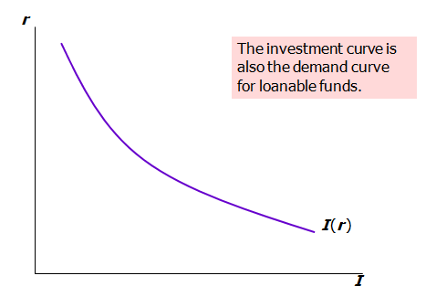

Supply of funds: Saving
The supply of loanable funds comes from saving:
  - Households use their saving to make bank deposits, purchase bonds and other assets. These funds become available to firms to borrow to finance investment spending.
  - The government may also contribute to saving if it does not spend all of the tax revenue it receives.

Types of saving
- private saving = (Y –T ) – C
- public saving = T – G
- national saving, S
= private saving + public saving
= (Y –T ) – C + T – G
= Y – C – G

Notation: Δ = change in a variable
- For any variable X, ΔX = “the change in X ”
- Δ is the Greek (uppercase) letter Delta

Digression: Budget surpluses and deficits
- When T > G ,
budget surplus = (T – G ) = public saving
- When T < G ,
budget deficit = (G –T )
and public saving is negative.
- When T = G ,
budget is balanced and public saving = 0.

Loanable funds supply curve
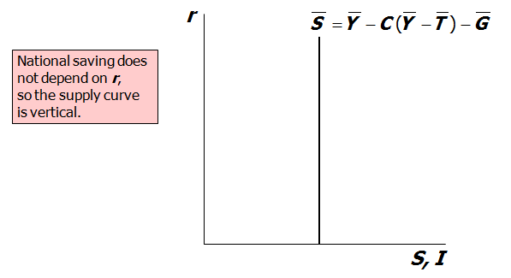
Loanable funds market equilibrium
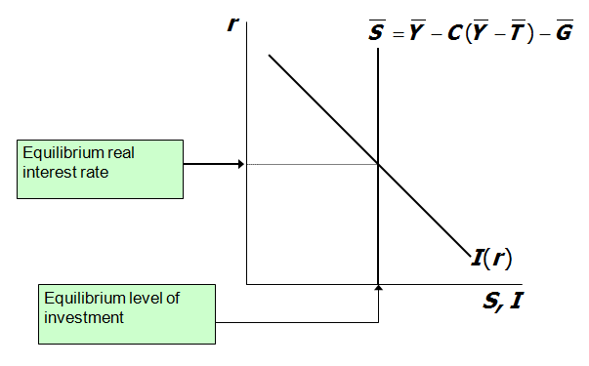

The special role of r
- r adjusts to equilibrate the goods market and the loanable funds market simultaneously:
If L.F. market in equilibrium, then
Y – C – G = I
Add (C +G ) to both sides to get
Y = C + I + G (goods market eq’m)
Thus,

Digression: mastering models
To learn a model well, be sure to know:
- Which of its variables are endogenous and which are exogenous.
- For each curve in the diagram, know
  - definition
  - intuition for slope
  - all the things that can shift the curve
- Use the model to analyze the effects of each item in 2c .

Mastering the loanable funds model
Things that shift the saving curve
  - public saving
    - fiscal policy: changes in G or T
  - private saving
    - preferences
    - tax laws that affect saving
      - 401(k)
      - IRA
      - replace income tax with consumption tax
- Things that shift the investment curve
  - certain technological innovations
    - to take advantage of the innovation, firms must buy new investment goods
  - tax laws that affect investment
    - investment tax credit

An increase in investment demand
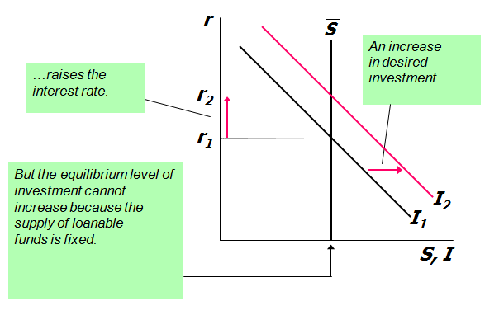

Saving and the interest rate
- An increase in investment demand when saving depends on the interest rate
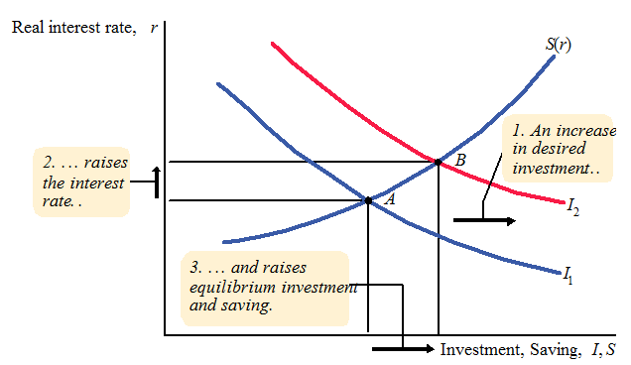
Summary
- Total output is determined by
  - how much capital and labor the economy has
  - the level of technology
- Competitive firms hire each factor until its marginal product equals its price.
- If the production function has constant returns to scale, then labor income plus capital income equals total income (output).
- The economy’s output is used for
  - consumption (which depends on disposable income)
  - investment (depends on the real interest rate)
  - government spending (exogenous)
5. The real interest rate adjusts to equate the demand for and supply of
  - goods and services
  - loanable funds
6. A decrease in national saving causes the interest rate to rise and investment to fall.
7. An increase in investment demand causes the interest rate to rise, but does not affect the equilibrium level of investment
if the supply of loanable funds is fixed.

