Chapter 2

The data of Macroeconomics- GDP, Unemployment & inflation 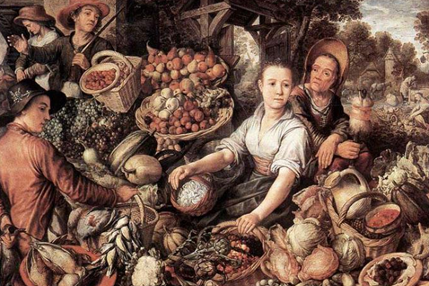
Instructor: Prof. Dr.Qaisar Abbas

Gross Domestic Product
Gross Domestic Product is the total market value of all goods and services produced within the political boundaries of an economy during a given period of time, usually one year. This is the government's official measure of how much output our economy produces. It includes:
- Total expenditure on domestically-produced final goods and services
- Total income earned by domestically-located factors of production

Why expenditure = income

The Circular Flow
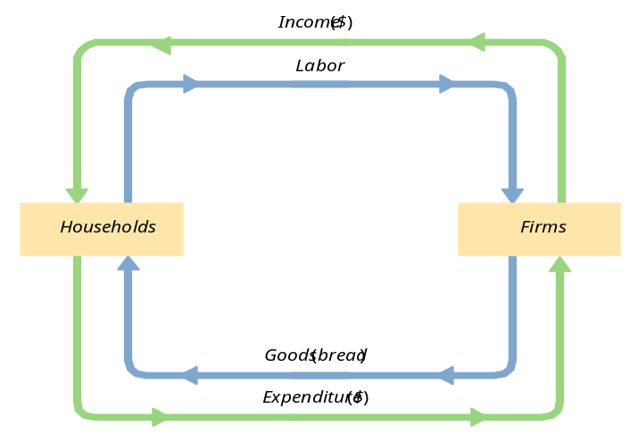
Value added
Definition
A firm’s value added is the value of its output minus the value of the intermediate goods the firm used to produce that output.
The expenditure components of GDP
- Consumption
- Investment
- government spending
- net exports
Consumption (C)
It is defined as the value of all goods and services bought by households. It includes:
  - durable goods :last a long time
ex: cars, home appliances

  - non-durable goods: last a short time
ex: food, clothing
  - services: work done for consumers
ex: dry cleaning, air travel.
Investment (I)
def1: spending on [the factor of production] capital.
def2: spending on goods bought for future use.
Includes:
  - business fixed investment
spending on plant and equipment that firms will use to produce other goods & services
  - residential fixed investment
spending on housing units by consumers and landlords
  - inventory investment
the change in the value of all firms’ inventories

Investment vs. Capital
- Capital is one of the factors of production.
- At any given moment, the economy has a certain overall stock of capital.
- Investment is spending on new capital.
Example (assumes no depreciation):
  - 1/1/2002:
economy has $500b worth of capital
  - during 2002:
investment = $37b
  - 1/1/2003:
economy will have $537b worth of capital

Stocks vs. Flows
stock flow
a person’s wealth a person’s saving
# of people with # of new college
college degrees graduates
the govt. debt the govt. budget deficit

Government spending (G)
- G includes all government spending on goods and services.
- G excludes transfer payments (e.g. unemployment insurance payments), because they do not represent spending on goods and services.

Net exports (NX = EX - IM)
def: the value of total exports (EX) minus the value of total imports (IM)
- An important identity
Y = C + I + G + NX
where
Y = GDP = the value of total output
C + I + G + NX = aggregate expenditure

Why output = expenditure
- Unsold output goes into inventory, and is counted as “inventory investment”……whether the inventory buildup was intentional or not.
- In effect, we are assuming that firms purchase their unsold output.

GDP: An important and versatile concept
We have now seen that GDP measures
  - total income
  - total output
  - total expenditure
  - the sum of value-added at all stages
in the production of final goods

GNP vs. GDP
- Gross National Product (GNP)
total income earned by the nation’s factors of production, regardless of where located
- Gross Domestic Product (GDP)
total income earned by domestically-located factors of production, regardless of nationality.
Real vs. Nominal GDP
- GDP is the value of all final goods and services produced.
- Nominal GDP measures these values using current prices.
- Real GDP measure these values using the prices of a base year.
- Real GDP controls for inflation
- Changes in nominal GDP can be due to:
  - changes in prices
  - changes in quantities of output produced
- Changes in real GDP can only be due to changes in quantities, because real GDP is constructed using constant base-year prices.

GDP Deflator
- The GDP deflator, also called the implicit price deflator for GDP, measures the price of output
relative to its price in the base year. It reflects what’s happening to the overall level of prices in the economy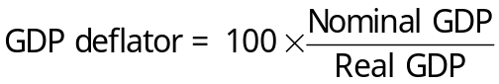

Consumer Price Index (CPI)
- CPI is a measure of the overall level of prices
- Published by the Bureau of Labor Statistics (BLS)
CPI is used to
- track changes in the typical household’s cost of living
- allow comparisons of dollar figures from different years

How the BLS constructs the CPI
- It surveys consumers to determine composition of the typical consumer’s “basket” of goods.
- Every month, data is collected on prices of all items in the basket to compute cost of basket
- CPI in any month equals
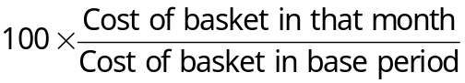

CPI vs. GDP deflator
Prices of capital goods
- included in GDP deflator (if produced domestically)
- excluded from CPI
Prices of imported consumer goods
- included in CPI
- excluded from GDP deflator
The basket of goods
- CPI: fixed
- GDP deflator: changes every year

Two measures of inflation
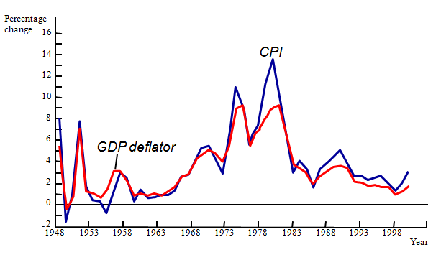

Categories of the population
- employed
working at a paid job
- unemployed
not employed but looking for a job
- labor force
the amount of labor available for producing goods and services; all employed plus unemployed persons
- not in the labor force
not employed, not looking for work.

Two important labor force concepts
- unemployment rate
percentage of the labor force that is unemployed
- labor force participation rate
the fraction of the adult population that ‘participates’ in the labor force

Okun’s Law
One would expect a negative relationship between unemployment and real GDP. This relationship is clear in the data. Percentage Change in Real GDP = 3% - 2 * (change in the Unemployment rate). Okun’s Law states that a one-percent decrease in unemployment is associated with two percentage points of additional growth in real GDP.

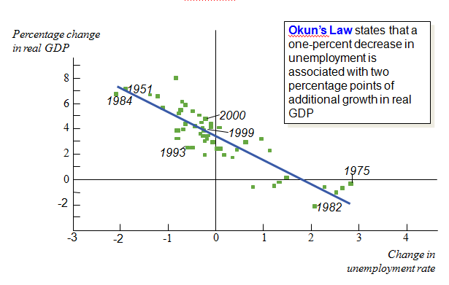

Summary
- Gross Domestic Product (GDP) measures both total income and total expenditure on the economy’s output of goods & services.
- Nominal GDP values output at current prices; real GDP values output at constant prices. Changes in output affect both measures, but changes in prices only affect nominal GDP.
- GDP is the sum of consumption, investment, government purchases, and net exports.
- The overall level of prices can be measured by either
- the Consumer Price Index (CPI), the price of a fixed basket of goods purchased by the typical consumer
- the GDP deflator, the ratio of nominal to real GDP
- The unemployment rate is the fraction of the labor force that is not employed.
- When unemployment rises, the growth rate of real GDP falls.

