Chapter 17

Investment

Instructor: Prof. Dr.Qaisar Abbas

Types of Investment
Following are the types of investment
- Business fixed investment:
businesses’ spending on equipment and structures for use in production
- Residential investment:
purchases of new housing units (either by occupants or landlords)
- Inventory investment:
the value of the change in inventories of finished goods, materials and supplies, and work in progress.

Understanding business fixed investment
- The standard model of business fixed investment: the neoclassical model of investment
- Shows how investment depends on
  - MPK
  - interest rate
  - tax rules affecting firms

Two types of firms
For simplicity, assume two types of firms:
- Production firms rent the capital they use to produce goods and services.
2. Rental firms own capital, rent it out to production firms.

The capital rental market
- Production firms must decide how much capital to rent.
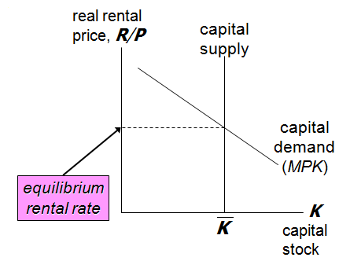
The cost of capital
Components of the cost of capital:
  - interest cost: i ×P_{K},
where P_{K} = nominal price of capital
  - depreciation cost: δ ×P_{K},
where δ = rate of depreciation
  - capital loss: − ΔP_{K}
(A capital gain, ΔP_{K} > 0, reduces cost of K )
The total cost of capital is the sum of these three parts:
- The cost of capital
Example car rental company (capital: cars)
Suppose P_{K} = $10,000, i = 0.10, δ = 0.20,
and ΔP_{K}/P_{K} = 0.06
For simplicity, assume ΔP_{K}/P_{K} = π.
Then, the nominal cost of capital equals
P_{K}(i + δ − π) = P_{K}(r +δ )
and the real cost of capital equals
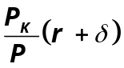
The real cost of capital depends positively on:
  - the relative price of capital
  - the real interest rate
  - the depreciation rate

The rental firm’s profit rate
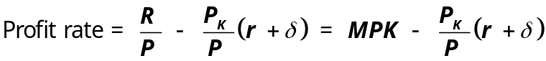Firm’s net investment depends on the profit rate:

- If profit rate > 0,
then it’s profitable for firm to increase K
- If profit rate < 0, then firm increases profits by reducing its capital stock.
(Firm reduces K by not replacing it as it depreciates)

Net investment & gross investment
where I_{n}( ) is a function showing how net investment responds to the incentive to invest.
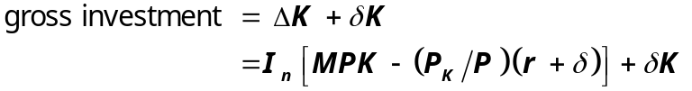Total spending on business fixed investment equals net investment plus the replacement of depreciated capital

The investment function
An increase in r
- raises the cost of capital
- reduces the profit rate
- and reduces investment:

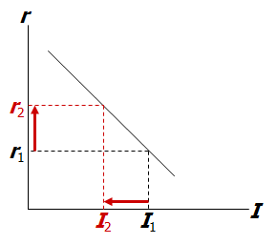
An increase in MPK or decrease in P_{K}/P
  - increases the profit rate
  - increases investment at any given interest rate
  - shifts I curve to the right.
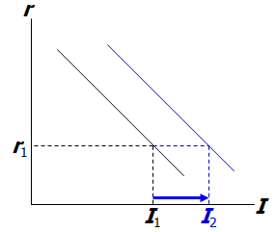
Taxes and Investment
Two of the most important taxes affecting investment:
  - Corporate income tax
  - Investment tax credit

Corporate Income Tax: A tax on profits
Impact on investment depends on definition of “profits”
  - If the law used our definition (rental price minus cost of capital), then the tax doesn’t affect investment.
  - In our definition, depreciation cost is measured using the current price of capital.
  - But, legal definition uses the historical price of capital.
  - If P_{K} rises over time, then the legal definition understates the true cost and overstates profit,
so firms could be taxed even if their true economic profit is zero.
  - Thus, corporate income tax discourages investment.

The investment tax credit (ITC)
- The ITC reduces a firm’s taxes by a certain amount for each dollar it spends on capital
- Hence, the ITC effectively reduces P_{K}
- which increases the profit rate and the incentive to invest.

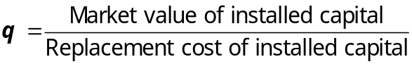Tobin’s q

- numerator: the stock market value of the economy’s capital stock
- denominator: the actual cost to replace the capital goods that were purchased when the stock was issued
- If q > 1, firms buy more capital to raise the market value of their firms
- If q < 1, firms do not replace capital as it wears out.

Relation between q theory and neoclassical theory described above

- The stock market value of capital depends on the current & expected future profits of capital.
- If MPK > cost of capital,
then profit rate is high, which drives up the stock market value of the firms, which implies a high value of q.
- If MPK < cost of capital, then firms are incurring loses, so their stock market value falls, and q is low.

The stock market and GDP
Why one might expect a relationship between the stock market and GDP:
- A wave of pessimism about future profitability of capital would
  - cause stock prices to fall
  - cause Tobin’s q to fall
  - shift the investment function down
  - cause a negative aggregate demand shock
2. A fall in stock prices would
  - reduce household wealth
  - shift the consumption function down
  - cause a negative aggregate demand shock
3. A fall in stock prices might reflect bad news about technological progress and long-run economic growth.
- This implies that aggregate supply and full-employment output will be expanding more slowly than people had expected.

Financing constraints
- Neoclassical theory assumes firms can borrow to buy capital whenever doing so is profitable
- But some firms face financing constraints: limits on the amounts they can borrow (or otherwise raise in financial markets)
- A recession reduces current profits. If future profits expected to be high, it might be worthwhile to continue to invest. But if firm faces financing constraints, then firm might be unable to obtain funds due to current profits being low.

Residential investment
- The flow of new residential investment, I_{H} , depends on the relative price of housing,
P_{H} /P.
- P_{H} /P is determined by supply and demand in the market for existing houses.

The tax treatment of housing
- The tax code, in effect, subsidizes home ownership by allowing people to deduct mortgage interest.
- The deduction applies to the nominal mortgage rate, so this subsidy is higher when inflation and nominal mortgage rates are high than when they are low.
- Some economists think this subsidy causes over-investment in housing relative to other forms of capital
- But eliminating the mortgage interest deduction would be politically difficult.

Motives for holding inventories
1. production smoothing
Sales fluctuate, but many firms find it cheaper to produce at a steady rate.
When sales < production, inventories rise.
When sales > production, inventories fall.
2. Inventories as a factor of production
Inventories allow some firms to operate more efficiently.
  - samples for retail sales purposes
  - spare parts for when machines break down
3. stock-out avoidance
To prevent lost sales in the event of higher than expected demand.
4. Work in process
Goods not yet completed are counted as part of inventory.

The Accelerator Model
A simple theory that explains the behavior of inventory investment, without endorsing any particular motive
- The Accelerator Model
- Notation:
N = stock of inventories
ΔN = inventory investment
- Assume:
Firms hold a stock of inventories proportional to their output
N = βY,
where β is an exogenous parameter reflecting firms’ desired stock of inventory as a proportion of output.
Result:
ΔN = β ΔY
Inventory investment is proportion to the change in output.
  - When output is rising, firms increase their inventories.
  - When output is falling, firms allow their inventories to run down.

Inventories and the real interest rate
- The opportunity cost of holding goods in inventory: the interest that could have been earned on the revenue from selling those goods.
- Hence, inventory investment depends on the real interest rate.
- Example:
High interest rates in the 1980s motivated many firms to adopt just-in-time production, which is designed to reduce inventories.
Summary
- All types of investment depend negatively on the real interest rate.
- Things that shift the investment function:
  - Technological improvements raise MPK and raise business fixed investment.
  - Increase in population raises demand for, price of housing and raises residential investment.
  - Economic policies (corporate income tax, investment tax credit) alter incentives to invest.
3. Investment is the most volatile component of GDP over the business cycle.
  - Fluctuations in employment affect the MPK and the incentive for business fixed investment.
  - Fluctuations in income affect demand for, price of housing and the incentive for residential investment.
  - Fluctuations in output affect planned & unplanned inventory investment.

