Chapter 15

Consumption

Instructor: Prof. Dr.Qaisar Abbas

Keynes’s Conjectures
Following are the three conjectures
- 0 < MPC < 1
- APC falls as income rises where APC
= average propensity to consume
= C/Y
- Income is the main determinant of consumption.

The Keynesian Consumption Function
A consumption function with the properties Keynes conjectured:
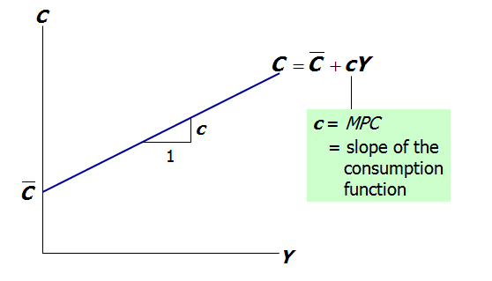

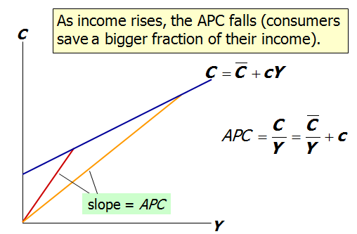

Problems for the Keynesian Consumption Function
Based on the Keynesian consumption function, economists predicted that C would grow more slowly than Y over time.
This prediction did not come true:
  - As incomes grew, the APC did not fall, and C grew just as fast.
  - Simon Kuznets showed that C/Y was very stable in long time series data.

The Consumption Puzzle
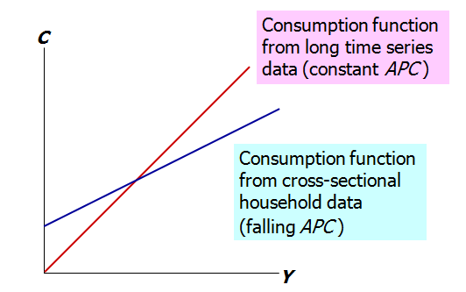
Irving Fisher and Intertemporal Choice
- The basis for much subsequent work on consumption.
- Assumes consumer is forward-looking and chooses consumption for the present and future to maximize lifetime satisfaction.
- Consumer’s choices are subject to an intertemporal budget constraint, a measure of the total resources available for present and future consumption

The basic two-period model
- Period 1: the present
- Period 2: the future
- Notation
Y₁ is income in period 1
Y₂ is income in period 2
C₁ is consumption in period 1
C₂ is consumption in period 2
S = Y₁ - C₁ is saving in period 1
(S < 0 if the consumer borrows in period 1)

Deriving the intertemporal budget constraint
- 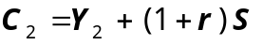Period 2 budget constraint:
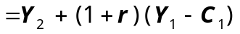
- Rearrange to put C terms on one side and Y terms on the other:
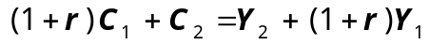
- 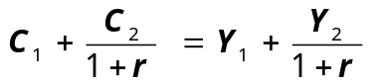Finally, divide through by (1+r ):

The intertemporal budget constraint
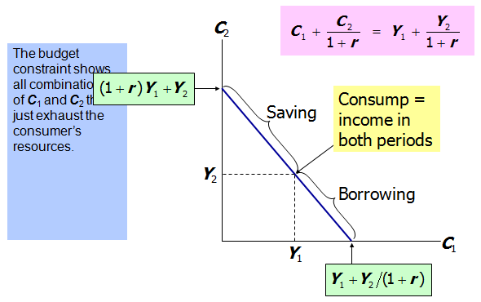
- The intertemporal budget constraint
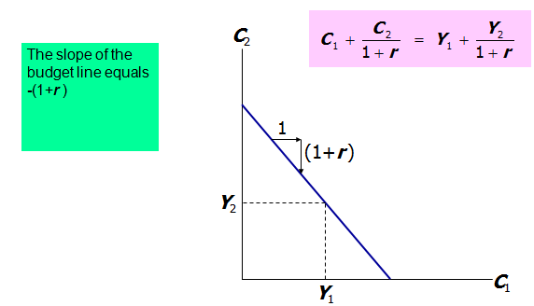
Consumer preferences
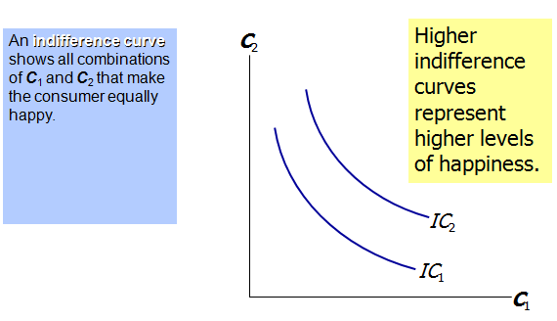
Consumer preferences
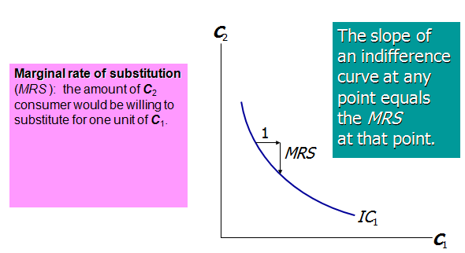
Optimization
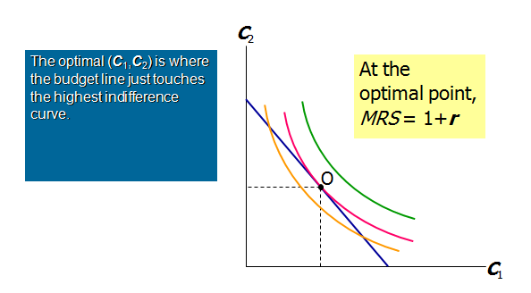

How C responds to changes in Y
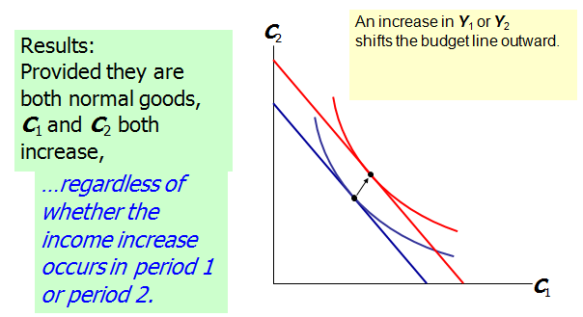

Keynes vs. Fisher
- Keynes:
current consumption depends only on current income
- Fisher:
current consumption depends only on the present value of lifetime income; the timing of income is irrelevant because the consumer can borrow or lend between periods.
How C responds to changes in r
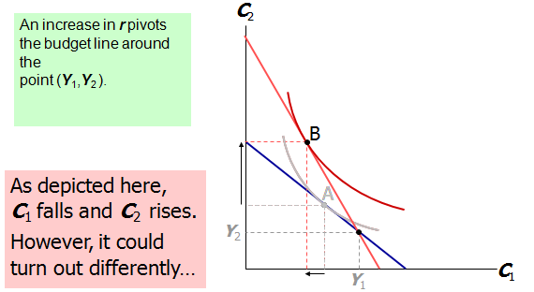

- income effect
If consumer is a saver, the rise in r makes him better off, which tends to increase consumption in both periods.
- substitution effect
The rise in r increases the opportunity cost of current consumption, which tends to reduce C₁ and increase C₂.
- Both effects Þ C₂.
Whether C₁ rises or falls depends on the relative size of the income & substitution effects.
- Constraints on borrowing
- In Fisher’s theory, the timing of income is irrelevant because the consumer can borrow and lend across periods.
- Example: If consumer learns that her future income will increase, she can spread the extra consumption over both periods by borrowing in the current period.
- However, if consumer faces borrowing constraints (aka “liquidity constraints”), then she may not be able to increase current consumption and her consumption may behave as in the Keynesian theory even though she is rational & forward-looking
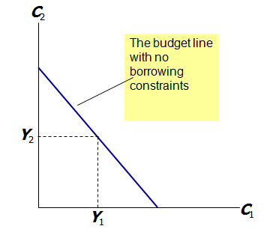
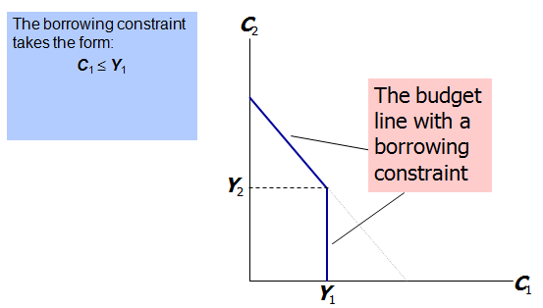
Consumer optimization when the borrowing constraint is not binding
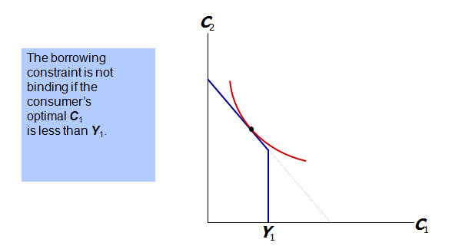

Consumer optimization when the borrowing constraint is binding
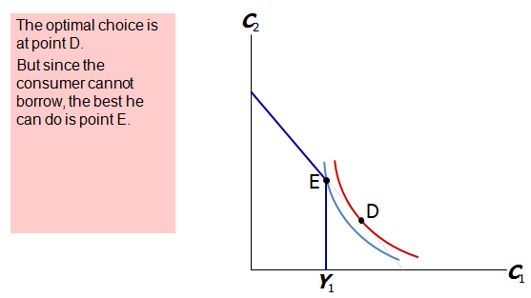
- The Life-Cycle Hypothesis
- due to Franco Modigliani (1950s)
- Fisher’s model says that consumption depends on lifetime income, and people try to achieve smooth consumption.
- The LCH says that income varies systematically over the phases of the consumer’s “life cycle,”
and saving allows the consumer to achieve smooth consumption.
- The basic model:
W = initial wealth
Y = annual income until retirement (assumed constant)
R = number of years until retirement
T = lifetime in years
- Assumptions:
  - zero real interest rate (for simplicity)
  - consumption-smoothing is optimal
- Lifetime resources = W + RY
- To achieve smooth consumption, consumer divides her resources equally over time:
C = (W + RY )/T , or
C = aW + bY
where
a = (1/T ) is the marginal propensity to consume out of wealth
b = (R/T ) is the marginal propensity to consume out of income

Implications of the Life-Cycle Hypothesis
The Life-Cycle Hypothesis can solve the consumption puzzle:
  - The APC implied by the life-cycle consumption function is
C/Y = a(W/Y ) + b
  - Across households, wealth does not vary as much as income, so high income households should have a lower APC than low income households.
  - Over time, aggregate wealth and income grow together, causing APC to remain stable.
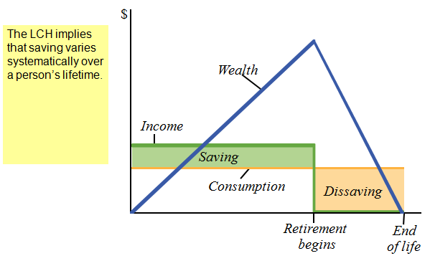

The Permanent Income Hypothesis
- due to Milton Friedman (1957)
- The PIH views current income Y as the sum of two components:
permanent income Y ^{P}
(average income, which people expect to persist into the future)
transitory income Y ^{T}
(temporary deviations from average income)
- Consumers use saving & borrowing to smooth consumption in response to transitory changes in income.
- The PIH consumption function:
C = aY ^{P}
where a is the fraction of permanent income that people consume per year.
- The PIH can solve the consumption puzzle:
  - The PIH implies
APC = C/Y = aY ^{P}/Y
  - To the extent that high income households have higher transitory income than low income households, the APC will be lower in high income households.
  - Over the long run, income variation is due mainly if not solely to variation in permanent income, which implies a stable APC.
PIH vs. LCH
- In both, people try to achieve smooth consumption in the face of changing current income.
- In the LCH, current income changes systematically as people move through their life cycle.
- In the PIH, current income is subject to random, transitory fluctuations.
- Both hypotheses can explain the consumption puzzle.

The Random-Walk Hypothesis
- due to Robert Hall (1978)
- based on Fisher’s model & PIH, in which forward-looking consumers base consumption on expected future income
- Hall adds the assumption of rational expectations, that people use all available information to forecast future variables like income.
- If PIH is correct and consumers have rational expectations, then consumption should follow a random walk: changes in consumption should be unpredictable.
  - A change in income or wealth that was anticipated has already been factored into expected permanent income, so it will not change consumption.
  - Only unanticipated changes in income or wealth that alter expected permanent income will change consumption.

Implication of the R-W Hypothesis
If consumers obey the PIH and have rational expectations, then policy changes will affect consumption only if they are unanticipated.

The Psychology of Instant Gratification
- Theories from Fisher to Hall assumes that consumers are rational and act to maximize lifetime utility.
- recent studies by David Laibson and others consider the psychology of consumers.
- Consumers consider themselves to be imperfect decision-makers.
  - E.g., in one survey, 76% said they were not saving enough for retirement.
- Laibson: The “pull of instant gratification” explains why people don’t save as much as a perfectly rational lifetime utility maximizer would save.

Two Questions and Time Inconsistency
Would you prefer
(A) a candy today, or
(B) two candies tomorrow?
Would you prefer
(A) a candy in 100 days, or
(B) two candies in 101 days?
In studies, most people answered A to question 1, and B to question 2.
A person confronted with question 2 may choose B.
100 days later, when he is confronted with question 1, the pull of instant gratification may induce him to change his mind.

Summing up
- Keynes suggested that consumption depends primarily on current income.
- Recent work suggests instead that consumption depends on
  - current income
  - expected future income
  - wealth
  - interest rates
- Economists disagree over the relative importance of these factors and of borrowing constraints and psychological factors.

Summary
1. Keynesian consumption theory
  - Keynes’ conjectures
    - MPC is between 0 and 1
    - APC falls as income rises
    - current income is the main determinant of current consumption
  - Empirical studies
    - in household data & short time series: confirmation of Keynes’ conjectures
    - in long time series data:
APC does not fall as income rises
2. Fisher’s theory of intertemporal choice
  - Consumer chooses current & future consumption to maximize lifetime satisfaction subject to an intertemporal budget constraint.
  - Current consumption depends on lifetime income, not current income, provided consumer can borrow & save.
3. Modigliani’s Life-Cycle Hypothesis
  - Income varies systematically over a lifetime.
  - Consumers use saving & borrowing to smooth consumption.
  - Consumption depends on income & wealth.
4. Friedman’s Permanent-Income Hypothesis
  - Consumption depends mainly on permanent income.
  - Consumers use saving & borrowing to smooth consumption in the face of transitory fluctuations in income.
5. Hall’s Random-Walk Hypothesis
  - Combines PIH with rational expectations.
  - Main result: changes in consumption are unpredictable, occur only in response to unanticipated changes in expected permanent income.
6. Laibson and the pull of instant gratification
  - Uses psychology to understand consumer behavior.
  - The desire for instant gratification causes people to save less than they rationally know they should.

