Chapter 14

Advances in Business Cycle Theory
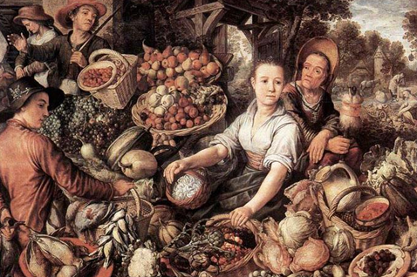
Instructor: Prof. Dr.Qaisar Abbas

The Theory of Real Business Cycles
Real business cycle theory (RBC theory) are a class of macroeconomic models in which business cycle fluctuations to a large extent can be accounted for by real (in contrast to nominal) shocks. Unlike other leading theories of the business cycle, RBC theory sees recessions and periods of economic growth as the efficient response to exogenous changes in the real economic environment.
The economics of Robinson Crusoe
- Economy consists of a single producer-consumer, like Robinson Crusoe on a desert island.
- Assume Crusoe divides his time between
  - leisure
  - working
    - catching fish (production)
    - making fishing nets (investment)
- Assume Crusoe optimizes given the constraints he faces.

Shocks in the Crusoe island economy
- Big school of fish swims by island. Then, GDP rises because
  - Crusoe’s fishing productivity is higher
  - Crusoe’s employment rises: he decides to shift some time from leisure to fishing to take advantage of the high productivity
- Big storm hits the island. Then, GDP falls:
  - The storm reduces productivity, so Crusoe spends less time fishing for consumption.
  - More importantly, investment falls, because it’s easy to postpone making nets until storm passes
  - Employment falls: Since he’s not spending as much time fishing or making nets, Crusoe decides to enjoy more leisure time.
Economic fluctuations as optimal responses to shocks
- In Real Business Cycle theory, fluctuations in our economy are similar to those in Crusoe’s economy.
- The shocks aren’t always desirable. But once they occur, fluctuations in output, employment, and other variables are the optimal responses to them.

The debate over RBC theory
The RBC theory raises four issues:
- Do changes in employment reflect voluntary changes in labor supply?
- Does the economy experience large, exogenous productivity shocks in the short run?
- Is money really neutral in the short run?
- Are wages and prices flexible in the short run? Do they adjust quickly to keep supply and demand in balance in all markets?

The labor market
- Intertemporal substitution of labor:
In RBC theory, workers are willing to reallocate labor over time in response to changes in the reward to working now versus later.
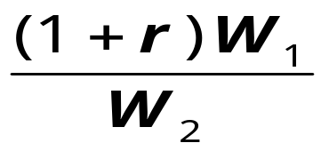
- The intertemporal relative wage equals

where W₁ is the wage in period 1 (the present) and W₂ is the wage in period 2 (the future).
- In RBC theory,
  - shocks cause fluctuations in the intertemporal wage
  - workers respond by adjusting labor supply
  - this causes employment and output to fluctuate
- Critics argue that
  - labor supply is not very sensitive to the intertemporal real wage
  - high unemployment observed in recessions
is mainly involuntary

Technology shocks
- In RBC theory, economic fluctuations are caused by productivity shocks.
- The Solow residual is a measure of productivity shocks: it shows the change in output that cannot be explained by changes in capital and labor.
- RBC theory implies that the Solow residual should be highly correlated with output.
Is it?
- Proponents of RBC theory argue that the strong correlation between output growth and Solow residuals is evidence that productivity shocks are an important source of economic fluctuations.
- Critics note that the measured Solow residual is biased to appear more cyclical than the true, underlying technology.

The neutrality of money
- RBC critics note that reductions in money growth and inflation are almost always associated with periods of high unemployment and low output.
- RBC proponents respond by claiming that the money supply is endogenous:
  - Suppose output is expected to fall.
Central bank reduces money supply in response to an expected fall in money demand.

The flexibility of wages and prices
- RBC theory assumes that wages and prices are completely flexible, so markets always clear.
- RBC proponents argue that the extent to which wages or prices may be sticky in the real world is not important for understanding economic fluctuations.
- They also prefer to assume flexible prices to be consistent with microeconomic theory.
- Critics believe that wage and price stickiness explains involuntary unemployment and the non-neutrality of money.

New Keynesian Economics
- Most economists believe that short-run fluctuations in output and employment represent deviations from the natural rate,and that these deviations occur because wages and prices are sticky.
- New Keynesian research attempts to explain the stickiness of wages and prices by examining the microeconomics of price adjustment.

Small menu costs and aggregate-demand externalities
- There are externalities to price adjustment: A price reduction by one firm causes the overall price level to fall (albeit slightly).This raises real money balances and increases aggregate demand, which benefits other firms.
- Menu costs are the costs of changing prices (e.g., costs of printing new menus or mailing new catalogs)
- In the presence of menu costs, sticky prices may be optimal for the firms setting them even though they are undesirable for the economy as a whole.

Recessions as coordination failure
- In recessions, output is low, workers are unemployed, and factories sit idle.
- If all firms and workers would reduce their prices, then economy would return to full employment.
- But, no individual firm or worker would be willing to cut his price without knowing that others will cut their prices. Hence, prices remain high and the recession continues.

The staggering of wages and prices
- All wages and prices do not adjust at the same time.
- This staggering of wage & price adjustment causes the overall price level to move slowly in response to demand changes.
- Each firm and worker knows that when it reduces its nominal price, its relative price will be low for a time. This makes them reluctant to reduce their price.

Top reasons for sticky prices: results from surveys of managers
1. Coordination failure: firms hold back on price changes, waiting for others to go first
2. Firms delay raising prices until costs rise
3. Firms prefer to vary other product attributes, such as quality, service, or delivery lags
4. Implicit contracts: firms tacitly agree to stabilize prices, perhaps out of ‘fairness’ to customers
5. Explicit contracts that fix nominal prices
6. Menu costs

Conclusion: the frontiers of research
- This chapter has explored two distinct approaches to the study of business cycles: Real Business Cycle theory and New Keynesian Theory.
- Not all economists fall entirely into one camp or the other.
- An increasing amount of research incorporates insights from both schools of thought to advance our study of economic fluctuations.

Summary
1. Real Business Cycle theory
  - assumes perfect flexibility of wages and prices
  - shows how fluctuations arise in response to productivity shocks
  - the fluctuations are optimal given the shocks
2. Points of controversy in RBC theory
  - intertemporal substitution of labor
  - the importance of technology shocks
  - the neutrality of money
  - the flexibility of prices and wages
3. New Keynesian economics
  - accepts the traditional model of aggregate demand and supply
  - attempts to explain the stickiness of wages and prices with microeconomic analysis, including
    - menu costs
    - coordination failure
    - staggering of wages and prices

