Chapter 12

Aggregate Supply

Instructor: Prof. Dr.Qaisar Abbas

Three models of aggregate supply
- The sticky-wage model
- The imperfect-information model
- The sticky-price model
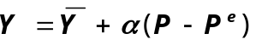All three models imply:

The sticky-wage model
- Assumes that firms and workers negotiate contracts and fix the nominal wage before they know what the price level will turn out to be.
- 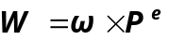The nominal wage, W, they set is the product of a target real wage, ω, and the expected price level:
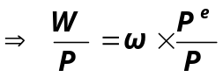

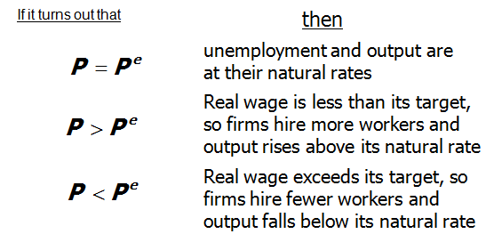
Implies that the real wage should be counter-cyclical , it should move in the opposite direction as output over the course of business cycles:
  - In booms, when P typically rises, the real wage should fall.
  - In recessions, when P typically falls, the real wage should rise.
- This prediction does not come true in the real world:

The cyclical behavior of the real wage
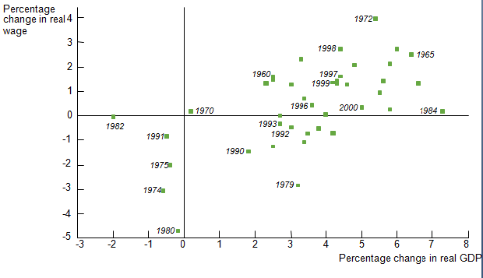

The imperfect-information model
Assumptions:
  - all wages and prices perfectly flexible, all markets clear
  - each supplier produces one good, consumes many goods
  - each supplier knows the nominal price of the good she produces, but does not know the overall price level
- The imperfect-information model
- Supply of each good depends on its relative price: the nominal price of the good divided by the overall price level.
- Supplier doesn’t know price level at the time she makes her production decision, so uses the expected price level, P ^{e}.
- Suppose P rises but P ^{e} does not.
Then supplier thinks her relative price has risen, so she produces more.
With many producers thinking this way, Y will rise whenever P rises above P ^{e}.

The sticky-price model
- Reasons for sticky prices:
  - long-term contracts between firms and customers
  - menu costs
  - firms do not wish to annoy customers with frequent price changes
- Assumption:
  - Firms set their own prices
(e.g. as in monopolistic competition)
- An individual firm’s desired price is
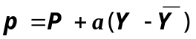
where a > 0.
Suppose two types of firms:
  - firms with flexible prices, set prices as above
  - firms with sticky prices, must set their price before they know how P and Y will turn out:
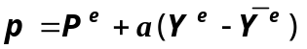

- 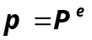Assume firms w/ sticky prices expect that output will equal its natural rate. Then,

- To derive the aggregate supply curve, we first find an expression for the overall price level.
- Let s denote the fraction of firms with sticky prices. Then, we can write the overall price level as
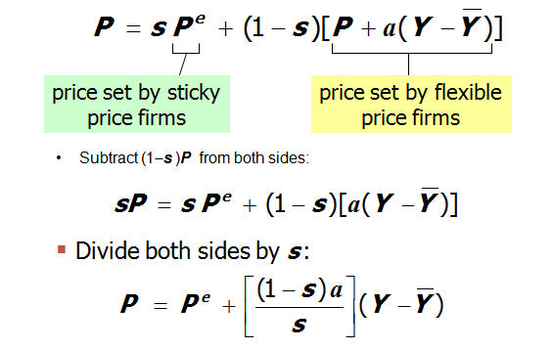

- High P ^{e} Þ High P
If firms expect high prices, then firms who must set prices in advance will set them high.
Other firms respond by setting high prices.
- 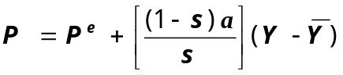High Y Þ High P
When income is high, the demand for goods is high. Firms with flexible prices set high prices.

- 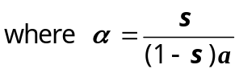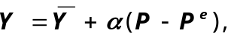Finally, derive AS equation by solving for Y :

In contrast to the sticky-wage model, the sticky-price model implies a procyclical real wage:
Suppose aggregate output/income falls. Then,
  - Firms see a fall in demand for their products.
  - Firms with sticky prices reduce production, and hence reduce their demand for labor.
  - The leftward shift in labor demand causes the real wage to fall.
Summary & implications
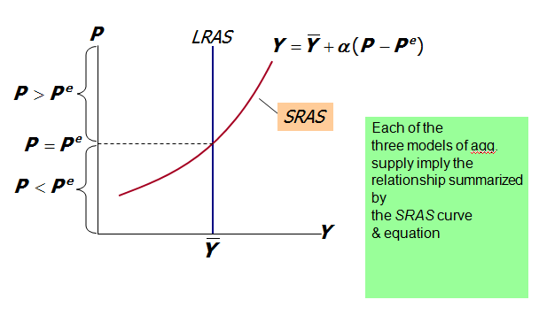
- Inflation, Unemployment, and the Phillips Curve
The Phillips curve states that π depends on
  - expected inflation, π^{e}
  - cyclical unemployment: the deviation of the actual rate of unemployment from the natural rate
  - 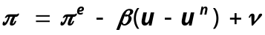supply shocks, ν

- Deriving the Phillips Curve from SRAS
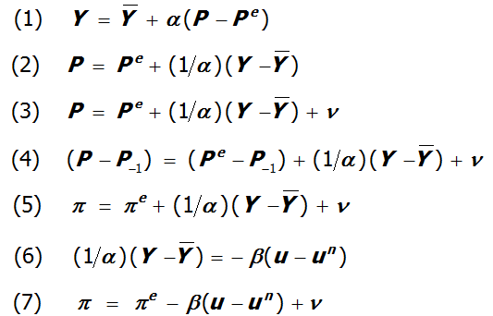

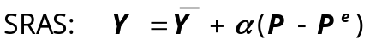The Phillips Curve and SRAS

- SRAS curve:
output is related to unexpected movements in the price level
- Phillips curve:
unemployment is related to unexpected movements in the inflation rate

Adaptive expectations
- Adaptive expectations: an approach that assumes people form their expectations of future inflation based on recently observed inflation.
- A simple example:
Expected inflation = last year’s actual inflation
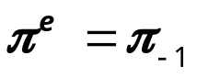
- Then, the P.C. becomes
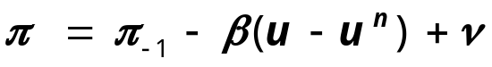

Inflation inertia
- In this form, the Phillips curve implies that inflation has inertia:
  - In the absence of supply shocks or cyclical unemployment, inflation will continue indefinitely at its current rate.
  - Past inflation influences expectations of current inflation, which in turn influences the wages & prices that people set.

Two causes of rising & falling inflation
- cost-push inflation: inflation resulting from supply shocks. Adverse supply shocks typically raise production costs and induce firms to raise prices, “pushing” inflation up.
- demand-pull inflation: inflation resulting from demand shocks. Positive shocks to aggregate demand cause unemployment to fall below its natural rate, which “pulls” the inflation rate up.

Graphing the Phillips curve
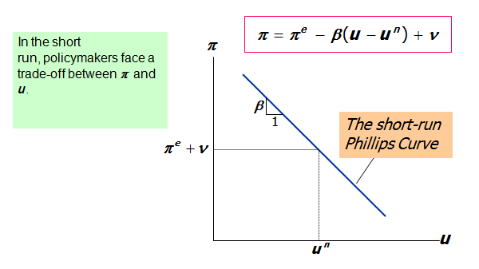
Shifting the Phillips curve
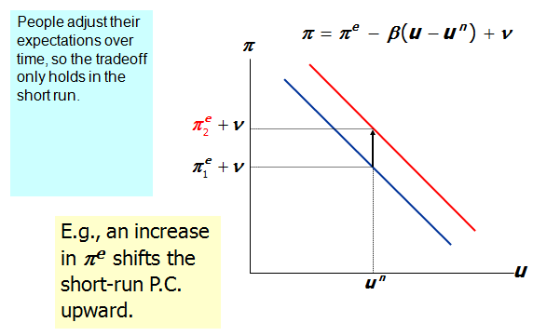
The sacrifice ratio
- To reduce inflation, policymakers can contract agg. demand, causing unemployment to rise above the natural rate.
- The sacrifice ratio measures the percentage of a year’s real GDP that must be foregone to reduce inflation by 1 percentage point.
- Estimates vary, but a typical one is 5.
- Suppose policymakers wish to reduce inflation from 6 to 2 percent.
If the sacrifice ratio is 5, then reducing inflation by 4 points requires a loss of 4×5 = 20 percent of one year’s GDP.
- This could be achieved several ways, e.g.
  - reduce GDP by 20% for one year
  - reduce GDP by 10% for each of two years
  - reduce GDP by 5% for each of four years
- The cost of disinflation is lost GDP. One could use Okun’s law to translate this cost into unemployment.
- Rational expectations
Ways of modeling the formation of expectations:
  - adaptive expectations:
People base their expectations of future inflation on recently observed inflation.
  - rational expectations:
People base their expectations on all available information, including information about current and prospective future policies.

Painless disinflation?
- Proponents of rational expectations believe that the sacrifice ratio may be very small:
- Suppose u = u ^{n} and π = π^{e} = 6%, and suppose the Fed announces that it will do whatever is necessary to reduce inflation from 6 to 2 percent as soon as possible.
- If the announcement is credible, then π^{e} will fall, perhaps by the full 4 points.
- Then, π can fall without an increase in u.

The natural rate hypothesis
- Our analysis of the costs of disinflation, and of economic fluctuations in the preceding chapters, is based on the natural rate hypothesis:
- Changes in aggregate demand affect output and employment only in the short run. In the long run, the economy returns to the levels of output, employment, and unemployment described by the classical model
An alternative hypothesis: hysteresis
- Hysteresis: the long-lasting influence of history on variables such as the natural rate of unemployment.
- Negative shocks may increase u ^{n} , so economy may not fully recover:
  - The skills of cyclically unemployed workers deteriorate while unemployed, and they cannot find a job when the recession ends.
  - Cyclically unemployed workers may lose their influence on wage-setting; insiders (employed workers) may then bargain for higher wages for themselves. Then, the cyclically unemployed “outsiders” may become structurally unemployed when the recession ends.
Summary
1. Three models of aggregate supply in the short run:
  - sticky-wage model
  - imperfect-information model
  - sticky-price model
All three models imply that output rises above its natural rate when the price level falls below the expected price level.
2. Phillips curve
  - derived from the SRAS curve
  - states that inflation depends on
    - expected inflation
    - cyclical unemployment
    - supply shocks
  - presents policymakers with a short-run tradeoff between inflation and unemployment
3. How people form expectations of inflation
  - adaptive expectations
    - based on recently observed inflation
    - implies “inertia”
  - rational expectations
    - based on all available information
    - implies that disinflation may be painless
    - Summary
4. The natural rate hypothesis and hysteresis
  - the natural rate hypotheses
    - states that changes in aggregate demand can only affect output and employment in the short run
  - hysteresis
    - states that agg. demand can have permanent effects on output and employment

