Chapter 11

Aggregate Demand - II

Instructor: Prof. Dr.Qaisar Abbas

Shocks in the IS-LM Model
IS shocks: exogenous changes in the demand for goods & services.
Examples:
  - stock market boom or crash
⇒ change in households’ wealth
⇒ ΔC
  - change in business or consumer confidence or expectations
⇒ ΔI and/or ΔC
LM shocks: exogenous changes in the demand for money.
Examples:
  - a wave of credit card fraud increases demand for money
  - more ATMs or the Internet reduce money demand
IS-LM and Aggregate Demand
- So far, we’ve been using the IS-LM model to analyze the short run, when the price level is assumed fixed.
- However, a change in P would shift the LM curve and therefore affect Y.
- The aggregate demand curve captures this relationship between P and Y

Deriving the AD curve
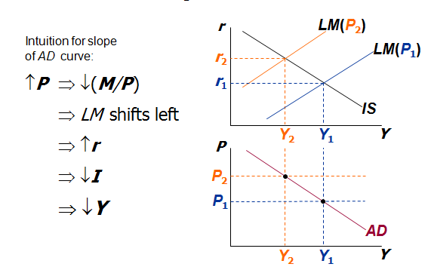
Monetary policy and the AD curve
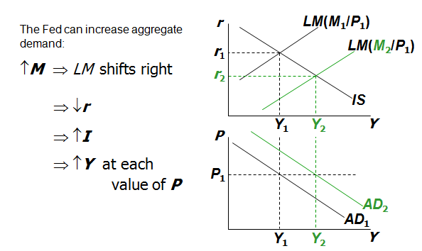
Fiscal policy and the AD curve
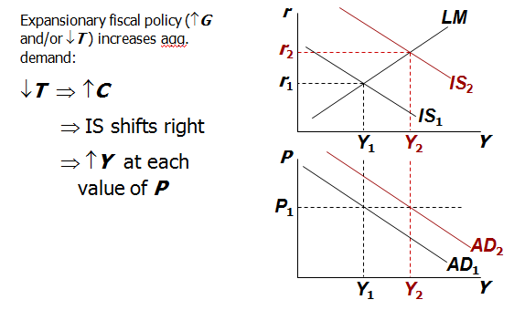
The SR and LR effects of an IS shock
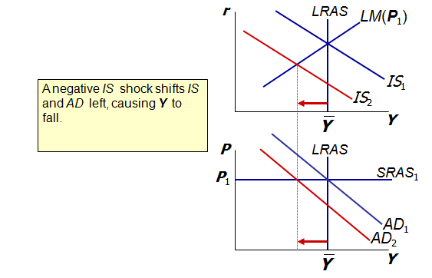
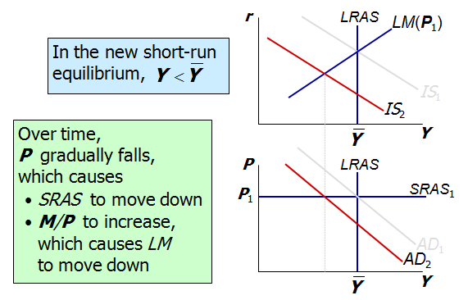
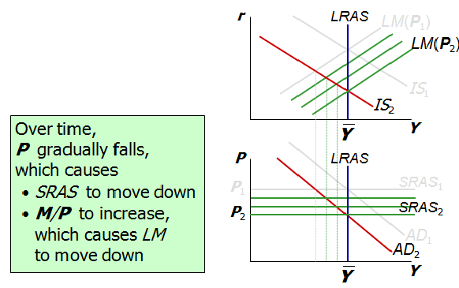

Great Depression
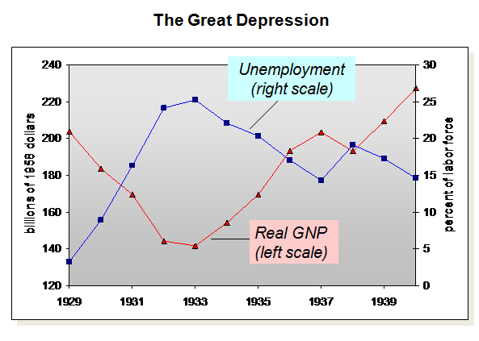

The Spending Hypothesis: Shocks to the IS Curve
- Asserts that the Depression was largely due to an exogenous fall in the demand for goods & services -- a leftward shift of the IS curve
- evidence:
output and interest rates both fell, which is what a leftward IS shift would cause

- The Spending Hypothesis: Reasons for the IS shift
- Stock market crash ⇒ exogenous ↓C
  - Oct-Dec 1929: S&P 500 fell 17%
  - Oct 1929-Dec 1933: S&P 500 fell 71%
- Drop in investment
  - “correction” after overbuilding in the 1920s
  - widespread bank failures made it harder to obtain financing for investment
- Contractionary fiscal policy
  - in the face of falling tax revenues and increasing deficits, politicians raised tax rates and cut spending

The Money Hypothesis: A Shock to the LM Curve
- asserts that the Depression was largely due to huge fall in the money supply
- evidence:
M1 fell 25% during 1929-33.
But, two problems with this hypothesis:
  - P fell even more, so M/P actually rose slightly during 1929-31.
  - nominal interest rates fell, which is the opposite of what would result from a leftward LM shift.

- The Money Hypothesis Again: The Effects of Falling Prices
- asserts that the severity of the Depression was due to a huge deflation:
P fell 25% during 1929-33.
- This deflation was probably caused by the fall in M, so perhaps money played an important role after all.
- In what ways does a deflation affect the economy?
- The stabilizing effects of deflation:
- ↓P ⇒ ↑(M/P ) ⇒ LM shifts right ⇒ ↑Y
- Pigou effect:
↓P ⇒ ↑(M/P )
⇒ consumers’ wealth ↑
⇒ ↑C
⇒ IS shifts right
⇒ ↑Y
- The destabilizing effects of unexpected deflation: debt-deflation theory
↓P (if unexpected)
  - transfers purchasing power from borrowers to lenders
  - borrowers spend less, lenders spend more
⇒ if borrowers’ propensity to spend is larger than lenders, then aggregate spending falls, the IS curve shifts left, and Y falls
- The destabilizing effects of expected deflation:
↓π^{e}
  - r ↑ for each value of i
⇒ I ↓ because I = I (r )
⇒ planned expenditure & agg. demand ↓
⇒ income & output ↓

Why another Depression is unlikely
- Policymakers (or their advisors) now know much more about macroeconomics:
  - The Fed knows better than to let M fall so much, especially during a contraction.
  - Fiscal policymakers know better than to raise taxes or cut spending during a contraction.
- Federal deposit insurance makes widespread bank failures very unlikely.
- Automatic stabilizers make fiscal policy expansionary during an economic downturn.

Summary
IS-LM model
  - a theory of aggregate demand
  - exogenous: M, G, T,
P exogenous in short run, Y in long run
  - endogenous: r,
Y endogenous in short run, P in long run
  - IS curve: goods market equilibrium
  - LM curve: money market equilibrium
AD curve
  - shows relation between P and the IS-LM model’s equilibrium Y.
  - negative slope because
↑P ⇒ ↓(M/P ) ⇒ ↑r ⇒ ↓I ⇒ ↓Y
  - expansionary fiscal policy shifts IS curve right, raises income, and shifts AD curve right
  - expansionary monetary policy shifts LM curve right, raises income, and shifts AD curve right
  - IS or LM shocks shift the AD curve

