Chapter 10

Aggregate Demand - I

Instructor: Prof. Dr.Qaisar Abbas

The Keynesian Cross
- A simple closed economy model in which income is determined by expenditure.
(due to J.M. Keynes)
- Notation:
- I = planned investment
- E = C + I + G = planned expenditure
- Y = real GDP = actual expenditure
- Difference between actual & planned expenditure: unplanned inventory investment

Elements of the Keynesian Cross
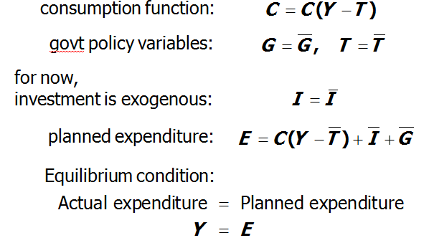

Graphing planned expenditure
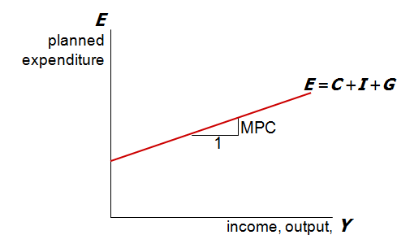
Graphing the equilibrium condition
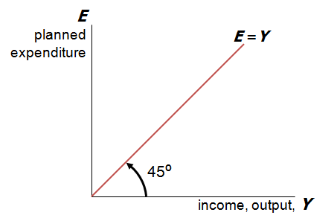
The equilibrium value of income
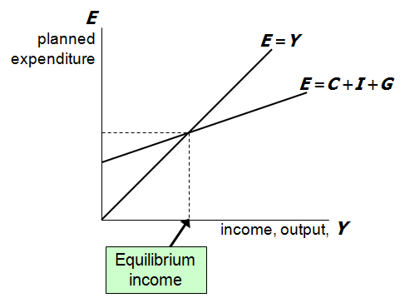
An increase in government purchases
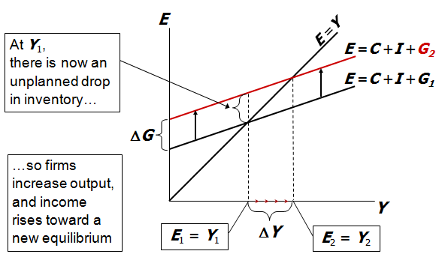
Solving for ΔY
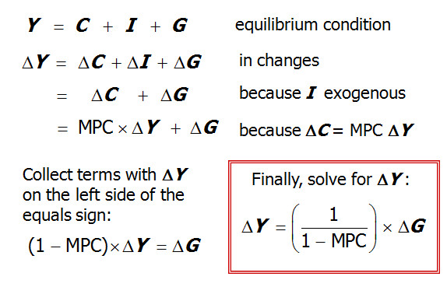
The government purchases multiplier
Example: MPC = 0.8
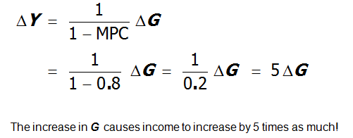

The government purchases multiplier
Definition: the increase in income resulting from a $1 increase in G.In this model, the G multiplier equals
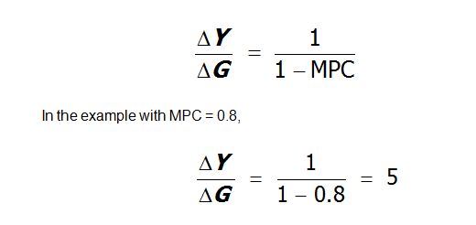

Why the multiplier is greater than 1
- Initially, the increase in G causes an equal increase in Y: ΔY = ΔG.
- But ↑Y ⇒ ↑C
⇒ further ↑Y
⇒ further ↑C
⇒ further ↑Y
- So the final impact on income is much bigger than the initial ΔG.

An increase in taxes
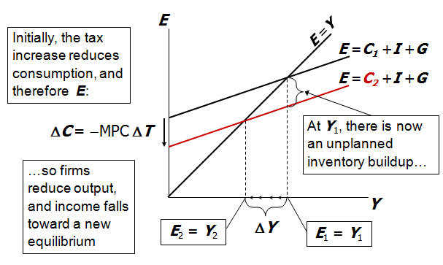

Solving for ΔY
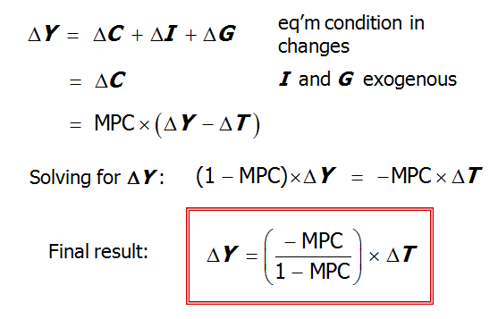

The Tax Multiplier
def: the change in income resulting from a $1 increase in T :
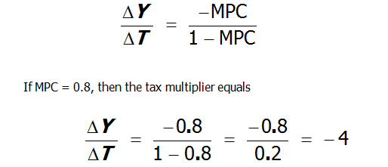
- …is negative: A tax hike reduces consumer spending, which reduces income.
- …is greater than one (in absolute value): A change in taxes has a multiplier effect on income.
- …is smaller than the govt spending multiplier: Consumers save the fraction (1-MPC) of a tax cut, so the initial boost in spending from a tax cut is smaller than from an equal increase in G.

- …is negative: An increase in taxes reduces consumer spending, which reduces equilibrium income.
- …is greater than one (in absolute value): A change in taxes has a multiplier effect on income.
- …is smaller than the govt spending multiplier: Consumers save the fraction (1-MPC) of a tax cut, so the initial boost in spending from a tax cut is smaller than from an equal increase in G.

The IS curve
def: a graph of all combinations of r and Y that result in goods market equilibrium,
i.e. actual expenditure (output) = planned expenditure
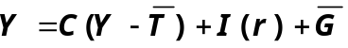The equation for the IS curve is:

Deriving the IS curve
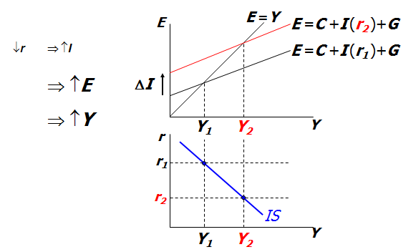

Understanding the IS curve’s slope
- The IS curve is negatively sloped.
- Intuition:
A fall in the interest rate motivates firms to increase investment spending, which drives up total planned spending (E ).
To restore equilibrium in the goods market, output (a.k.a. actual expenditure, Y ) must increase.
The IS curve and the Loanable Funds model
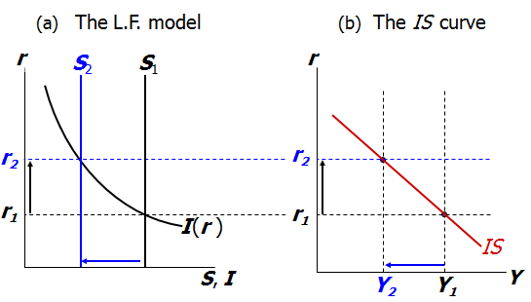

Fiscal Policy and the IS curve
- We can use the IS-LM model to see how fiscal policy (G and T ) can affect aggregate demand and output.
- Let’s start by using the Keynesian Cross to see how fiscal policy shifts the IS curve…

Shifting the IS curve: ΔG
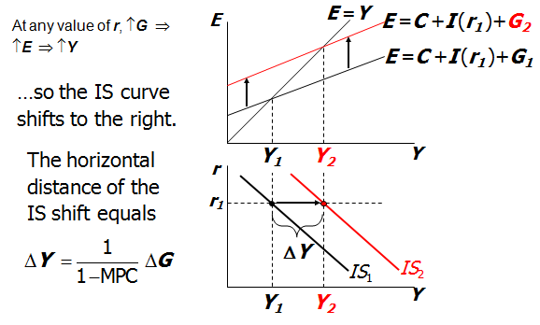
The Theory of Liquidity Preference
- due to John Maynard Keynes.
- A simple theory in which the interest rate is determined by money supply and money demand.

Money Supply
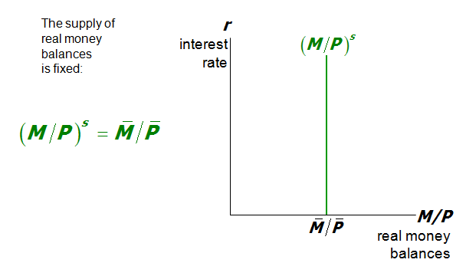

Money Demand
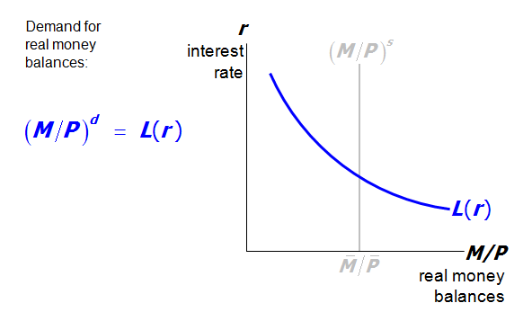
Equilibrium
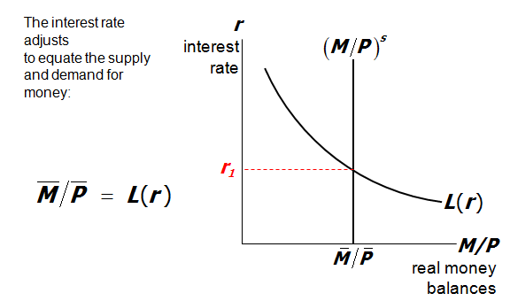

How the Fed raises the interest rate
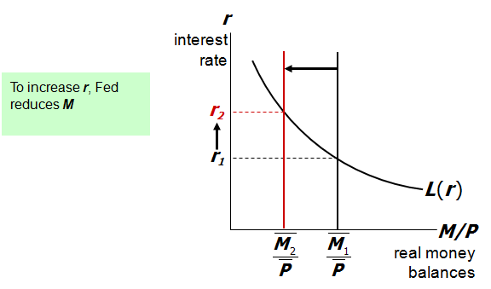
The LM curve
Now let’s put Y back into the money demand function:
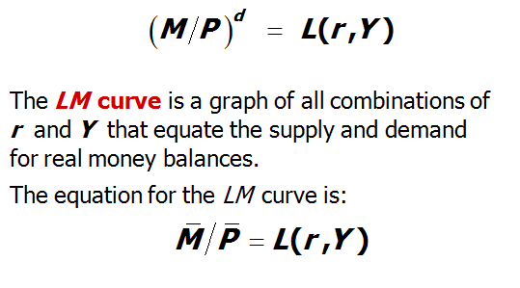

Deriving the LM curve
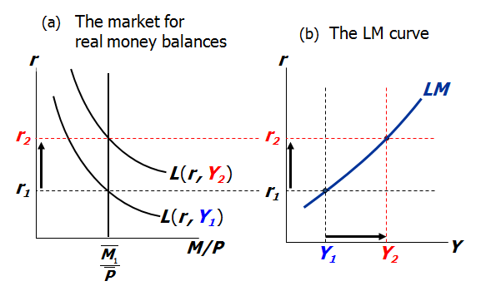

Understanding the LM curve’s slope
- The LM curve is positively sloped.
- Intuition:
An increase in income raises money demand.
Since the supply of real balances is fixed, there is now excess demand in the money market at the initial interest rate.
The interest rate must rise to restore equilibrium in the money market.

How ΔM shifts the LM curve
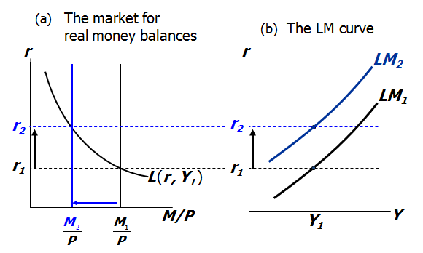
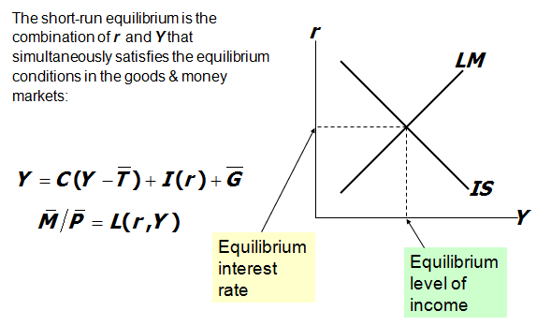
The short-run equilibrium

The Big Picture
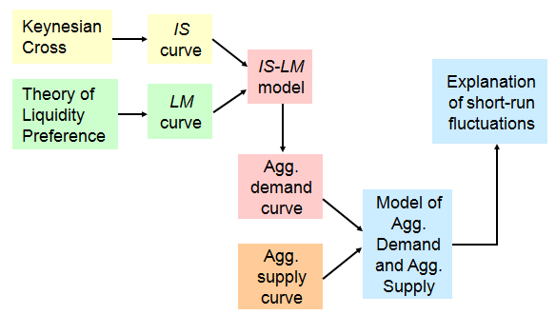

Summary
- Keynesian Cross
  - basic model of income determination
  - takes fiscal policy & investment as exogenous
  - fiscal policy has a multiplied impact on income.
- IS curve
  - comes from Keynesian Cross when planned investment depends negatively on interest rate
  - shows all combinations of r and Y that equate planned expenditure with actual expenditure on goods & services
- Theory of Liquidity Preference
  - basic model of interest rate determination
  - takes money supply & price level as exogenous
  - an increase in the money supply lowers the interest rate
- LM curve
  - comes from Liquidity Preference Theory when money demand depends positively on income
  - shows all combinations of r and Y that equate demand for real money balances with supply
- IS-LM model
  - Intersection of IS and LM curves shows the unique point (Y, r ) that satisfies equilibrium in both the goods and money markets.

