Chapter 1

The Science of Macroeconomics

Instructor: Prof. Dr.Qaisar Abbas

Macroeconomics
It can be defined as
- The field of economics that studies the behavior of the aggregate economy.
- Macroeconomics examines economy-wide phenomena such as changes in unemployment, national income, rate of growth, gross domestic product, inflation and price levels.

Important issues in macroeconomics
- Why does the cost of living keep rising?
- Why are millions of people unemployed, even when the economy is booming?
- Why are there recessions? Can the government do anything to combat recessions? Should it??
- What is the government budget deficit? How does it affect the economy?
- Why does the U.S. have such a huge trade deficit?
- Why are so many countries poor? What policies might help them grow out of poverty?

Why learn macroeconomics?
1- The macro economy affects society’s well-being e-g unemployment and social problems.
Each one-point increase in the unemployment rate is associated with:
• 920 more suicides
• 650 more homicides
• 4000 more people admitted to state mental institutions
• 3300 more people sent to state prisons
• 37,000 more deaths
• increases in domestic violence and homelessness

2- The macro economy affects your well-being e-g unemployment and earnings growth, interest rates and mortgage payments etc.
3- The macro economy affects politics & current events e-g inflation and unemployment in election years.

Economic models
They are simplified versions of a more complex reality in irrelevant details are stripped away and are used to
  - show the relationships between economic variables
  - explain the economy’s behavior
  - devise policies to improve economic performance
Example of a model:
The supply & demand for new cars
- Explains the factors that determine the price of cars and the quantity sold.
- Assumes the market is competitive: each buyer and seller is too small to affect the market price
- Variables:
Q ^{d} = quantity of cars that buyers demand
Q ^{s} = quantity that producers supply
P = price of new cars
Y = aggregate income
P_{s} = price of steel (an input)
The demand for cars shows that the quantity of cars consumers demand is related to the price of cars and aggregate income.

Functional notation
- General functional notation shows only that the variables are related:


- The market for cars: demand
The demand curve is the graph depicting the relationship between the price of a certain commodity and the amount of it that consumers are willing and able to purchase at that given price. The demand curve shows that there is an inverse relationship between quantity demanded and price as shown in the figure below.
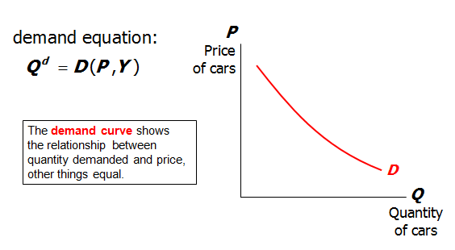
- The market for cars: supply
The supply curve is a graphic representation of the relationship between product price and quantity of product that a seller is willing and able to supply. The supply curve shows that there is positive relationship between quantity supplied and price as shown in the figure below.
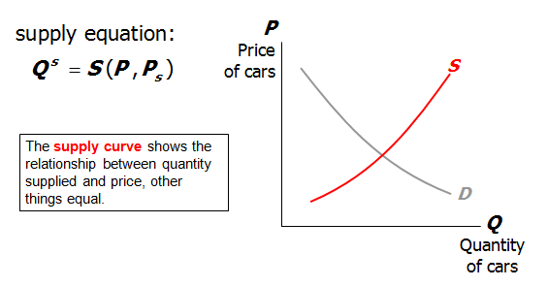
- The market for cars: equilibrium
Equilibrium is defined to be the price-quantity pair where the quantity demanded is equal to the quantity supplied, represented by the intersection of the demand and supply curves.
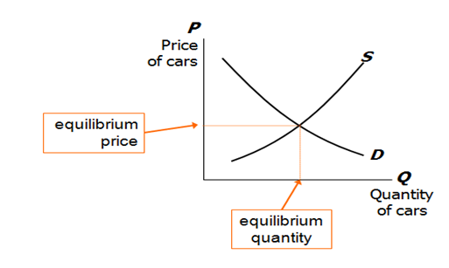
- The effects of an increase in income
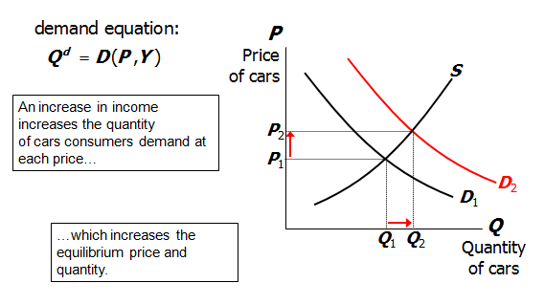

- The effects of a steel price increase
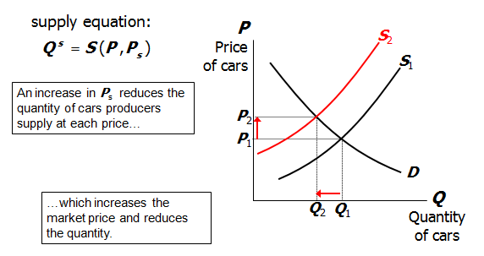

Endogenous vs. exogenous variables
- Endogenous variable is a variable that is identified within the workings of the model. Also termed a dependent variable, an endogenous variable is in essence the "output" of the model.

- Exogenous variable is a variable that is identified outside the workings of the model. Also termed an independent variable, an exogenous variable is in essence the "input" of the model.
- The values of endogenous variables are determined in the model.
- The values of exogenous variables are determined outside the model: the model takes their values & behavior as given.
- In the model of supply & demand for cars,
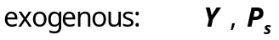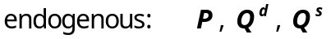

A Multitude of Models
No one model can address all the issues we care about. For example,
  - If we want to know how a fall in aggregate income affects new car prices, we can use the S/D model for new cars.
  - But if we want to know why aggregate income falls, we need a different model.
- So we will learn different models for studying different issues (e.g. unemployment, inflation, long-run growth).
- For each new model, you should keep track of
  - its assumptions,
  - which of its variables are endogenous and which are exogenous,
  - the questions it can help us understand,
  - and those it cannot.

Prices: Flexible Versus Sticky
- Market clearing: an assumption that prices are flexible and adjust to equate supply and demand.
- In the short run, many prices are sticky---they adjust only sluggishly in response to supply/demand imbalances.
- For example,
  - labor contracts that fix the nominal wage for a year or longer
  - magazine prices that publishers change only once every 3-4 years
- The economy’s behavior depends partly on whether prices are sticky or flexible:
- If prices are sticky, then demand won’t always equal supply. This helps explain
  - unemployment (excess supply of labor)
  - the occasional inability of firms to sell what they produce
  - Long run: prices flexible, markets clear, economy behaves very differently.

Summary
- Macroeconomics is the study of the economy as a whole, including
  - growth in incomes
  - changes in the overall level of prices
  - the unemployment rate
  - Macroeconomists attempt to explain the economy and to devise policies to improve its performance.
- Economists use different models to examine different issues.
- Models with flexible prices describe the economy in the long run; models with sticky prices describe economy in the short run.
- Macroeconomic events and performance arise from many microeconomic transactions, so macroeconomics uses many of the tools of microeconomics.

