Data Security and Encryption
(CSE348)

Handout -9
AES

Advanced Encryption Standard
The AES Cipher – Rijndael
The Rijndael proposal for AES defined a cipher in which the block length and the key length can be independently specified to be 128,192,or 256 bits. The AES specification uses the same three key size alternatives but limits the block length to 128 bits. Rijndael is an academic submission, based on the earlier Square cipher, from Belgium academics Dr Joan Daemen and Dr Vincent Rijmen. It is an iterative cipher (operates on entire data block in every round) rather than feistel (operate on halves at a time), and was designed to have characteristics of: Resistance against all known attacks, Speed and code compactness on a wide range of platforms, & Design simplicity.

AES Encryption Process
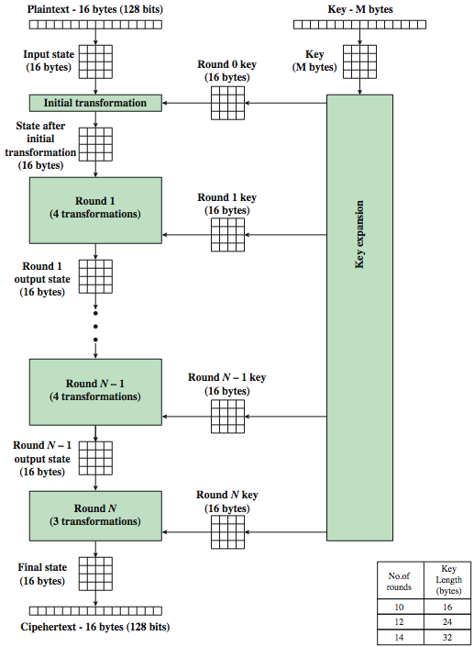

The input to the AES encryption and decryption algorithms is a single 128-bit block, depicted in FIPS PUB 197, as a square matrix of bytes .This block is copied into the State array, which is modified at each stage of encryption or decryption. After the final stage, State is copied to an output.
The key is expanded into 44/52/60 lots of 32-bit words (see later), with 4 used in each round. Note that the ordering of bytes within a matrix is by column. So, for example, the first four bytes of a 128-bit plaintext input to the encryption cipher occupy the first column of the in matrix, the second four bytes occupy the second column, and so on. Similarly, the first four bytes of the expanded key, which form a word, occupy the first column of the w matrix.
The data computation then consists of an “add round key” step, then 9/11/13 rounds with all 4 steps, and a final 10th/12th/14th step of byte subs + mix cols + add round key. This can be viewed as alternating XOR key & scramble data bytes operations. All of the steps are easily reversed, and can be efficiently implemented using XOR’s & table lookups.
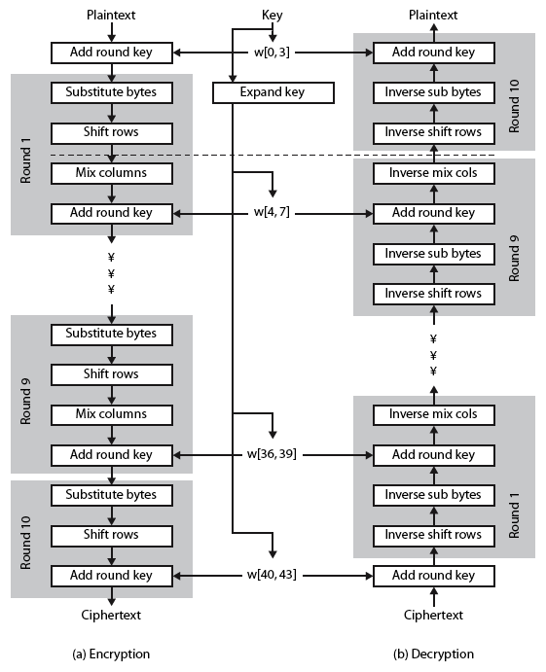

Stallings Figure shows the structure of AES in more detail. The cipher consists of N rounds, where the number of rounds depends on the key length: 10 rounds for a 16-byte key; 12 rounds for a 24-byte key; and 14 rounds for a 32-byte key. The first N – 1 rounds consist of four distinct transformation functions: SubBytes, ShiftRows, MixColumns, and AddRoundKey, which are described subsequently. The final round contains only 3 transformation, and there is a initial single transformation (AddRoundKey) before the first round, which can be considered Round 0. Each transformation takes one or more 4 x 4 matrices as input and produces a 4 x 4 matrix as output. Figure 5.1 shows that the output of each round is a 4 x 4 matrix, with the output of the final round being the ciphertext. Also, the key expansion function generates N + 1 round keys, each of which is a distinct 4 x 4 matrix. Each round key serve as one of the inputs to the AddRoundKey transformation in each round.

Some Comments on AES
- an iterative rather than feistel cipher
- key expanded into array of 32-bit words
  - four words form round key in each round
- 4 different stages are used as shown
- has a simple structure
- only AddRoundKey uses key
- AddRoundKey a form of Vernam cipher
- each stage is easily reversible
- decryption uses keys in reverse order
- decryption does recover plaintext
- final round has only 3 stages

-----------------------------------------------

