Data Security and Encryption
(CSE348)

Handout -7
DES

Data Encryption Standard (DES)
- most widely used block cipher in world
- adopted in 1977 by (National Bureau of Standards) NBS (now NIST)
  - as FIPS PUB 46
- encrypts 64-bit data using 56-bit key
- has widespread use
- has been considerable controversy over its security
DES Design Controversy
- although DES standard is public
- was considerable controversy over design
  - in choice of 56-bit key (vs Lucifer 128-bit)
  - and because design criteria were classified
- subsequent events and public analysis show in fact design was appropriate
- use of DES has flourished
  - especially in financial applications
  - still standardised for legacy application use

- DES Encryption Overview

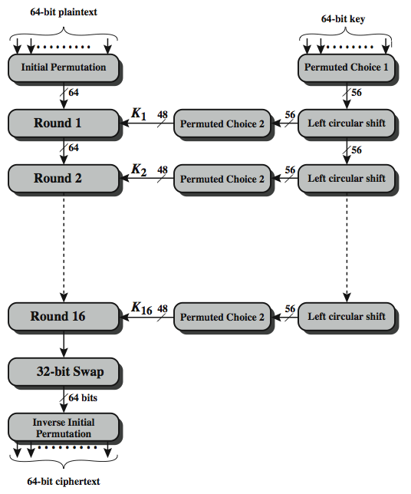
The overall scheme for DES encryption is illustrated in Stallings Figure, which takes as input 64-bits of data and of key.
The left side shows the basic process for enciphering a 64-bit data block which consists of:
- an initial permutation (IP) which shuffles the 64-bit input block
- 16 rounds of a complex key dependent round function involving substitutions & permutations
- a final permutation, being the inverse of IP
The right side shows the handling of the 56-bit key and consists of:
- an initial permutation of the key (PC1) which selects 56-bits out of the 64-bits input, in two 28-bit halves
- 16 stages to generate the 48-bit subkeys using a left circular shift and a permutation of the two 28-bit halves
Avalanche in DES
A desirable property of any encryption algorithm is that a small change in either the plaintext or the key should produce a significant change in the ciphertext. In particular, a change in one bit of the plaintext or one bit of the key should produce a change in many bits of the ciphertext. This is referred to as the avalanche effect. Using the example from Table 3.5, Table 3.6 shows the result when the fourth bit of the plaintext is changed, so that the plaintext is 12468aceeca86420. The second column of the table shows the intermediate 64-bit values at the end of each round for the two plaintexts. The third column shows the number of bits that differ between the two intermediate values. The table shows that after just three rounds, 18 bits differ between the two blocks. On completion, the two ciphertexts differ in 32 bit positions. Table 3.7 in the text shows a similar test using the original plaintext of with two keys that differ in only the fourth bit position. Again, the results show that about half of the bits in the ciphertext differ and that the avalanche effect is pronounced after just a few rounds.

-----------------------------------------------

