Data Security and Encryption
(CSE348)

Handout -6
Block Ciphers

Block vs Stream Ciphers
- block ciphers process messages in blocks, each of which is then en/decrypted
- like a substitution on very big characters
  - 64-bits or more
- stream ciphers process messages a bit or byte at a time when en/decrypting
- many current ciphers are block ciphers
  - better analysed
  - broader range of applications
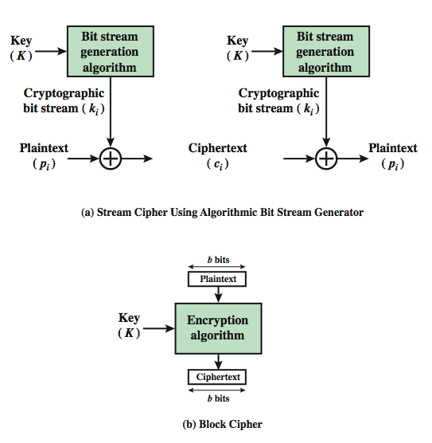
- A block cipher is one in which a block of plaintext is treated as a whole and used to produce a ciphertext block of equal length
- Typically, a block size of 64 or 128 bits is used
- As with a stream cipher, the two users share a symmetric encryption key
Block Cipher Principles
- Most symmetric block ciphers are based on a Feistel Cipher Structure
- needed since must be able to decrypt ciphertext to recover messages efficiently
- block ciphers look like an extremely large substitution
- would need table of 2⁶⁴ entries for a 64-bit block
- instead create from smaller building blocks
- using idea of a product cipher
- A block cipher operates on a plaintext block of n bits to produce a ciphertext block of n bits
- An arbitrary reversible substitution cipher for a large block size is not practical
- however, from an implementation and performance point of view
- In general, for an n-bit general substitution block cipher, the size of the key is n x 2^{n}
- For a 64-bit block, which is a desirable length to thwart statistical attacks
- the key size is 64x 2⁶⁴ = 2⁷⁰ = 10²¹ bits
- In considering these difficulties, Feistel points out that what is needed is an approximation to the ideal block cipher system for large n
- built up out of components that are easily realizable

Confusion and Diffusion
- The terms diffusion and confusion were introduced by Claude Shannon
- To capture the two basic building blocks for any cryptographic system
- Shannon's concern was to thwart cryptanalysis based on statistical analysis
- Every block cipher involves a transformation of a block of plaintext into a block of ciphertext
- where the transformation depends on the key
- The mechanism of diffusion seeks to make the statistical relationship between the plaintext and ciphertext
- as complex as possible in order to thwart attempts to deduce the key
- Confusion seeks to make the relationship between:
- the statistics of the ciphertext and the value of the encryption key as complex as possible
- again to thwart attempts to discover the key
- So successful are diffusion and confusion
- In capturing the essence of the desired attributes of a block cipher
- That they have become the cornerstone of modern block cipher design
- cipher needs to completely obscure statistical properties of original message
- a one-time pad does this
- more practically Shannon suggested combining S & P elements to obtain:
- diffusion – dissipates statistical structure of plaintext over bulk of ciphertext
- confusion – makes relationship between ciphertext and key as complex as possible
Feistel Cipher Structure
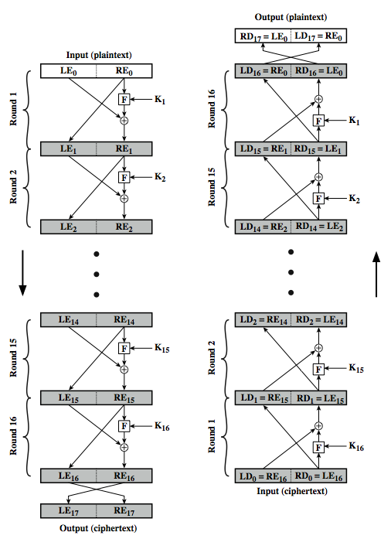
Feistel Cipher Design Elements
- block size
- key size
- number of rounds
- subkey generation algorithm
- round function
- fast software en/decryption
- ease of analysis
-----------------------------------------------

