Data Security and Encryption
(CSE348)

Handout -30
Privacy and Ethical Aspects

  - cybercrime and computer crime
  - intellectual property issues
  - privacy
  - ethical issues
Privacy
An issue with considerable overlap with computer security is that of privacy. On the one hand, the scale and interconnectedness of personal information collected and stored in information systems has increased dramatically, motivated by law enforcement, national security, and economic incentives. The last mentioned has been perhaps the main driving force. In a global information economy, it is likely that the most economically valuable electronic asset is aggregations of information on individual. On the other hand, individuals have become increasingly aware of the extent to which government agencies, businesses, and even Internet users have access to their personal information and private details about their lives and activities. Concerns about the extent to which personal privacy has been and may be compromised have led to a variety of legal and technical approaches to reinforcing privacy rights.

A number of international organizations and national governments have introduced laws and regulations intended to protect individual privacy.
European Union Data Protection Directive was adopted in 1998, to both (1) ensure that member states protected fundamental privacy rights when processing personal information, and (2) prevent member states from restricting the free flow of personal information within the EU. The Directive is organized around the following principles of personal information use:
• Notice: organizations must notify individuals what personal information they are collecting, the uses of that information, and what choices the individual may have.
• Consent: individuals must be able to choose whether and how their personal information is used by, or disclosed to, third parties. They have the right not to have any sensitive information collected or used without express permission, including race, religion, health, union membership, beliefs, and sex life.
• Consistency: organizations may use personal information only in accordance with the terms of the notice given the data subject and the choices the make on its use
• Access: individuals must have the right and ability to access their information and correct, modify, or delete any portion of it.
• Security: organizations must provide adequate security, using technical and other means, to protect the integrity and confidentiality of personal information.
• Onward transfer: third parties receiving personal information must provide the same level of privacy protection as the organization from whom the information is obtained.
• Enforcement: grants a private right of action to data subjects when organizations do not follow the law.
The first comprehensive privacy legislation adopted in the United States was the Privacy Act of 1974, which dealt with personal information collected and used by federal agencies. The act is intended to:
1. Permit individuals to determine what records pertaining to them are collected, maintained, used, or disseminated.
2. Permit individuals to forbid records obtained for one purpose to be used for another purpose without consent.
3. Permit individuals to obtain access to records pertaining to them and to correct and amend such records as appropriate.
4. Ensure that agencies collect, maintain, and use personal information in a manner that ensures that the information is current, adequate, relevant, and not excessive for its intended use.
5. Create a private right of action for individuals whose personal information is not used in accordance with the act.
As with all privacy laws and regulations, there are exceptions and conditions attached to this act, such as criminal investigations, national security concerns, and conflicts between competing individual rights of privacy.
While the 1974 Privacy Act covers government records, a number of other U.S. laws have been enacted that cover other areas, including: Banking and financial records, Credit , Medical and health insurance records, Children's privacy, Electronic communications.
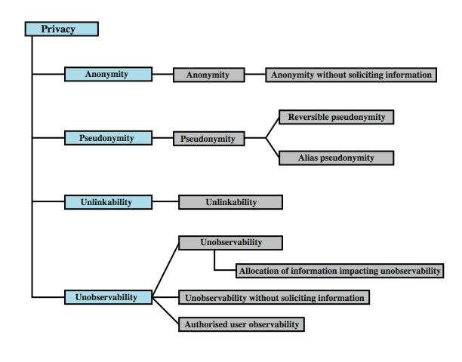
Ethical Issues
Because of the ubiquity and importance of information systems in organization of all types, there are many potential misuses and abuses of information and electronic communication that create privacy and security problems. In addition to questions of legality, misuse and abuse raise concerns of ethics. Ethics refers to a system of moral principles that relates to the benefits and harms of particular actions, and to the rightness and wrongness of motives and ends of those actions.
To a certain extent, a characterization of what constitutes ethical behavior for those who work with or have access to information systems is not unique to this context. The basic ethical principles developed by civilizations apply. However, there are some unique considerations surrounding computers and information systems. Firstly, computer technology makes possible a scale of activities not possible before. This includes a larger scale of record keeping, particularly on individuals with the ability to develop finer-grained personal information collection and more precise data mining and data matching. The expanded scale of communications and the expanded scale of interconnection brought about by the Internet magnify the power of an individual to do harm. Secondly, computer technology has involved the creation of new types of entities for which no agreed ethical rules have previously been formed, such as databases, Web browsers, chat rooms, cookies, and so on.
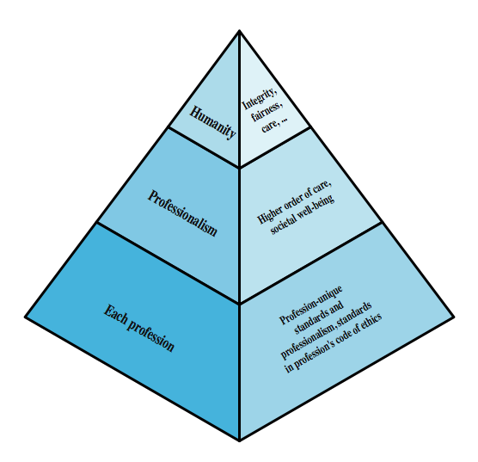

Ethical Question Examples
We cite two areas here of the types of ethical questions that face a computing or IS professional.
The first is that IS professionals may find themselves in situations where their ethical duty as professionals comes into conflict with loyalty to their employer. Such a conflict may give rise for an employee to consider 'blowing the whistle,' or exposing a situation that can harm the public or a company's customers. For example, a software developer may know that a product is scheduled to ship with inadequate testing to meet the employer's deadlines. The decision of whether to blow the whistle is one of the most difficult that an IS professional can face. Organizations have a duty to provide alternative, less extreme opportunities for the employee, such as an in-house ombudsperson coupled with a commitment not to penalize employees for exposing problems in-house. Additionally, professional societies should provide a mechanism whereby society members can get advice on how to proceed.
Another example of an ethical question concerns a potential conflict of interest. For example, if a consultant has a financial interest in a certain vendor, this should be revealed to any client if that vendor's products or services might be recommended by the consultant.

Now consider some ethical issues that arise from computer technology. A classic paper on computers and ethics points out that ethical issues arise as the result of the roles of computers, such as:
• Repositories and processors of information: Unauthorized use of otherwise unused computer services or of information stored in computers raises questions of appropriateness or fairness.
• Producers of new forms and types of assets: For example, computer programs are entirely new types of assets, possibly not subject to the same concepts of ownership as other assets.
• Instruments of acts: To what degree must computer services and users of computers, data, and programs be responsible for the integrity and appropriateness of computer output?
• Symbols of intimidation and deception: The images of computers as thinking machines, absolute truth producers, infallible, subject to blame, and as anthropomorphic replacements of humans who err should be carefully considered.
Those who can understand and exploit the technology, plus those who have obtained access permission, have power related to those assets.
Another listing of ethical issues is shown in Table 23.3 in the text.
Both of these lists are concerned with balancing professional responsibilities with ethical or moral responsibilities.
Unlike scientific and engineering fields, ethics cannot be reduced to precise laws or sets of facts. Although an employer or a client of a professional can expect that the professional has an internal moral compass, many areas of conduct may present ethical ambiguities. To provide guidance to professionals and to articulate what employers and customers have a right to expect, a number of professional societies have adopted ethical codes of conduct. A professional code of conduct can:
1. serve as a positive stimulus for ethical conduct on the part of the professional, and to instill confidence in the customer or user of an IS product or service.
2. be educational and inform the professional about what should be their commitment to undertake a certain level of quality of work & their responsibility for the well being of users of their product and the public, to the extent the product may affect non-users. The code also serves to educate managers on their responsibility to encourage and support employee ethical behavior and on their own ethical responsibilities.
3. provide a measure of support for a professional whose decision to act ethically in a situation may create conflict with an employer or customer.
4. be a means of deterrence and discipline. A professional society can use a code as a justification for revoking membership or even a professional license. An employee can use a code as a basis for a disciplinary action.
5. enhance the profession's public image, if it is seen to be widely honored.

-----------------------------------------------

