Data Security and Encryption
(CSE348)

Handout -29
Cybercrime and Computer Crime

- cybercrime and computer crime
- intellectual property issues
- Computer crime, or cybercrime, is a term used broadly to describe criminal activity in which computers or computer networks are a tool, a target, or a place of criminal activity. These categories are not exclusive and many activities can be characterized as falling in one or more categories. The term cybercrime has a connotation of the use of networks specifically, whereas computer crime may or may not involve networks. The U.S. Department of Justice categorizes computer crime based on the role that the computer plays in the criminal activity, as follows:
- • Computers as targets: to acquire information stored on that computer system, to control the target system without authorization or payment (theft of service), or to alter the integrity of data or interfere with the availability of the computer or server.
- • Computers as storage devices: as a passive storage medium, e.g. for stolen password lists, credit card or calling card numbers, proprietary corporate information, pornographic image files, or "warez" (pirated commercial software).
- • Computers as communications tools: often traditional crimes committed online. Examples include the illegal sale of prescription drugs, controlled substances, alcohol, and guns; fraud; gambling; and child pornography.
- A more specific list of crimes is defined in the international Convention on Cybercrime and shown in Table 18.1, in the text. Yet another categorization is used in the CERT 2006 annual E-crime Survey, the results of which are shown in Table 23.2.

Law Enforcement Challenges
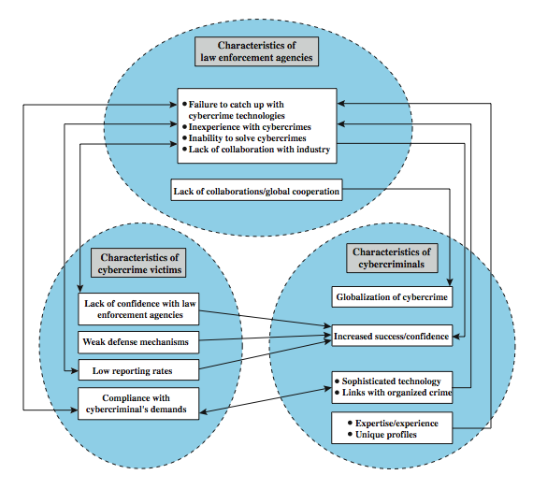
The deterrent effect of law enforcement on computer and network attacks correlates with the success rate of criminal arrest and prosecution. The nature of cybercrime is such that consistent success is extraordinarily difficult. To see this, consider the vicious cycle of cybercrime, involving law enforcement agencies, cybercriminals, and cybercrime victims, as illustrated in Figure 23.1 from the text.
For law enforcement agencies, cybercrime presents some unique difficulties. Proper investigation requires a fairly sophisticated grasp of the technology, and many jurisdictions lack investigators knowledgeable and experienced in dealing with it. Lack of resources represents another handicap. The global nature of cybercrime is an additional obstacle: many crimes will involve perpetrators who are remote from the target system, in another jurisdiction or even another country. A lack of collaboration and cooperation with remote law enforcement agencies can greatly hinder an investigation. Initiatives such as international Convention on Cybercrime introduces a common terminology for crimes and a framework for harmonizing laws globally.
The relative lack of success in bringing cybercriminals to justice has led to an increase in their numbers, boldness, and the global scale of their operations. The cybercriminal tends to be young and very computer-savvy, but the range of behavioral characteristics is wide.
The success of cybercriminals, and the relative lack of success of law enforcement, influence the behavior of cybercrime victims. Reporting rates are low because of a lack of confidence in law enforcement, a concern about corporate reputation, and a concern about civil liability. The low reporting rates and reluctance to work with law enforcement feeds into the law enforcement handicaps, completing the vicious cycle.

Intellectual Property

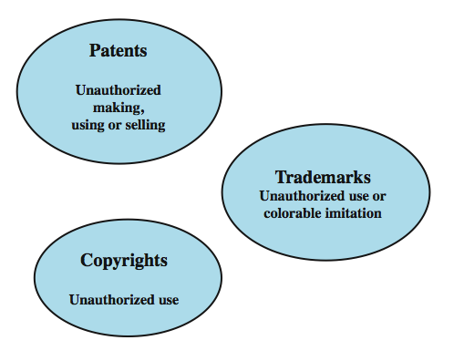
Copyrights
Copyright law protects the tangible or fixed expression of an idea, not the idea itself. Copyright is automatically assigned to newly created works in countries that subscribe to the Berne convention, which encompasses the vast majority of nations. Some countries, such as the United States, provide additional legal protection if the work is registered. Copyright exists if the following conditions are fulfilled:
• the proposed work is original
• the creator has put this original idea into a concrete form, such as hard copy (paper), software, or multimedia form
Examples of items that may be copyrighted include: literary works, musical works, dramatic works, pantomimes and choreographic works, pictorial, graphic, and sculptural works, motion pictures and other audiovisual works, sound recordings, architectural works, software-related works.
Patents
A patent for an invention is the grant of a property right to the inventor. The right conferred by the patent grant is, in the language of the U.S. statute and of the grant itself, "the right to exclude others from making, using, offering for sale, or selling" the invention in the United States or "importing" the invention into the United States. Similar wording appears in the statutes of other nations.
There are three types of patents:
• Utility patents: may be granted to anyone who invents or discovers any new and useful process, machine, article of manufacture, or composition of matter, or any new and useful improvement thereof;
• Design patents: may be granted to anyone who invents a new, original, and ornamental design for an article of manufacture; and
• Plant patents: may be granted to anyone who invents or discovers and asexually reproduces any distinct and new variety of plant.
An example of a patent from the computer security realm is the RSA public-key cryptosystem. From the time it was granted in 1983 until the patent expired in 2000, the patent holder, RSA Security, was entitled to receive a fee for each implementation of RSA.
Trademarks
A trademark is a word, name, symbol, or device that is used in trade with goods to indicate the source of the goods and to distinguish them from the goods of others. A servicemark is the same as a trademark except that it identifies and distinguishes the source of a service rather than a product. The terms trademark and mark are commonly used to refer to both trademarks and servicemarks. Trademark rights may be used to prevent others from using a confusingly similar mark, but not to prevent others from making the same goods or from selling the same goods or services under a clearly different mark.

-----------------------------------------------

