Data Security and Encryption
(CSE348)

Handout -28
Firewalls

  - firewalls
  - types of firewalls
    - packet-filter, stateful inspection, application proxy, circuit-level
  - basing
    - bastion, host, personal
  - location and configurations
    - DMZ, VPN, distributed, topologies

A firewall is inserted between the premises network and the Internet to establish a controlled link and to erect an outer security wall or perimeter, forming a single choke point where security and audit can be imposed. A firewall:
- defines a single choke point that keeps unauthorized users out of the protected network, prohibits potentially vulnerable services from entering or leaving the network, and provides protection from various kinds of IP spoofing and routing attacks.
2. provides a location for monitoring security-related events
3. is a convenient platform for several Internet functions that are not security related, such as NAT and Internet usage audits or logs
4. A firewall can serve as the platform for IPSec to implement virtual private networks.
The firewall itself must be immune to penetration, since it will be a target of attack.
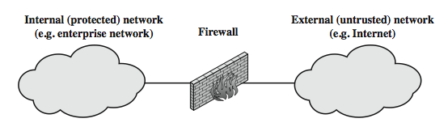

Firewalls have their limitations, including that they:
1. cannot protect against attacks that bypass the firewall, eg PCs with dial-out capability to an ISP, or dial-in modem pool use
2. do not protect against internal threats, eg disgruntled employee or one who cooperates with an attacker
3. An improperly secured wireless LAN may be accessed from outside the organization. An internal firewall that separates portions of an enterprise network cannot guard against wireless communications between local systems on different sides of the internal firewall.
4. A laptop, PDA, or portable storage device may be used and infected outside the corporate network, and then attached and used internally.

Have three common types of firewalls: packet filters, application-level gateways, & circuit-level gateways.
A packet-filtering router applies a set of rules to each incoming and outgoing IP packet to forward or discard the packet. Filtering rules are based on information contained in a network packet such as src & dest IP addresses, ports, transport protocol & interface. Some advantages are simplicity, transparency & speed.
If there is no match to any rule, then one of two default policies are applied:
• that which is not expressly permitted is prohibited (default action is discard packet), conservative policy
• that which is not expressly prohibited is permitted (default action is forward packet), permissive policy
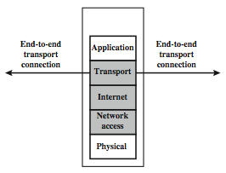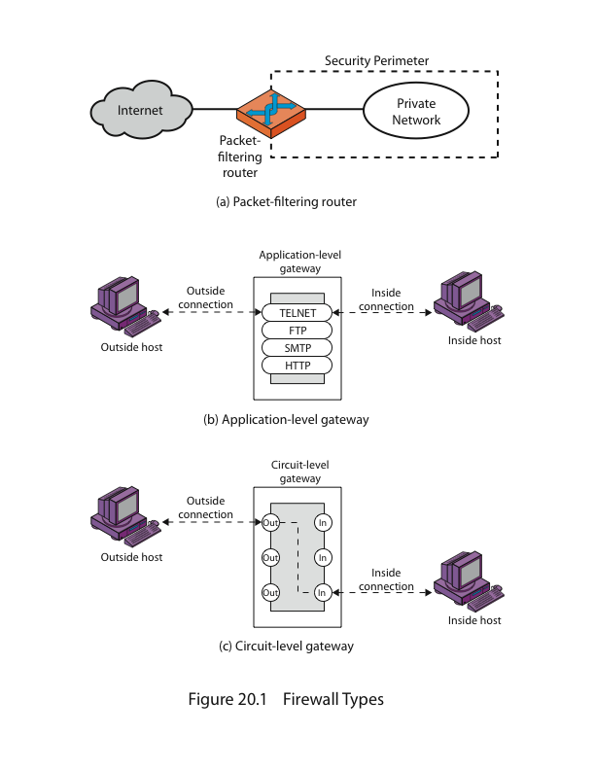
Some of the attacks that can be made on packet-filtering routers & countermeasures are:
• IP address spoofing: where intruder transmits packets from the outside with internal host source IP addr, need to filter & discard such packets
• Source routing attacks: where source specifies the route that a packet should take to bypass security measures, should discard all source routed packets
• Tiny fragment attacks: intruder uses the IP fragmentation option to create extremely small fragments and force the TCP header information into a separate fragments to circumvent filtering rules needing full header info, can enforce minimum fragment size to include full header.

Firewalls - Application Level Gateway (or Proxy)
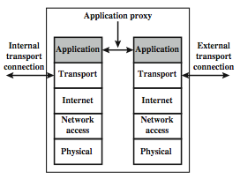

Firewalls - Circuit Level Gateway
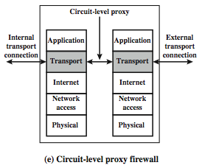

A personal firewall controls the traffic between a personal computer or workstation on one side and the Internet or enterprise network on the other side. Personal firewall functionality can be used in the home environment and on corporate intranets. Typically, the personal firewall is a software module on the personal computer. In a home environment with multiple computers connected to the Internet, firewall functionality can also be housed in a router that connects all of the home computers to a DSL, cable modem, or other Internet interface.
Personal firewalls are typically much less complex than either server-based firewalls or stand-alone firewalls. The primary role of the personal firewall is to deny unauthorized remote access to the computer. The firewall can also monitor outgoing activity in an attempt to detect and block worms and other malware.
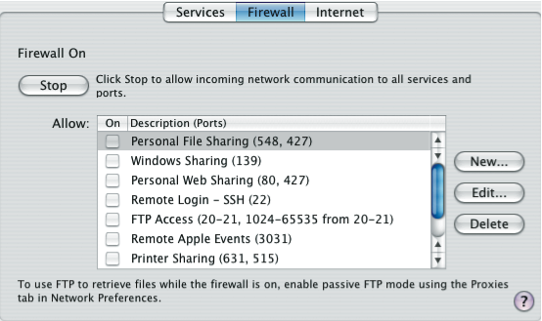

Firewall Configurations
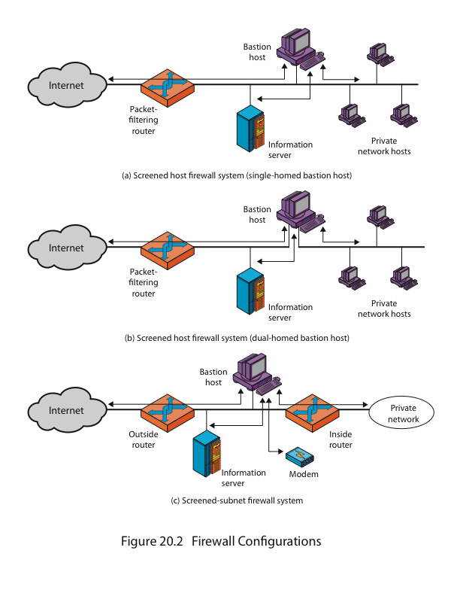
Bastion Host
It is common to base a firewall on a stand-alone machine running a common operating system, such as UNIX or Linux. Firewall functionality can also be implemented as a software module in a router or LAN switch.
A bastion host is a critical strong point in the network’s security, serving as a platform for an application-level or circuit-level gateway, or for external services. It is thus potentially exposed to "hostile" elements and must be secured to withstand this. Common characteristics of a bastion host include that it:
• executes a secure version of its O/S, making it a trusted system
• has only essential services installed on the bastion host
• may require additional authentication before a user may access to proxy services
• configured to use only subset of standard commands, access only specific hosts
• maintains detailed audit information by logging all traffic
• each proxy module a very small software package designed for network security
• has each proxy independent of other proxies on the bastion host
• have a proxy performs no disk access other than read its initial configuration file
• have each proxy run as a non-privileged user in a private and secured directory
A bastion host may have two or more network interfaces (or ports), and must be trusted to enforce trusted separation between these network connections, relaying traffic only according to policy.

-----------------------------------------------

