Data Security and Encryption
(CSE348)

Handout -25
IP Security

  - IPSec security framework
  - IPSec security policy
  - ESP
  - combining security associations
  - internet key exchange
  - cryptographic suites used

IP Security
The Internet community has developed application-specific security mechanisms in a number of application areas, including electronic mail (S/MIME, PGP), client/server (Kerberos), Web access (Secure Sockets Layer), and others. However users have some security concerns that cut across protocol layers. By implementing security at the IP level, an organization can ensure secure networking not only for applications that have security mechanisms but also for the many security-ignorant applications.
IP-level security encompasses three functional areas: authentication, confidentiality, and key management. The authentication mechanism assures that a received packet was transmitted by the party identified as the source in the packet header, and that the packet has not been altered in transit. The confidentiality facility enables communicating nodes to encrypt messages to prevent eavesdropping by third parties. The key management facility is concerned with the secure exchange of keys. IPSec provides the capability to secure communications across a LAN, across private and public WANs, and across the Internet.
In 1994, the Internet Architecture Board (IAB) issued a report titled "Security in the Internet Architecture" (RFC 1636). The report stated the general consensus that the Internet needs more and better security and identified key areas for security mechanisms. To provide security, the IAB included authentication and encryption as necessary security features in the next-generation IP, which has been issued as IPv6. Fortunately, these security capabilities were designed to be usable both with the current IPv4 and the future IPv6.
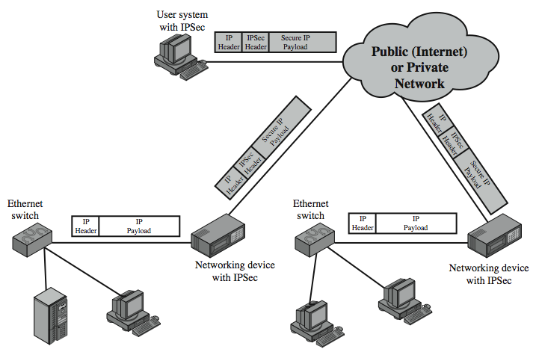

Some of the benefits of IPSec include:
• When implemented in a firewall or router, it provides strong security that can be applied to all traffic crossing the perimeter. Traffic within a company or workgroup does not incur the overhead of security-related processing.
• in a firewall is resistant to bypass if all traffic from the outside must use IP and the firewall is the only means of entrance from the Internet into the organization.
• is below the transport layer (TCP, UDP) and so is transparent to applications. There is no need to change software on a user or server system when IPsec is implemented in the firewall or router. Even if IPsec is implemented in end systems, upper-layer software, including applications, is not affected.
• can be transparent to end users. There is no need to train users on security mechanisms, issue keying material on a per-user basis, or revoke keying material when users leave the organization.
• can provide security for individual users if needed. This is useful for offsite workers and for setting up a secure virtual subnetwork within an organization for sensitive applications.
It also plays a vital role in the routing architecture required for internetworking.

IP Security Architecture
The IPSec specification has become quite complex. key management. The totality of the IPsec specification is scattered across dozens of RFCs and draft IETF documents, making this the most complex and difficult to grasp of all IETF specifications. The best way to keep track of and get a handle on this body of work is to consult the latest version of the IPsec document roadmap. The documents can be categorized into the following groups:
• Architecture: Covers the general concepts, security requirements, definitions, and mechanisms defining IPsec technology, see RFC 4301, Security Architecture for the Internet Protocol.
• Authentication Header (AH): AH is an extension header for message authentication, now deprecated. See RFC 4302, IP Authentication Header.
• Encapsulating Security Payload (ESP): ESP consists of an encapsulating header and trailer used to provide encryption or combined encryption/authentication. See RFC 4303, IP Encapsulating Security Payload (ESP).
• Internet Key Exchange (IKE): a collection of documents describing the key management schemes for use with IPsec. See RFC4306, Internet Key Exchange (IKEv2) Protocol, and other related RFCs.
• Cryptographic algorithms: a large set of documents that define and describe cryptographic algorithms for encryption, message authentication, pseudorandom functions (PRFs), and cryptographic key exchange.
• Other: There are a variety of other IPsec-related RFCs, including those dealing with security policy and management information base (MIB) content.

Transport and Tunnel Modes
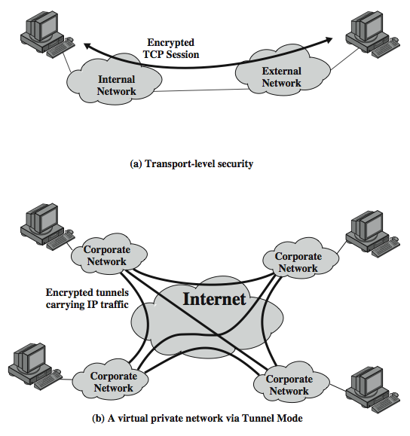
Encapsulating Security Payload (ESP)
ESP can be used to provide confidentiality, data origin authentication, connectionless integrity, an anti-replay service (a form of partial sequence integrity), and (limited) traffic flow confidentiality. The set of services provided depends on options selected at the time of Security Association (SA) establishment and on the location of the implementation in a network topology. ESP can work with a variety of encryption and authentication algorithms, including authenticated encryption algorithms such as GCM.



