Data Security and Encryption
(CSE348)

Handout -24
Electronic Mail Security

Email Security
- Email is one of the most widely used and regarded network services
- Currently message contents are not secure
  - may be inspected either in transit
  - or by suitably privileged users on destination system

Email Security Enhancements
- Confidentiality
  - protection from disclosure
- Authentication
  - of sender of message
- Message integrity
  - protection from modification
- Non-repudiation of origin
  - protection from denial by sender

Pretty Good Privacy (PGP)
The Pretty Good Privacy (PGP) secure email program, is a remarkable phenomenon, has grown explosively and is now widely used. Largely the effort of a single person, Phil Zimmermann, who selected the best available crypto algorithms to use & integrated them into a single program, PGP provides a confidentiality and authentication service that can be used for electronic mail and file storage applications. It runs on a wide range of systems, in both free & commercial versions.

PGP Operation – Authentication
The actual operation of PGP, as opposed to the management of keys, consists of four services: authentication, confidentiality, compression, and e-mail compatibility. Stallings Figure 18.1a illustrates the digital signature service provided by PGP. The sequence is as listed. Note this assumes use of RSA digital signatures, created using the sender's private key, and verified with the sender's public key. Recent PGP versions also support the use of DSS signatures. Signatures can also be detached from a message/file and sent/stored separately. This can be useful to maintain a separate signature log of all messages sent or received; or on an executable program to detect subsequent virus infection, or when more than one party must sign a document.
PGP Operation – Confidentiality
Another basic service provided by PGP is confidentiality, provided by encrypting messages to be transmitted or to be stored locally as files, using symmetric encryption algorithms CAST-128, IDEA or 3DES in 64-bit cipher feedback (CFB) mode. The randomly chosen session key used for this is sent encrypted using the recipient’s public RSA key. The steps used in this process are as listed. Stallings Figure 18.1b illustrates the sequence. Recent PGP versions also support the use of ElGamal (a Diffie-Hellman variant) for session-key exchange.

PGP Operation – Confidentiality & Authentication
As Stallings Figure 18.1c illustrates, both confidentiality & authentication services may be used for the same message. Firstly a signature is generated for the plaintext message and prepended to the it. Then the plaintext message plus signature is encrypted using CAST-128 (or IDEA or 3DES), and the session key is encrypted using RSA (or ElGamal). This sequence is preferable to the opposite: encrypting the message and then generating a signature for the encrypted message. It is generally more convenient to store a signature with a plaintext version of a message. Furthermore, for purposes of third-party verification, if the signature is performed first, a third party need not be concerned with the symmetric key when verifying the signature. In summary, when both services are used, the sender first signs the message with its own private key, then encrypts the message with a session key, and then encrypts the session key with the recipient's public key.

PGP Operation – Compression
By default PGP compresses the message after applying the signature but before encryption. This has the benefit of saving space both for e-mail transmission and for file storage. The signature is generated before compression for the reasons shown. The compression algorithm used is ZIP, and is indicated by Z for compression and Z–1 for decompression in Figure 18.1. It is described in Online Appendix O.
PGP Operation – Email Compatibility
When PGP is used, at least part of the block to be transmitted is encrypted, and thus consists of a stream of arbitrary 8-bit octets. However many electronic mail systems only permit the use of ASCII text. To accommodate this restriction, PGP provides the service of converting the raw 8-bit binary stream to a stream of printable ASCII characters. It uses radix-64 conversion, in which each group of three octets of binary data is mapped into four ASCII characters. The use of radix 64 expands a message by 33%. Fortunately, the session key and signature portions of the message are relatively compact, and the plaintext message has been compressed, often by more than enough to compensate for the radix-64 expansion. This format also appends a CRC to detect transmission errors. See Stallings Appendix 18A for a description.
PGP also automatically subdivides a message that is too large for a single email, into segments that are small enough to send.
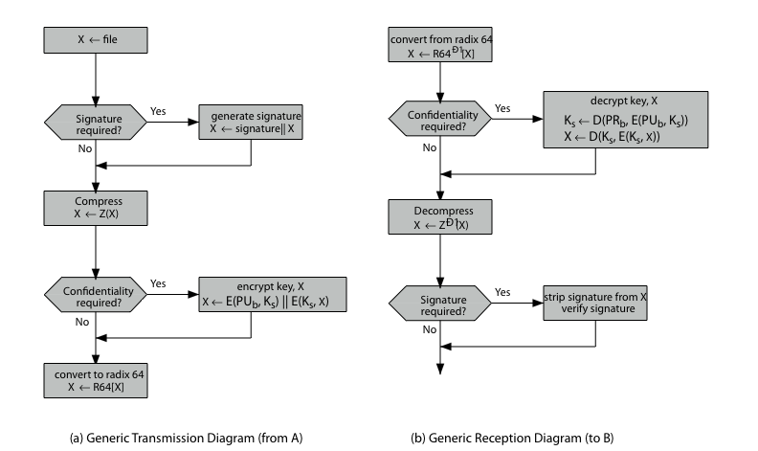

PGP Key Management
The PGP documentation notes that “This whole business of protecting public keys from tampering is the single most difficult problem in practical public key applications”. Its solution is to support a variety of formal and informal environments, in which any user can act as a “CA” to certify another user’s public key, and then act as a “trusted introducer” to other users, thus forming a “web of trust”. PGP provides a convenient means of using trust, associating trust with public keys, and exploiting trust information. The key ring is regularly processed to derive trust indicators for keys in it. Associated with each such entry is a key legitimacy field that indicates the extent to which PGP will trust that this is a valid public key for this user; the higher the level of trust, the stronger is the binding of this user ID to this key. PGP allows a user to revoke their current public key, either because compromise is suspected or simply to avoid the use of the same key for an extended period.
PGP Trust Model Example
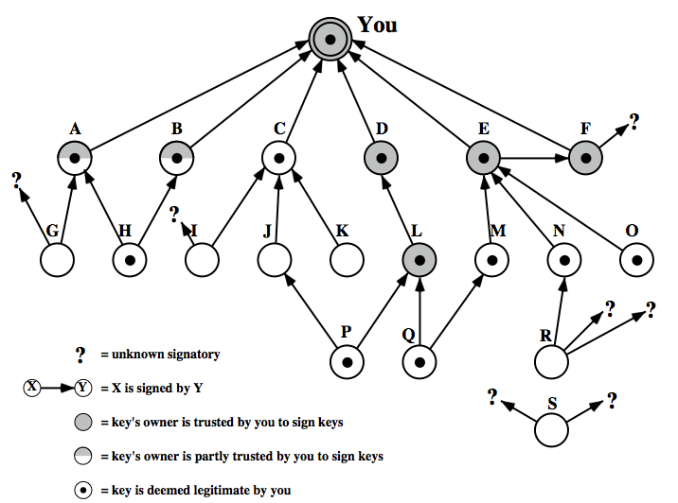

Internet Mail Architecture
To understand to operation of DKIM, it is useful to have a basic grasp of the Internet mail architecture, as illustrated in Stallings Figure 18.9. At its most fundamental level, the Internet mail architecture consists of a user world in the form of Message User Agents (MUA), and the transfer world, in the form of the Message Handling Service (MHS), which is composed of Message Transfer Agents (MTA). A MUA is usually housed in the user's computer, and referred to as a client email program, or on a local network email server. The MHS accepts a message from one User and delivers it to one or more other users, creating a virtual MUA-to-MUA exchange environment. The MSA accepts the message submitted by an MUA and enforces the policies of the hosting domain and the requirements of Internet standards. This function may be co-located with the MUA or be a separate functional model. In the latter case, the Simple Mail Transfer Protocol (SMTP) is used between the MUA and the MSA. The MTA relays mail for one application-level hop. Relaying is performed by a sequence of MTAs, until the message reaches a destination MDA. The MDA is responsible for transferring the message from the MHS to the MS. An MS can be located on a remote server or on the same machine as the MUA. Typically, an MUA retrieves messages from a remote server using POP (Post Office Protocol) or IMAP (Internet Message Access Protocol). Also an administrative management domain (ADMD) is an Internet email provider. The Domain Name System (DNS) is a directory lookup service that provides a mapping between the name of a host on the Internet and its numerical address.
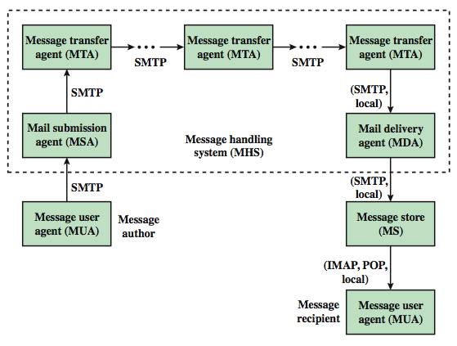
S/MIME (Secure/Multipurpose Internet Mail Extensions)
S/MIME (Secure/Multipurpose Internet Mail Extension) is a security enhancement to the MIME Internet e-mail format standard, which in turn provided support for varying content types and multi-part messages over the text only support in the original Internet RFC822 (now RFC5322) email standard. See text for discussion of these extensions. MIME is specified in RFCs 2045 through 2049. MIME allows encoding of binary data to textual form for transport over traditional RFC822 email systems. S/MIME support is now included in many modern mail agents.

-----------------------------------------------

