Data Security and Encryption
(CSE348)

Handout -23
Wireless Network Security

IEEE 802 is a committee that has developed standards for a wide range of local area networks (LANs). In 1990, the IEEE 802 Committee formed a new working group, IEEE 802.11, with a charter to develop a protocol and transmission specifications for wireless LANs (WLANs). Since that time, the demand for WLANs, at different frequencies and data rates, has exploded. Keeping pace with this demand, the IEEE 802.11 working group has issued an ever-expanding list of standards.
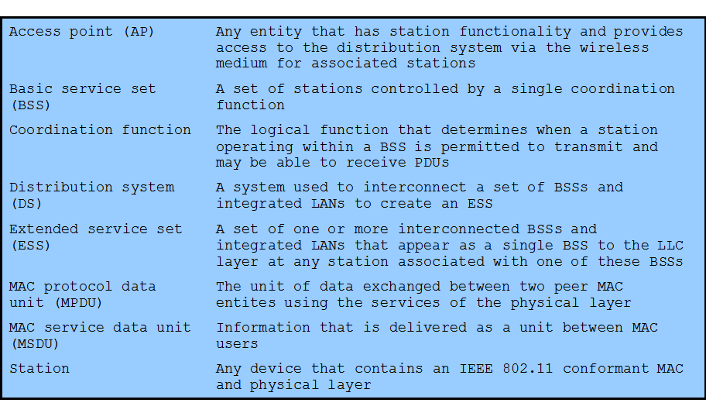

IEEE 802 Protocol Architecture
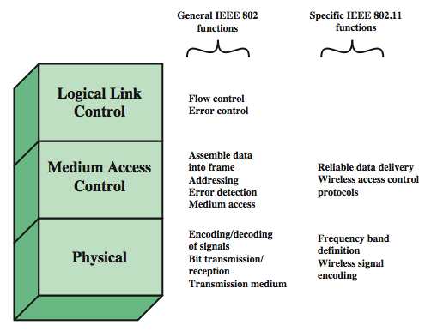

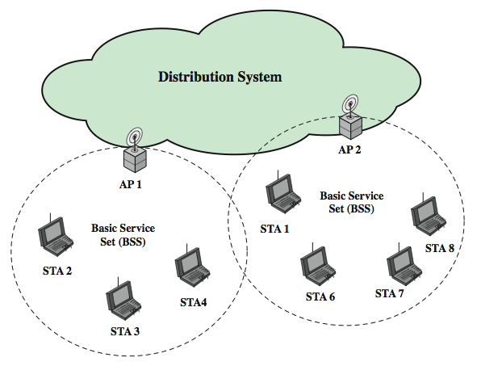

IEEE 802.11 Services
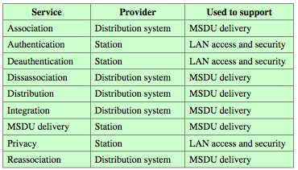
The differences between wired and wireless LANs (in that wireless traffic can be monitored by any radio in range, and need not be physically connected) suggest the increased need for robust security services and mechanisms for wireless LANs. The original 802.11 specification included a set of security features for privacy and authentication that were quite weak. For privacy, 802.11 defined the Wired Equivalent Privacy (WEP) algorithm. The privacy portion of the 802.11 standard contained major weaknesses. Subsequent to the development of WEP, the 802.11i task group has developed a set of capabilities to address the WLAN security issues. In order to accelerate the introduction of strong security into WLANs, the Wi-Fi Alliance promulgated Wi-Fi Protected Access (WPA) as a Wi-Fi standard. WPA is a set of security mechanisms that eliminates most 802.11 security issues and was based on the current state of the 802.11i standard. The final form of the 802.11i standard is referred to as Robust Security Network (RSN). The Wi-Fi Alliance certifies vendors in compliance with the full 802.11i specification under the WPA 2 program.

Stallings Figure 17.13 illustrates the overall stack architecture implemented in a WAP client. In essence, this is a five-layer model. Each layer provides a set of functions and/or services to other services and applications through a set of well-defined interfaces. Each of the layers of the architecture is accessible by the layers above, as well as by other services and applications. Many of the services in the stack may be provided by more than one protocol. For example, either HTTP or WSP may provide the Hypermedia Transfer service. Common two all five layers are a sets of services that are accessible by multiple layers. These common services fall into two categories: security services and service discovery. The WAP specification includes mechanisms to provide confidentiality, integrity, authentication, and nonrepudiation. There is a collection of service discovery services that enable the WAP client and the Web server to determine capabilities and services. See text for further details.
The Wireless Application Environment (WAE) specifies an application framework for wireless devices such as mobile telephones, pagers, and PDAs. In essence, the WAE consists of tools and formats that are intended to ease the task of developing applications and devices supported by WAP.
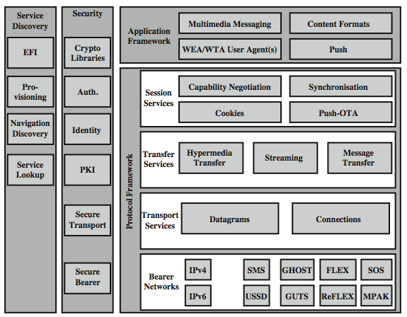

We now provide an overview of the WAP protocols.
The Wireless Session Protocol (WSP) provides applications with an interface for two session services. The connection-oriented session service operates above WTP, and the connectionless session service operates above the unreliable transport protocol WDP. In essence, WSP is based on HTTP with some additions and modifications to optimize its use over wireless channels. The principal limitations addressed are low data rate and susceptibility to loss of connection due to poor coverage or cell overloading. WSP is a transaction-oriented protocol based on the concept of a request and a reply.
The Wireless Transaction Protocol (WTP) manages transactions by conveying requests and responses between a user agent (such as a WAP browser) and an application server for such activities as browsing and e- commerce transactions. WTP provides a reliable transport service but dispenses with much of the overhead of TCP, resulting in a lightweight protocol that is suitable for implementation in "thin" clients using low-bandwidth wireless links. WTP is transaction oriented rather than connection oriented.
The Wireless Datagram Protocol (WDP) is used to adapt a higher-layer WAP protocol to the communication mechanism (called the bearer) used between the mobile node and the WAP gateway. Adaptation may include partitioning data into segments of appropriate size for the bearer and interfacing with the bearer network. WDP hides details of the various bearer networks from the other layers of WAP. In some instances, WAP is implemented on top of IP.

-----------------------------------------------

