Data Security and Encryption
(CSE348)

Handout -18
Hash Function

Hash Functions
A hash function H accepts a variable-length block of data M as input and produces a fixed-size hash value h = H(M). A "good" hash function has the property that the results of applying the function to a large set of inputs will produce outputs that are evenly distributed, and apparently random. In general terms, the principal object of a hash function is data integrity. A change to any bit or bits in M results, with high probability, in a change to the hash code. The kind of hash function needed for security applications is referred to as a cryptographic hash function. A cryptographic hash function is an algorithm for which it is computationally infeasible (because no attack is significantly more efficient than brute force) to find either (a) a data object that maps to a pre-specified hash result (the one-way property) or (b) two data objects that map to the same hash result (the collision-free property). Because of these characteristics, hash functions are often used to determine whether or not data has changed.
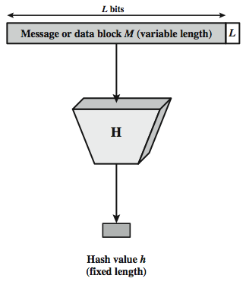
Stallings Figure depicts the general operation of a cryptographic hash function. Typically, the input is padded out to an integer multiple of some fixed length (e.g., 1024 bits) and the padding includes the value of the length of the original message in bits. The length field is a security measure to increase the difficulty for an attacker to produce an alternative message with the same hash value.
Hash Functions & Message Authentication
Message authentication is a mechanism or service used to verify the integrity of a message, by assuring that the data received are exactly as sent. Stallings Figure 11.2 illustrates a variety of ways in which a hash code can be used to provide message authentication, as follows:
- The message plus concatenated hash code is encrypted using symmetric encryption. Since only A and B share the secret key, the message must have come from A and has not been altered. The hash code provides the structure or redundancy required to achieve authentication.
- Only the hash code is encrypted, using symmetric encryption. This reduces the processing burden for those applications not requiring confidentiality.
- Shows the use of a hash function but no encryption for message authentication. The technique assumes that the two communicating parties share a common secret value S. A computes the hash value over the concatenation of M and S and appends the resulting hash value to M. Because B possesses S, it can recompute the hash value to verify. Because the secret value itself is not sent, an opponent cannot modify an intercepted message and cannot generate a false message.
- Confidentiality can be added to the approach of (c) by encrypting the entire message plus the hash code.
When confidentiality is not required, method (b) has an advantage over methods (a) and (d), which encrypts the entire message, in that less computation is required.
Another important application, which is similar to the message authentication application, is the digital signature. The operation of the digital signature is similar to that of the MAC. In the case of the digital signature, the hash value of a message is encrypted with a user's private key. Anyone who knows the user's public key can verify the integrity of the message that is associated with the digital signature. In this case an attacker who wishes to alter the message would need to know the user's private key. As we shall see in Chapter 14, the implications of digital signatures go beyond just message authentication. Stallings Figure 11.3 illustrates, in a simplified fashion, how a hash code is used to provide a digital signature:
- The hash code is encrypted, using public-key encryption and using the sender's private key. As with Figure 11.2b, this provides authentication. It also provides a digital signature, because only the sender could have produced the encrypted hash code. In fact, this is the essence of the digital signature technique.
- If confidentiality as well as a digital signature is desired, then the message plus the private-key-encrypted hash code can be encrypted using a symmetric secret key. This is a common technique.
Hash functions are commonly used to create a one-way password file. Chapter 20 explains a scheme in which a hash of a password is stored by an operating system rather than the password itself. Thus, the actual password is not retrievable by a hacker who gains access to the password file. In simple terms, when a user enters a password, the hash of that password is compared to the stored hash value for verification. This approach to password protection is used by most operating systems.
Hash functions can be used for intrusion detection and virus detection. Store H(F) for each file on a system and secure the hash values (e.g., on a CD-R that is kept secure). One can later determine if a file has been modified by recomputing H(F). An intruder would need to change F without changing H(F).
A cryptographic hash function can be used to construct a pseudorandom function (PRF) or a pseudorandom number generator (PRNG). A common application for a hash-based PRF is for the generation of symmetric keys. We discuss this application in Chapter 12.
Hash Function Requirements
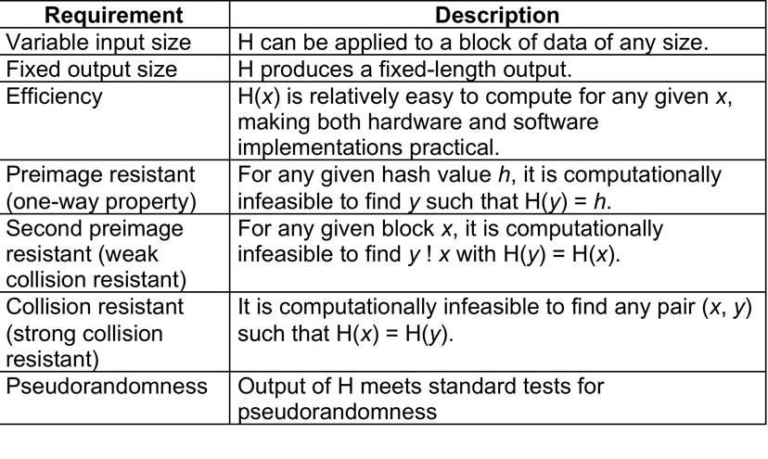
As yet, SHA-1 has not yet been "broken". That is, no one has demonstrated a technique for producing collisions in less than brute-force time. However, because SHA-1 is very similar in structure and in the basic mathematical operations used to MD5 and SHA-0, both of which have been broken, SHA-1 is considered insecure and has been phased out for SHA-2.
SHA-2, particularly the 512-bit version, would appear to provide unassailable security. However, SHA-2 shares the same structure and mathematical operations as its predecessors, and this is a cause for concern. Because it will take years to find a suitable replacement for SHA-2, should it become vulnerable, NIST decided to begin the process of developing a new hash standard. Accordingly, NIST announced in 2007 a competition to produce the next generation NIST hash function, to be called SHA-3. NIST would like to have a new standard in place by the end of 2012, but emphasizes that this is not a fixed timeline.

The basic requirements that must be satisfied by any candidate for SHA-3 are:
- It must be possible to replace SHA-2 with SHA-3 in any application by a simple drop-in substitution. Therefore, SHA-3 must support hash value lengths of 224, 256, 384, and 512 bits.
- SHA-3 must preserve the online nature of SHA-2. That is, the algorithm must process comparatively small blocks (512 or 1024 bits) at a time instead of requiring that the entire message be buffered in memory before
Beyond these basic requirements, NIST has defined a set of evaluation criteria. These criteria are designed to reflect the requirements for the main applications supported by SHA-2, and are:
• Security: The strength of SHA-3 should be close to the theoretical maximum for the different required hash sizes, and for both preimage resistance and collision resistance. SHA-3 algorithms must be designed to resist any potentially successful attack on SHA-2 functions
• Cost: be both time and memory efficient over a range of hardware platforms.
• Algorithm and implementation characteristics: such as flexibility (e.g., tunable parameters for security/performance tradeoffs, opportunity for parallelization, and so on), and simplicity (which makes it easier to analyze the security properties of the algorithm)

-----------------------------------------------

