Data Security and Encryption
(CSE348)

Handout -17
Other Public Key Cryptosystems

Diffie-Hellman Key Exchange
Continue our overview of public-key cryptography systems (PKCSs), and begins with a description of one of the earliest and simplest PKCS, Diffie-Hellman key exchange. This first published public-key algorithm appeared in the seminal paper by Diffie and Hellman that defined public-key cryptography [DIFF76b] and is generally referred to as Diffie-Hellman key exchange. The concept had been previously described in a classified report in 1970 by Williamson (UK CESG) - and subsequently declassified in 1987, see [ELLI99]. The purpose of the algorithm is to enable two users to securely exchange a key that can then be used for subsequent encryption of messages. The algorithm itself is limited to the exchange of secret values. A number of commercial products employ this key exchange technique.
The purpose of the algorithm is to enable two users to securely exchange a key that can then be used for subsequent encryption of messages. The algorithm itself is limited to the exchange of secret values, which depends on the value of the public/private keys of the participants. The Diffie-Hellman algorithm uses exponentiation in a finite (Galois) field (modulo a prime or a polynomial), and depends for its effectiveness on the difficulty of computing discrete logarithms.
The actual key exchange for either party consists of raising the others "public key' to power of their private key. The resulting number (or as much of as is necessary) is used as the key for a block cipher or other private key scheme. For an attacker to obtain the same value they need at least one of the secret numbers, which means solving a discrete log, which is computationally infeasible given large enough numbers. Note that if Alice and Bob subsequently communicate, they will have the same key as before, unless they choose new public-keys.
Diffie-Hellman Example
Here is an example of Diffie-Hellman from the text using prime q=353, showing how each computes its public key, and then how after they exchange public keys, each can compute the common secret key.I n this simple example, it would be possible by brute force to determine the secret key 160. In particular, an attacker E can determine the common key by discovering a solution to the equation 3ª mod 353 = 40 or the equation 3^{b} mod 353 = 248. The brute-force approach is to calculate powers of 3 modulo 353, stopping when the result equals either 40 or 248. The desired answer is reached with the exponent value of 97, which provides 3⁹⁷ mod 353 = 40. With larger numbers, the problem becomes impractical.
Now consider a simple protocol that makes use of the Diffie-Hellman calculation. Suppose that user A wishes to set up a connection with user B and use a secret key to encrypt messages on that connection. User A can generate a one-time private key X_{A}, calculate Y_{A}, and send that to user B. User B responds by generating a private value X_{B}, calculating Y_{B}, and sending Y_{B} to user A. Both users can now calculate the key. The necessary public values q and a would need to be known ahead of time. Alternatively, user A could pick values for q and a and include those in the first message.
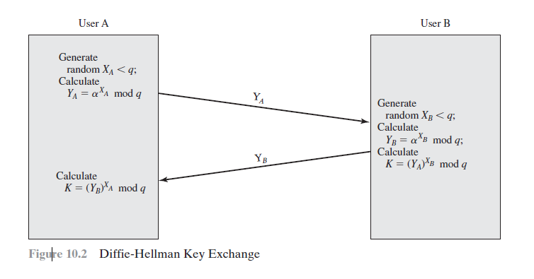
ElGamal Cryptography
In 1984, T. Elgamal announced a public-key scheme based on discrete logarithms, closely related to the Diffie-Hellman technique [ELGA84, ELGA85]. The ElGamal cryptosystem is used in some form in a number of standards including the digital signature standard (DSS) and the S/MIME email standard. As with Diffie-Hellman, the global elements of ElGamal are a prime number q and a, which is a primitive root of q. User A generates a private/public key pair as shown. The security of ElGamal is based on the difficulty of computing discrete logarithms, to recover either x given y, or k given K (next slide).
ElGamal Message Exchange
Any user B that has access to A's public key can encrypt a message as shown. These steps correspond to Figure 9.1a in that Alice generates a public/private key pair; Bob encrypts using Alice's public key; and Alice decrypts using her private key. See text for details of why these steps result in M being recovered. Note that K functions as a one-time key, used to encrypt and decrypt the message. If a message must be broken up into blocks and sent as a sequence of encrypted blocks, a unique value of k should be used for each block. If k is used for more than one block, knowledge of one block m of the message enables the user to compute other blocks as shown in the text.
The basic idea with El Gamal encryption is to choose a random key, protect it, then use it to scramble the message by multiplying the message with it. Two bits of info have to be sent: the first to recover this temporary key, the second the actual scrambled message. See that El Gamal encryption involves 1 modulo exponentiation and a multiplication (vs 1 exponentiation for RSA).



