Data Security and Encryption
(CSE348)

Handout -15
Public Key Cryptography

Public-Key Cryptography
Will now discuss the radically different public key systems, in which two keys are used. Public-key cryptography provides a radical departure from all that has gone before. The development of public-key cryptography is the greatest and perhaps the only true revolution in the entire history of cryptography. It is asymmetric, involving the use of two separate keys, in contrast to symmetric encryption, that uses only one key. Anyone knowing the public key can encrypt messages or verify signatures, but cannot decrypt messages or create signatures, counter-intuitive though this may seem. The use of two keys has profound consequences in the areas of confidentiality, key distribution, and authentication. It works by the clever use of number theory problems that are easy one way but hard the other. Note that public key schemes are neither more nor less secure than private key (security depends on the key size for both), nor do they replace private key schemes (they are too slow to do so), rather they complement them. Both also have issues with key distribution, requiring the use of some suitable protocol.
Why Public-Key Cryptography?
The concept of public-key cryptography evolved from an attempt to attack two of the most difficult problems associated with symmetric encryption: key distribution and digital signatures. The first problem is that of key distribution, which under symmetric encryption requires either (1) that two communicants already share a key, which somehow has been distributed to them; or (2) the use of a key distribution center. This seemed to negated the very essence of cryptography: the ability to maintain total secrecy over your own communication. The second was that of "digital signatures." If the use of cryptography was to become widespread, not just in military situations but for commercial and private purposes, then electronic messages and documents would need the equivalent of signatures used in paper documents.
The idea of public key schemes, and the first practical scheme, which was for key distribution only, was published in 1976 by Diffie & Hellman. The concept had been previously described in a classified report in 1970 by James Ellis (UK CESG) - and subsequently declassified [ELLI99]. Its interesting to note that they discovered RSA first, then Diffie-Hellman, opposite to the order of public discovery! There is also a claim that the NSA knew of the concept in the mid-60’s [SIMM93].
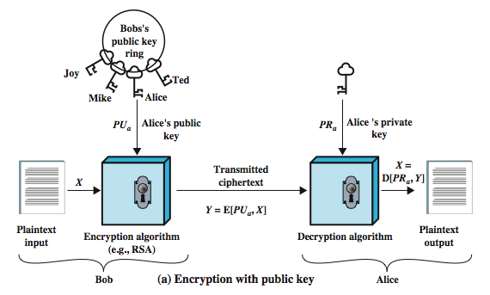
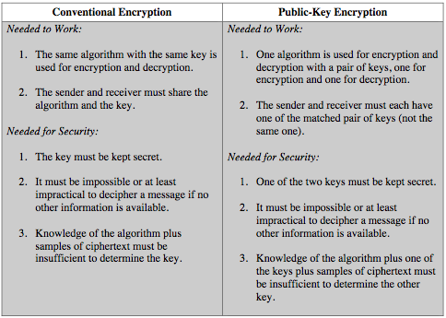
Public-Key Requirements
The requirements boil down to the need for a trap-door one-way function. A one-way function is one that maps a domain into a range such that every function value has a unique inverse, with the condition that the calculation of the function is easy whereas the calculation of the inverse is infeasible:
Y = f(X) easy
X = f^{–1}(Y) infeasible
Generally, easy is defined to mean a problem that can be solved in polynomial time as a function of input length. The term infeasible is a much fuzzier concept. In general, we can say a problem
Now consider a trap-door one-way function, which is easy to calculate in one direction and infeasible to calculate in the other direction unless certain additional information is known. With the additional information the inverse can be calculated in polynomial time. We can summarize as follows: A trap-door one-way function is a family of invertible functions f_{k}, such that:
Y = f_{k}(X) easy, if k and X are known
X = f_{k}^{–1}(Y) easy, if k and Y are known
X = f_{k}^{–1}(Y) infeasible, if Y known but k not known
Thus, the development of a practical public-key scheme depends on discovery of a suitable trap-door one-way function.

-----------------------------------------------

