Requirements Elicitation Process
Lecture-8

Scenarios
- Scenarios are stories which explain how a system might be used. They should include
  - A description of the system state before entering the scenario
  - The normal flow of events in the scenario
  - Exceptions to the normal flow of events
  - Information about concurrent activities
  - A description of the system state at the end of the scenario
- Scenarios are examples of interaction sessions which describe how a user interacts with a system
- Discovering scenarios exposes possible system interactions and reveals system facilities which may be required

Library scenario - document ordering
- Log on to EDDIS system
- Issue order document command
- Enter reference number of the required document
- Select a delivery option
- Log out from EDDIS
- This sequence of events can be illustrated in a diagram

Library Scenario

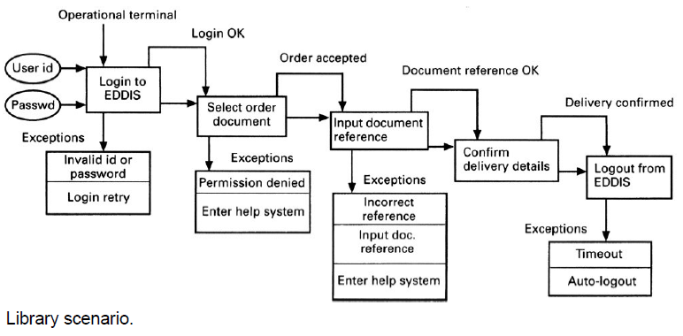

Scenarios and OOD
- Scenarios are an inherent part of some object-oriented development methods
- The term use-case (i.e. a specific case of system usage) is sometimes used to refer to a scenario
- There are different views on the relationship between use cases and scenarios:
  - A use-case is a scenario
  - A scenario is a collection of use-cases. Therefore, each exceptional interaction is represented as a separate use-case

Observation and social analysis
- People often find it hard to describe what they do because it is so natural to them. Sometimes, the best way to understand it is to observe them at work
- Ethnography is a technique from the social sciences which has proved to be valuable in understanding actual work processes
- Actual work processes often differ from formal, prescribed processes
- An ethnographer spends some time observing people at work and building up a picture of how work is done

Ethnography guidelines
- Assume that people are good at doing their job and look for non-standard ways of working
- Spend time getting to know the people and establish a trust relationship
- Keep detailed notes of all work practices. Analyze them and draw conclusions from them
- Combine observation with open-ended interviewing
- Organize regular de-briefing session where the ethnographer talks with people outside the process
- Combine ethnography with other elicitation techniques

Ethnography in elicitation

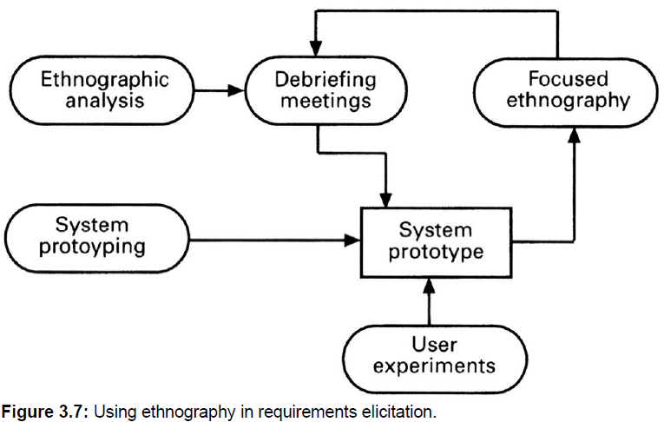

Ethnographic perspectives
- The work setting viewpoint: This describes the context and the physical location of the work and how people use objects to carry out tasks. Therefore, in a study of a help desk (say), this would describe the objects which the helper had to hand and how these were organized.
- Social and organizational perspectives: This tries to bring out the day -to-day experience of work as seen by different people who are involved. Each individual typically sees the work in a different ways and this viewpoint tries to organize and integrate all of these perceptions.
- The workflow viewpoint: This viewpoint presents the work from a series of work activities with information flowing from one activity to another.

Requirements reuse
- Reuse involves taking the requirements which have been developed for one system and using them in a different system
- Requirements reuse saves time and effort as reused requirements have already been analyzed and validated in other systems
- Currently, requirements reuse is an informal process but more systematic reuse could lead to larger cost savings

Reuse possibilities
- Where the requirement is concerned with providing application domain information.
- Where the requirement is concerned with the style of information presentation. Reuse leads to a consistency of style across applications.
- Where the requirement reflects company policies such as security policies.

Prototyping
- A prototype is an initial version of a system which may be used for experimentation
- Prototypes are valuable for requirements elicitation because users can experiment with the system and point out its strengths and weaknesses. They have something concrete to criticize
- Rapid development of prototypes is essential so that they are available early in the elicitation process

Prototyping benefits
- The prototype allows users to experiment and discover what they really need to support their work
- Establishes feasibility and usefulness before high development costs are incurred
- Essential for developing the ‘look and feel’ of a user interface
- Can be used for system testing and the development of documentation
- Forces a detailed study of the requirements which reveals inconsistencies and omissions

Types of prototyping
- Throw-away prototyping
  - Intended to help elicit and develop the system requirements.
  - The requirements which should be prototyped are those which cause most difficulties to customers and which are the hardest to understand. Requirements which are well-understood need not be implemented by the prototype.
- Evolutionary prototyping
  - Intended to deliver a workable system quickly to the customer.
  - Therefore, the requirements which should be supported by the initial versions of this prototype are those which are well-understood and which can deliver useful end -user functionality. It is only after extensive use that poorly understood requirements should be implemented.

Prototyping costs and problems
- Training costs - prototype development may require the use of special purpose tools
- Development costs - depend on the type of prototype being developed
- Extended development schedules - developing a prototype may extend the schedule although the prototyping time may be recovered because rework is avoided
- Incompleteness - it may not be possible to prototype critical system requirements

Approaches to prototyping
- Paper prototyping: A paper mock -up of the system is developed and used for system experiments
- ‘Wizard of Oz’ prototyping: A person simulates the responses of the system in response to some user inputs
- Executable prototyping: A fourth generation language or other rapid development environment is used to develop an executable prototype

Executable prototype development
- Fourth generation languages based around database systems
- Visual programming languages such as Visual Basic or Object Works
- Internet-based prototyping solutions based on World Wide Web browsers and languages such as Java

