Requirements Elicitation Process
Lecture-6
Inception Process: Details of inception as a process

Introduction- Requirements elicitation
- Requirements elicitation is the usual name given to activities involved in discovering the requirements of the system.
- System developers and engineers work with customers and end-users to find out about
  - The problem to be solved, the system services, the required performance of the system, hardware constraints, and so on.
- This doesn't just involve asking people what they want;
  - It requires a careful analysis of the organization, the application domain and business processes where the system will be used.

Components of requirements elicitation
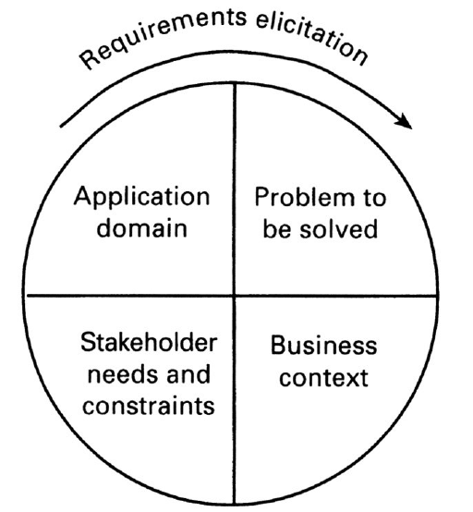
Elicitation activities
Application domain understanding: Application domain knowledge is knowledge of the general area where the system is applied. For Example: to understand the requirements for a railway signaling system, you must have background knowledge about the operation of railways and the physical characteristics of trains.
Problem understanding: The details of the specific customer problem where the system will be applied must be understood. For a railway signaling system, you must know the way in which speed limits are applied to particular track segments.
Business understanding: You must understand how systems interact and contribute to overall business goals. (Means, the contribution of the system in business goal)
Understanding the needs and constraints of system stakeholders: You must understand, in detail, the specific needs of people who require system support in their work.

Elicitation process problems
- Application domain knowledge is not collected neatly in one place.
  - It exists in a variety of different sources such as in textbooks, operating manuals and in the heads of the people working in that area.
  - It usually involves specialist terminology which is not immediately understandable by the requirements engineer.
- People who understand the problem to be solved are often too busy solving the problem without any new system.
  - They can't spend a lot of time helping requirements engineers understand the requirements for a new system.
  - They will not necessarily be convinced of the need for a new system so may not want to be involved in the requirements engineering process.
- Organizational issues and political factors may influence the system requirements.
  - Higher management may influence the system requirements in ways that satisfy their personal agendas.
- Stakeholders often don't really know what they want from the computer system except in the most general terms.

Elicitation stages
- Objective setting: The organizational objectives should be established including general goals of the business, an outline description of the problem to be solved, why the system is necessary and the constraints on the system.
- Background knowledge acquisition: Background information about the system includes information about the organization where the system is to be installed, the application domain of the system and information about existing systems
- Knowledge organization: The large amount of knowledge which has been collected in the previous stage must be organized and collected.
- Stakeholder requirements collection: System stakeholders are consulted to discover their requirements.

Analysis checks
- Necessity checking: The need for the requirement is analyzed. In some cases, requirements may be proposed which don’t contribute to the business goals of the organization or to the specific problem to be addressed by the system.
- Consistency and completeness checking: The requirements are cross-checked for consistency and completeness. Consistency means that no requirements should be contradictory; completeness means that no services or constraints which are needed have been missed out.
- Feasibility checking: The requirements are checked to ensure that they are feasible in the context of the budget and schedule available for the system development.

Requirements negotiation
- Requirements discussion: Requirements which have been highlighted as problematical are discussed and the stakeholders involved present their views about the requirements.
- Requirements prioritization: Disputed requirements are prioritized to identify critical requirements and to help the decision making process.
- Requirements agreement: Solutions to the requirements problems are identified and a compromise set of requirements are agreed. Generally, this will involve making changes to some of the requirements.

