Methods for Requirements Engineering
Lecture-30
Class definition
- An implementation of an object type
  - The object type Bank Customer refers to a class of bank customers
- Objects that share common attributes and operations
  - An object is an instance of a class
  - For example, if “John Smith” is a bank customer, then bank customer is the class and “John Smith” is an instance of the bank customer

Operations and methods
- Used to read and manipulate the data of an object
- Reference only the data structures of that object type
- To access the data structures of another object, objects must send messages to that object
- Methods specify the way in which operations are encoded in software

Encapsulation
- Packaging together of data and operations that manipulate the data
- Details of how the operation is performed hidden from user
- Prevents the unauthorised access of an object’s data

Inheritance
- Objects at a lower level in class hierarchy inherit the operations and attributes of their parent(s)
- Objects are able to incorporate data and/or operations specific to themselves
- Inherits data from more than one parent is called multiple inheritance.

Messages
- Objects communicate by sending messages
- Message comprises:
  - Name of receiver object
  - Operation to be invoked
  - Optional set of parameters
- When an object receives a message it causes an operation to be invoked
- The operation performs the appropriate method

Object modelling - Library example
- A library system is intended to provide its users with the ability to automate the process of:
  - Acquiring library items
  - Cataloguing library items
  - Browsing library items
  - Loaning library items
- Library items comprise published and recorded material
- The system will be administered by a member of the library staff
- Users must register with the system administrator before they can borrow library items
- Library users are drawn from three primary groups:
  - Students, Members of staff and External users
- All library users have as part of their registration:
  - Name, Library number, Address, Account
- In addition the following information also required for registration:
  - Students - Degree programme and admission number.
  - Staff - Staff number
  - External users - Employer details

Steps in object-oriented method
- Most methods based on the object-oriented model share certain common analysis steps:
  - Identify core objects
  - Construct the object structures defining the associations between object classes
  - Define the attributes associated with each object
  - Determine the relevant operations for each object
  - Define the messages that may be passed between objects

Step 1 - Initial classes identified
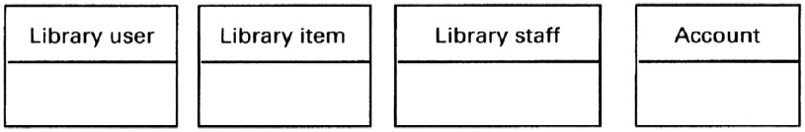

Step 2 - Relationships between classes
- We can identify the following relationships from the partial requirements:
- A library user borrows a library item
- A library item is recorded or published
- The system administrator registers the library user
- Library users are students, staff and external users
- The system administrator catalogues the library items
- The library assistant issues the library items

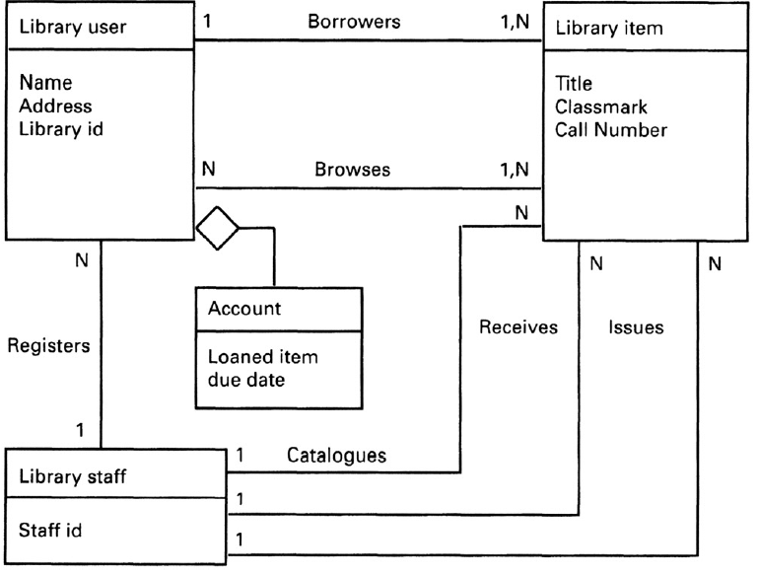

Step 2 - Inheritance for Library user

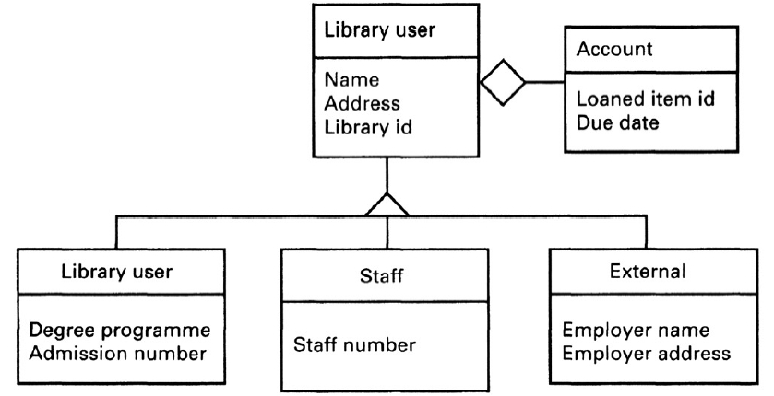

Step 2 - Inheritance for library item

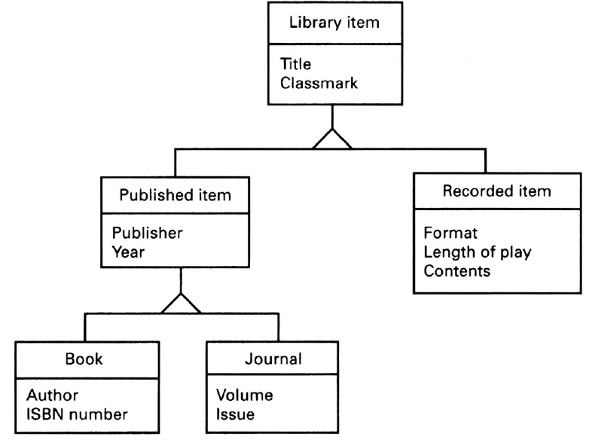

Step 3 - Identifying the attributes
- Attributes can be revealed by the analysis of the system requirements
- For example, it is a requirement that all library users must be registered before they can use the library
  - This means that we need to keep registration data about library users
  - Library users may also be provided with an account to keep track of the items loaned to them
- Library item has the attributes; title, description and classmark
- The library user class has the attributes; name, address and library id

Step 4 - Object operations
- This step is intended to describe operations to be performed on the objects
- Certain operations are implicit from the object structure
  - These include operations for accessing and modifying the attribute values. These operations are assumed and we need not show them explicitly in the model
- One way of identifying operations is by modelling the messages that may be passed between the objects

Step 4 - Messages between objects
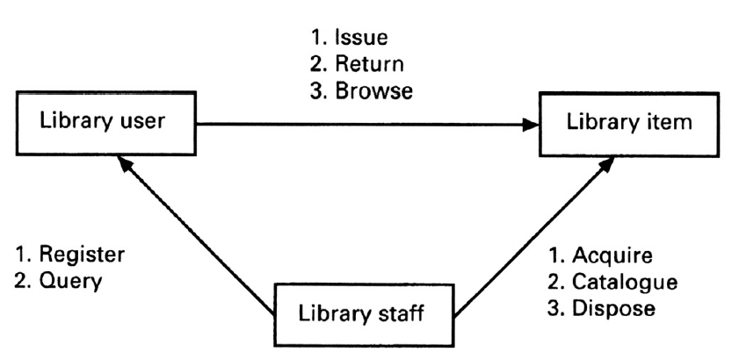

Step 4 - Operations for library user and library staff
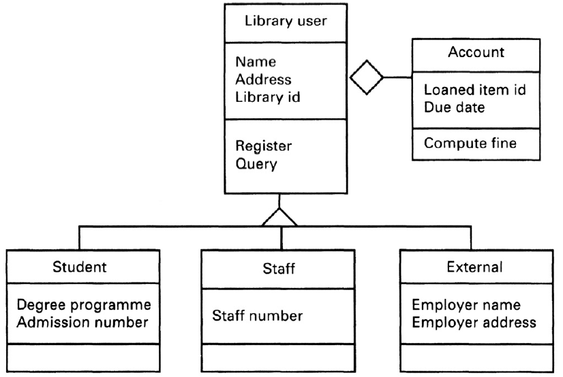

Step 4 - Operations for library item
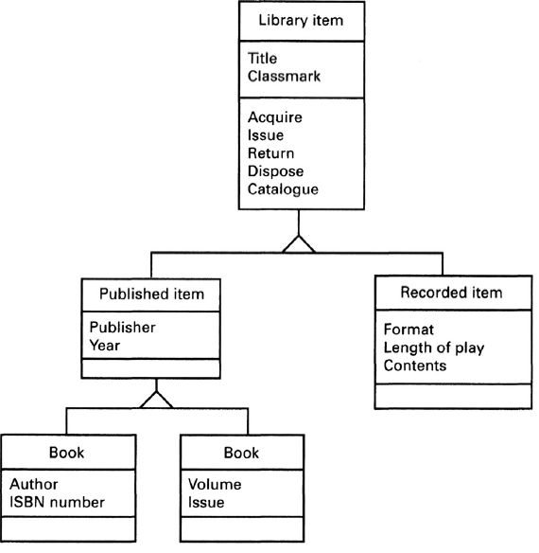

Formal methods
Introduction
- Requirements specification techniques can be categorised on a “formality” spectrum
- Semi-formal and informal methods
  - Use natural language, diagrams, tables and simple notation
  - Include structured analysis and object-oriented analysis
- Formal methods include:
  - Based on mathematically formal syntax and semantics
  - Include Z, B, VDM, LOTOS
- Provide a means for achieving a high degree of confidence that a system will conform to its specification
- Do not absolute guarantee of correctness
- Have little directly to offer to the problems of managing software projects
  - However, benefits can be gained from gaining a clear understanding of the task at an early stage

Components of formal specification language
- Syntax that defines the specific notation with which the specification is represented
- Semantics that help to define a “universe of objects” that will be used to describe the system
- Relations which define the rules that indicate which objects properly satisfy the specification

Formal methods not widespread
- Formal methods are not widely used amongst software developers
- Factors contributing to slow acceptance of formal methods:
  - Difficulty in understanding the notations
  - Difficulty in formalising certain aspects of requirements
  - Payoff is not obvious.
Formal specification languages
The number of formal specification languages in use today can be broadly divided into two categories.
- Model-based notations
  - Z and Vienna Development Method (VDM)
- Process algebras -based notations
  - Communicating Sequential Processes (CSP), CCS and LOTOS

Advantages of formal methods
- Removes ambiguity
- Encourages greater rigor in the early stages of software engineering
- Possible to verify the correctness, incompleteness and inconsistency checking of the specification

Disadvantages of formal methods
- Difficult to represent behavioural aspects of problem
- Some requirements can only be determined through empirical evaluation and prototyping
- Do not address the problem of how the requirements are constructed
- Lack of adequate tool support

Z - A model based formal method
- A Z specification is presented as a collection of schemas
- A Schema comprises three main parts:
- Name, Declarations and Predicates
- Schema declarations set out the names and types of entities introduced in the schema
- Schema predicate sets out the relationships between the entities in the declaration

Using Z
- Variable declarations are of the form identifier:type
- Predicates give properties of, and relationships between the variables
- A schema may be used to describe either a state or an operation
  - To describe a state, the declared variables form the components of the state and the predicates give the invariant properties of the state
  - For an operation, the declarations consist of the initial state components, the final components, the inputs and the outputs of the operation
  - For an operation, the predicate part describes the relation between the inputs, outputs, and initial and final states
Z Schema
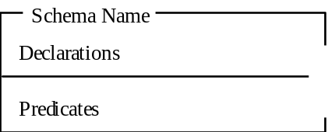

Library example
- The state space of the lending library can be defined using the following schema:
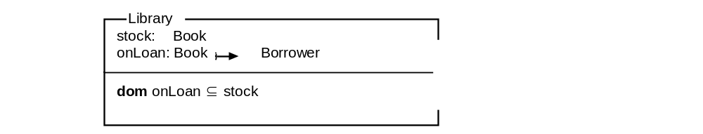

Schema for borrow operation


Schema for ‘New’ and ‘Return’ operations
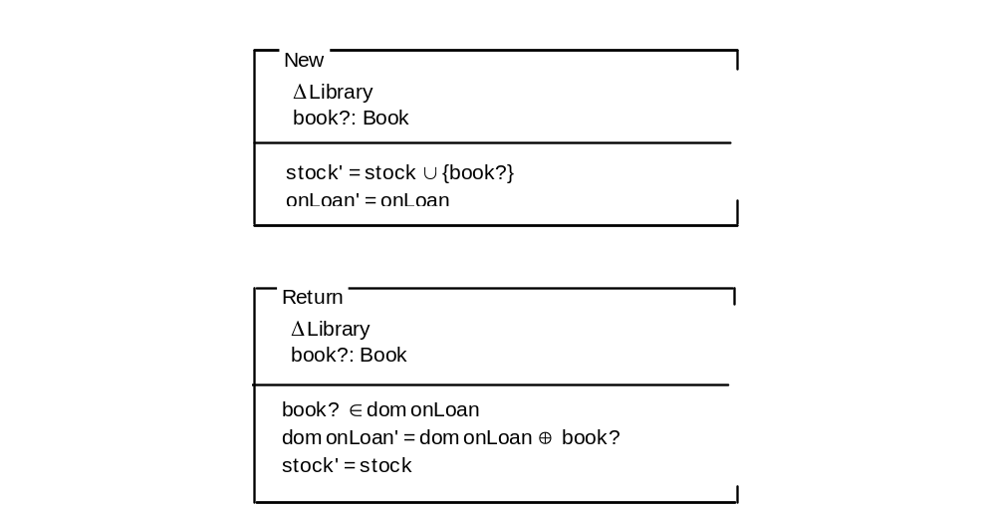

Key points
- No ideal requirements method
- System models can be considerably enriched by combining different techniques
- Data-flow model is based on the notion that systems can be modelled as a set of interacting functions
- The object-oriented approach is based on the notion that systems can be modelled as a set of interacting objects
- Formal methods are based on mathematical principles and are intended to achieve a high degree of confidence that a system will conform to its specifications

