Requirements Engineering in Agile Methods
Lecture-29

XP and agile principles
- Incremental development is supported through small, frequent system releases.
- Customer involvement means full-time customer engagement with the team.
- People not process through pair programming, collective ownership and a process that avoids long working hours.
- Change supported through regular system releases.
- Maintaining simplicity through constant refactoring of code.

Customer involvement
- Customer involvement is a key part of XP where the customer is part of the development team.
- The role of the customer is:
  - To help develop stories that define the requirements
  - To help prioritize the features to be implemented in each release
  - To help develop acceptance tests which assess whether or not the system meets its requirements.

Requirements scenarios
- In XP, user requirements are expressed as scenarios or user stories.
- These are written on cards and the development team break them down into implementation tasks. These tasks are the basis of schedule and cost estimates.
- The customer chooses the stories for inclusion in the next release based on their priorities and the schedule estimates.

Story card for document downloading
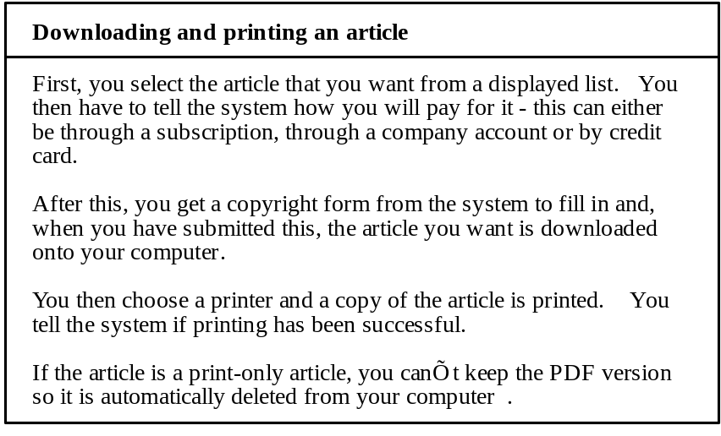

XP and change
- Conventional wisdom in software engineering is to design for change. It is worth spending time and effort anticipating changes as this reduces costs later in the life cycle.
- XP, however, maintains that this is not worthwhile as changes cannot be reliably anticipated.
- Rather, it proposes constant code improvement (refactoring) to make changes easier when they have to be implemented.

Refactoring
- Refactoring is the process of code improvement where code is reorganised and rewritten to make it more efficient, easier to understand, etc.
- Refactoring is required because frequent releases mean that code is developed incrementally and therefore tends to become messy.
- Refactoring should not change the functionality of the system.
- Automated testing simplifies refactoring as you can see if the changed code still runs the tests successfully.

Testing in XP
- Test-first development.
- Incremental test development from scenarios.
- User involvement in test development and validation.
- Automated test harnesses are used to run all component tests each time that a new release is built.

Task cards for document downloading
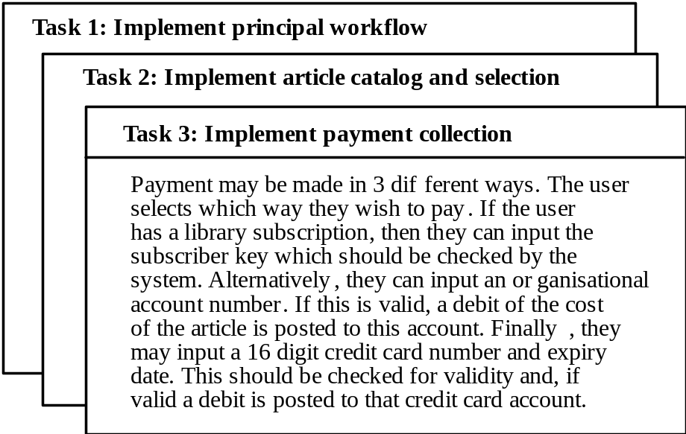

Test case description
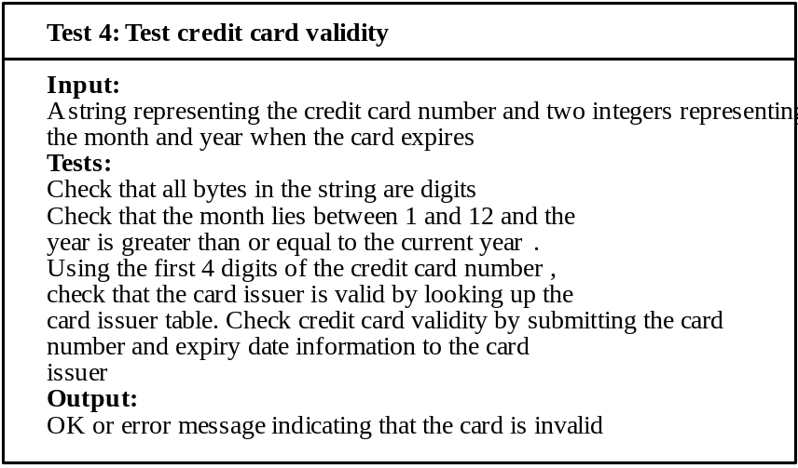
Test-first development
- Writing tests before code clarifies the requirements to be implemented.
- Tests are written as programs rather than data so that they can be executed automatically. The test includes a check that it has executed correctly.
- All previous and new tests are automatically run when new functionality is added. Thus checking that the new functionality has not introduced errors.

Tools for Requirements Management in AMs
- UML Modeling Tools
- Requirements Negotiation Tools
- Instant Messaging Tools
- Project Management Tools

Methods for Requirement Engineering

Role of methods in RE
- Process of requirements engineering (RE) is usually guided by a requirements method
- Requirement methods are systematic ways of producing system models
- System models bridges gap between the analysis and the design process

Necessary properties for a RE method
- Suitability for agreement with the end-user
- The precision of definition of its notation
- Assistance with formulating requirements
- Definition of the world outside
- Scope for malleability
- Scope for integrating other approaches
- Scope for communication
- Tool support

No ideal RE method
- There is no ideal requirement method
- A number of methods use a variety of modelling techniques to formulate system requirements
- System models can be enriched by modelling different aspects of using modelling techniques

Modeling techniques
- Data-flow models
- Compositional models
- Classification models
- Stimulus-response models
- Process models

Data flow modelling
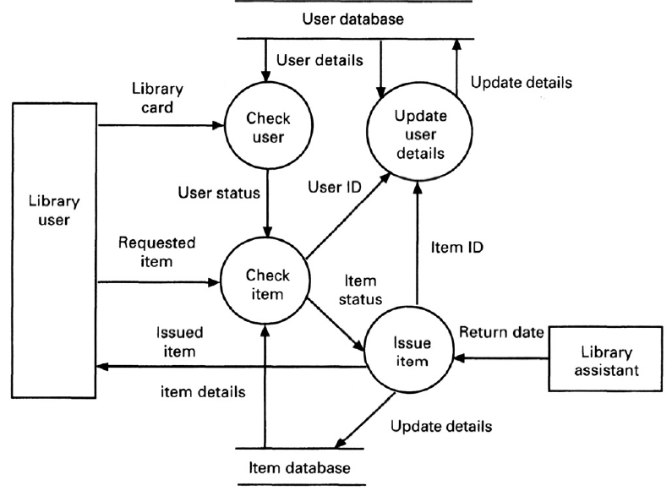

Object-oriented approaches
- Closest precursor is entity relationship model
- Requirements methods based on object orientation:
  - Shlaer and Mellor (1988)
  - Colbert (1989)
  - Coad and Yourdon (1989)
  - Wirf-Brock (1990)
  - Rumbaugh (1991)
  - Jacobson (1992)
  - Martin-Odell (1992)
- Notations for the various methods are semantically similar

Object
- Are major actors, agents, and servers in the problem space of the system
- Identified by analysing the domain
- Objects include:
  - Devices that the system interacts with
  - Systems that interface with the system under study
  - Organisational units
  - Things that must be remembered over time
  - Physical locations or sites
  - Specific roles played by humans

Basic concepts
- Encapsulation
- Class
- Inheritance
- Operations or Services
Object definition
- Something real or abstract about which we store data and those operations that manipulate the data
- Examples include:
- An account, a sensor, a software design, a car , an organisation
- May be composite - composed of other objects

