Requirements Management
Lecture-25

Requirements DB - choice factors
- The statement of requirements
  - If there is a need to store more than just simple text, a database with multimedia capabilities may have to be used.
- The number of requirements
  - Larger systems usually need a database which is designed to manage a very large volume of data running on a specialised database server.
- Teamwork, team distribution and computer support
  - If the requirements are developed by a distributed team of people, perhaps from different organisations, you need a database which provides for remote, multi-site access.
- CASE tool use
  - The database should be the same as or compatible with CASE tool databases. However, this can be a problem with some CASE tools which use their own proprietary database
- Existing database usage
  - If a database for software engineering support is already in use, this should be used for requirements management.

Change management
- Change management is concerned with the procedures, processes and standards which are used to manage changes to system requirements
- Change management policies may cover:
  - The change request process and the information required to process each change request
  - The process used to analyse the impact and costs of change and the associated traceability information
  - The membership of the body which formally considers change requests
  - The software support (if any) for the change control process

The change management process
- Some requirements problem is identified.
  - This could come from an analysis of the requirements, new customer needs, or operational problems with the system. The requirements are analysed using problem information and requirements changes are proposed.
- The proposed changes are analysed
  - This checks how many requirements (and, if necessary, system components) are affected by the change and roughly how much it would cost, in both time and money, to make the change.
- The change is implemented.
  - A set of amendments to the requirements document or a new document version is produced. This should, of course, be validated using whatever normal quality checking procedures are used.

Change management stages

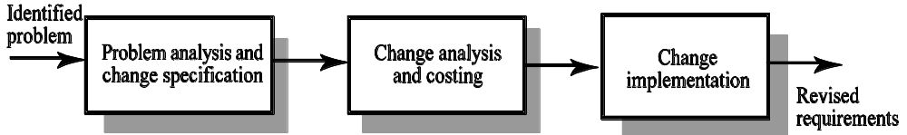

Change analysis and costing

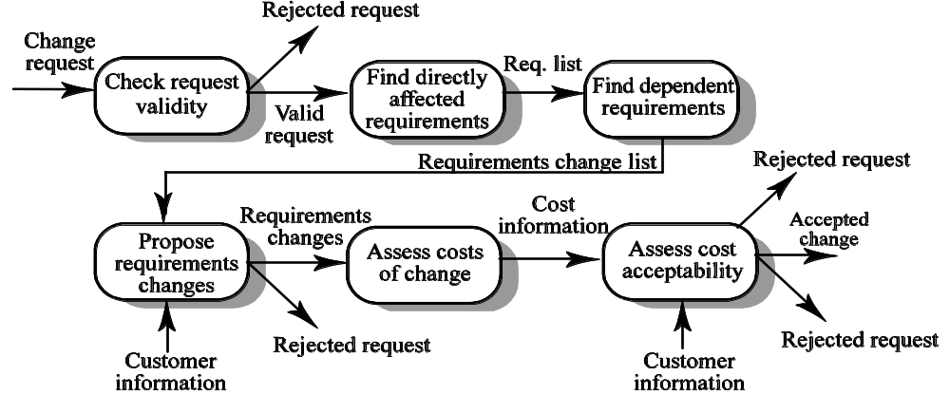

Change analysis activities
- The change request is checked for validity. Customers can misunderstand requirements and suggest unnecessary changes.
- The requirements which are directly affected by the change are discovered.
- Traceability information is used to find dependent requirements affected by the change.
- The actual changes which must be made to the requirements are proposed.
- The costs of making the changes are estimated.
- Negotiations with customers are held to check if the costs of the proposed changes are acceptable.

Change request rejection
- If the change request is invalid. This normally arises if a customer has misunderstood something about the requirements and proposed a change which isn’t necessary.
- If the change request results in consequential changes which are unacceptable to the user.
- If the cost of implementing the change is too high or takes too long.

Change processing
- Proposed changes are usually recorded on a change request form which is then passed to all of the people involved in the analysis of the change
- Change request forms may include
  - fields to document the change analysis
  - data fields
  - responsibility fields
  - status field
  - comments field

Tool support for change management
- May be provided through requirements management tools or through configuration management tools
- Tool facilities may include
  - Electronic change request forms which are filled in by different participants in the process.
  - A database to store and manage these forms.
  - A change model which may be instantiated so that people responsible for one stage of the process know who is responsible for the next process activity.
  - Electronic transfer of forms between people with different responsibilities and electronic mail notification when activities have been completed.
  - In some cases, direct links to a requirements database.

