Elaboration Process
Lecture-16
Flow-Oriented Modeling

Data Flow Diagram
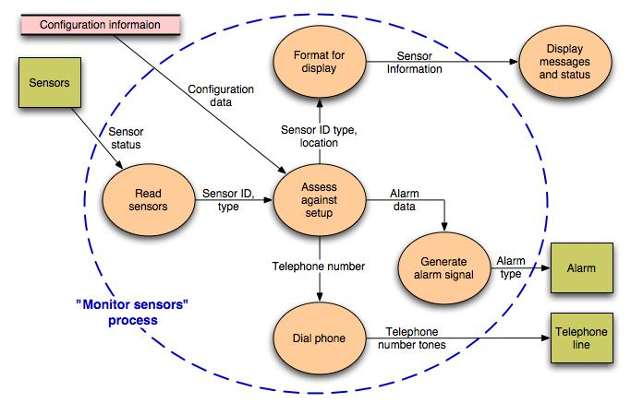

Control Flow Diagram
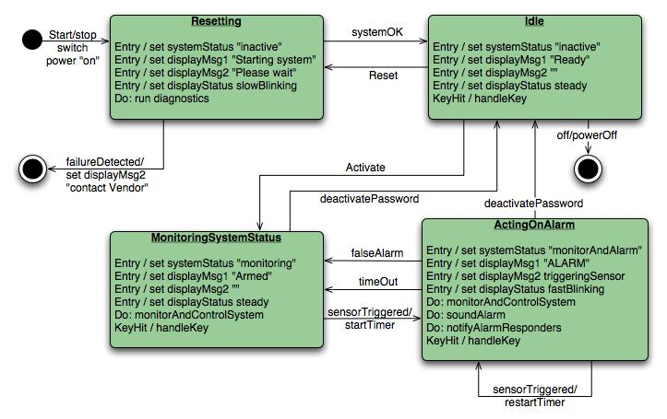

Processing narrative
- When a sensor event is recognized, the software invokes an audible alarm attached to the system. After a delay time that is specified by the homeowner during system configuration activities, the software dials a telephone number of a monitoring service, provides information about the location, reporting the nature of the event that has been detected. The telephone number will be redialed every 20 seconds until a telephone connection is obtained.

