Elaboration Process
Lecture-12

System Boundaries
- By definition, use cases capture the functionality of a particular subject.
- Anything not realized by the subject is considered outside the system boundaries and should be modeled as an actor.
- This technique is very useful in determining the scope and assignment of responsibilities when designing a system, subsystem, or component.
- For example,
  - If while you are modeling an ATM system, your design discussions deviate into discussions of the details of the back-end banking system,
  - A use case model with clearly defined system boundaries would identify the banking system as an actor and therefore outside the scope of the problem.
  - You represent system boundaries in a generic sense using a simple rectangle, with the name of the system at the top.

A use case diagram showing the system boundaries of an ATM System

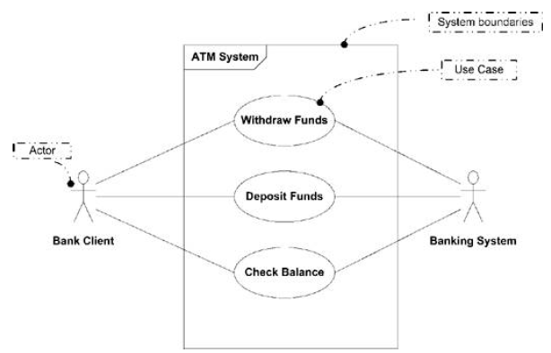

Use Case Relationships <include>
- The include relationship occurs when you have a chunk of behavior that is similar across more than one use case and you don't want to keep copying the description of that behavior.
- For instance, both Analyze Risk and Price Deal require you to rate the deal.
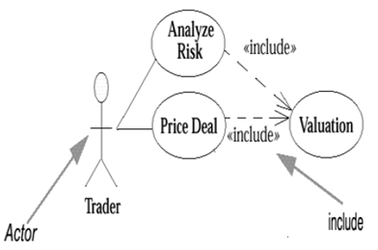

Use Case Relationships (generalization)
- You use use case generalization when you have one use case that is similar to another use case but does a bit more.
- In effect, this gives us another way of capturing alternative scenarios.
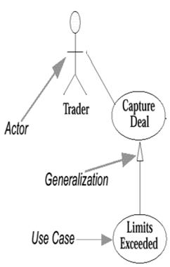

Use Case Relationships <extend>
- This is similar to generalization but with more rules to it.
- With this construct, the extending use case may add behavior to the base use case, but this time the base use case must declare certain "extension points," and the extending use case may add additional behavior only at those extension points.
- A use case may have many extension points, and an extending use case may extend one or more of these extension points.
- You indicate which ones on the line between the use cases on the diagram.
- Both generalization and extend allow you to split up a use case, when it getting too complicated.
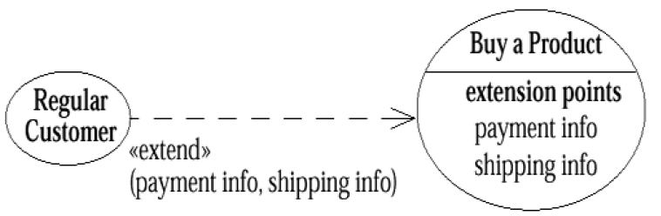

Apply the following rules
- Use include when you are repeating yourself in two or more separate use cases and you want to avoid repetition.
- Use generalization when you are describing a variation on normal behavior and you wish to describe it casually.
- Use extend when you are describing a variation on normal behavior and you wish to use the more controlled form, declaring your extension points in your base use case.
Format and guideline to write use case(s)
Use Case ID: | Enter a unique numeric identifier for the Use Case. e.g. UC-1.2.1
Use Case Name: | Enter a short name for the Use Case using an active verb phrase. e.g. Withdraw Cash
Actors: | [An actor is a person or other entity external to the software system being specified who interacts with the system and performs use cases to accomplish tasks. Different actors often correspond to different user classes, or roles, identified from the customer community that will use the product. Name the actor that will be initiating this use case (primary) and any other actors who will participate in completing the use case (secondary).]
Description: | [Provide a brief description of the reason for and outcome of this use case.]
Trigger: | [Identify the event that initiates the use case. This could be an external business event or system event that causes the use case to begin, or it could be the first step in the normal flow.]
Preconditions: | [List any activities that must take place, or any conditions that must be true, before the use case can be started. Number each pre-condition. e.g.  - Customer has active deposit account with ATM privileges  - Customer has an activated ATM card.]
Postconditions: | [Describe the state of the system at the conclusion of the use case execution. Should include both minimal guarantees (what must happen even if the actor’s goal is not achieved) and the success guarantees (what happens when the actor’s goal is achieved. Number each post-condition. e.g.  - Customer receives cash  - Customer account balance is reduced by the amount of the withdrawal and transaction fees]
Normal Flow: | [Provide a detailed description of the user actions and system responses that will take place during execution of the use case under normal, expected conditions. This dialog sequence will ultimately lead to accomplishing the goal stated in the use case name and description.  - Customer inserts ATM card  - Customer enters PIN  - System prompts customer to enter language performance English or Spanish  - System validates if customer is in the bank network  - System prompts user to select transaction type  - Customer selects Withdrawal From Checking  - System prompts user to enter withdrawal amount  - …  - System ejects ATM card]
Alternative Flows:  [Alternative Flow 1 – Not in Network] | [Document legitimate branches from the main flow to handle special conditions (also known as extensions). For each alternative flow reference the branching step number of the normal flow and the condition which must be true in order for this extension to be executed. e.g. Alternative flows in the Withdraw Cash transaction:  4a. In step 4 of the normal flow, if the customer is not in the bank network  - System will prompt customer to accept network fee  - Customer accepts  - Use Case resumes on step 5  4b. In step 4 of the normal flow, if the customer is not in the bank network  - System will prompt customer to accept network fee  - Customer declines  - Transaction is terminated  - Use Case resumes on step 9 of normal flow  Note: Insert a new row for each distinctive alternative flow. ]
Exceptions: | [Describe any anticipated error conditions that could occur during execution of the use case, and define how the system is to respond to those conditions.  e.g. Exceptions to the Withdraw Case transaction  2a. In step 2 of the normal flow, if the customer enters and invalid PIN  - Transaction is disapproved  - Message to customer to re-enter PIN  - Customer enters correct PIN  - Use Case resumes on step 3 of normal flow]
Includes: | [List any other use cases that are included (“called”) by this use case. Common functionality that appears in multiple use cases can be split out into a separate use case that is included by the ones that need that common functionality. e.g. steps 1-4 in the normal flow would be required for all types of ATM transactions- a Use Case could be written for these steps and “included” in all ATM Use Cases.]
Special Requirements: | [Identify any additional requirements, such as nonfunctional requirements, for the use case that may need to be addressed during design or implementation. These may include performance requirements or other quality attributes.]
Assumptions: | [List any assumptions that were made in the analysis that led to accepting this use case into the product description and writing the use case description.  e.g. For the Withdraw Cash Use Case, an assumption could be:  The Bank Customer understands either English or Spanish language.]
Notes and Issues: | [List any additional comments about this use case or any remaining open issues or TBDs (To Be Determined) that must be resolved. e.g.  - What is the maximum size of the that a use can have?]

Example
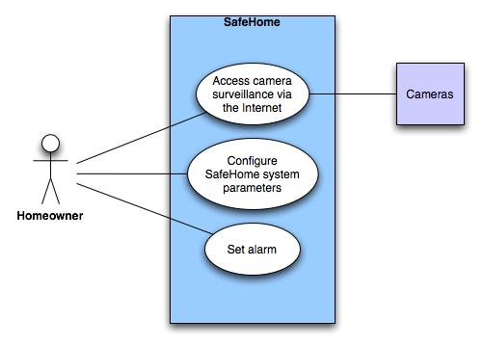

Alternate Actions
- Can the actor take some other action at this point?
- Is it possible that the actor will encounter some error condition at this point?
- Is it possible that the actor will encounter behavior invoked by some event outside the actor’s control?

Activity Diagram
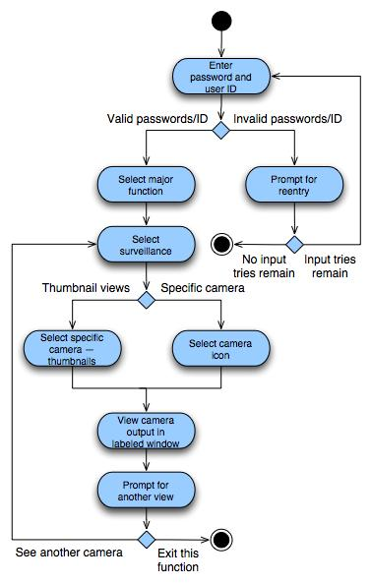

Swimlane Diagram
