Elicitation and Analysis
Lecture-11

Goals of Analysis Modeling
- Provides the first technical representation of a system
- Is easy to understand and maintain
- Deals with the problem of size by partitioning the system
- Uses graphics whenever possible
- Differentiates between essential information versus implementation information
- Helps in the tracking and evaluation of interfaces
- Provides tools other than narrative text to describe software logic and policy

Analysis Rules of Thumb
- The analysis model should focus on requirements that are visible within the problem or business domain
- The level of abstraction should be relatively high
- Each element of the analysis model should add to an overall understanding of software requirements and provide insight into the following
- Information domain, function, and behavior of the system
- The model should delay the consideration of infrastructure and other non-functional models until the design phase
- First complete the analysis of the problem domain
- The model should minimize coupling throughout the system
- Reduce the level of interconnectedness among functions and classes
- The model should provide value to all stakeholders
- The model should be kept as simple as can be

Analysis Modeling Approaches
- Structured analysis
  - Considers data and the processes that transform the data as separate entities
  - Data is modeled in terms of only attributes and relationships (but no operations)
  - Processes are modeled to show the 1) input data, 2) the transformation that occurs on that data, and 3) the resulting output data
- Object-oriented analysis
  - Focuses on the definition of classes and the manner in which they collaborate with one another to fulfill customer requirements

Elements of the Analysis Model
- Scenario-based elements
  - Describe the system from the user's point of view using scenarios that are depicted in use cases and activity diagrams
- Class-based elements
  - Identify the domain classes for the objects manipulated by the actors, the attributes of these classes, and how they interact with one another; they utilize class diagrams to do this
- Behavioral elements
  - Use state diagrams to represent the state of the system, the events that cause the system to change state, and the actions that are taken as a result of a particular event; can also be applied to each class in the system
- Flow-oriented elements
  - Use data flow diagrams to show the input data that comes into a system, what functions are applied to that data to do transformations, and what resulting output data are produced

Developing Use Cases
- Step One – Define the set of actors that will be involved in the story
  - Actors are people, devices, or other systems that use the system or product within the context of the function and behavior that is to be described
  - Actors are anything that communicate with the system or product and that are external to the system itself
- Step Two – Develop use cases, where each one answers a set of questions

Questions Commonly Answered by a Use Case
- Who is the primary actor(s), the secondary actor(s)?
- What are the actor’s goals?
- What preconditions should exist before the scenario begins?
- What main tasks or functions are performed by the actor?
- What exceptions might be considered as the scenario is described?
- What variations in the actor’s interaction are possible?
- What system information will the actor acquire, produce, or change?
- Will the actor have to inform the system about changes in the external environment?
- What information does the actor desire from the system?
- Does the actor wish to be informed about unexpected changes?

When to Use Use Cases
- No body can imagine a situation in which use cases are not used.
- They are an essential tool in requirements capture and in planning and controlling an iterative project.
- Capturing use cases is one of the primary tasks of the elaboration phase.
- Every use case is a potential requirement, and until you have captured a requirement, you cannot plan to deal with it.
- Some people list and discuss the use cases first, then do some modeling..
- It is important to remember that use cases represent an external view of the system. As such, don't expect any correlations between use cases and the classes inside the system.
- Use cases are not as helpful in identifying the nonfunctional aspects of the system requirements, such as the requirements for usability, reliability, performance, and the like. We'll rely on other techniques to address these issues.

What is a scenario?
- A scenario is a sequence of steps describing an interaction between a user and a system.
- So if we have a Web-based online store, we might have a Buy a Product scenario that would say this:
- The customer browses the catalog and adds desired items to the shopping basket. When the customer wishes to pay, the customer describes the shipping and credit card information and confirms the sale.
- The system checks the authorization on the credit card and confirms the sale both immediately and with a follow-up email.
- This scenario is one thing that can happen. However, the credit card authorization might fail. This would be a separate scenario.

What is use case
- A use case, then, is a set of scenarios tied together by a common user goal.
- Other, alternative paths for the use case would be further scenarios.
- A simple format for capturing a use case involves describing its primary scenario as a sequence of numbered steps and the alternatives as variations on that sequence
Example Use Case Text
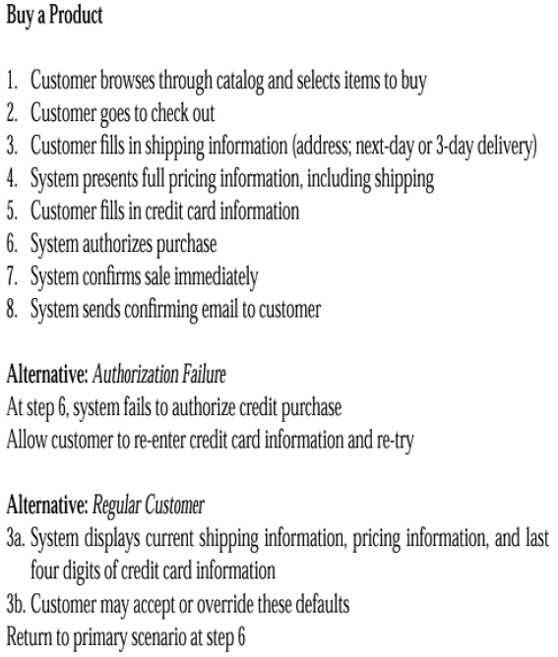

Additional section
- There are also additional sections you can add. For example, you can add a line for preconditions, which are things that should be true when the use case can start.
- Take a look at the various books that address use cases, and add the elements that make sense for you.
- Don't include everything, just those things that really seem to help

Use Case Diagrams-example
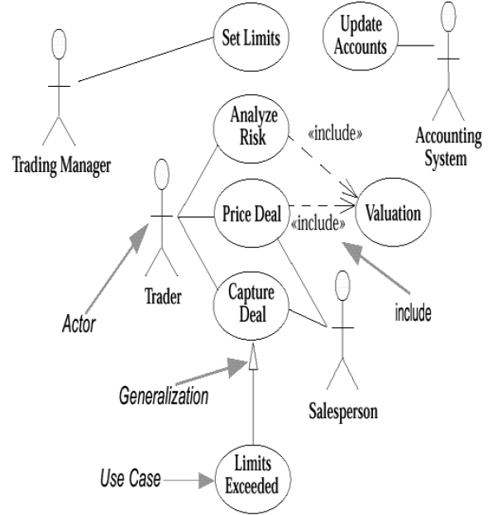

Actors
- An actor is a role that a user plays with respect to the system. There are four actors in the Figure
  - Trading Manager,
  - Trader,
  - Salesperson,
  - and Accounting System.
- There will probably be many traders in the given organization, but as far as the system is concerned, they all play the same role.
- A user may also play more than one role.
  - For instance, one senior trader may play the Trading Manager role and also be a regular trader;
  - A Trader may also be a Salesperson.
- When dealing with actors, it is important to think about roles rather than people or job titles.
- Actors carry out use cases.
- A single actor may perform many use cases; conversely, a use case may have several actors performing it.
- In practice, actors are most useful when trying to come up with the use cases.
- Faced with a big system, it can often be difficult to come up with a list of use cases.
- It is easier in those situations to arrive at the list of actors first, and then try to work out the use cases for each actor.
- Actors don't need to be human, even though actors are represented as stick figures within a use case diagram.
- An actor can also be an external system that needs some information from the current system.
- Different representation of an actor
- There are several variations on what people show as actors.
- Some people show every external system or human actor on the use case diagram;
- Others prefer to show the initiator of the use case.
- But recommended is to show the actor that gets value from the use case, which some people refer to as the primary actor.

- There are some situations in which it can be worth tracking the actors later.
  - The system may need configuring for various kinds of users. In this case, each kind of user is an actor, and the use cases show you what each actor needs to do.
  - Tracking who wants use cases can help you negotiate priorities among various actors.

- Some use cases don't have clear links to specific actors.
- Consider a utility company. Clearly, one of its use cases is Send Out Bill.
- A good source for identifying use cases is external events.
- Think about all the events from the outside world to which you (system) want to react.
- A given event may cause a system reaction that does not involve users, or it may cause a reaction mainly from the users.
- Identifying the events that you need to react to will help you identify the use cases.

