Software Quality Engineering
Lecture No. 32
Revision of the course
Test Planning and Preparation
  - Major testing activities:
    - . test planning and preparation
    - . execution (testing)
    - . analysis and follow-up
  - Test planning:
    - . goal setting
    - . overall strategy
  - Test preparation:
    - . preparing test cases & test suite(s) (systematic: model-based; our focus)
    - . preparing test procedure
Applications of Testing Techniques
• Major testing techniques covered so far:
- . Ad hoc (non-systematic) testing.
- . Checklist-based testing.
- . Partition-based coverage testing.
- . Musa’s OP for UBST.
- . Boundary testing (BT).
- . Control flow testing (CFT).
- . Data flow testing (DFT)
• Application and adaptation issues:
- . For different purposes/goals.
- . In different environments/sub-phases.
- . Existing techniques: select/adapt.
- . May need new or specialized techniques.
Testing Sub-Phases: V-Model
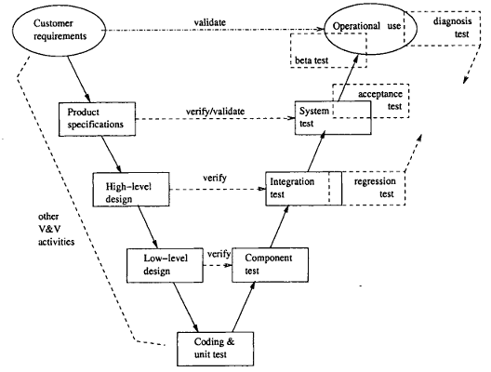
Testing sub-phases associated with the V-Model
Testing Levels
Unit Testing
- Programs will be tested at unit level
- The same developer will do the test
Integration Testing
- When all the individual program units are tested in the unit testing phase and all units are clear of any known bugs, the interfaces between those modules will be tested
- Ensure that data flows from one piece to another piece
System Testing
- After all the interfaces are tested between multiple modules, the whole set of software is tested to establish that all modules work together correctly as an application.
- Put all pieces together and test
Acceptance Testing
- The client will test it, in their place, in a near-real-time or simulated environment.
Testing Vs Debugging
- Testing is focused on identifying the problems in the product
- Done by Tester
- Need not know the source code
- Debugging is to make sure that the bugs are removed or fixed
- Done by Developer
- Need to know the source Code
QA Alternatives
  - Defect and QA:
- . Defect: error/fault/failure.
- . Defect prevention/removal/containment.
- . Map to major QA activities
  - Defect prevention:
- Error source removal & error blocking
  - Defect removal: Inspection/testing/etc.
  - Defect containment: Fault tolerance and failure containment (safety assurance).
Generic Ways for Defect Prevention
  - Error blocking
- . Error: missing/incorrect actions
- . Direct intervention
- . Error blocked ⇒ fault injections prevented (or errors tolerated)
- . Rely on technology/tools/etc.
  - Error source removal
- . Root cause analysis ⇒ identify error sources
- . Removal through education/training/etc.
Inspection as Part of QA
  - Throughout the software process
- . Coding phase: code inspection
- . Design phase: design inspection
- . Inspection in other phases and at transitions from one phase to another
  - Many different software artifacts:
- . program code, typically
- . requirement/design/other documents
- . charts/models/diagrams/tables/etc.
  - Other characteristics:
- . People focus.
- . Not waiting for implemented system.
- . Complementary to other QA activities.
Generic Inspection Process
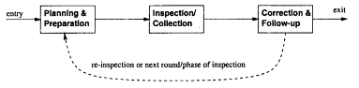
1. Planning and preparation (individual)
2. Collection (group/meeting)
3. Repair (follow-up)
Inspection Process Variations
  - Overall planning:
- . who? team organization/size/roles/etc. .
- what? inspection objects
- . objectives?
- . number/coordination of multiple sessions?
  - Technique
- . for preparation (individual inspection)
- . for collection
  - What to do with defects?
- . always: detect and confirm defects
- . classify/analyze defects for feedback?
  - Use of post-collection feedback?
Fagan Inspection
• General description
- . Earliest, Fagan at IBM
- . Lead to other variations
- . Generic process and steps
• Six steps of Fagan inspection:
1. Planning
2. Overview (1-to-n meeting)
3. Preparation (individual inspection)
4. Inspection (n-to-n meeting)
5. Rework
6. Follow-up.
Other Inspection Methods
Variations to Fagan inspection: size/scope and formality variations.
Alternative inspection techniques/processes:
- . Two-person inspection
- . Meeting-less inspections
- . Gilb inspection
- . Phased inspections
- . N-fold inspections
- . Informal check/review/walkthrough
- . Active design reviews
- . Inspection for program correctness
- . Code reading
- . Code reading with stepwise abstraction
QA and Formal Verification
• Formal methods = formal specification + formal verification
• Formal specification (FS):
- . As part of defect prevention
- . Formal ⇒ prevent/reduce defect injection due to imprecision, ambiguity, etc.
- . Briefly covered as related to FV.
• Formal verification (FV):
- . As part of QA, but focus on positive: “Prove absence of fault”
- . People intensive
- . Several commonly used approaches
Formal Specification: Ideas
Formal specification:
- . Correctness focus
- . Different levels of details
- . 3Cs: complete, clear, consistent
- . Two types: descriptive & behavioral
Descriptive formal specifications:
- . Logic: pre-/post-conditions.
- . Math functions
- . Notations and language support: Z, VDM, etc.
Behavioral formal specifications: FSM, Petri-Net, etc.

Formal Specification: Ideas
• “Testing shows the presence of errors, not their absence.” — Dijkstra
• Formal verification: proof of correctness
- . Formal specs: as pre/post-conditions
- . Axioms for components or functional units
- . Composition (bottom-up, chaining)
- . Development and verification together
• Other related approaches:
- . Semi-formal verification
- . Model checking
- . Inspection for correctness
Formal Verification Basics
• Basic approaches:
- . Floyd/Hoare axiomatic
- . Dijkstra/Gries weakest precondition (WP)
- . Mills’ program calculus/functional approach
• Basis for verification:
- . logic (axiomatic and WP)
- . mathematical function (Mills)
- . other formalisms
• Procedures/steps used:
- . bottom-up (axiomatic)
- . backward chaining (WP)
- . forward composition (Mills), etc.
QA and Fault Tolerance (FT)
• Fault tolerance as part of QA:
- . Duplication: over time or components
- . High cost, high reliability
- . Run-time/dynamic focus
- . FT design and implementation
- . Complementary to other QA activities
• General idea
- . Local faults not lead to system failures
- . Duplication/redundancy used
- . redo ⇒ recovery block (RB)
- . parallel redundancy
⇒ N version programming (NVP)
FT: Recovery Blocks (RB)
General idea:
- . Periodic check-pointing
- . Problem detection/acceptance test
- . Rollback (recovery)
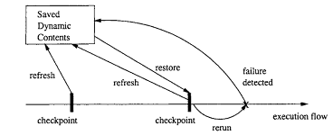
FT: Recovery Blocks (RB)
• Periodic check-pointing
- . too often: expensive check-pointing
- . too rare: expensive recovery
- . smart/incremental check-pointing
• Problem detection/acceptance test
- . exceptions due to in/external causes
- . periodic vs event-triggered
• Recovery (rollback) from problems:
- . external disturbance: environment?
- . internal faults: tolerate/correct?
Fault Tolerance: N- Version Programming
• FT with NVP:
- . NVP: N-Version Programming
- . Multiple independent versions
- . Dynamic voting/decision ⇒ FT.

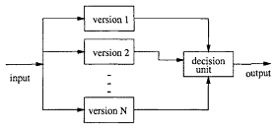
Fault Tolerance: N- Version Programming
Multiple independent versions
- . Multiple: parallel vs backup?
- . How to ensure independence?
Support environment:
- . concurrent execution
- . switching
- . voting/decision algorithms
Correction/recovery?
- . p-out-of-n reliability
- . in conjunction with RB
- . dynamic vs. off-line correction
FT/NVP: Ensure Independence
Ways to ensure independence:
- . People diversity: type, background, training, teams, etc. . Process variations
- . Technology: methods/tools/PL/etc.
. End result/product:
- design diversity: high potential
- implementation diversity: limited
Ways to ensure design diversity:
- . People/teams
- . Algorithm/language/data structure
- . Software development methods
- . Tools and environments
- . Testing methods and tools
- . Formal/near-formal specifications
Hazard Elimination
• Hazard sources identification ⇒ elimination (Some specific faults prevented or removed.)
• Traditional QA (but with hazard focus):
- . Fault prevention activities:
- education/process/technology/etc
- formal specification & verification
- . Fault removal activities:
- rigorous testing/inspection/analyses
• “Safe” design: More specialized techniques:
- . Substitution, simplification, decoupling.
- . Human error elimination.
- . Hazardous material/conditions↓
Hazard Reduction
• Hazard identification ⇒ reduction (Some specific system failures prevented or tolerated.)
• Traditional QA (but with hazard focus):
- . Fault tolerance
- . Other redundancy
• “Safe” design: More specialized techniques:
- . Creating hazard barriers
- . Safety margins and safety constraints
- . Locking devices
- . Reducing hazard likelihood
- . Minimizing failure probability
- . Mostly “passive” or “reactive”
Hazard Control
• Hazard identification ⇒ control
- . Key: failure severity reduction.
- . Post-failure actions.
- . Failure-accident link weakened.
- . Traditional QA: not much, but good design principles may help.
• “Safe” design: More specialized techniques:
- . Isolation and containment
- . Fail-safe design & hazard scope↓
- . Protection system . More “active” than “passive”
- . Similar techniques to hazard reduction,
- but focus on post-failure severity↓ vs. pre-failure hazard likelihood↓.
Software Safety Program (SSP)
• Leveson’s approach (Leveson, 1995) — Software safety program (SSP)
• Process and technology integration
- . Limited goals
- . Formal verification/inspection based
- . But restricted to safety risks
- . Based on hazard analyses results
- . Safety analysis and hazard resolution
- . Safety verification:
  - few things carried over
Software Safety Program (SSP)
  - In overall development process:
- . Safety as part of the requirement
- . Safety constraints at different levels/phases
- . Verification/refinement activities
- . Distribution over the whole process
TFM: Two-Frame-Model
• TFM: Two-Frame-Model
- . Physical frame
- . Logical frame
- . Sensors: physical ⇒ logical
- . Actuators: logical ⇒ physical
• TFM characteristics and comparison:
- . Interaction between the two frames
- . Nondeterministic state transitions and encoding/decoding functions
- . Focuses on symmetry/consistency between the two frames.
Comparison of the QA Alternatives: Applicability
• Objects QA activities applied on:
- . Mostly on specific objects, e.g., testing executable code
- . Exception: defect prevention on (implementation related) dev. Activities
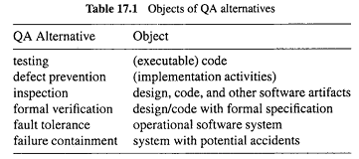
Comparison: Applicability
• Applicability to development phases:
- . In waterfall or V-model: implementation (req/design/coding) & testing/later.
- . Inspection in all phases.
- . Other QA in specific sets of phases.
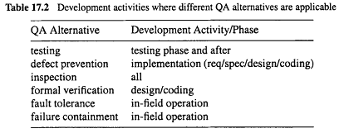
Comparison: Applicability/Expertise
• General expertise levels: mostly in ranges, depending on specific techniques used.
• Specific background knowledge
Required expertise and background knowledge for people to perform different QA Alternatives
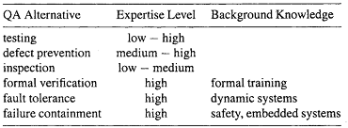
Comparison: Effectiveness
• Defect specifics or perspectives:
. Dealing with errors/faults/failures?
. Direct action vs follow-up action: may deal with different defect perspectives.
. Example: failures detected in testing but (failure-causing) faults fixed in follow-up.
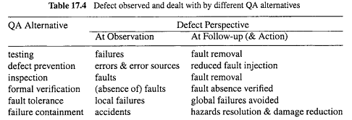
Comparison: Effectiveness
Problem or defect types:
errors/faults/failures of different types or characteristics
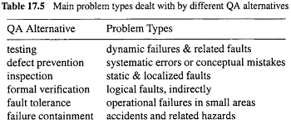
Comparison: Effectiveness
Ease of result interpretation
Specific info/measurement
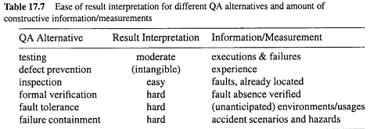
Comparison: Cost
• Overall cost comparison:
- . rough values and ranges
- . multiple factors but focus on performing the specific QA activities
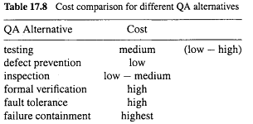
Importance of Feedback Loop
All QA activities covered in Part II and Part III need additional support:
- . Planning and goal setting
- . Management via feedback loop:
  - When to stop?
  - Adjustment and improvement, etc.
All based on assessments/predictions
Importance of Feedback Loop
Feedback loop for quantification/improvement:
- . Focus of Part IV chapters .
  - mechanism and implementation.
  - models and measurements.
  - defect analyses and techniques.
  - risk identification techniques.
  - software reliability engineering
QE Activities and Process Review
• Major activities:
- . Pre-QA planning (earlier lectures).
- . QA (Part II and Part III).
- . Post-QA analysis & feedback
Part IV (maybe parallel instead of “post-”)
• Overall process:– Software quality engineering (SQE)
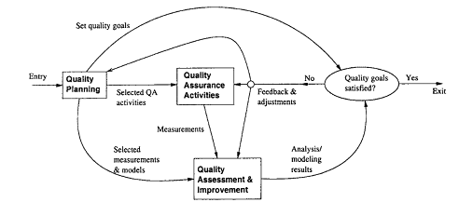
Quality Engg. Process
QE Activities and Process Review
Feedback loop zoom-in:
. Multiple measurement sources.
. Many types of analysis performed.
. Multiple feedback paths.
Refined Quality Engineering Process: Management, Analysis and feedback for Quantifiable improvement
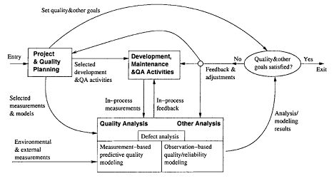
Quality Models
  - Model taxonomy:
- . Generalized:
- overall, segmented, and dynamic
- . Product-specific:
- semi-customized: product history
- observation-based: observations
- measurement-driven: predictive
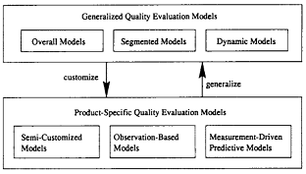
Quality Model Summary
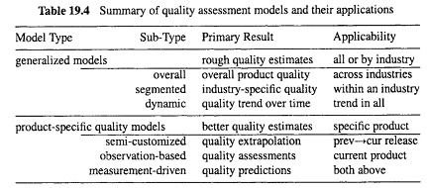
Defect Analysis
Goal: (actual/potential) defect↓ or quality↑ in current and future products.
General defect analyses:
- . Questions: what/where/when/how/why?
- . Distribution/trend/causal analyses.
- Analyses of classified defect data:
- . Prior: defect classification.
- . Use of historical baselines.
- . Attribute focusing in 1-way and 2-way analyses.
- . Tree-based defect analysis (Lecture 29)
Defect in Quality Data/Models
• Defect data ⊂ quality measurement data:
- . As part of direct Q data.
- . Extracted from defect tracking tools.
- . Additional (defect classification) data may be available.
• Defect data in quality models:
- . As results in generalized models (GMs).
- . As r.v. (response/independent variable) in product specific models (PSMs).
  - semi-customized models ≈ GMs,
  - observation-based: r.v. in SRGMs,
  - predictive: r.v. in TBDMs
General Defect Analysis
• General defect analyses: Questions
- . What? identification (and classification).
- type, severity, etc.,
- even without formal classification.
- . Where? distribution across location.
- . When? discovery/observation
- what about when injection? harder
- pre-release: more data
- post-release: more meaningful/sensitive
- . How/why? related to injection
⇒ use in future defect prevention.
Risk Identification: Why?
• Observations and empirical evidences:
- . 80:20 rule: non-uniform distribution:
- 20% of the modules/parts/etc. contribute to
- 80% of the defects/effort/etc.
- . implication: non-uniform attention – risk identification – risk management/resolution
• Risk Identification in SQE:
- . 80:20 rule as implicit hypothesis
- . focus: techniques and applications
Risk Identification: How?
• Qualitative and subjective techniques:
- . Causal analysis
- . Delphi and other subjective methods
• Traditional statistical techniques:
- . Correlation analysis
- . Regression models:
- linear, non-linear, logistic, etc.
• Newer (more effective) techniques:
- . Statistical: PCA, DA, TBM
- . AI-based: NN, OSR
- . Focus of our Lecture.
Risk Identification Techniques
• New statistical techniques:
- . PCA: principal component analysis
- . DA: discriminant analysis
- . TBM: tree-based modeling
• AI-based new techniques:
- . NN: artificial neural networks.
- . OSR: optimal set reduction.
- . Abductive-reasoning, etc.
What Is SRE
• Reliability: Probability of failure-free operation for a specific time period or input set under a specific environment
- . Failure: behavioral deviations
- . Time: how to measure?
- . Input state characterization and Environment: OP
• Software reliability engineering:
- . Engineering (applied science) discipline
- . Measure, predict, manage reliability
- . Statistical modeling
- . Customer perspective:
– failures vs. faults
– meaningful time vs. development days
– customer operational profile
The End of the Course

