Software Quality Engineering
Lecture No. 31
REVISION
Summary of the previous lecture
- In previous lecture, we talked about the Software Reliability Engineering (SRE)
- Concepts and Approaches
- Existing Approaches: SRGMs & IDRMs
- Assessment & Improvement with TBRMs
Revision of the course
Course overview
- The course is comprised of 32 lectures and is divided in following parts:
- Part - 1: Overview and Basics.
- Part - 2: Software Testing: models & techniques, management, automation, and integration,
- Part - 3: Other Quality Assurance Techniques:
defect prevention, process improvement, inspection, formal verification, fault tolerance, accident prevention, and safety assurance.
- Part – 4: Quantifiable Quality Improvement: analysis and feedback, measurements and models, defect analysis, risk identification, and software reliability engineering.
The Software Engineering
“Software is instructions (computer programs) that when executed provide desired function and performance.
Or
Data structures that enable the programs to adequately manipulate information”
(Roger S. Pressman)

The Software Engineering
Characteristics of a software:
1. Software is developed or engineered, it is not manufactured in the classical sense.
  - Software doesn't "wear out.“

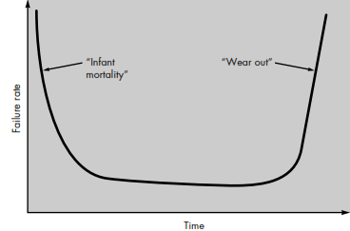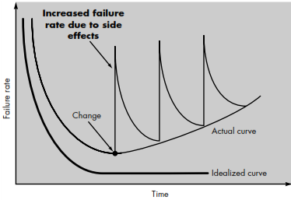

Hardware failure Software failure
Although the industry is moving toward component-based assembly, most software continues to be custom built.
Difference b/w Engineering and Manufacturing
- Engineering refers to planning or designing whereas manufacturing refers to using of machines and raw materials to physically make the thing.
- Manufacturing does not refer to making of civil architectures. Its called construction.
For example Company A makes the blueprint of a building. Its in engineering business. Company B makes cement and bricks to make the building. Its in manufacturing. Company C takes raw material from B and blue print from A and makes the building, Its in construction.
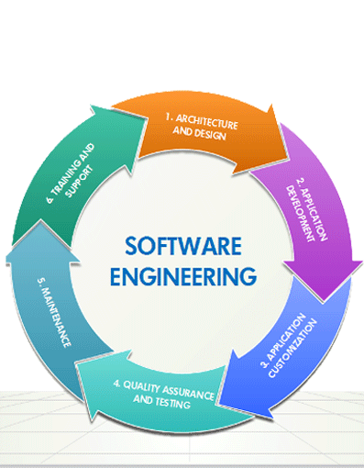
What is Quality
- In general, people’s quality expectations for software systems they use and rely upon are two-fold:
1. The software systems must do what they are supposed to do. In other words, they must do the right things.
2. They must perform these specific tasks correctly or satisfactorily. In other words, they must do the things right.
- Now you can define Software Quality Engineering.
SRE Perspectives
• New models and applications
- . Expand from “medium-reliable” systems.
  - New models for new application domains.
  - Data selection/treatment
• Reliability improvement
- . Followup to TBRMs
Predictive (early!) modeling for risk identification and management
• Other SRE frontiers:
- . Coverage/testing and reliability
- . Reliability composition and maximization
Meeting People’s Quality Expectations
- As we know that, if people’s expectations are met in any product, then the product is supposed to have quality in it.
- Must perform expected behavior.
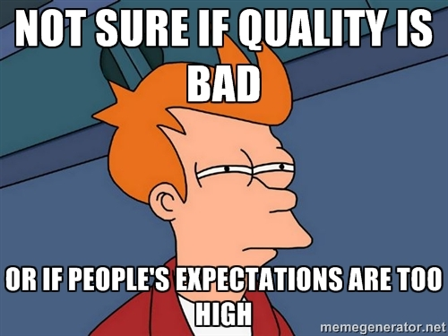
General Expectations
- General expectation: “good” software quality
  - Objects of our study: software
  - software products, systems, and services
  - stand-alone to embedded
  - software-intensive systems
- wide variety, but focus on software
  - Quality (and how “good”) formally defined in Ch.2
Quality Expectations
- People: Consumers vs producers .
- quality expectations by consumers
- to be satisfied by producers through software quality engineering (SQE)
- Deliver software system that... .
- does what it is supposed to do –
- needs to be “validated” .
- does the things correctly
  - needs to be “verified” .
- show/demonstrate/prove it (“does”) – modeling/analysis needed
Meeting Quality Expectations
- Difficulties in achieving good quality:
  - size: MLOC products common
  - Complexity
  - environmental stress/constraints
  - flexibility/adaptability expected
- Other difficulties/factors:
  - product type
  - cost and market conditions

Major SQE Activities
- Major SQE Activities:
- Testing: MLOC products common
- Other quality assurance alternatives to testing
- How do you know: analysis & modeling
- Scope and content hierarchy:
Software Quality Engineering
Quality Assurance
Testing
Correctness, Defect and Quality
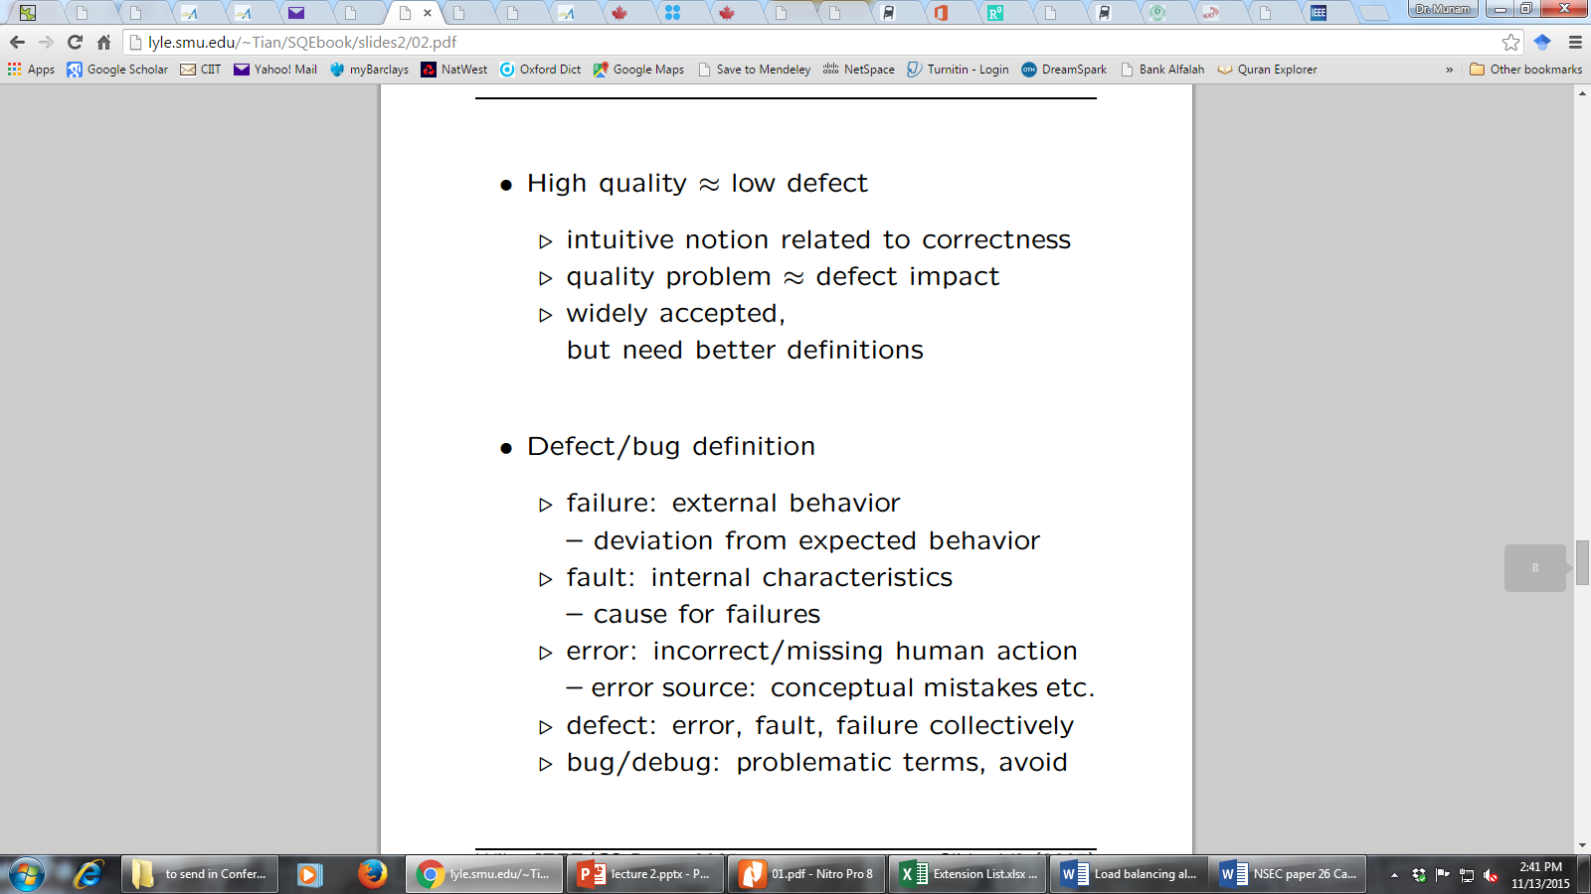
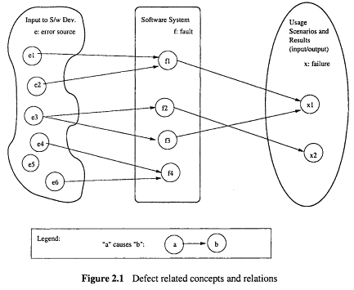
Defining Quality in SQE
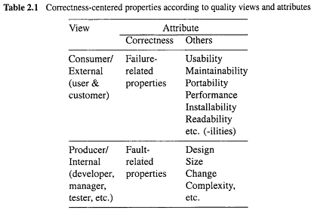

ISO-9126 Quality Framework
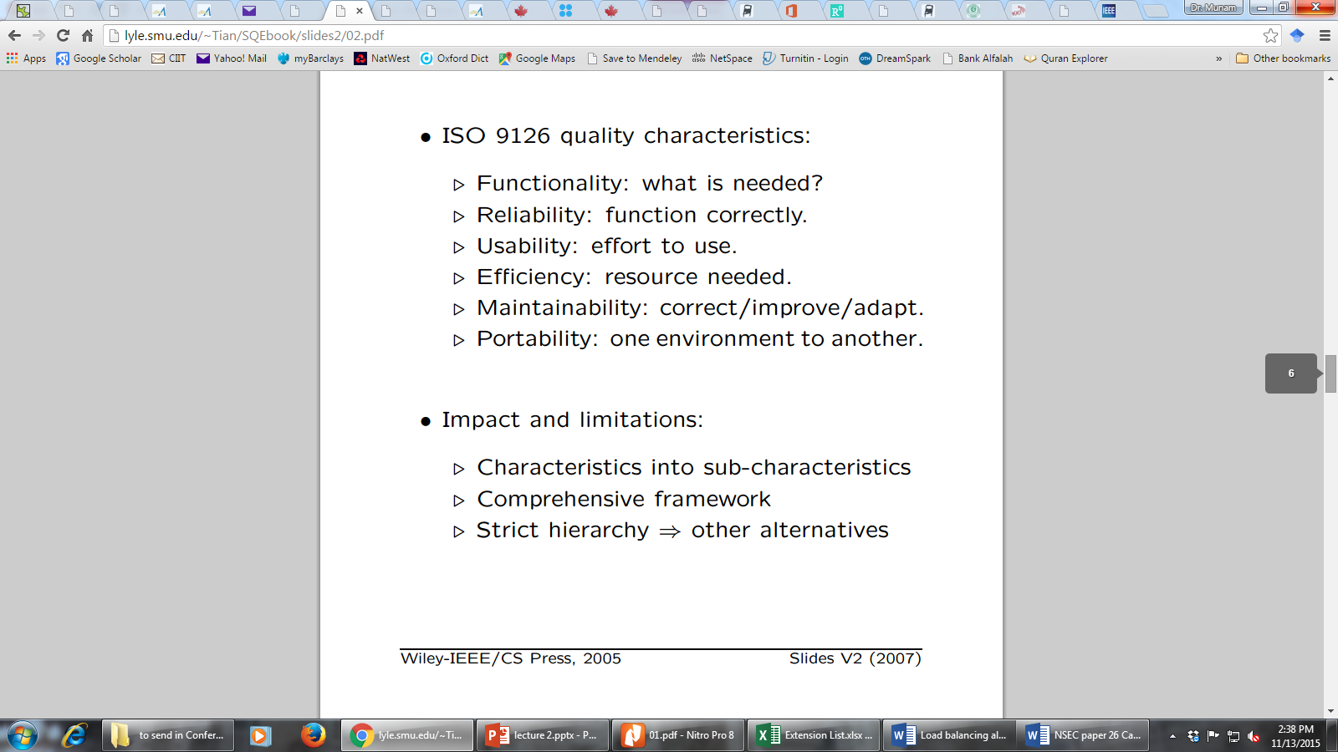
Other Quality Frameworks
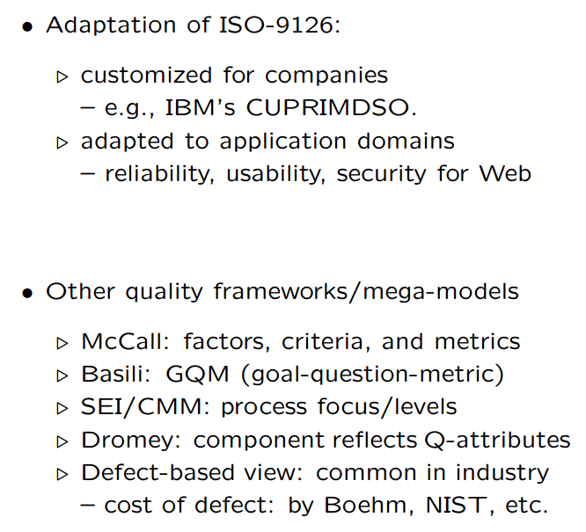

Quality Assurance
Quality Assurance mainly deals in
    - Dealing with Defect
    - Defect Prevention
    - Defect Detection and Removal
- QA focus on correctness aspect of Q
- QA as dealing with defects
  - – post-release: impact on consumers
  - – pre-release: what producer can do .
- what: testing & many others
- when: earlier ones desirable (lower cost) but may not be feasible
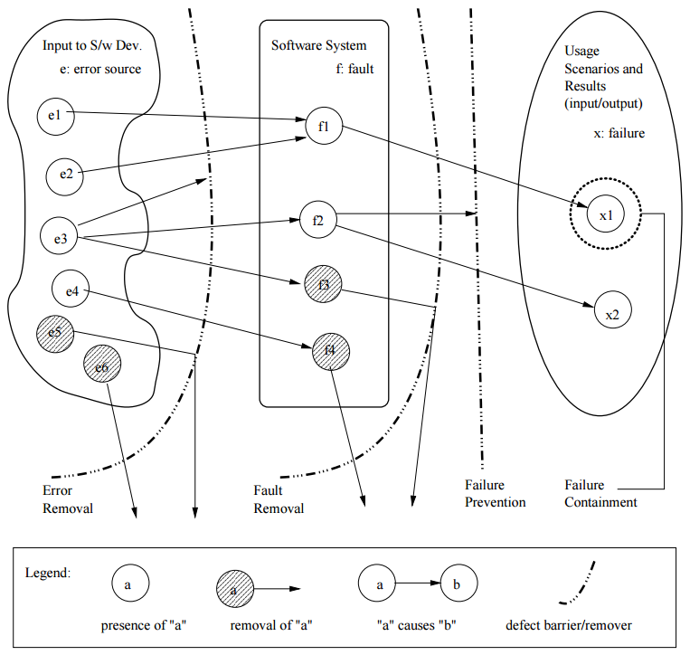
- how ⇒ classification below
QA Classification
dealing with errors, faults, or failures
removing or blocking defect sources
preventing undesirable consequences
Overview of some topics related to SQE
We covered the following topics in the course
- Detect Prevention
- Testing
- Fault Tolerance
- Safety Assurance
- Formal Method
- Inspection
QA in Software Processes
Mega-process:
- initiation, development, maintenance, termination.
Development process components:
- requirement, specification, design, coding, testing, release.

QA in software Process
Process variations:
- waterfall development process
- iterative development process
- spiral development process
- lightweight/agile development processes and XP (extreme programming)
- maintenance process too
- mixed/synthesized/customized processes
- QA important in all processes
QA in Waterfall Process
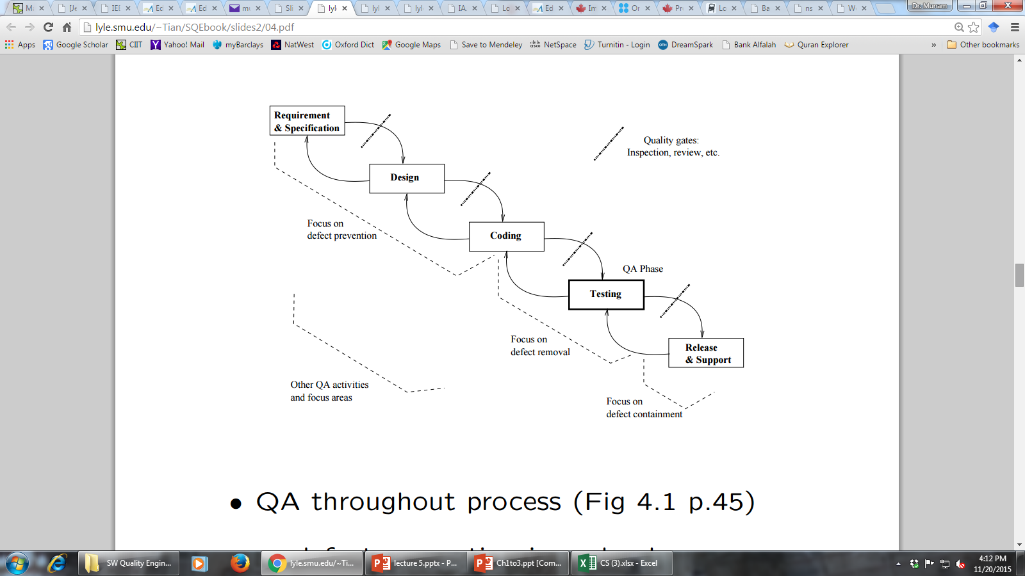
- defect prevention in early phases . focused defect removal in testing phase . defect containment in late phases . phase transitions: inspection/review/etc
QA in software Processes
- Process variations (¬ waterfall) and QA:
  - iterative: QA in iterations/increments
  - spiral: QA and risk management
  - XP: test-driven development
  - mixed/synthesized: case specific
  - more evenly distributed QA activities
- QA in maintenance processes:
  - focus on defect handling;
  - some defect containment activities for critical or highly-dependable systems;
  - data for future QA activities •
  - QA scattered throughout all processes
V & V
- Core QA activities grouped into V&V
- Validation: w.r.t. requirement (what?)
  - appropriate/fit-for-use/“right thing”?
  - scenario and usage inspection/testing;
  - system/integration/acceptance testing;
  - beta testing and operational support.
- Verification: w.r.t. specification/design (how?)
  - correct/“doing things right”?
  - design as specification for components;
  - structural and functional testing;
  - inspections and formal verification.
V&V in Software Process
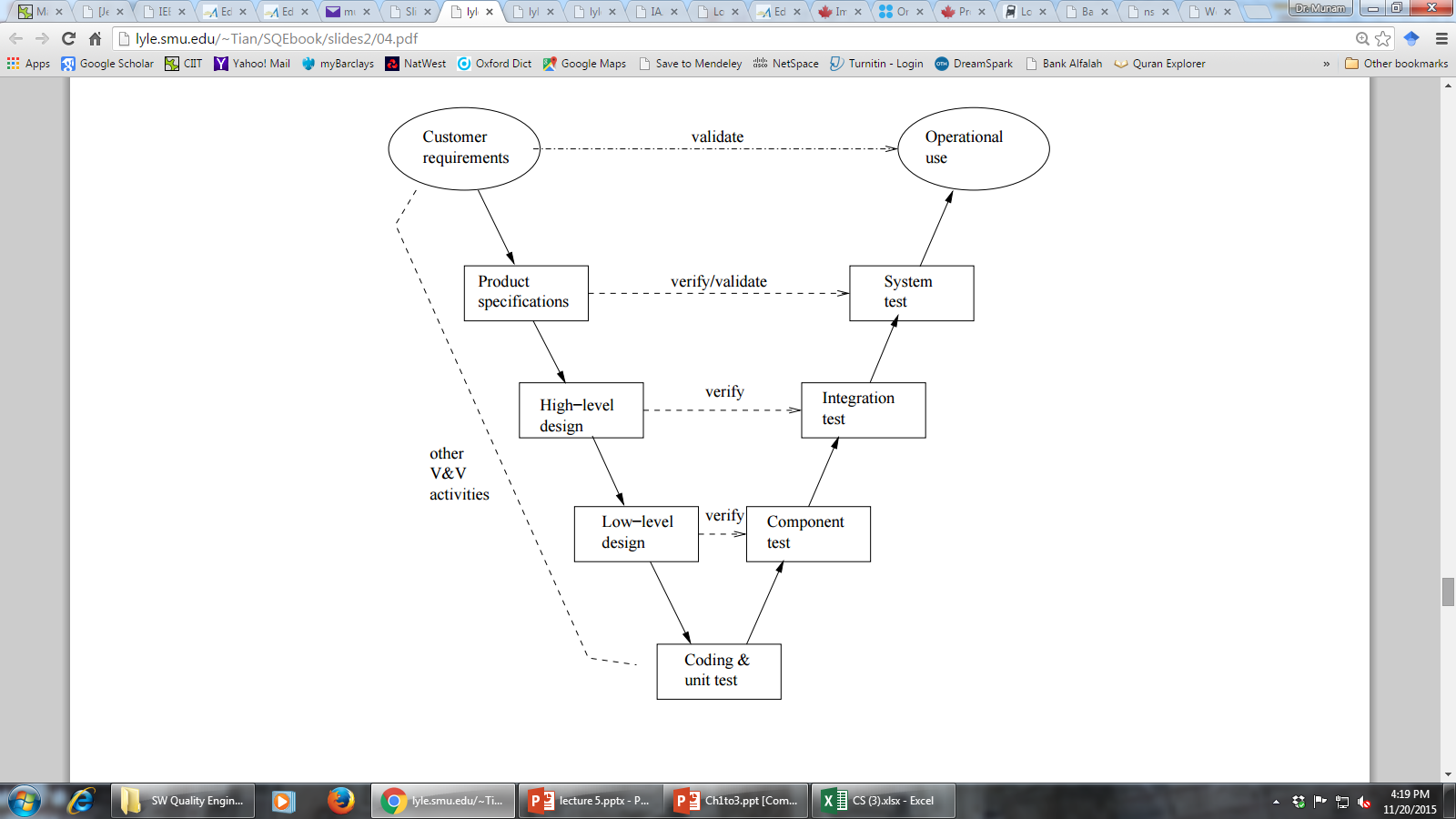
V & V
V-model
V&V in Software Process
- V-model as bent-over waterfall .
  - left-arm: implementation (& V&V)
  - right-arm: testing (& V&V)
  - user@top vs. developer@bottom
  - V&V vs DC View
Two views of QA:
  - V&V view
  - DC (defect-centered)
  - Interconnected: mapping possible?

QA to SQE
QA activities need additional support:
- Planning and goal setting
- Management:
  - when to stop?
  - adjustment and improvement, etc.
  - all based on assessments/predictions
Assessment of quality/reliability/etc.:
- Data collection needed
- Analysis and modeling
- Providing feedback for management
QA + above ⇒ software quality engineering (SQE)
SQE Process
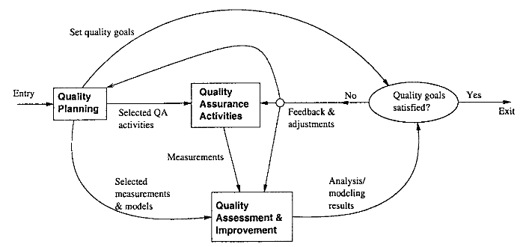
Quality Engineering Process
Quality Concepts
Software quality assurance is an umbrella activity that is applied throughout the software process.
SQA encompasses:
(1) a quality management approach
(2) effective software engineering technology
(3) formal technical reviews
(4) a multi-tiered testing strategy
(5) document change control
(6) software development standard and its control procedure
(7) measurement and reporting mechanism)
Quality Concepts
- Quality --> refers to measurable characteristics of a software. These items can be compared based on a given standard
- Two types of quality control:
Quality design -> the characteristics that designers specify for an item. --> includes: requirements, specifications, and the design of the system.
Quality of conformance -> the degree to which the design specification are followed. It focuses on implementation based on the design.
Quality Control
- What is quality control -- the series of inspections, reviews, and test used throughout the develop cycle of a software product
- Quality control includes a feedback loop to the process.
- Objective ---> minimize the produced defects, increase the product quality. Implementation approaches:
  - Fully automated
  - Entirely manual
  - Combination of automated tools and human interactions
Quality Control
- Key concept of quality control:
  - compare the work products with the specified and measurable standards
- Quality assurance consists of:
- the auditing and reporting function of management
- Goal --> provide management with the necessary data about product quality. --> gain the insight and confidence of product quality
Cost of Quality
prevention cost:
  - quality planning
  - formal technical reviews
  - testing equipment
  - training
appraisal cost:
  - in-process and inter-process inspection
  - equipment calibration and maintenance
  - testing
failure cost:
- internal failure cost:
- Repair, and failure mode analysis, external failure cost: complaint resolution, product return and replacement, help line support , warranty work
What is Software Testing
Several definitions:
“Testing is the process of establishing confidence that a program or system does what it is supposed to.” by Hetzel 1973
“Testing is the process of executing a program or system with the intent of finding errors.”
By Myers 1979
“Testing is any activity aimed at evaluating an attribute or capability of a program or system and determining that it meets its required results.”
by Hetzel 1983
What is Software Testing
- One of very important software development phases
- A software process based on well-defined software quality control and testing standards, testing methods, strategy, test criteria, and tools.
- Engineers perform all types of software testing activities to perform a software
test process.
- The last quality checking point for software on its production line
Software Testing
- “Testing is the process of executing a program with the intention of finding errors.”
- “Testing can show the presence of bugs but never their absence.”
Objective Testing
- Uncover as many as error(or bug) as possible in a given produce.
- Demonstrate a given software product matching its requirement specification.
- Validate the quality of a software testing using the minimum cost and effort.
- Generate high quality test case, perform effective test and issue correct and helpful problem report.

How Testing Has Changed
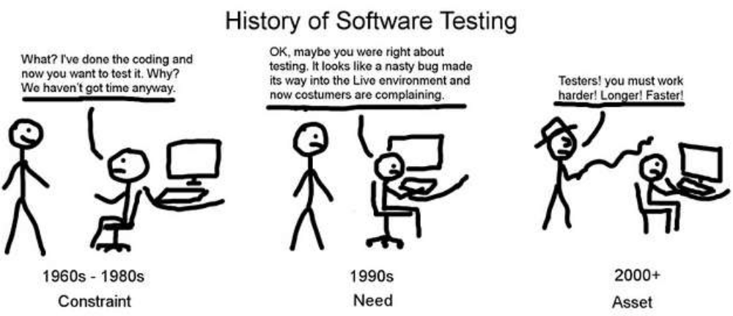
What? I have done the coding and now you want to test it? Why? We have not got time anyway
OK. May be you were right about testing. It looks like a nasty bug made its way into Live environment and now customers are complaining
Testers! You must work harder! Longer! Fasters!
History of Software Testing
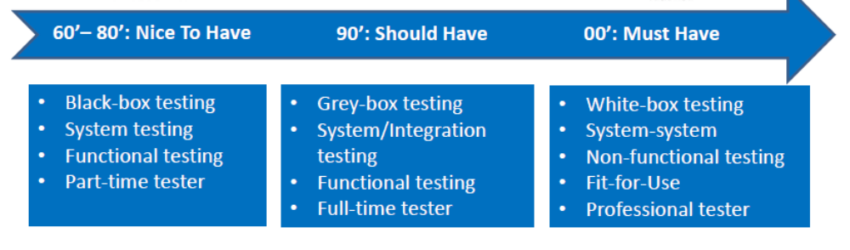
Phases in Testing
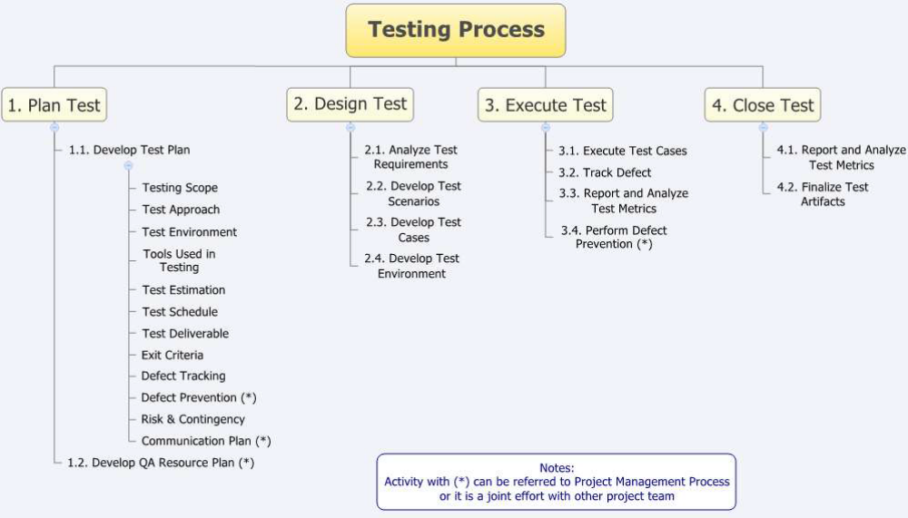
Defect Prevention Overview
- Error blocking
- error: missing/incorrect actions .
- direct intervention to block errors ⇒ fault injections prevented
- rely on technology/tools/etc.
- Error source removal .
- root cause analysis ⇒ identify error sources
- removal through education/training/etc.
- Systematic defect prevention via process improvement.
Formal Method Overview
Motivation .
- fault present: – revealed through testing/inspection/etc.
- fault absent: formally verify. (formal methods ⇒ fault absent)
Basic ideas .
- behavior formally specified:
- pre/post conditions, or
- as mathematical functions. .
- verify “correctness”: – intermediate states/steps, – axioms and compositional rules. .
- Approaches: axiomatic/functional/etc.
Inspection Overview
Artifacts (code/design/test-cases/etc.) from req./design/coding/testing/etc. phases. •
Informal reviews: .
- self-conducted reviews.
- independent reviews.
- orthogonality of views desirable.
Formal inspections: .
Fagan inspection and variations. .
- process and structure. .
- individual vs. group inspections. .
- what/how to check: techniques
Testing Overview
Product/Process characteristics: .
- object: product type, language, etc. .
- scale/order: unit, component, system, . . . .
- who: self, independent, 3rd party •
What to check: .
- verification vs. validation .
- external specifications (black-box) .
- internal implementation (white/clear-box)
Criteria: when to stop? .
- coverage of specs/structures. .
- reliability ⇒ usage-based testing
Fault Tolerance Overview
Motivation .
- fault present but removal infeasible/impractical .
- fault tolerance ⇒ contain defects.
FT techniques: break fault-failure link
- recovery: rollback and redo .
- NVP: N-version programming – fault blocked/out-voted
Safety Assurance Overview
- Extending FT idea for safety:
- fault tolerance to failure “tolerance” •
Safety related concepts: .
- safety: accident free .
- accident: failure w/ severe consequences .
- hazard: precondition to accident
Safety assurance: .
- hazard analysis .
- hazard elimination/reduction/control .
- damage control

THE END

