Software Quality Engineering
Lecture No. 30
Part- 4:
Quantifiable Quality Improvement
Summary of the previous lecture
- In our previous lecture, we talked about different techniques that are available for Risk Identification such as NN, PCA and OSR etc. Some of them are classified as statistical-based while other are Artificial Intelligence based
- Each technique has some merits and limitations.
- These techniques could be compared amongst each other using some parameters such as accuracy and usability etc.
Outlines of today’s lecture
- In today’s lecture, we will talk about the last topic of the course, i.e., Software Reliability Engineering (SRE)
  - Concepts and Approaches
  - Existing Approaches: SRGMs & IDRMs
  - Assessment & Improvement with TBRMs

Objectives
To understand and distinguish between different concepts and approaches used for Software Reliability Engineering (SRE)
What Is SRE
• Reliability: Probability of failure-free operation for a specific time period or input set under a specific environment
- . Failure: behavioral deviations
- . Time: how to measure?
- . Input state characterization and Environment: OP
• Software reliability engineering:
- . Engineering (applied science) discipline
- . Measure, predict, manage reliability
- . Statistical modeling
- . Customer perspective:
  - failures vs. faults
  - meaningful time vs. development days
  - customer operational profile
Assumption: SRE and OP
• Assumption 1: OP, to ensure software reliability from a user’s perspective.
• OP: Operational Profile
- . Quantitative characterization of the way a (software) system will be used.
- . Test case generation/selection/execution
- . Realistic assessment
- . Predictions (minimize discontinuity)
Other Assumptions in Context
• Assumption 2: Randomized testing
- . Independent failure intervals/observations
- . Approximation in large software systems
- . Adjustment for non-random testing
  - ⇒ new models or data treatments
• Assumption 3: Failure-fault relation
- . Failure probability ∼ # faults
- . Exposure through OP-based testing
- . Possible adjustment?
- . Statistical validity for large s/w systems

Other Assumptions and Context
• Assumption 4: time-reliability relation
- . time measurement in SRGMs
- . usage-dependent vs. usage-independent
- . proper choice under specific environment.
• Usage-independent time measurement:
- . calendar/wall-clock time
- . only if stable or constant workload
• Usage-dependent time measurement:
- . for systems with uneven workload
- . execution time – Musa’s models
- . alternatives: runs, transactions, etc.
Workload for Products: An example of IBM
IBM product D workload
- . number of test runs for each day
- . wide variability
- . need usage-dependent time measurement (# of runs used)
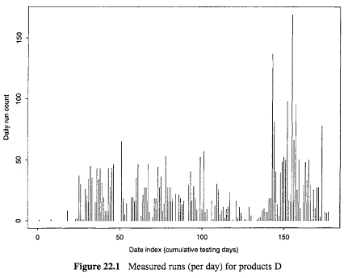
Input Domain Reliability Models (IDRMs)
• IDRMs: Current reliability snapshot based on observed testing data of n samples.
• Assessment of current reliability.
• Prediction of future reliability (limited prediction due to snapshot)
• Management and improvement
- . As acceptance criteria.
- . Risk identification and follow-ups:
  - reliability for input subsets
  - remedies for problematic areas
  - preventive actions for other areas
Nelson’s IDRM
• Nelson Model:
- . Running for a sample of n inputs.
- . Randomly selected from set E:
    - E = {Ei : i = 1, 2, . . . , N}
- . Sampling probability vector:
    - {Pi : i = 1, 2, . . . , N} .
- .{Pi}: Operational profile.
- . Number of failures: f.
- . Estimated reliability:
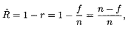
IDRM Applications
• Nelson model for web applications
daily error rates:
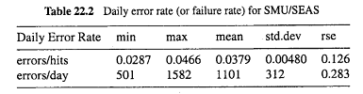
Other IDRMs
• Brown-Lipow model:
. explicit input state distribution.
. known probability for sub-domains Ei
. fi failures for ni runs from subdomain Ei
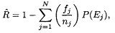
would be the same as Nelson model for representative sampling
IDRM Applications
• IDRM applications
- . overall reliability at acceptance testing
- . reliability snapshots over time: in Nelson model examples earlier
- . reliability for input subsets: in TBRMs
Time Domain Measures and Models
• Reliability measurement
- . Reliability: time & probability
- . Result: failure vs. success
- . Time/input measurement
- . Failure intensity (rate): alternative
- . Mean Time Between/To Failures (MTBF/MTTF): summary measure
S/w reliability growth models (SRGMs)
• S/w reliability growth models (SRGMs):
- . Reliability growth due to defect removal based on observed testing data.
- . Reliability-fault relations
- . Exposure assumptions
- . Data: time-between-failure (TBF) vs. period-failure-count (PFC) models
SRGM Applications
  - Assessment of current reliability
  - Prediction of future reliability and resource to reach reliability goals
  - Management and improvement
- . Reliability goals as exit criteria
- . Resource allocation (time/distribution)
- . Risk identification and followups:
  - reliability (growth) of different areas
  - remedies for problematic areas
  - preventive actions for other areas
Assessing Existing Approaches
• Time domain reliability analysis:
- . Customer perspective.
- . Overall assessment and prediction.
- . Ability to track reliability change.
- . Issues: assumption validity.
- . Problem: how to improve reliability?
• Input domain reliability analysis:
- . Explicit operational profile.
- . Better input state definition.
- . Hard to handle change/evolution.
- . Issues: sampling and practicality.
- . Problem: realistic reliability assessment?
TBRMs: An Integrated Approach
• Combine strengths of the two.
• TBRM for reliability modeling:
- . Input state: categorical information.
- . Each run as a data point.
- . Time cutoff for partitions.
- . Data sensitive partitioning ⇒ Nelson models for subsets.
• Using TBRMs:
- . Reliability for partitioned subsets.
- . Use both input and timing information.
- . Monitoring changes in trees.
- . Enhanced exit criteria.
- . Integrate into the testing process.
TBRMs: Interpretation & Usage
• Interpretation of trees:
- . Predicted response: success rate. (Nelson reliability estimate.)
- . Time predictor: reliability change.
- . State predictor: risk identification.
• Change monitoring and risk identification:
- . Change in predicted response.
- . Through tree structural change.
- . Identify high risk input state.
- . Additional analyses often necessary.
- . Enhanced test cases or components.
TBRMs at Different Times
An early TBRM.
- high-risk areas identified by input
- early actions to improve reliability
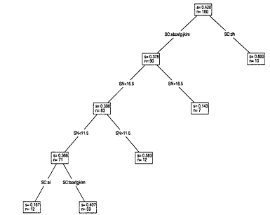
TBRMs at Different Times
An early/late TBRM.
- high-risk areas identified by input
- early actions to improve reliability
- high-risk areas ≈ early runs
- . uniformly reliable ⇒ ready for release
TBRM Impact
• Evaluation/validation with SRGMs:
- . Trend of reliability growth.
- . Stability of failure arrivals.
- . Estimated reliability:
    - Important: deployment at all successor products at IBM

Integrated Approach: Implementation
• Modified testing process:
- . Additional link for data analysis.
- . Process change and remedial actions.
• Activities and Responsibilities:
- . Evolutionary, stepwise refinement.
- . Collaboration: project & quality orgs.
- . Experience factory prototype.
• Implementation:
- . Passive tracking and active guidance.
- . Periodic and event-triggered.
- . S/W tool support
Tool Support
• Types of tool support:
- . Data capturing
  - mostly existing logging tools
  - modified to capture new data
- . Analysis and modeling
  - SMERFS modeling tool
  - S-PLUS and related programs
- . Presentation/visualization and feedback
- S-PLUS and Tree-Browser
Implementation Support
Implementation of tool support:
- . Existing tools: minimize cost
  - internal as well as external tools
- . New tools and utility programs
- . Tool integration
- loosely coupled suite of tools
- connectors/utility programs
SRE Perspectives
• New models and applications
- . Expand from “medium-reliable” systems.
- New models for new application domains.
- Data selection/treatment
• Reliability improvement
- . Followup to TBRMs
Predictive (early!) modeling for risk identification and management
• Other SRE frontiers:
- . Coverage/testing and reliability
- . Reliability composition and maximization
Summary of Today’s Lecture
- In today’s lecture, we talked about the Software Reliability Engineering (SRE)
- Concepts and Approaches
- Existing Approaches: SRGMs & IDRMs
- Assessment & Improvement with TBRMs
Overview of the next lecture
- The last two lectures of the course, i.e., Lecture No. 21 & 32 are going to be the revision of the whole course.
The End

