Software Quality Engineering
Lecture No. 29
Part- 4:
Quantifiable Quality Improvement
Summary of the previous lecture
In our previous lecture, we talked about Defect Classification and Analysis. We also focused on:
- General Types of Defect Analyses,
- ODC: Orthogonal Defect Classification.
- Analysis of ODC Data.
- We also discussed an examples of most common defects that occur in a web based project.
Outlines of today’s lecture
- In today’s lecture, we will talk about Risk Identification for Quantifiable Quality Improvement
- Basic Ideas and Concepts
- Traditional Statistical Techniques
- Newer/More Effective Techniques
- NN, TBM, OSR etc.
- Tree-Based Analysis of ODC Data
Objectives
- To understand and distinguish between different techniques that are available for risk identification in a software
- To apply the knowledge learnt in the real life software.
Risk Identification: Why?
• Observations and empirical evidences:
- . 80:20 rule: non-uniform distribution:
  - 20% of the modules/parts/etc. contribute to
  - 80% of the defects/effort/etc.
- . implication: non-uniform attention – risk identification – risk management/resolution
• Risk Identification in SQE:
- . 80:20 rule as implicit hypothesis
- . focus: techniques and applications
Risk Identification: How?
• Qualitative and subjective techniques:
- . Causal analysis
- . Delphi and other subjective methods
• Traditional statistical techniques:
- . Correlation analysis
- . Regression models:
  - linear, non-linear, logistic, etc.
• Newer (more effective) techniques:
- . Statistical: PCA, DA, TBM
- . AI-based: NN, OSR
- . Focus of our Lecture.
Risk Identification: Where?
• 80% or target:
- . Mostly quality or defect (most of our examples also)
- . Effort and other external metrics
- . Typically directly related to goal
- . Resultant improvement
• 20% or contributor:
- . 20%: risk identification!
- . Understand the link
- . Control the contributor:
  - corrections/defect removal/etc.
  - future planning/improvement
  - remedial vs preventive actions
Statistics Basics
• Random variables
- . used in statistical analysis/modeling and in risk identification in particular
- . used as either i.v./p.v. or d.v./r.v. . i.v. or p.v.: independent variable – also called predictor (variable)
- . d.v. or r.v.: dependent variable – also called response (variable)
• Statistical distributions:
- . 1d: normal, exponential, binomial, etc.
- . 2d: independent vs. correlated
- . covariance, correlation (coefficient)

Traditional Technique: Correlation
• Correlation coefficient (c.c.):
- . ranges between −1 and 1
- . positive: move in same direction
- . negative: move in opposite direction
- . 0: not correlated (independent)
• Correlation analysis:
- . use correlation coefficient
- . linear (Pearson) correlation vs. non-parametric (Spearman) correlation
- . based on measurement type/distribution:
  - non-normal distribution
  - ordinal measurement etc
Traditional Technique: Correlation
• Correlation analysis: applications
- . understand general relationship – e.g., complexity-defect correlation
- . risk identification also
- . cross validation (metrics etc.)
• Correlation analysis: assessment
- . only partially successful
- . low correlation, then what?
- . data skew: 0-defect example
- . uniform treatment of data ⇒ Other risk identification techniques needed.
Traditional Technique: Regression
• Regression analysis: applications
- . similar to correlation analysis
- . multiple attribute data
• Regression analysis: assessment
- . only partially successful
- . similar to correlation analysis
- . often marginally better (R-sqr vs c.c.)
- . same kind of problems
- . data transformation problem
- . synthesized metrics ∼ regression model?
  - ⇒ Other risk identification techniques needed
New Techniques
• New statistical techniques:
- . PCA: principal component analysis
- . DA: discriminant analysis
- . TBM: tree-based modeling
• AI-based new techniques:
- . NN: artificial neural networks.
- . OSR: optimal set reduction.
- . Abductive-reasoning, etc.
New Techniques: PCA & DA
• Not really new techniques, but rather new applications in SE.
• PCA: principal component analysis
- . Idea of linear transformation.
- . PCA to reduce dimensionality.
- . Effectively combined with DA and other techniques.
• DA: discriminant analysis
- . Discriminant function
- . Risk id as a classification problem
- . Combine with other techniques
New Techniques: PCA & DA
• DA: how?
Other/similar definitions possible.
- . Minimize misclassification rate in model fitting and in prediction.
- . Good results (Khoshgoftaar et al., 1996).
• PCA&DA: Summary and Observations:
- . Positive/encouraging results, but,
- . Much processing/transformation needed.
- . Much statistics knowledge.
- . Difficulty in data/result interpretation.
New Technique: NN
• NN or ANN: artificial neural networks
- . Inspired by biological computation
- . Neuron: basic computational unit
- different functions
- . Connection: neural network
- . Input/output/hidden layers
• NN applications:
- . AI and AI problem solving
- . In SQE: defect/risk identification
New Technique: TBM
• TBM: tree-based modeling
- . Similar to decision trees
- . But data-based (derived from data)
- . Preserves tree advantages:
  - easy to understand/interpret
  - both numerical and categorical data
  - partition ⇒ non-uniform treatment
• TBM applications:
- . Main: defect analysis TBDMs (tree-based defect models)
  - Reliability: TBRMs (next lecture)
• Risk identification and characterization.
New Technique: TBM
• TBM for risk identification:
- . Assumption in traditional techniques: – linear relation – uniformly valid result
- . Reality of defect distribution: – isolated pocket – different types of metrics – correlation/dependency in metrics – qualitative differences
- . Need new risk id. techniques.
• TBM for risk characterization:
- . Identified, then what? . Result interpretation.
- . Remedial/corrective actions.
- . Extrapolation to new product/release.
- . TBDMs appropriate.
New Technique: TBM
• TBDMs: tree-based defect models using tree-based modeling (TBM) technique
• Decision trees:
- . multiple/multi-stage decisions
- . may be context-sensitive
- . natural to the decision process
- . applications in many problems – decision making & problem solving – decision analysis/optimization
• Tree-based models:
- . reverse process of decision trees
- . data ⇒ tree . idea of decision extraction
- . generalization of “decision”
TBM Example
• TBDM example:
Defect prediction for IBM-NS
- . 11 design/size/complexity metrics
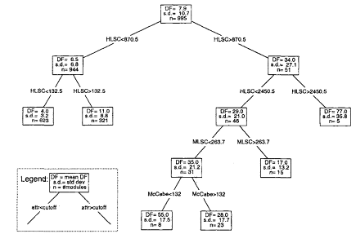
New Technique: OSR
• OSR: optimal set reduction
- . pattern matching idea
- . clusters and cluster analysis
- . similar to TBM but different in: pattern extraction vs. partition
Following are the steps for OST algorithm
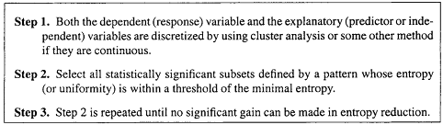
New Technique: OSR
• Organization/modeling results:
- . no longer a tree, see example above
- . general subsets, may overlap
. details and some positive results:
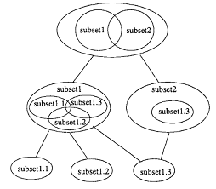
Risk Identification: Comparison
• Comparison: cost-benefit analysis ≈ comparing QA alternatives (Last lecture of Part III).
• Comparison area: benefit-related
- . accuracy
- . early availability and stability
- . constructive information and guidance for (quality) improvement
• Comparison area: cost-related
- . simplicity
- . ease of result interpretation
- . availability of tool support

Comparison: Accuracy
• Accuracy in assessment:
- . model fits data well
- use various goodness-of-fit measures
- . avoid over-fitting
- . cross validation by review etc.
• Accuracy in prediction:
- . over-fitting ⇒ bad predictions
- . prediction: training and testing sets
- within project: jackknife
- across projects: extrapolate
- . minimize prediction errors
Comparison: Usefulness
• Early availability and stability
- . to be useful must be available early
- . focus on control/improvement
- . apply remedial/preventive actions early
- . track progress: stability
• Constructive information and guidance
- . what: assessment/prediction
- . how to improve?
- constructive information
- guidance on what to do
- . example of TBRMs
Comparison: Usability
• Can’t be explained in a few words ⇒ difficulties with reception/deployment
• Simplicity & result interpretation?
- . technique easy to use/understand
- . what does it (the result) mean?
- . training effort involved
- . causal and other connections
• Tool and other support:
- . availability of easy-to-use tools
- . other support: process/personnel/etc.
- . direct impact on deployment
Comparison Summary
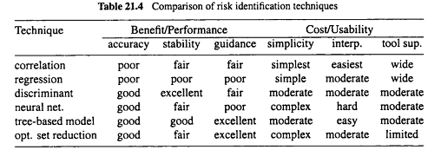
Recommendations and Integration
• General recommendations:
- . TBM good balance ⇒ prime candidate.
- . Other techniques might be useful too.
- . A suite of techniques might be suitable.
• Lifecycle integration:
- . Process and data availability
  - ⇒ inspection/testing/other QA data.
- . Experience/infrastructure/tools/etc. for implementation/technology transfer.
- . Similar techniques for other problems
  - e.g., identifying effort, schedule risks.
- . Tailoring to individual process/product
Summary of Today’s Lecture
- There are different techniques available for Risk Identification.
- Each technique has some merits and limitations.
- These techniques could be compared amongst each other using some parameters such as accuracy and usability etc.
Overview of the next lecture
- Last Topic of the course, i.e., Software Reliability Engineering
- Concepts and Approaches
- Existing Approaches: SRGMs & IDRMs
- Assessment & Improvement with TBRMs
The End

