Software Quality Engineering
Lecture No. 28
Part- 4:
Quantifiable Quality Improvement
Summary of the previous lecture
- In our previous lecture, we talked about quality models. We discussed different types of quality models
  - . Generalized: averages or trends
  - . Product-specific: more customized
- We also discussed Model/Measurement Selection
Outlines of today’s lecture
- In today’s lecture, we will talk about Defect Classification and Analysis
- General Types of Defect Analyses.
- ODC: Orthogonal Defect Classification.
- Analysis of ODC Data.
Objectives
- To understand and distinguish defect analysis and defect distribution analysis.
- To apply the knowledge learnt of the ODC to real life software.
Defect Analysis
- Goal: (actual/potential) defect↓ or quality↑ in current and future products.
- General defect analyses:
  - . Questions: what/where/when/how/why?
  - . Distribution/trend/causal analyses.
Analyses of classified defect data:
- . Prior: defect classification.
- . Use of historical baselines.
- . Attribute focusing in 1-way and 2-way analyses.
- . Tree-based defect analysis (Lecture 29)

Defect in Quality Data/Models
• Defect data ⊂ quality measurement data:
- . As part of direct Q data.
- . Extracted from defect tracking tools.
- . Additional (defect classification) data may be available.
• Defect data in quality models:
- . As results in generalized models (GMs).
- . As r.v. (response/independent variable) in product specific models (PSMs).
  - semi-customized models ≈ GMs,
  - observation-based: r.v. in SRGMs,
  - predictive: r.v. in TBDMs
General Defect Analysis
- General defect analyses: Questions
- . What? identification (and classification).
  - type, severity, etc.,
  - even without formal classification.
- . Where? distribution across location.
- . When? discovery/observation
  - what about when injection? harder
  - pre-release: more data
  - post-release: more meaningful/sensitive
- . How/why? related to injection
    - ⇒ use in future defect prevention.
General defect analyses
General defect analyses: Types
- . Distribution by type or area.
- . Trend over time.
- . Causal analysis.
- . Other analysis for classified data.
Defect Analysis: Data Treatment
• Variations of defect data:
- . Error/fault/failure perspective.
- . Pre-/post-release. . Unique defect?
- . Focus here: defect fixes.
• Why defect fixes (DF):
- . Propagation information.
- . Close ties to effort (defect fixing).
- . Pre-release: more meaningful. (post release: each failure occurrence.)
Defect Distribution Analysis
• Distribution: what, where, etc.
• What: Distribution over defect types.
- . Ties to quality views/attributes.
- . Within specific view: types/sub-types.
- . Defect types ⇐ product’s “domain”.
• Important observation:
- . Skewed distribution, or 80:20 rule
    - ⇒ importance of risk identification for effective quality improvement
- . Early indicators needed! (Cannot wait after defect discoveries.)
Defect Distribution Analysis
Web example:
- . defect = “error” in web community.
- . dominance of type E “missing files”.
- . type A: further information needed.
- . all other types: negligible.
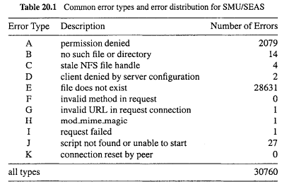
Defect Distribution Analysis
• Further analysis of web example above:
- . for dominant type E “missing files”
- . web error distribution by file type
- . again, skewed distribution!
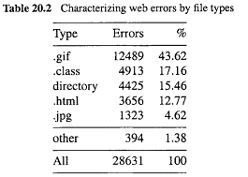
Defect Trend Analysis
• Trend as a continuous function:
- Customized with local data
- Other analysis related to SRE
- defect/effort/reliability curves
- more in Lecture 30.
. Sometimes discrete analysis may be more meaningful (see below).
• Defect dynamics model:
- . Important variation to trend analysis.
- . Defect categorized by phase.
- . Discovery (already done).
- . Analysis to identify injection phase.
Defect Trend Analysis
• Defect dynamics model:
- . row: where (phase) injected
- . column: where (phase) removed/discovered
- . focus out-of-phase/off-diagonal ones!
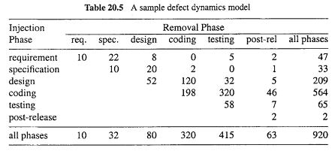
Defect Causal Analysis
• Defect causal analyses: Types
. Causal relation identified:
error-fault vs fault-failure
works backwards
. Techniques: statistical or logical.
• Root cause analysis (logical):
. Human intensive.
. Good domain knowledge.
. Fault-failure: individual and common.
. Error-fault: project-wide effort focused on pervasive problems.
• Statistical causal analysis: ≈ risk identification techniques in Lecture 29
Orthogonal Defect Classification ODC: Overview
• Development . Chillarege et al. at IBM
. Applications in IBM Labs and several other companies
. Recent development and tools
• Key elements of ODC
. Aim: tracking/analysis/improve
. Approach: classification and analysis
. Key attributes of defects
. Views: both failure and fault
. Applicability: inspection and testing
. Analysis: attribute focusing
. Need for historical data
ODC: Why?
• Statistical defect models:
- Quantitative and objective analyses.
- Problems: accuracy & timeliness.
• Causal (root cause) analyses:
- Qualitative but subjective analyses.
- Use in defect prevention.
• Gap and ODC solution:
- Bridge the gap between the two.
- Systematic scheme used.
- Wide applicability
ODC: Ideas
• Cause-effect relation by type:
- Different types of faults.
- Causing different failures.
- Need defect classification.
- Multiple attributes for defects.
• Good measurement:
- Orthogonality (independent view).
- Consistency across phases.
- Uniformity across products.
ODC process/implementation:
- Human classification.
- Analysis method and tools.
- Feedback results (and follow-up)

ODC Theory
• Semantic classification:
- . defect classes for a product
- . related-to/explain process
- . akin to event measurement
- . sufficient condition:
- spanning set over process
- formed by defect attributes
• Classification for cause-effect or views:
- . cause: type, trigger, etc.
- . effect: severity, impact, etc.
- . failure vs fault (internal cause) views
- . additional causal-analysis-related: source, where/when injected.
- . sub-population: environment data.
ODC Example
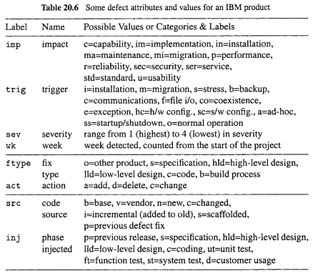
ODC Attributes: Failure-View
• Defect trigger:
- . Associated with verification process
- similar to test case measurement
- collected by testers
- . Trigger classes
  - product specific
  - black box in nature
  - pre/post-release triggers
• Other attributes:
- . Impact
- . Severity: low-high
- . Detection time, etc.
ODC Attributes: Cause/Fault-View
• Defect type:
- . Associated with development process.
- . Missing or incorrect.
- . Collected by developers.
- . May be adapted for other products.
- Other attributes:
- . Action: add, delete, change.
- . Number of lines changed, etc.
ODC Attributes: Cause/Error-View
• Key attributes:
- . Defect source: vendor/base/new code.
- . Where injected.
- . When injected.
• Characteristics:
- . Associated to additional causal analysis.
- . (May not be performed.)
- . Many subjective judgment involved (evolution of ODC philosophy)
• Phase injected: rough “when”.
Adapting ODC for Web Error Analysis
• Continuation of web testing/QA study.
• Web error = observed failures, with causes already recorded in access/error logs.
• Key attributes mapped to ODC:
- . Error type = defect impact.
- response code (4xx) in access logs
- . Referring page = defect trigger.
- individual pages with embedded links
- classified: internal/external/empty
- focus on internal problems
- . Missing file type = defect source – different fixing actions to follow.
• May include other attributes for different kinds of web sites.
ODC Analysis: Attribute Focusing
• General characteristics
- . Graphical in nature
- . 1-way or 2-way distribution
- . Phases and progression
- . Historical data necessary
- . Focusing on big deviations
• Representation and analysis
- . 1-way: histograms
- . 2-way: stack-up vs. multiple graphics
- . Support with analysis tools
ODC Analysis Examples
• 1-way analysis:
- . Defect impact distribution for an IBM product.
- . Uneven distribution of impact areas!
    - ⇒ risk identification and focus.
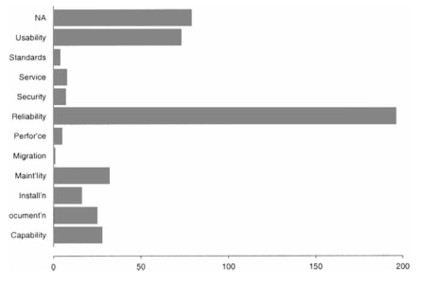
ODC Analysis Examples
• 2-way analysis:
- . Defect impact-severity analysis.
- . IBM product study continued.
- . Huge contrast: severity of reliability and usability problems!
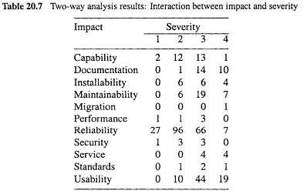
ODC Process and Implementation
• ODC process:
- . Human classification
- defect type: developers,
- defect trigger and effect: testers,
- other information: coordinator/other.
- . Tie to inspection/testing processes.
- . Analysis: attribute focusing.
- . Feedback results: graphical.
• Implementation and deployment:
- . Training of participants.
- . Data capturing tools.
- . Centralized analysis.
- . Usage of analysis results.
Linkage to Other Topics
• Development process
- . Defect prevention process/techniques.
- . Inspection and testing.
• Testing and reliability:
- . Expanded testing measurement
  - Defects and other information:
  - Environmental (impact)
  - Test case (trigger)
  - Causal (fault)
- . Reliability modeling for ODC classes
Summary of Today’s Lecture
- In today’s lecture, we talked about Defect Classification and Analysis. We also focused on:
- General Types of Defect Analyses.
- ODC: Orthogonal Defect Classification.
- Analysis of ODC Data.
Overview of the next lecture
- Risk Identification for Quantifiable Quality Improvement
- Basic Ideas and Concepts
- Traditional Statistical Techniques
- Newer/More Effective Techniques
- Tree-Based Analysis of ODC Data
The End

