Software Quality Engineering
Lecture No. 27
Part- 4:
Quantifiable Quality Improvement
Summary of the previous lecture
- In last lecture, we talked about Quality Models and Measurements
- Post-QA analysis & feedback
- Part IV (maybe parallel instead of “post-)
- Analysis => Feedback loops => Follow-ups
QE Activities and Process Review
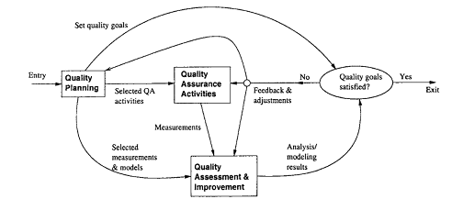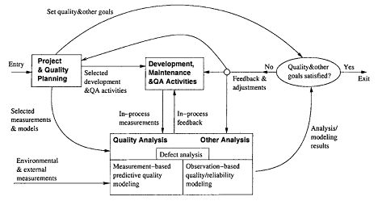
Quality Engg. Process
Refined Quality Engineering Process: Management, Analysis and feedback for Quantifiable improvement
Outlines
Quality Models and Measurements
• Types of Quality Assessment Models.
• Comparing Quality Assessment Models.
• Data Requirements and Measurement
• Measurement and Model Selection.
Objectives
- To understand and distinguish different types of quality models such as Generalized and Product-specific
- To apply and use different types of product specific models to solve real life software challenges
QA Data and Analysis
- Generic testing process:
- . Test planning and preparation.
- . Execution and measurement.
- . Test data analysis and follow-up.
- . Related data ⇒ quality ⇒ decisions
- Other QA activities:
- . Similar general process.
- . Data from QA/other sources (previous lecture).
- . Models used in analysis and follow-up:
  - provide timely feedback/assessment
  - prediction, anticipating/planning
  - corrective actions ⇒ improvement
QA Models and Measures
• General approach
- . Adapt GQM-paradigm.
- . Quality: basic concept and ideas.
- . Compare models ⇒ taxonomy.
- . Data requirements ⇒ measurements.
- . Practical selection steps.
- . Illustrative examples.
• Quality attributes and definitions:
- . Q models: data ⇒ quality
- . Correctness vs. other attributes
- . Our definition/restriction: being defect-free or of low-defect
- . Examples: reliability, safety, defect count/density/distribution/etc.
Quality Analysis
• Analysis and modeling:
. Quality models: data ⇒ quality
Also known as quality assessment models or quality evaluation models
. Various models needed
. Assessment, prediction, control
. Management decisions
. Problematic areas for actions
. Process improvement
• Measurement data needed
. Direct quality measurements: success/failure (defect info)
. Indirect quality measurements:
activities/internal/environmental.
Indirect but early quality indicators. All described in Lecture26.
Quality Models
• Practical issues:
- . Applicability vs. appl. environment
- . Goal/Usefulness: information/results?
- . Data: measurement data required
- . Cost of models and related data
• Type of quality models
- . Generalized: averages or trends
- . Product-specific: more customized
- . Relating to issues above
Generalized Models: Overall
- Model taxonomy:
- . Generalized:
  - overall, segmented, and dynamic
- . Product-specific:
  - semi-customized: product history
  - observation-based: observations
  - measurement-driven: predictive
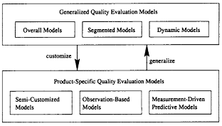
Classification of quality assessment models

Generalized Models: Overall
• Key characteristics
- . Industrial averages/patterns ⇒ (single) rough estimate.
- . Most widely applicable.
- . Low cost of use.
• Examples: Defect density.
- . Estimate total defect with sizing model.
- . Variation: QI in IBM (counting in-field unique defect only)
• Non-quantitative overall models:
- . As extension to quantitative models.
- . Examples: 80:20 rule, and other general observations.
Product-Specific Models (PSM)
• Product-specific models (PSMs):
- . Product-specific info. used (vs. none used in generalized models)
- . Better accuracy/usefulness at cost ↑
- . Three types:
  - semi-customized
  - observation-based
  - measurement-driven predictive
• Connection to generalized models (GMs):
- . Customize GMs to PSMs with new/refined models and additional data.
- . Generalize PSMs to GMs with empirical evidence and general patterns.
PSM: Semi-Customized
• Semi-customized models:
- . Project level model based on history.
- . Data captured by phase.
- . Both projections and actual.
- . Linear extrapolation.
Related extensions to Defect Removal Model (DRM):
- . Defect dynamics model in Lecture 28,
- . Orthogonal Defect Classification (ODC) defect analyses in Lecture 28:
  - 1-way distribution/trend analysis
  - 2-way analysis of interaction.
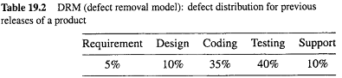
PSM: Observation-Based
• Observation-based models:
- . Detailed observations and modeling
- . Software reliability growth models
- . Other reliability/safety models
• Model characteristics
- . Focus on the effect/observations
- . Assumptions about the causes
- . Assessment-centric
PSM: Predictive
• Measurement-driven predictive models
- . Establish predictive relations
- . Modeling techniques: regression, TBM, NN, OSR etc.
- . Risk assessment and management
• Model characteristics:
- . Response: chief concern
- . Predictors: observable/controllable
- . Linkage quantification
Model Summary
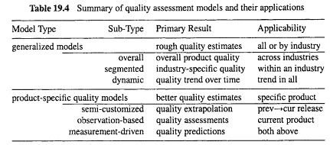

Model Applications
• Applications: . ¬ data ⇒ GMs as early choices.
- . Data arrival ⇒ phase in PSMs:
- special case: historical data ⇒
- semi-customized models.
- . Model customization within application.
• Model customization
- (from generalized to product-specific) in connection with model applications.
• Model generalization:
- . data/results accumulation
- . generalized model possible?
- . mathematical function/empirical trend
Relating Models to Measurements
- Data required by quality models (Lecture 26):
- . Direct quality measurements
- to be assessed/predicted/controlled
- . Indirect quality measurements
  - means to achieve the goal
  - environmental, activity, product-internal
- . Data requirement by models summarized below
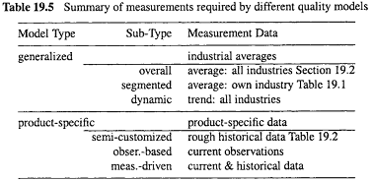

Relating Models to Measurements
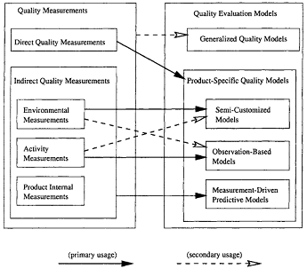
Model/Measurement Selection
• Customize Goal-Question-Metric (GQM) into 3-steps
• Step 1: Quality goals
  - . Restricted, not general goals
• Step 2: Quality models
  - . Model characteristics/taxonomy
  - . Model applicability/usefulness
  - . Data requirement/affordability
• Step 3: Quality measurements
  - . Model-measurements relations
  - . Detailed model information
Selection Example A
• Goal: rough quality estimates
• Situation 1:
  - . No product specific data
  - . Industrial averages/patterns
  - . Commercial tools: SLIM etc.
  - . Product planning stage
  - . Defect profile in lifecycle
  - . Use generalized models
• Situation 2: . Data from related products
  - . DRM for legacy products
  - . ODC profile for IBM products
  - . Semi-customized models
Selection Example B
• Goal: customer-view of quality in system testing
• Quality model:
  - . Software Reliability Growth Model (SRGMs): info. about reliability
  - . Assessment: customer-view
  - . Prediction: project management
  - . Decisions: exit criteria
  - . Affordability: data and modeling
Selection Example B
• Quality measurements:
  - . Reliability: failure-free operation for a given time under a specific environment
  - . Result: success/failure measurement
  - . Time measurement: reflect activity
  - . Environment: implicitly assumed
Selection Example C
- Goal: testing process/quality improvement, but SRGMs inadequate
- Selecting Tree-based reliability model (TBRM) to focus on reliability improvement
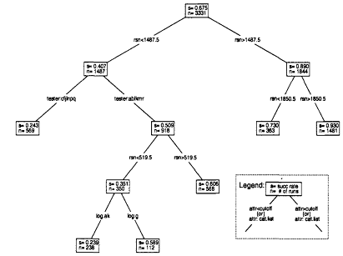
Selection Example C
- TBRM: improvement focus
  - what’s wrong: risk identification
  - what to do: remedial actions
- Data attributes:
- . Result: success/failure measurement
- . Timing info.: time-domain analysis
- . Input state: input-domain analysis
Conclusion and Perspectives
- Practical need for quality measurement and model selection
- Viable approach
- . Model characteristics ⇒ taxonomy
- . Model data requirement: different types of quality measurements
- . Selection steps: customized GQM
- . Viability: examples
- Perspective and future work:
- . Refined taxonomy
- . Relating models to measurements:
- more details and specific info.
- . Lifecycle activities and support
Summary of Today’s Lecture
- In today’s lecture, we talked about quality models. We discussed some generalized models and their characteristics and we also discussed PSMs.
- Certain models can be appropriate for specific type of softwares.
Overview of the next lecture
In next lecture, we will talk about Defect Classification and Analysis
General Types of Defect Analyses.
ODC: Orthogonal Defect Classification.
Analysis of ODC Data.
The End

