Software Quality Engineering
Lecture No. 26
Summary of the previous lecture
In last lecture, we compared different QA Alternatives (including Testing, Inspection, Validation) More specifically, we will talk about
- General Areas
- Questions for Comparison
- Applicability, Effectiveness, and Cost
- Summary and Recommendations.
- We have seen different comparison tables to identify which QA alternative is appropriate for what type of software

Part- 4:
Quantifiable Quality Improvement
Outlines
Feedback Loop and Activities for Quantifiable Quality Improvement
• Feedback Loop and Overall Mechanism
• Monitoring and Measurement
• Analysis and Feedback
• Tool and Implementation Support
Objectives
- To understand and distinguish between Pre-QA activities and Post-QA activities.
- To be able to apply the knowledge of quantifiable quality improvement in real life software.
Importance of Feedback Loop
All QA activities covered in Part II and Part III need additional support:
- . Planning and goal setting
- . Management via feedback loop:
    - When to stop?
    - Adjustment and improvement, etc.
    - All based on assessments/predictions
Importance of Feedback Loop
Feedback loop for quantification/improvement:
- . Focus of Part IV chapters .
  - mechanism and implementation.
  - models and measurements.
  - defect analyses and techniques.
  - risk identification techniques.
  - software reliability engineering
QE Activities and Process Review
• Major activities:
  - . Pre-QA planning (earlier lectures).
  - . QA (Part II and Part III).
  - . Post-QA analysis & feedback
Part IV (maybe parallel instead of “post-”)
• Overall process:– Software quality engineering (SQE)
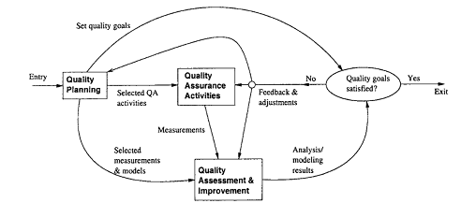
Quality Engg. Process
QE Activities and Process Review
Feedback loop zoom-in: Fig 18.1 (p.304)
- . Multiple measurement sources.
- . Many types of analysis performed.
- . Multiple feedback paths.
Refined Quality Engineering Process: Management, Analysis and feedback for Quantifiable improvement
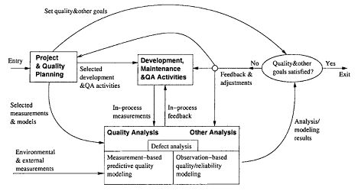
Feedback Loop Related Activities
Monitoring and measurement:
- defect monitoring ∈ process management.
- defect measurement ∈ defect handling.
- many other related measurements.
Analysis modeling:
- Historical baselines and experience.
- Choosing models and analysis techniques.
- Focus on defect/risk/reliability analyses.
- Goal: assessment/prediction/improvement.
Feedback and followup:
- Frequent feedback: assessment/prediction.
- Possible improvement areas identified.
- Overall management and improvement.
Quality Monitoring and Measurements
Quality monitoring needs:
- Quality as a quantified entity over time.
- Able to assess, predict, and control.
- Various measurement data needed.
- Some directly in quality monitoring.
- Others via analyses to provide feedback.
Direct quality measurements:
- Result, impact and related info. – e.g., success vs. failure
- Defect information: directly monitored. – additional defect analysis
- Mostly used in quality monitoring.
Indirect Quality Measurements
• Indirect quality measurements: Why?
- . Other quality measurements (reliability) need additional analyses/data.
- Unavailability of direct quality measurements early in the development cycle ⇒ early (indirect) indicators.
- Used to assess/predict/control quality. (to link to or affect various direct quality measurements)
• Types of indirect quality measurements:
- Environmental measurements.
- Product internal measurements.
- Activity measurements.
Indirect Measurements: Environment
• Process characteristics
- . Entities and relationships
- . Preparation, execution and followup
- . Techniques used
• People characteristics
- . Skills and experience
- . Roles: planners/developers/testers
- . Process management and teams
• Product characteristics
- . Product/market environment
- . Hardware/software environment
Indirect Measurements: Internal
• Product internal measurements: most studied/understood in SE
• Software artifacts being measured:
- . Mostly code-related
- . Sometimes SRS, design, docs etc.
• Product attributes being measured:
- . Control: e.g., McCabe complexity
- . Data: e.g., Halstead metrics
- . Presentation: e.g., indentation rules
• Structures:
Indirect Measurements: Activity
• Execution/activity measurements:
- Overall: e.g., cycle time, total effort.
- Phased: profiles/histograms.
- Detailed: transactions in SRGMs.
• Testing activity examples:
- Timing during testing/usage
- Path verification (white-box)
- Usage-component mapping (black-box)
- Measurement along the path
• Usage of observations/measurements: observation-based and predictive models
Immediate Followup and Feedback
• Immediate (without analyses): Why?
- . Immediate action needed right away: – critical problems ⇒ immediate fixing – most other problems: no need to wait
- . Some feedback as built-in features in various QA alternatives and techniques.
- . Activities related to immediate actions.
• Testing activity examples:
- . Shifting focus from failed runs/areas.
- . Re-test to verify defect fixing.
- . Other defect-related adjustments.
• Defect and activity measurements used.
Analyses, Feedback, and Followup
• Most feedback/follow-up relies on analyses.
Types of analyses:
- . Product release decision related.
- . For other project management decisions, at the phase or overall project level.
- . Longer-term or wider-scope analyses.
• Types of feedback paths:
- . Shorter vs. longer feedback loops.
- . Frequency and time duration variations.
- . Overall scope of the feedback.
- . Data source refinement.
- . Feedback destinations.
Analysis for Product Release Decisions
• Most important usage of analysis results
- “when to stop testing?”
• Basis for decision making:
- . Without explicit quality assessment:
  - implicit: planned activities,
  - indirect: coverage goals,
  - other factors: time/$-based.
- . With explicit quality assessment:
  - failure-based: reliability,
  - fault-based: defect count & density.
• Criteria preference: reliability – defect – coverage – activity.
Analyses for Other Decisions
• Transition from one (sub-)phase to another:
- . Later ones: similar to product release.
- . Earlier ones: reliability undefined
  - defects – coverage – activity,
  - inspection and other early QA
• Other decisions/management-activities:
- . Schedule adjustment.
- . Resource allocation and adjustment.
- . Planning for post-release support.
- . Planning for future products or updates.
• These are product-level or sub-product-level decisions and activities.
Other Feedback and Followup
- Other (less frequent) feedback/followup:
- . Goal adjustment (justified/approved).
- . Self-feedback (measurement & analysis)
  - unsuitable measurements and models?
  - SRE measurement example in IBM.
- . Longer term, project-level feedback.
- . May even carry over to followup projects.
- Beyond a single-project duration/scope:
- . Future product quality improvement
  - overall goal/strategy/model/data,
  - especially for defect prevention.
- . Process improvement.
- . More experienced people.
Feedback Loop Implementation
- Key question: sources and destinations. (Analysis and modeling activity at center.)
- Sources of feedback loop = data sources:
- . Result and defect data:
  - the QA activities themselves.
- . Activity data:
  - both QA and development activities.
- . Product internal data: product. (produced by development activities)
- . Environmental data: environment.
- Additional sources of feedback loop:
- . From project/QA planning.
- . Extended environment: measurement data and models beyond project scope.
Feedback Loop Implementation
- Feedback loop at different duration/scope levels.
- Immediate feedback to current development activities (locally).
- Short-term or sub-project-level feedback:
- . transition, schedule, resource,
- . destination: development activities.
- Medium-term or project-level feedback:
- . overall project adjustment and release
- Longer-term or multi-project feedback: – to external destinations
Feedback Loop Implementation
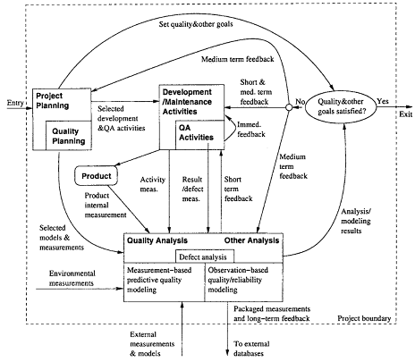
Implementation Support Tools
- Type of tools:
- . Data gathering tools.
- . Analysis and modeling tools.
- . Presentation tools.
- Data gathering tools:
- . Defects/direct quality measurements:
  - from defect tracking tools.
- . Environmental data: project db.
- . Activity measurements: logs.
- . Product internal measurements:
  - commercial/home-build tools.
- . New tools/APIs might be needed.
Implementation Support Tools
- Analysis and modeling tools:
- . Dedicated modeling tools: – e.g., SMERFS and CASRE for SRE
- . General modeling tools/packages: – e.g., multi-purpose S-Plus, SAS.
- . Utility programs often needed for data screening and processing.
- Presentation tools:
- . Aim: easy interpretation of feedback ⇒ more likely to act on.
- . Graphical presentation preferred.
- . Some “what-if”/exploration capability.

Strategy for Tool Support
- Using existing tools ⇒ cost↓:
- . Functionality and availability/cost.
- . Usability.
- . Flexibility and programmability.
- . Integration with other tools.
- Tool integration issues:
- . Assumption: multiple tools used. (All-purpose tools not feasible/practical.)
- . External rules for inter-operability, – common data format and repository.
- . Multi-purpose tools.
- . Utilities for inter-operability.
Tool Support Example (IBM)
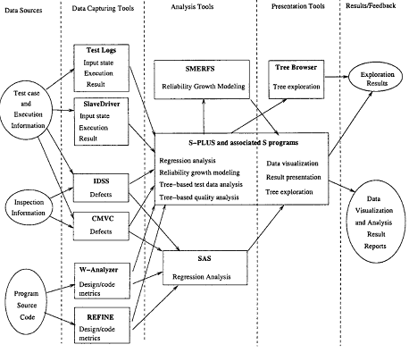
Summary of Today’s Lecture
- In today’s lecture, we talked about Feedback Loop and Activities for Quantifiable Quality Improvement. We discussed the Feedback Loop and Overall Mechanism, Monitoring and Measurement, Analysis and Feedback and lastly, we talked about Tool and Implementation Support.
Overview of the next lecture
- We will talk about Quality Models and Measurements
- Types of Quality Assessment Models.
- Comparing Quality Assessment Models.
- Data Requirements and Measurement
- Measurement and Model Selection.
The End

